**To run the program manually**

How to run the program:

Before running the program, you have to compile the 3 source files that I provide. (Please use the StdDraw from the source file, otherwise the outcomes may be different because I modify the StdDraw a little bit.)

How to modify the board size:

To modify the board size, you can do it by change the first argument when you call the tileBoard().

Note: If n is the first argument, it mean that the board will have the size of $2^{n}$ $2^{n}$

*

Decoration:

If you want to see the colorful board, please put true in the last argument when you call tileBoard().

Screen size:

You can set the application display size by calling the method   
setScreenSize(int n), the application display size will be set to n*n pixels.

You can put the hole anywhere you want:

You can simply put the hole anywhere by put in x-coordinates and y-coordinates after the board size argument. (If you don’t put the coordinates in, the coordinates will be random)

Note: The coordinates can’t be more than $2^{n}-1$ (n is the argument that you put in at first), for example, if $n=5$, the coordinates can be any number from 0 to 31.

** There will be an example and more explanation below. **

**To run the program automatically:**

How to run the program:

Just compile the source files and run the BoardTilingApp class.

The display size is 800*800 pixels. (Default)

Note: the rules are the same as run the program manually.

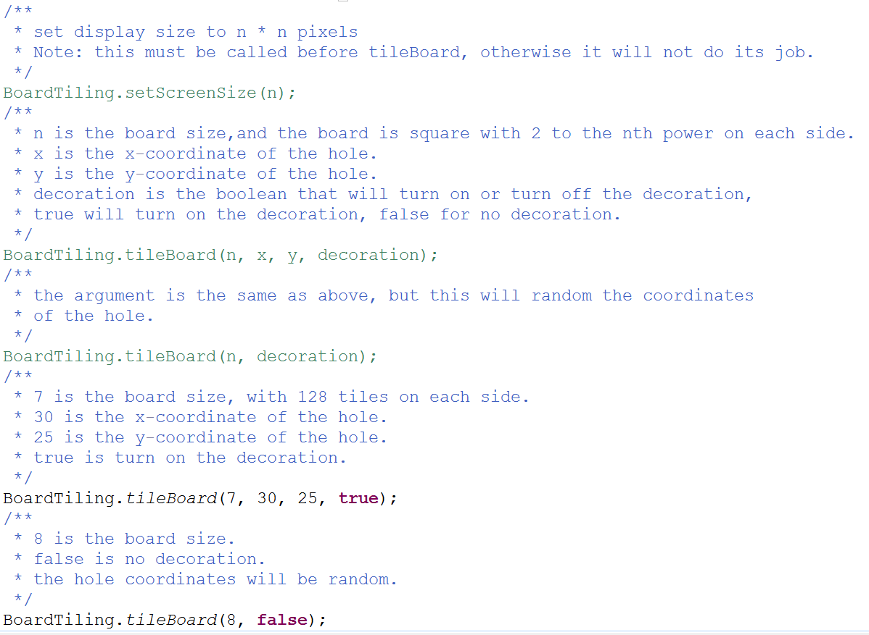Explanation:

Example:

1. 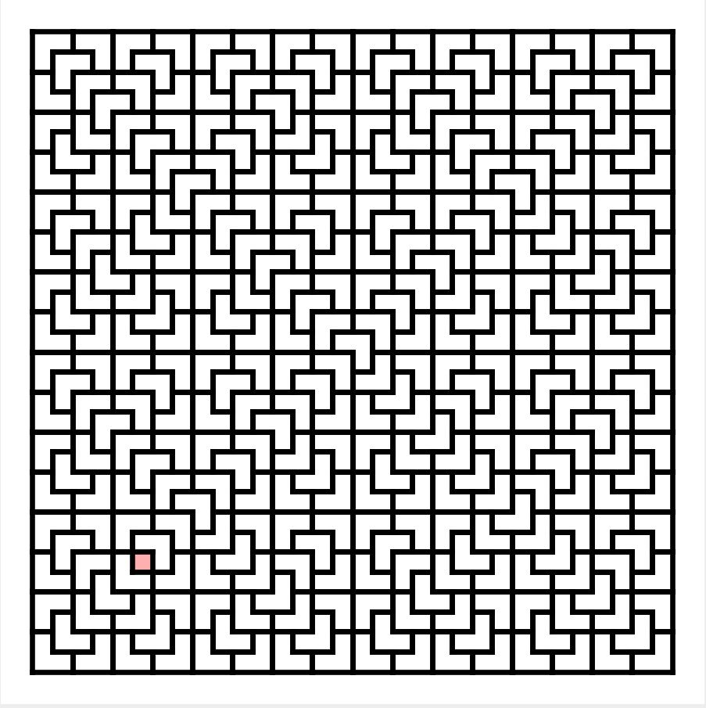BoardTiling.tileBoard(5, 5, 5, false)
2. 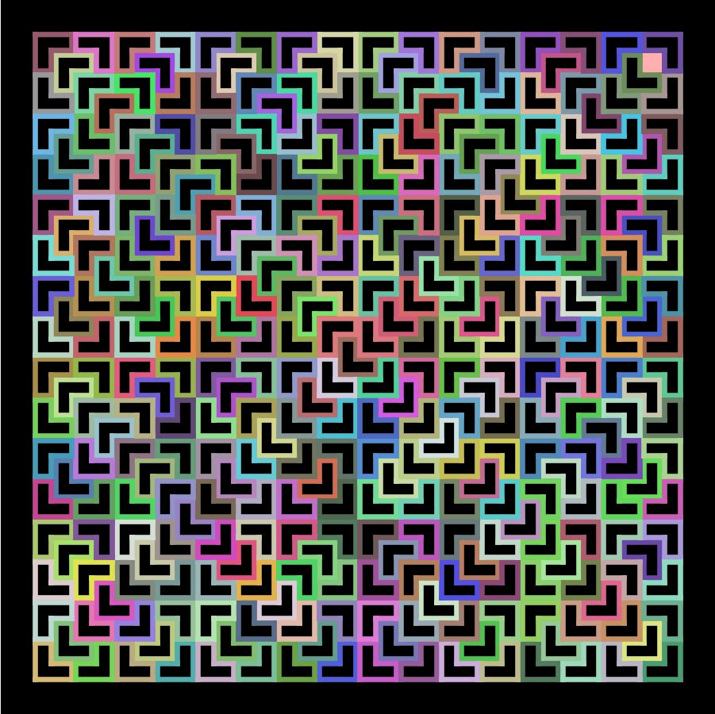BoardTiling.tileBoard(5, 30, 30, true);
3. 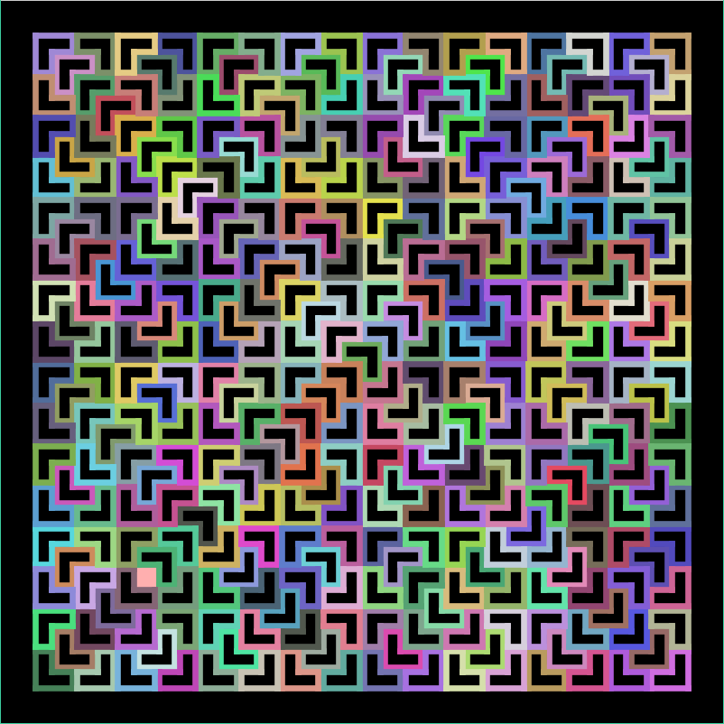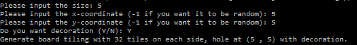Run automatically