**How to run the program**

You can compile and run the examples (or test cases) by compile all classes in the source code and run the TestCases class, or if you want to customize the infix you can do it by follow the pattern in the TestCases class

**Limitations**

There are few limitations in this program: 1. The program will not work correctly if the parentheses are mismatched. 2. This program can do int/int division. 3. The program will not work properly if the infix is not correct.

**More Information**

Users can modify the space of the TreeExp and the Tree (TreeCell) in the TreeExp.printExpTree(), and TreeCell.printTree() ,but you should make sure that you change only the space, otherwise the program may not work correctly.

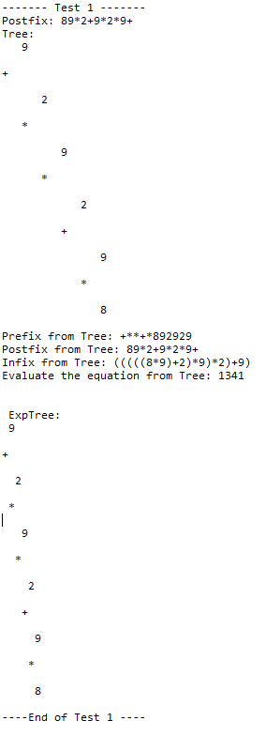**Test case 1:** (8*9+2)*9*2+9

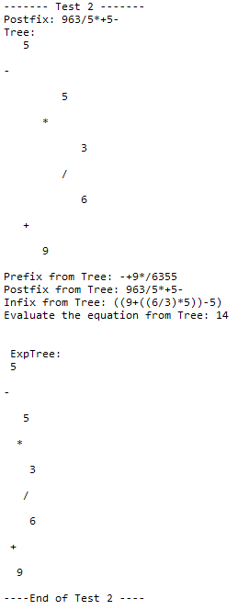**Test case 2:** (9+6/3*5)-(5)

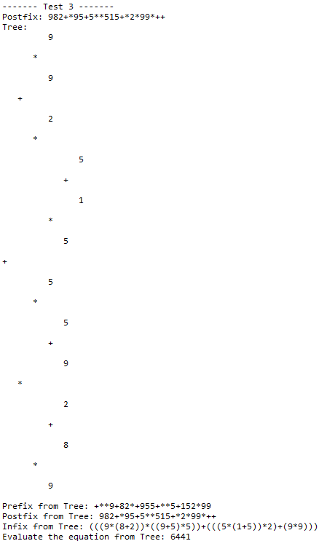**Test case 3 :** (9*(8+2))*((9+5)*5)+(((5*(1+5)*2+9*9)))

Test case 3 continue on the next page.

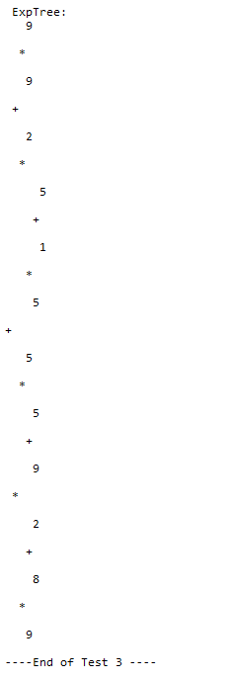

**Test case 4:** (1*1+1-2+2-1)*1*(1*4)*(1/1)+((1+5)/3*2-3)/(1*1*1*1)



Since the tree is too long to fit in this page, you have to run this test case yourself.



**Test case 5:** (9+9)*(9/9-1)*(4/2*5+2)

