**CS599 (Deep Learning)**

**Homework 02**

1. **Python Code:**

zip_url = "https://github.com/tdhock/cs570-spring-2022/raw/master/data/zip.test.gz"

import os

from urllib.request import urlretrieve

if not os.path.exists("zip.test.gz"):

print("Downloading!")

urlretrieve(zip_url, "zip.test.gz")

import pandas as pd

df = pd.read_csv("zip.test.gz", sep = " ", header = None)

print(df.shape)

print(df)

import numpy as np

from math import sqrt

image_number = 50

one_image_label = df.iloc[image_number, 0]

intensity_vec = df.iloc[image_number, 1:]

n_pixels = int(sqrt(len(intensity_vec)))

np.flip(np.repeat(np.arange(n_pixels),n_pixels))

np.tile(np.arange(n_pixels),n_pixels)

one_image_df = pd.DataFrame({

"intensity": intensity_vec,

"row": np.flip(np.repeat(np.arange(n_pixels),n_pixels)),

"column": np.tile(np.arange(n_pixels),n_pixels)

})

import plotnine as p9

gg = p9.ggplot()+\

p9.geom_tile(#draw squares

p9.aes(

x = "column",

y = "row",

fill = "intensity"

),

data = one_image_df

)+\

p9.scale_fill_gradient(

low = "black",

high = "white")+\

p9.ggtitle("Label = %d"%one_image_label)+\

p9.coord_equal()

gg.save("HW2_image.png")

list_images = []

for image_num in [5,50,500]:

multi_image_label = df.iloc[image_num, 0]

intensity_m_vec = df.iloc[image_num, 1:]

multi_image_df = pd.DataFrame({

"observation" : image_num,

"label" : multi_image_label,

"intensity": intensity_m_vec,

"row": np.flip(np.repeat(np.arange(n_pixels),n_pixels)),

"column": np.tile(np.arange(n_pixels),n_pixels)

})

list_images.append(multi_image_df)

several_images = pd.concat(list_images)

gg1 = p9.ggplot()+\

p9.facet_wrap(["observation", "label"], labeller = "label_both")+\

p9.geom_tile(#draw squares

p9.aes(

x = "column",

y = "row",

fill = "intensity"

),

data = several_images

)+\

p9.scale_fill_gradient(

low = "black",

high = "white")+\

p9.ggtitle("Multi image Data Visualization")+\

p9.coord_equal()

gg1.save("HW2_multi_image.png")

1. **Output:**

Single Image Visualization

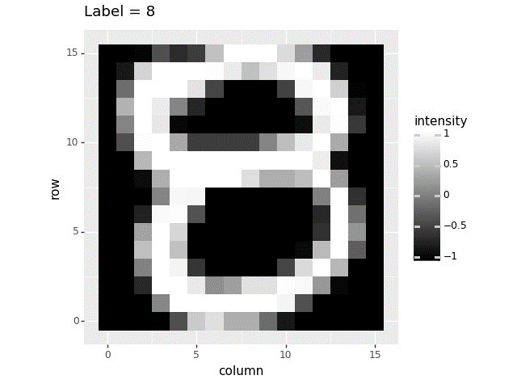

Multi Image Visualization

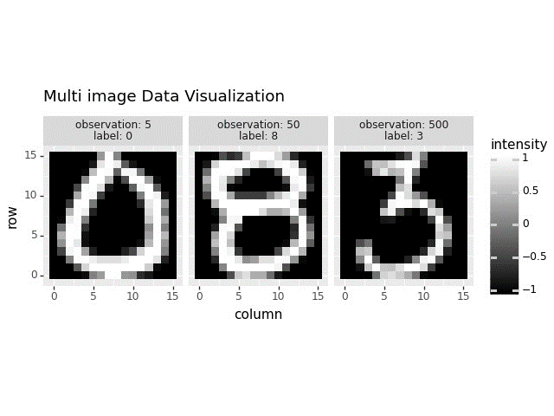

Multi Image Visualization using first 9 rows

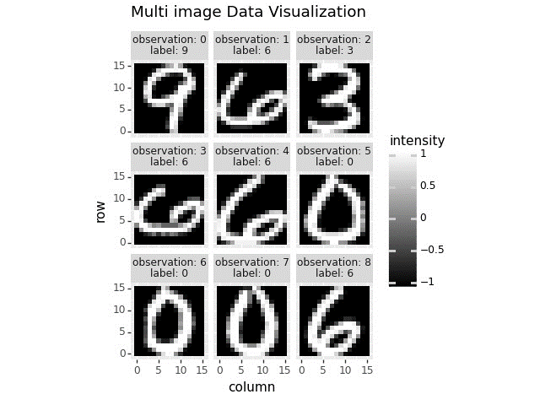

1. **Summary:**

* Here we have 3 sub questions. First, we need to do as HW01 download the file if not available and store it in a dataframe.
* Then, we need to create a dataframe using one row of input with columns row, col, intensity.
* We need to plot that using ggplot(). The output is Single Image Visualization.
* We need to create a multi image dataframe using several rows of data with columns observation, label, row, col, intensity.
* The output is Multi Image Data Visualization.