**CS599 (Deep Learning)**

**Homework – 3**

1. **Python Code:**

import pandas as pd

from sklearn.model_selection import KFold, GridSearchCV

import matplotlib

matplotlib.use("agg")

#preapring zip data for binary classification

zip_df = pd.read_csv("zip.test.gz", sep = " ", header = None)

zip_label_col_num = 0

zip_label_vec = zip_df.iloc[:, zip_label_col_num]

is_01 = zip_label_vec.isin([0,1])

zip_01_df = zip_df.loc[is_01, :]

is_label_col = zip_01_df.columns == zip_label_col_num

zip_features = zip_01_df.iloc[:, ~is_label_col]

zip_labels = zip_01_df.iloc[:, is_label_col]

#preparing spam data for binary classification

spam_df = pd.read_csv("spam.data", sep= " ", header = None)

spam_label_col_num = -1

spam_label_vec = spam_df.iloc[:, spam_label_col_num]

spam_is_01 = spam_label_vec.isin([0,1])

spam_01_df = spam_df.loc[spam_is_01, :]

spam_features = spam_df.iloc[:, :spam_label_col_num]

spam_labels = spam_df.iloc[:, spam_label_col_num]

import numpy as np

from sklearn.neighbors import KNeighborsClassifier

from sklearn.linear_model import LogisticRegressionCV

from sklearn.pipeline import make_pipeline

from sklearn.preprocessing import StandardScaler

from sklearn.metrics import accuracy_score

data_dict = {

"zip" : (zip_features, zip_labels),

"spam" : (spam_features, spam_labels)

}

accuracy_data_frames = []

for data_name, (data_features, data_labels) in data_dict.items():

kf = KFold(n_splits = 3, shuffle = True, random_state = 3)

enum_obj = enumerate(kf.split(data_features))

for fold_num, (train_index, test_index) in enum_obj:

X_train, X_test = np.array(data_features.iloc[train_index]), np.array(data_features.iloc[test_index])

y_train, y_test = np.ravel(data_labels.iloc[train_index]), np.ravel(data_labels.iloc[test_index])

#K-nearest neighbors

knn = KNeighborsClassifier()

hp_parameters = {"n_neighbors": list(range(1,21))}

grid = GridSearchCV(knn, hp_parameters, cv = 5)

grid.fit(X_train, y_train)

best_n_neighbors = grid.best_params_['n_neighbors']

print("Best N-Neighbors = ", best_n_neighbors)

knn = KNeighborsClassifier(n_neighbors = best_n_neighbors)

knn.fit(X_train, y_train)

knn_pred = knn.predict(X_test)

#Logistic Regression

pipe = make_pipeline(StandardScaler(), LogisticRegressionCV(cv=5, max_iter=2000))

pipe.fit(X_train, y_train)

lr_pred = pipe.predict(X_test)

y_train_series = pd.Series(y_train)

most_frequent_class = y_train_series.value_counts().idxmax()

print("Most Frequent Class = ", most_frequent_class)

#create a featureless baseline

featureless_pred = np.repeat(most_frequent_class, len(y_test))

#store predict data in dict

pred_dict = {'nearest neighbors': knn_pred,

'linear_model': lr_pred,

'featureless': featureless_pred}

test_accuracy = {}

for algorithm, predictions in pred_dict.items():

accuracy = accuracy_score(y_test, predictions)

test_accuracy[algorithm] = accuracy

for algorithm, accuracy in test_accuracy.items():

print(f"{algorithm} Test Accuracy: {accuracy * 100}")

accuracy_df = pd.DataFrame({

"data_set": [data_name],

"fold_id": [fold_num],

"algorithm": [algorithm],

"accuracy": [test_accuracy[algorithm]]})

accuracy_data_frames.append(accuracy_df)

print(f"****************************End of {data_name}({fold_num})*****************************")

total_accuracy_df = pd.concat(accuracy_data_frames, ignore_index = True)

print(total_accuracy_df)

import plotnine as p9

gg = p9.ggplot(total_accuracy_df, p9.aes(x ='accuracy', y = 'algorithm', fill = 'data_set'))+\

p9.facet_grid('.~data_set') + p9.geom_point()

gg.save("Output.png")

1. **Output:**

**>>> for data_name, (data_features, data_labels) in data_dict.items():**

**... kf = KFold(n_splits = 3, shuffle = True, random_state = 3)**

**... …**

**... print(f"****************************End of {data_name}({fold_num})*****************************")**

Best N-Neighbors = 1

Most Frequent Class = 0

nearest neighbors Test Accuracy: 100.0

linear_model Test Accuracy: 99.51923076923077

featureless Test Accuracy: 58.65384615384615

****************************End of zip(0)*****************************

Best N-Neighbors = 1

Most Frequent Class = 0

nearest neighbors Test Accuracy: 99.51923076923077

linear_model Test Accuracy: 99.03846153846155

featureless Test Accuracy: 57.21153846153846

****************************End of zip(1)*****************************

Best N-Neighbors = 3

Most Frequent Class = 0

nearest neighbors Test Accuracy: 99.03381642512076

linear_model Test Accuracy: 99.03381642512076

featureless Test Accuracy: 57.00483091787439

****************************End of zip(2)*****************************

Best N-Neighbors = 3

Most Frequent Class = 0

nearest neighbors Test Accuracy: 79.85658409387223

linear_model Test Accuracy: 91.39504563233378

featureless Test Accuracy: 60.88657105606258

****************************End of spam(0)*****************************

Best N-Neighbors = 5

Most Frequent Class = 0

nearest neighbors Test Accuracy: 77.90091264667535

linear_model Test Accuracy: 92.63363754889178

featureless Test Accuracy: 60.104302477183836

****************************End of spam(1)*****************************

Best N-Neighbors = 1

Most Frequent Class = 0

nearest neighbors Test Accuracy: 81.99608610567515

linear_model Test Accuracy: 92.8897586431833

featureless Test Accuracy: 60.79582517938682

****************************End of spam(2)*****************************

**>>> total_accuracy_df = pd.concat(accuracy_data_frames, ignore_index = True)**

**>>> print(total_accuracy_df)**

data_set fold_id algorithm accuracy

0 zip 0 nearest neighbors 1.000000

1 zip 0 linear_model 0.995192

2 zip 0 featureless 0.586538

3 zip 1 nearest neighbors 0.995192

4 zip 1 linear_model 0.990385

5 zip 1 featureless 0.572115

6 zip 2 nearest neighbors 0.990338

7 zip 2 linear_model 0.990338

8 zip 2 featureless 0.570048

9 spam 0 nearest neighbors 0.798566

10 spam 0 linear_model 0.913950

11 spam 0 featureless 0.608866

12 spam 1 nearest neighbors 0.779009

13 spam 1 linear_model 0.926336

14 spam 1 featureless 0.601043

15 spam 2 nearest neighbors 0.819961

16 spam 2 linear_model 0.928898

17 spam 2 featureless 0.607958

**>>> gg = p9.ggplot(total_accuracy_df, p9.aes(x ='accuracy', y = 'algorithm', fill = 'data_set'))+\**

**... p9.facet_grid('.~data_set') + p9.geom_point()**

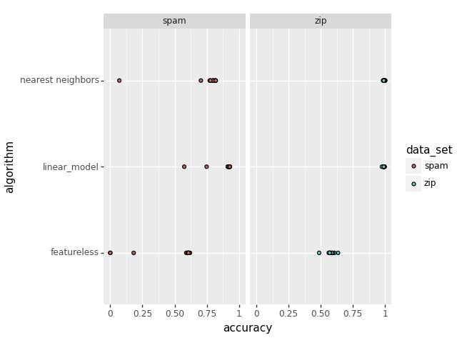

1. **Summary:**

* First, we need to prepare the data such that it contains 0’s and 1’s in any of the labels, so that we can perform binary classification.
* To do that, we need to remove all non-01 labels from the both datasets.
* Need to create a data dictionary and run a loop over it.
* Use sklearn package to perform KFold validation, GridSearch, KNeighborsClassifier, LogisticRegression.
* Create a prediction dictionary and print all the 3 prediction accuracy. (Nearest Neighbors, Linear Model & Featureless)
* Make a ggplot using geom_point().