**CS599 (Deep Learning)**

**Homework – 4**

1. **Python Code:**

import pandas as pd

import numpy as np

import matplotlib

#matplotlib.use("agg")

data_set_dict = {"zip" : ("zip.test.gz", 0),

"spam" : ("spam.data", 57)}

data_dict = {}

for data_name, (file_name, label_col_num) in data_set_dict.items():

data_df = pd.read_csv(file_name, sep = " ", header = None)

data_label_vec = data_df.iloc[:, label_col_num]

is_01 = data_label_vec.isin([0, 1])

data_01_df = data_df.loc[is_01, :]

is_label_col = data_df.columns == label_col_num

data_features = data_df.iloc[:, ~is_label_col]

data_labels = data_df.iloc[:, is_label_col]

data_dict[data_name] = (data_features, data_labels)

#scaling the data

n_data_features = data_features.shape[1]

data_mean = data_features.mean().to_numpy().reshape(1, n_data_features)

data_std = data_features.std().to_numpy().reshape(1, n_data_features)

data_scaled = (data_features - data_mean)/data_std

data_name_scaled = data_name + "_scaled"

data_scaled = data_scaled.dropna(axis = "columns")

data_dict[data_name_scaled] = (data_scaled, data_labels)

from sklearn.model_selection import KFold, GridSearchCV

from sklearn.neighbors import KNeighborsClassifier

from sklearn.linear_model import LogisticRegressionCV

from sklearn.pipeline import make_pipeline

from sklearn.preprocessing import StandardScaler

from sklearn.metrics import accuracy_score

from collections import Counter

class MyKNN:

def __init__(self, n_neighbors):

"""store n_neighbors as attribute"""

self.n_neighbors = n_neighbors

def fit(self, X, y):

"""store data"""

self.X_train = X

self.y_train = y

def decision_function(self, X):

"""Compute vector of predicted scores.

Larger values mean more likely to be in positive class."""

scores = []

for x in X:

distances = np.sqrt(np.sum((x - self.X_train) ** 2, axis = 1))

n_neighbor_indices = np.argsort(distances)[:self.n_neighbors]

n_neighbor_labels = [self.y_train[i] for i in n_neighbor_indices]

most_common_label = Counter(n_neighbor_labels).most_common(1)[0][0]

scores.append(most_common_label)

return scores

def predict(self, X):

return self.decision_function(X)

class MyCV:

def __init__(self, estimator, param_grid, cv):

self.estimator = estimator

self.param_grid = param_grid

self.cv = cv

def fit_one(self, param_dict, X, y):

self.estimator.__init__(param_dict)

self.estimator.fit(X, y)

def fit(self, X, y):

validation_df_list = []

kf = KFold(n_splits=self.cv, shuffle=True, random_state=3)

for validation_fold, (train_index, test_index) in enumerate(kf.split(X)):

train_data = {"X": X[train_index], "y": y[train_index]}

test_data = {"X": X[test_index], "y": y[test_index]}

for param_dict in self.param_grid:

self.fit_one(param_dict, **train_data)

y_pred = self.estimator.predict(test_data["X"])

accuracy = np.mean(y_pred == test_data["y"])

validation_row = pd.DataFrame({

"validation_fold": [validation_fold],

"accuracy": [accuracy],

"param_value": [param_dict]

})

validation_df_list.append(validation_row)

validation_df = pd.concat(validation_df_list)

best_param_dict = validation_df.groupby("param_value")["accuracy"].mean().idxmax()

self.fit_one(best_param_dict, X, y)

def predict(self, X):

return self.estimator.predict(X)

class Featureless:

def fit(self, X_train, y_train):

y_train_series = pd.Series(y_train)

self.most_freq_labels = y_train_series.value_counts().idxmax()

def predict(self, x_test):

test_nrow, test_ncol = x_test.shape

return np.repeat(self.most_freq_labels, test_nrow)

accuracy_data_frames = []

for data_name, (data_features, data_labels) in data_dict.items():

kf = KFold(n_splits=3, shuffle=True, random_state=3)

enum_obj = enumerate(kf.split(data_features))

for fold_num, (train_index, test_index) in enum_obj:

X_train, X_test = np.array(data_features.iloc[train_index]), np.array(data_features.iloc[test_index])

y_train, y_test = np.ravel(data_labels.iloc[train_index]), np.ravel(data_labels.iloc[test_index])

# K-nearest neighbors

knn = KNeighborsClassifier()

hp_parameters = {"n_neighbors": list(range(1, 21))}

grid = GridSearchCV(knn, hp_parameters, cv=5)

grid.fit(X_train, y_train)

best_n_neighbors = grid.best_params_['n_neighbors']

print("Best N-Neighbors = ", best_n_neighbors)

knn = KNeighborsClassifier(n_neighbors=best_n_neighbors)

knn.fit(X_train, y_train)

knn_pred = knn.predict(X_test)

#KNN

knn1 = MyKNN(n_neighbors = 3)

#KNN + gridCV

gridcv = MyCV(estimator = knn1, param_grid= [n_neighbors for n_neighbors in range(1,21)], cv=5)

gridcv.fit(X_train, y_train)

knn1_pred = gridcv.predict(X_test)

# Logistic Regression

pipe = make_pipeline(StandardScaler(), LogisticRegressionCV(cv=5, max_iter=2000))

pipe.fit(X_train, y_train)

lr_pred = pipe.predict(X_test)

my_learner_instance = Featureless()

my_learner_instance.fit(X_train, y_train)

featureless_pred = my_learner_instance.predict(X_test)

# store predict data in dict

pred_dict = {'gridSearch + nearest neighbors': knn_pred,

'KNN + CV': knn1_pred,

'linear_model': lr_pred,

'featureless': featureless_pred}

test_accuracy = {}

for algorithm, predictions in pred_dict.items():

accuracy = accuracy_score(y_test, predictions)

test_accuracy[algorithm] = accuracy

for algorithm, accuracy in test_accuracy.items():

print(f"{algorithm} Test Accuracy: {accuracy * 100}")

accuracy_df = pd.DataFrame({

"data_set": [data_name],

"fold_id": [fold_num],

"algorithm": [algorithm],

"accuracy": [test_accuracy[algorithm]]})

accuracy_data_frames.append(accuracy_df)

print(f"****************************End of {data_name}({fold_num})*****************************")

total_accuracy_df = pd.concat(accuracy_data_frames, ignore_index=True)

print(total_accuracy_df)

import plotnine as p9

gg = p9.ggplot(total_accuracy_df, p9.aes(x='accuracy', y='algorithm')) + \

p9.facet_grid('.~data_set') + p9.geom_point()

gg.save("Output.png", height=8, width=12)

1. **Output:**

**>>> for data_name, (data_features, data_labels) in data_dict.items():**

**... kf = KFold(n_splits=3, shuffle=True, random_state=3)**

**... …**

**...**

**... # K-nearest neighbors**

**... knn = KNeighborsClassifier()**

**... hp_parameters = {"n_neighbors": list(range(1, 21))}**

**... ...**

**...**

**... for algorithm, accuracy in test_accuracy.items():**

**... print(f"{algorithm} Test Accuracy: {accuracy * 100}")**

**... …**

**... print(f"****************************End of {data_name}({fold_num})*****************************")**

Best N-Neighbors = 1

gridSearch + nearest neighbors Test Accuracy: 100.0

KNN + CV Test Accuracy: 100.0

linear_model Test Accuracy: 99.51923076923077

featureless Test Accuracy: 58.65384615384615

****************************End of zip(0)*****************************

Best N-Neighbors = 1

gridSearch + nearest neighbors Test Accuracy: 99.51923076923077

KNN + CV Test Accuracy: 99.51923076923077

linear_model Test Accuracy: 99.03846153846155

featureless Test Accuracy: 57.21153846153846

****************************End of zip(1)*****************************

Best N-Neighbors = 3

gridSearch + nearest neighbors Test Accuracy: 99.03381642512076

KNN + CV Test Accuracy: 100.0

linear_model Test Accuracy: 99.03381642512076

featureless Test Accuracy: 57.00483091787439

****************************End of zip(2)*****************************

Best N-Neighbors = 2

gridSearch + nearest neighbors Test Accuracy: 100.0

KNN + CV Test Accuracy: 100.0

linear_model Test Accuracy: 99.51923076923077

featureless Test Accuracy: 58.65384615384615

****************************End of zip_scaled(0)*****************************

Best N-Neighbors = 1

gridSearch + nearest neighbors Test Accuracy: 99.03846153846155

KNN + CV Test Accuracy: 99.03846153846155

linear_model Test Accuracy: 99.03846153846155

featureless Test Accuracy: 57.21153846153846

****************************End of zip_scaled(1)*****************************

Best N-Neighbors = 1

gridSearch + nearest neighbors Test Accuracy: 99.03381642512076

KNN + CV Test Accuracy: 99.03381642512076

linear_model Test Accuracy: 99.03381642512076

featureless Test Accuracy: 57.00483091787439

****************************End of zip_scaled(2)*****************************

Best N-Neighbors = 3

gridSearch + nearest neighbors Test Accuracy: 79.85658409387223

KNN + CV Test Accuracy: 82.13820078226858

linear_model Test Accuracy: 91.39504563233378

featureless Test Accuracy: 60.88657105606258

****************************End of spam(0)*****************************

Best N-Neighbors = 5

gridSearch + nearest neighbors Test Accuracy: 77.90091264667535

KNN + CV Test Accuracy: 79.92177314211213

linear_model Test Accuracy: 92.63363754889178

featureless Test Accuracy: 60.104302477183836

****************************End of spam(1)*****************************

Best N-Neighbors = 1

gridSearch + nearest neighbors Test Accuracy: 81.99608610567515

KNN + CV Test Accuracy: 81.60469667318982

linear_model Test Accuracy: 92.8897586431833

featureless Test Accuracy: 60.79582517938682

****************************End of spam(2)*****************************

Best N-Neighbors = 5

gridSearch + nearest neighbors Test Accuracy: 90.28683181225554

KNN + CV Test Accuracy: 91.13428943937419

linear_model Test Accuracy: 91.39504563233378

featureless Test Accuracy: 60.88657105606258

****************************End of spam_scaled(0)*****************************

Best N-Neighbors = 6

gridSearch + nearest neighbors Test Accuracy: 89.4393741851369

KNN + CV Test Accuracy: 90.67796610169492

linear_model Test Accuracy: 92.63363754889178

featureless Test Accuracy: 60.104302477183836

****************************End of spam_scaled(1)*****************************

Best N-Neighbors = 5

gridSearch + nearest neighbors Test Accuracy: 90.01956947162427

KNN + CV Test Accuracy: 90.93281148075668

linear_model Test Accuracy: 92.8897586431833

featureless Test Accuracy: 60.79582517938682

****************************End of spam_scaled(2)*****************************

**>>> total_accuracy_df = pd.concat(accuracy_data_frames, ignore_index=True)**

**>>> print(total_accuracy_df)**

data_set fold_id algorithm accuracy

0 zip 0 gridSearch + nearest neighbors 1.000000

1 zip 0 KNN + CV 1.000000

2 zip 0 linear_model 0.995192

3 zip 0 featureless 0.586538

4 zip 1 gridSearch + nearest neighbors 0.995192

5 zip 1 KNN + CV 0.995192

6 zip 1 linear_model 0.990385

7 zip 1 featureless 0.572115

8 zip 2 gridSearch + nearest neighbors 0.990338

9 zip 2 KNN + CV 1.000000

10 zip 2 linear_model 0.990338

11 zip 2 featureless 0.570048

12 zip_scaled 0 gridSearch + nearest neighbors 1.000000

13 zip_scaled 0 KNN + CV 1.000000

14 zip_scaled 0 linear_model 0.995192

15 zip_scaled 0 featureless 0.586538

16 zip_scaled 1 gridSearch + nearest neighbors 0.990385

17 zip_scaled 1 KNN + CV 0.990385

18 zip_scaled 1 linear_model 0.990385

19 zip_scaled 1 featureless 0.572115

20 zip_scaled 2 gridSearch + nearest neighbors 0.990338

21 zip_scaled 2 KNN + CV 0.990338

22 zip_scaled 2 linear_model 0.990338

23 zip_scaled 2 featureless 0.570048

24 spam 0 gridSearch + nearest neighbors 0.798566

25 spam 0 KNN + CV 0.821382

26 spam 0 linear_model 0.913950

27 spam 0 featureless 0.608866

28 spam 1 gridSearch + nearest neighbors 0.779009

29 spam 1 KNN + CV 0.799218

30 spam 1 linear_model 0.926336

31 spam 1 featureless 0.601043

32 spam 2 gridSearch + nearest neighbors 0.819961

33 spam 2 KNN + CV 0.816047

34 spam 2 linear_model 0.928898

35 spam 2 featureless 0.607958

36 spam_scaled 0 gridSearch + nearest neighbors 0.902868

37 spam_scaled 0 KNN + CV 0.911343

38 spam_scaled 0 linear_model 0.913950

39 spam_scaled 0 featureless 0.608866

40 spam_scaled 1 gridSearch + nearest neighbors 0.894394

41 spam_scaled 1 KNN + CV 0.906780

42 spam_scaled 1 linear_model 0.926336

43 spam_scaled 1 featureless 0.601043

44 spam_scaled 2 gridSearch + nearest neighbors 0.900196

45 spam_scaled 2 KNN + CV 0.909328

46 spam_scaled 2 linear_model 0.928898

47 spam_scaled 2 featureless 0.607958

**>>> gg = p9.ggplot(total_accuracy_df, p9.aes(x='accuracy', y='algorithm')) + \**

**... p9.facet_grid('.~data_set') + p9.geom_point()**

**>>> gg.save("Output.png", height=8, width=10)**

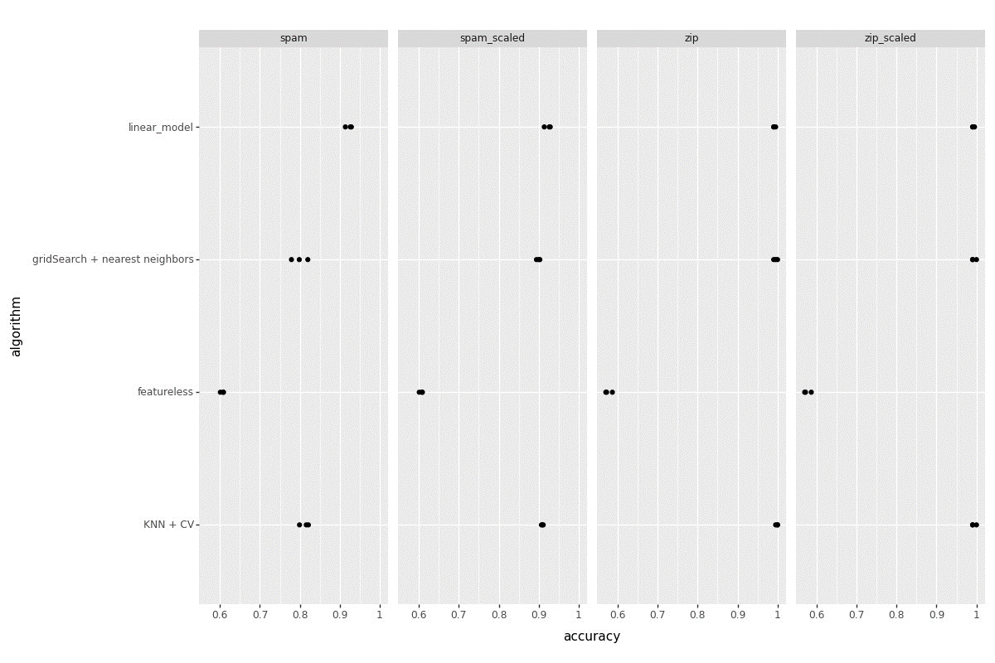

1. **Summary:**

* Similar to the HW3, we need to perform binary classification using KNN.
* Here, we need to scale the both datasets.
* Need to create MyKNN class, MyCV class from scratch.
* Need to plot the graph with all 4 datasets i.e., normal and scaled, with the algorithms MyKNN + MyCV, gridsearch + k-neighbors, linear model and featureless.