**CS599 (Deep Learning)**

**Homework – 5**

1. **Python Code:**

import pandas as pd

import matplotlib

import numpy as np

matplotlib.use("agg")

from sklearn.model_selection import KFold, GridSearchCV, ParameterGrid

from sklearn.neighbors import KNeighborsClassifier

from sklearn.linear_model import LogisticRegressionCV

from sklearn.pipeline import make_pipeline

from sklearn.preprocessing import StandardScaler

from sklearn.metrics import accuracy_score

from collections import Counter

data_set_dict = {"zip": ("zip.test.gz", 0),

"spam": ("spam.data", 57)}

data_dict = {}

for data_name, (file_name, label_col_num) in data_set_dict.items():

data_df = pd.read_csv(file_name, sep=" ", header=None)

data_label_vec = data_df.iloc[:, label_col_num]

is_01 = data_label_vec.isin([0, 1])

data_01_df = data_df.loc[is_01, :]

is_label_col = data_df.columns == label_col_num

data_features = data_01_df.iloc[:, ~is_label_col]

data_labels = data_01_df.iloc[:, is_label_col]

data_dict[data_name] = (data_features, data_labels)

# scaling the data

n_data_features = data_features.shape[1]

data_mean = data_features.mean().to_numpy().reshape(1, n_data_features)

data_std = data_features.std().to_numpy().reshape(1, n_data_features)

data_scaled = (data_features - data_mean) / data_std

data_name_scaled = data_name + "_scaled"

data_scaled = data_scaled.dropna(axis="columns")

data_dict[data_name_scaled] = (data_scaled, data_labels)

#print(data_scaled)

data_dict.pop("zip_scaled")

data_dict.pop("spam")

class MyLogReg:

def __init__(self, max_iterations, step_size):

self.max_iterations = max_iterations

self.step_size = step_size

def fit(self, X, y):

self.X_train = X

self.y_train = y

data_nrow, data_ncol = X.shape

self.intercept_ = 0.0

self.weight_vec = np.repeat(0.0, data_ncol).reshape(data_ncol,1) # Initialize weight vector with zeros

for i in range(self.max_iterations):

data_mat = X

pred_vec = np.matmul(data_mat, self.weight_vec) + self.intercept_

label_pos_neg_vec = np.where(y == 1, 1, -1).reshape(data_nrow,1)

grad_loss_wrt_pred = -label_pos_neg_vec / (1 + np.exp(label_pos_neg_vec * pred_vec))

loss_vec = np.log(1 + np.exp(-label_pos_neg_vec * pred_vec))

grad_loss_wrt_weight = np.matmul(data_mat.T, grad_loss_wrt_pred)/data_nrow

self.weight_vec -= self.step_size * grad_loss_wrt_weight

self.intercept_ -= self.step_size * grad_loss_wrt_pred.mean()

return loss_vec.mean()

def decision_function(self, X):

return np.matmul(X, self.weight_vec).reshape(X.shape[0], 1) + self.intercept_

def predict(self, X):

scores = self.decision_function(X)

return np.where(scores > 0, 1, 0)

class MyLogRegCV:

def __init__(self, max_iterations, step_size, num_splits):

self.max_iterations = max_iterations

self.step_size = step_size

self.num_splits = num_splits

def fit(self, X, y):

kf = KFold(n_splits=self.num_splits, shuffle=True, random_state=3)

self.scores_ = pd.DataFrame(columns = ["iteration", "set_name", "loss_value"])

best_loss = float("inf")

best_lr = None

for i in range(1, self.max_iterations + 1):

for validation_fold, (train_index, val_index) in enumerate(kf.split(X)):

subtrain_data = {"X": X[train_index], "y": y[train_index]}

val_data = {"X": X[val_index], "y": y[val_index]}

lr = MyLogReg(i, self.step_size)

subtrain_loss = lr.fit(subtrain_data["X"], subtrain_data["y"])

y_pred = lr.predict(val_data["X"])

#subtrain_loss = lr.loss_function(subtrain_data["X"], subtrain_data["y"])

val_loss = lr.fit(val_data["X"], val_data["y"])

self.scores_ = pd.concat([self.scores_, pd.DataFrame({"iteration": [i], "setname": ["subtrain"], "loss_value": [subtrain_loss]})], ignore_index = True, sort = False)

self.scores_ = pd.concat([self.scores_, pd.DataFrame({"iteration": [i], "setname": ["validation"], "loss_value": [val_loss]})], ignore_index = True, sort = False)

accuracy = np.mean(y_pred == val_data["y"])

subtrain_loss_values = self.scores_[self.scores_["setname"] == "subtrain"]["loss_value"].values

validation_loss_values = self.scores_[self.scores_["setname"] == "validation"]["loss_value"].values

#print("Val Loss: ", val_loss)

#print("Best Loss: ", best_loss)

if val_loss < best_loss:

best_loss = val_loss

best_lr = lr

self.best_iterations = i

#print(self.best_iterations)

self.lr = MyLogReg(self.best_iterations, self.step_size)

self.lr.fit(X,y)

return subtrain_loss_values, validation_loss_values

def predict(self, X):

return self.lr.predict(X)

accuracy_data_frames = []

for data_name, (data_features, data_labels) in data_dict.items():

kf = KFold(n_splits=3, shuffle=True, random_state=3)

enum_obj = enumerate(kf.split(data_features))

for fold_num, (train_index, test_index) in enum_obj:

X_train, X_test = np.array(data_features.iloc[train_index]), np.array(data_features.iloc[test_index])

y_train, y_test = np.ravel(data_labels.iloc[train_index]), np.ravel(data_labels.iloc[test_index])

# K-nearest neighbors

knn = KNeighborsClassifier()

hp_parameters = {"n_neighbors": list(range(1, 21))}

grid = GridSearchCV(knn, hp_parameters, cv=5)

grid.fit(X_train, y_train)

best_n_neighbors = grid.best_params_['n_neighbors']

print("Best N-Neighbors = ", best_n_neighbors)

knn = KNeighborsClassifier(n_neighbors=best_n_neighbors)

knn.fit(X_train, y_train)

knn_pred = knn.predict(X_test)

# Logistic Regression

pipe = make_pipeline(StandardScaler(), LogisticRegressionCV(cv=5, max_iter=2000))

pipe.fit(X_train, y_train)

lr_pred = pipe.predict(X_test)

y_train_series = pd.Series(y_train)

#MyLogReg + MyLogRegCV

mylogreg = MyLogRegCV(200, 0.1, 5)

subtrain_loss, validation_loss = mylogreg.fit(X_train, y_train)

lr_cv_pred = mylogreg.predict(X_test)

most_frequent_class = y_train_series.value_counts().idxmax()

print("Most Frequent Class = ", most_frequent_class)

# create a featureless baseline

featureless_pred = np.full_like(y_test, most_frequent_class)

# store predict data in dict

pred_dict = {'gridSearch + nearest neighbors': knn_pred,

'linear_model': lr_pred,

'MyLogRegCV': lr_cv_pred,

'featureless': featureless_pred}

test_accuracy = {}

for algorithm, predictions in pred_dict.items():

accuracy = accuracy_score(y_test, predictions)

test_accuracy[algorithm] = accuracy

for algorithm, accuracy in test_accuracy.items():

print(f"{algorithm} Test Accuracy: {accuracy * 100}")

accuracy_df = pd.DataFrame({

"data_set": [data_name],

"fold_id": [fold_num],

"algorithm": [algorithm],

"accuracy": [test_accuracy[algorithm]]})

accuracy_data_frames.append(accuracy_df)

print(f"****************************End of {data_name}({fold_num})*****************************")

total_accuracy_df = pd.concat(accuracy_data_frames, ignore_index = True)

print(total_accuracy_df)

import plotnine as p9

gg = p9.ggplot(total_accuracy_df, p9.aes(x ='accuracy', y = 'algorithm'))+\

p9.facet_grid('.~data_set') + p9.geom_point()

gg.save("output.png", height = 8, width = 12)

import matplotlib.pyplot as plt

# Number of iterations

iterations = range(1, len(subtrain_loss) + 1)

# Plot subtrain loss

plt.figure(figsize=(8, 6))

plt.subplot(1, 2, 1)

plt.plot(iterations, subtrain_loss, label='Subtrain Loss', color='red')

plt.xlabel('Iterations')

plt.ylabel('Loss')

plt.title('Subtrain Loss vs. Iterations')

plt.grid(True)

# Plot validation loss

plt.subplot(1, 2, 2)

plt.plot(iterations, validation_loss, label='Validation Loss', color='blue')

plt.xlabel('Iterations')

plt.ylabel('Loss')

plt.title('Validation Loss vs. Iterations')

plt.grid(True)

plt.tight_layout()

plt.savefig("test.png")

1. **Output:**

**>>> for data_name, (data_features, data_labels) in data_dict.items():**

**... kf = KFold(n_splits=3, shuffle=True, random_state=3)**

**... enum_obj = enumerate(kf.split(data_features))**

**... for fold_num, (train_index, test_index) in enum_obj:**

**... ...**

**... "accuracy": [test_accuracy[algorithm]]})**

**... accuracy_data_frames.append(accuracy_df)**

**... print(f"****************************End of {data_name}({fold_num})*****************************")**

Best N-Neighbors = 1

Most Frequent Class = 0

gridSearch + nearest neighbors Test Accuracy: 100.0

linear_model Test Accuracy: 99.51923076923077

MyLogRegCV Test Accuracy: 99.03846153846155

featureless Test Accuracy: 58.65384615384615

****************************End of zip(0)*****************************

Best N-Neighbors = 1

Most Frequent Class = 0

gridSearch + nearest neighbors Test Accuracy: 99.51923076923077

linear_model Test Accuracy: 99.03846153846155

MyLogRegCV Test Accuracy: 98.5576923076923

featureless Test Accuracy: 57.21153846153846

****************************End of zip(1)*****************************

Best N-Neighbors = 3

Most Frequent Class = 0

gridSearch + nearest neighbors Test Accuracy: 99.03381642512076

linear_model Test Accuracy: 99.03381642512076

MyLogRegCV Test Accuracy: 99.03381642512076

featureless Test Accuracy: 57.00483091787439

****************************End of zip(2)*****************************

Best N-Neighbors = 5

Most Frequent Class = 0

gridSearch + nearest neighbors Test Accuracy: 90.28683181225554

linear_model Test Accuracy: 91.39504563233378

MyLogRegCV Test Accuracy: 90.74315514993481

featureless Test Accuracy: 60.88657105606258

****************************End of spam_scaled(0)*****************************

Best N-Neighbors = 6

Most Frequent Class = 0

gridSearch + nearest neighbors Test Accuracy: 89.4393741851369

linear_model Test Accuracy: 92.63363754889178

MyLogRegCV Test Accuracy: 90.80834419817471

featureless Test Accuracy: 60.104302477183836

****************************End of spam_scaled(1)*****************************

Best N-Neighbors = 5

Most Frequent Class = 0

gridSearch + nearest neighbors Test Accuracy: 90.01956947162427

linear_model Test Accuracy: 92.8897586431833

MyLogRegCV Test Accuracy: 92.10697977821265

featureless Test Accuracy: 60.79582517938682

****************************End of spam_scaled(2)*****************************

**>>> total_accuracy_df = pd.concat(accuracy_data_frames, ignore_index = True)**

**>>> print(total_accuracy_df)**

data_set fold_id algorithm accuracy

0 zip 0 gridSearch + nearest neighbors 1.000000

1 zip 0 linear_model 0.995192

2 zip 0 MyLogRegCV 0.990385

3 zip 0 featureless 0.586538

4 zip 1 gridSearch + nearest neighbors 0.995192

5 zip 1 linear_model 0.990385

6 zip 1 MyLogRegCV 0.985577

7 zip 1 featureless 0.572115

8 zip 2 gridSearch + nearest neighbors 0.990338

9 zip 2 linear_model 0.990338

10 zip 2 MyLogRegCV 0.990338

11 zip 2 featureless 0.570048

12 spam_scaled 0 gridSearch + nearest neighbors 0.902868

13 spam_scaled 0 linear_model 0.913950

14 spam_scaled 0 MyLogRegCV 0.907432

15 spam_scaled 0 featureless 0.608866

16 spam_scaled 1 gridSearch + nearest neighbors 0.894394

17 spam_scaled 1 linear_model 0.926336

18 spam_scaled 1 MyLogRegCV 0.908083

19 spam_scaled 1 featureless 0.601043

20 spam_scaled 2 gridSearch + nearest neighbors 0.900196

21 spam_scaled 2 linear_model 0.928898

22 spam_scaled 2 MyLogRegCV 0.921070

23 spam_scaled 2 featureless 0.607958

**>>> gg = p9.ggplot(total_accuracy_df, p9.aes(x ='accuracy', y = 'algorithm'))+\**

**... p9.facet_grid('.~data_set') + p9.geom_point()**

**>>> gg.save("output.png", height = 8, width = 12)**

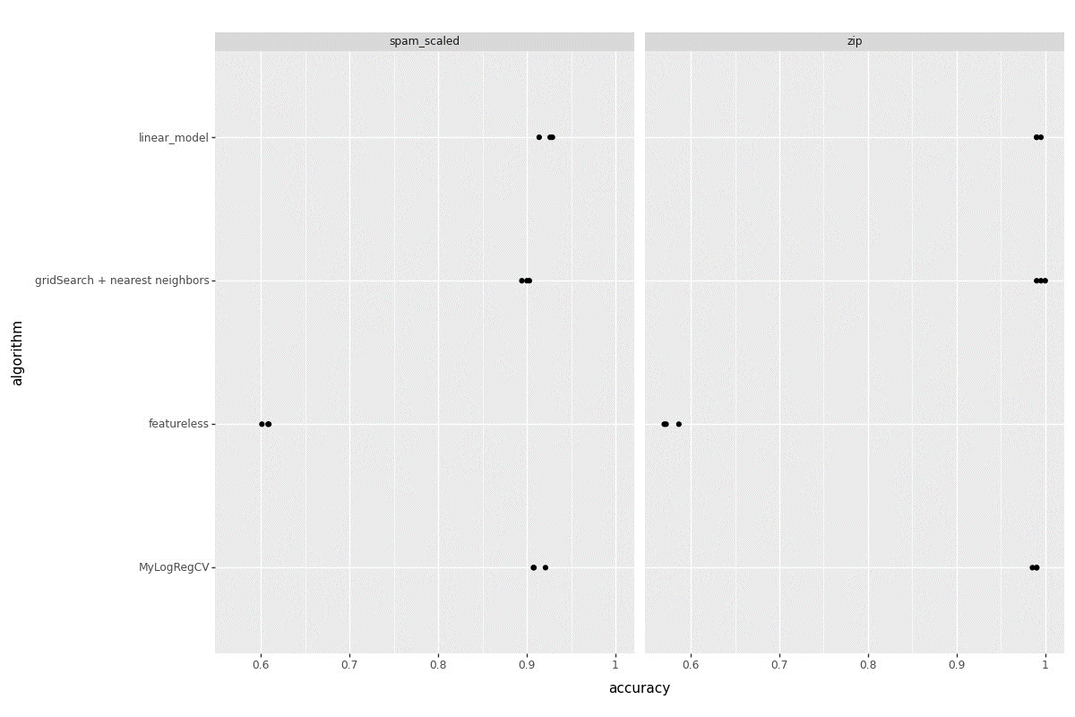

**>>> plt.savefig("test.png")**

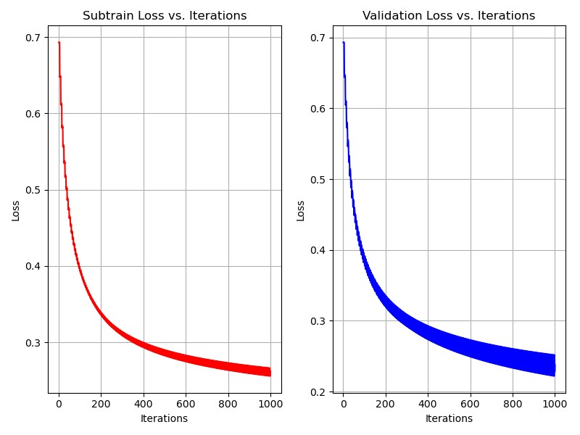

1. **Summary:**

* Create the MyLogReg and MyLogRegCV functions with the given requirements.
* Scale the spam dataset since zip dataset is already scaled.
* Need to plot the graph comparing KNeighbors, Linear Model, Featureless and created MyLogRegCV.
* Plot the subtrain loss & validation loss with respect to iterations