**CS 599 (Deep Learning)**

**Homework – 06**

1. **Python Code:**

import torch

import pandas as pd

import matplotlib

import numpy as np

matplotlib.use("agg")

from sklearn.model_selection import KFold, GridSearchCV, ParameterGrid

from sklearn.neighbors import KNeighborsClassifier

from sklearn.linear_model import LogisticRegressionCV

from sklearn.pipeline import make_pipeline

from sklearn.preprocessing import StandardScaler

from sklearn.metrics import accuracy_score

from collections import Counter

data_set_dict = {"zip": ("zip.test.gz", 0),

"spam": ("spam.data", 57)}

data_dict = {}

for data_name, (file_name, label_col_num) in data_set_dict.items():

data_df = pd.read_csv(file_name, sep=" ", header=None)

data_label_vec = data_df.iloc[:, label_col_num]

is_01 = data_label_vec.isin([0, 1])

data_01_df = data_df.loc[is_01, :]

is_label_col = data_df.columns == label_col_num

data_features = data_01_df.iloc[:, ~is_label_col]

data_labels = data_01_df.iloc[:, is_label_col]

data_dict[data_name] = (data_features, data_labels)

spam_features, spam_labels = data_dict.pop("spam")

spam_nrow, spam_ncol = spam_features.shape

spam_mean = spam_features.mean().to_numpy().reshape(1, spam_ncol)

spam_std = spam_features.std().to_numpy().reshape(1, spam_ncol)

spam_scaled = (spam_features - spam_mean)/spam_std

data_dict["spam_scaled"] = (spam_scaled, spam_labels)

{data_name:X.shape for data_name, (X,y) in data_dict.items()}

class TorchModel(torch.nn.Module):

def __init__(self, units_per_layer):

super(TorchModel, self).__init__()

seq_args = []

second_to_last = len(units_per_layer) - 1

for layer_i in range(second_to_last):

next_i = layer_i + 1

layer_units = units_per_layer[layer_i]

next_units = units_per_layer[next_i]

seq_args.append(torch.nn.Linear(layer_units, next_units))

if layer_i < second_to_last:

seq_args.append(torch.nn.ReLU())

self.stack = torch.nn.Sequential(*seq_args)

def forward(self, features):

return self.stack(features)

class CSV(torch.utils.data.Dataset):

def __init__(self, features, labels):

self.features = features

self.labels = labels

def __getitem__(self, item):

return self.features[item,:], self.labels[item]

def __len__(self):

return len(self.labels)

class TorchLearner:

def __init__(self, units_per_layer, max_epochs, batch_size, step_size):

self.max_epochs = max_epochs

self.batch_size = batch_size

self.step_size = step_size

self.model = TorchModel(units_per_layer)

self.optimizer = torch.optim.SGD(self.model.parameters(), lr = self.step_size)

self.loss_fun = torch.nn.BCEWithLogitsLoss()

def take_step(self, X, y):

self.optimizer.zero_grad()

pred_tensor = self.model(X)

loss_value = self.loss_fun(pred_tensor, y)

loss_value.backward()

self.optimizer.step()

return loss_value.item()

def fit(self, X, y):

ds = CSV(X, y)

dl = torch.utils.data.DataLoader(

ds, batch_size = self.batch_size, shuffle = True)

for epoch in range(self.max_epochs):

for batch_features, batch_labels in dl:

loss = self.take_step(batch_features, batch_labels)

def decision_function(self, X):

with torch.no_grad():

pred_vec = self.model(X)

return pred_vec.numpy()

def predict(self, X):

pred_scores = self.decision_function(X)

return np.where(pred_scores > 0, 1, 0)

class TorchLearnerCV:

def __init__(self, units_per_layer, max_epochs, batch_size, step_size, n_splits):

self.units_per_layer = units_per_layer

self.max_epochs = max_epochs

self.batch_size = batch_size

self.step_size = step_size

self.n_splits = n_splits

def fit(self, X, y):

kf = KFold(n_splits = self.n_splits, shuffle = True, random_state = 5)

best_loss = float('inf')

best_model = None

best_epochs = 0

valid_loss = []

sub_train_loss = []

loss_val = []

scores = pd.DataFrame(columns = ["validation_fold", "setname", "loss_value", "epoch"])

for max_epoch in range(1, self.max_epochs + 1):

loss_values = []

for fold_num, (train_index, val_index) in enumerate(kf.split(X)):

subtrain_data = {"X": X[train_index], "y": y[train_index]}

val_data = {"X": X[val_index], "y": y[val_index]}

learner = TorchLearner(self.units_per_layer, max_epoch, self.batch_size, self.step_size)

learner.fit(subtrain_data["X"], subtrain_data["y"])

val_loss = learner.take_step(val_data["X"], val_data["y"])

subtrain_loss = learner.take_step(subtrain_data["X"], subtrain_data["y"])

loss_values.append(val_loss)

loss_dict = {"validation": val_loss, "subtrain": subtrain_loss}

for setname, loss_value in loss_dict.items():

loss_val_row = pd.DataFrame({

"validation_fold": [fold_num],

"setname": [setname],

"loss_value": [loss_value],

"epoch" : [max_epoch]})

loss_val.append(loss_val_row)

loss_df = pd.concat(loss_val)

loss_values_mean = np.mean(loss_values)

if loss_values_mean < best_loss:

best_loss = loss_values_mean

best_model = learner

best_epochs = max_epoch

print("best_epoch: ", best_epochs)

self.best_model = best_model

self.best_model.fit(X,y)

return loss_df

def predict(self, X):

return self.best_model.predict(X)

zip_features, zip_labels = data_dict["zip"]

input_tensor = torch.from_numpy(zip_features.to_numpy()).float()

output_tensor = torch.from_numpy(zip_labels.to_numpy()).float()

accuracy_data_frames = []

loss_data_dict = {}

for data_name, (data_features, data_labels) in data_dict.items():

kf = KFold(n_splits=3, shuffle=True, random_state=3)

enum_obj = enumerate(kf.split(data_features))

data_nrow, data_ncol = data_features.shape

for fold_num, (train_index, test_index) in enum_obj:

X_train, X_test = torch.from_numpy(data_features.iloc[train_index].to_numpy()).float(), torch.from_numpy(data_features.iloc[test_index].to_numpy()).float()

y_train, y_test = torch.from_numpy(data_labels.iloc[train_index].to_numpy()).float(), torch.from_numpy(data_labels.iloc[test_index].to_numpy()).float()

input_tensor = torch.from_numpy(data_features.to_numpy()).float()

output_tensor = torch.from_numpy(data_labels.to_numpy()).float()

# K-nearest neighbors

knn = KNeighborsClassifier()

hp_parameters = {"n_neighbors": list(range(1, 21))}

grid = GridSearchCV(knn, hp_parameters, cv=3)

grid.fit(X_train, y_train.ravel())

best_n_neighbors = grid.best_params_['n_neighbors']

print("Best N-Neighbors = ", best_n_neighbors)

knn = KNeighborsClassifier(n_neighbors=best_n_neighbors)

knn.fit(X_train, y_train.ravel())

knn_pred = knn.predict(X_test)

# Logistic Regression

pipe = make_pipeline(StandardScaler(), LogisticRegressionCV(cv=3, max_iter=2000))

pipe.fit(X_train, y_train.ravel())

lr_pred = pipe.predict(X_test)

y_train_series = pd.Series(y_train.ravel())

#TorchLearnerCV

torch_learner = TorchLearnerCV([data_ncol, 100, 1], 15, 100, 0.15, 3)

loss = torch_learner.fit(X_train, y_train)

tl_pred = torch_learner.predict(X_test)

#TorchLearnerCV + deep

torch_learner_deep = TorchLearnerCV([data_ncol, 100, 10, 5, 1], 10, 100, 0.5, 3)

deep_loss = torch_learner_deep.fit(X_train, y_train)

tl_deep_pred = torch_learner_deep.predict(X_test)

most_frequent_class = y_train_series.value_counts().idxmax()

print("Most Frequent Class = ", most_frequent_class)

# create a featureless baseline

featureless_pred = np.full_like(y_test.ravel(), most_frequent_class)

# store predict data in dict

pred_dict = {'gridSearch + nearest neighbors': knn_pred,

'linear_model': lr_pred,

'TorchLearnerCV': tl_pred,

'TorchLearnerCV + Deep': tl_deep_pred,

'featureless': featureless_pred}

test_accuracy = {}

loss_data_dict[data_name] = {'TorchLearnerCV': loss,

'TorchLearnerCV + Deep': deep_loss}

for algorithm, predictions in pred_dict.items():

accuracy = accuracy_score(y_test, predictions)

test_accuracy[algorithm] = accuracy

for algorithm, accuracy in test_accuracy.items():

print(f"{algorithm} Test Accuracy: {accuracy * 100}")

accuracy_df = pd.DataFrame({

"data_set": [data_name],

"fold_id": [fold_num],

"algorithm": [algorithm],

"accuracy": [test_accuracy[algorithm]]})

accuracy_data_frames.append(accuracy_df)

print(f"****************************End of {data_name}({fold_num})*****************************")

total_accuracy_df = pd.concat(accuracy_data_frames, ignore_index = True)

print(total_accuracy_df)

import plotnine as p9

gg = p9.ggplot(total_accuracy_df, p9.aes(x ='accuracy', y = 'algorithm'))+\

p9.facet_grid('.~data_set') + p9.geom_point()

gg.save(“output.png", height = 8, width = 12)

zip_loss = loss_data_dict["zip"]

spam_loss = loss_data_dict["spam_scaled"]

gg1 = p9.ggplot(zip_loss["TorchLearnerCV"], p9.aes(x ='epoch', y = 'loss_value', fill = 'setname')) + p9.facet_grid('.~validation_fold') + p9.geom_point() + p9.ggtitle("Zip Data(TorchLearner): Subtrain/Validation vs Epoch")

gg1.save("valid_graph1.png", height = 8, width = 12)

gg2 = p9.ggplot(zip_loss["TorchLearnerCV + Deep"], p9.aes(x ='epoch', y = 'loss_value', fill = 'setname')) + p9.facet_grid('.~validation_fold') + p9.geom_point() + p9.ggtitle("Zip Data(TorchLearner + Deep): Subtrain/Validation vs Epoch")

gg2.save("valid_graph2.png", height = 8, width = 12)

gg3 = p9.ggplot(spam_loss["TorchLearnerCV"], p9.aes(x ='epoch', y = 'loss_value', fill = 'setname')) + p9.facet_grid('.~validation_fold') + p9.geom_point() + p9.ggtitle("Spam_scaled Data(TorchLearner): Subtrain/Validation vs Epoch")

gg3.save("valid_graph3.png", height = 8, width = 12)

gg4 = p9.ggplot(spam_loss["TorchLearnerCV + Deep"], p9.aes(x ='epoch', y = 'loss_value', fill = 'setname')) \

+ p9.facet_grid('.~validation_fold') + p9.geom_point() + p9.ggtitle("spam_scaled Data(TorchLearner + Deep): Subtrain/Validation vs Epoch")

gg4.save("valid_graph4.png", height = 8, width = 12)

1. **Outputs:**

**>>> for data_name, (data_features, data_labels) in data_dict.items():**

**... kf = KFold(n_splits=3, shuffle=True, random_state=3)**

**... enum_obj = enumerate(kf.split(data_features))**

**... data_nrow, data_ncol = data_features.shape**

**...**

**... for fold_num, (train_index, test_index) in enum_obj:**

**... X_train, X_test = torch.from_numpy(data_features.iloc[train_index].to_numpy()).float(), torch.from_numpy(data_features.iloc[test_index].to_numpy()).float()**

**... y_train, y_test = torch.from_numpy(data_labels.iloc[train_index].to_numpy()).float(), torch.from_numpy(data_labels.iloc[test_index].to_numpy()).float()**

**...**

**... input_tensor = torch.from_numpy(data_features.to_numpy()).float()**

**... ...**

**...**

**... for algorithm, accuracy in test_accuracy.items():**

**... print(f"{algorithm} Test Accuracy: {accuracy * 100}")**

**... accuracy_df = pd.DataFrame({**

**... "data_set": [data_name],**

**... "fold_id": [fold_num],**

**... "algorithm": [algorithm],**

**... "accuracy": [test_accuracy[algorithm]]})**

**... accuracy_data_frames.append(accuracy_df)**

**... print(f"****************************End of {data_name}({fold_num})*****************************")**

Best N-Neighbors = 1

best_epoch: 11

best_epoch: 9

Most Frequent Class = 0.0

gridSearch + nearest neighbors Test Accuracy: 100.0

linear_model Test Accuracy: 99.51923076923077

TorchLearnerCV Test Accuracy: 98.5576923076923

TorchLearnerCV + Deep Test Accuracy: 99.03846153846155

featureless Test Accuracy: 58.65384615384615

****************************End of zip(0)*****************************

Best N-Neighbors = 1

best_epoch: 14

best_epoch: 5

Most Frequent Class = 0.0

gridSearch + nearest neighbors Test Accuracy: 99.51923076923077

linear_model Test Accuracy: 99.03846153846155

TorchLearnerCV Test Accuracy: 96.63461538461539

TorchLearnerCV + Deep Test Accuracy: 96.63461538461539

featureless Test Accuracy: 57.21153846153846

****************************End of zip(1)*****************************

Best N-Neighbors = 4

best_epoch: 14

best_epoch: 7

Most Frequent Class = 0.0

gridSearch + nearest neighbors Test Accuracy: 99.03381642512076

linear_model Test Accuracy: 99.03381642512076

TorchLearnerCV Test Accuracy: 97.58454106280193

TorchLearnerCV + Deep Test Accuracy: 98.55072463768117

featureless Test Accuracy: 57.00483091787439

****************************End of zip(2)*****************************

Best N-Neighbors = 4

best_epoch: 14

best_epoch: 10

Most Frequent Class = 0.0

gridSearch + nearest neighbors Test Accuracy: 88.72229465449804

linear_model Test Accuracy: 91.52542372881356

TorchLearnerCV Test Accuracy: 91.98174706649283

TorchLearnerCV + Deep Test Accuracy: 93.08996088657105

featureless Test Accuracy: 60.88657105606258

****************************End of spam_scaled(0)*****************************

Best N-Neighbors = 5

best_epoch: 15

best_epoch: 7

Most Frequent Class = 0.0

gridSearch + nearest neighbors Test Accuracy: 90.80834419817471

linear_model Test Accuracy: 91.78617992177314

TorchLearnerCV Test Accuracy: 92.69882659713168

TorchLearnerCV + Deep Test Accuracy: 91.85136897001304

featureless Test Accuracy: 60.104302477183836

****************************End of spam_scaled(1)*****************************

Best N-Neighbors = 9

best_epoch: 15

best_epoch: 10

Most Frequent Class = 0.0

gridSearch + nearest neighbors Test Accuracy: 90.54142204827136

linear_model Test Accuracy: 92.49836921069797

TorchLearnerCV Test Accuracy: 91.71559034572732

TorchLearnerCV + Deep Test Accuracy: 92.75929549902152

featureless Test Accuracy: 60.79582517938682

****************************End of spam_scaled(2)*****************************

**>>> total_accuracy_df = pd.concat(accuracy_data_frames, ignore_index = True)**

**>>> print(total_accuracy_df)**

data_set fold_id algorithm accuracy

0 zip 0 gridSearch + nearest neighbors 1.000000

1 zip 0 linear_model 0.995192

2 zip 0 TorchLearnerCV 0.985577

3 zip 0 TorchLearnerCV + Deep 0.990385

4 zip 0 featureless 0.586538

5 zip 1 gridSearch + nearest neighbors 0.995192

6 zip 1 linear_model 0.990385

7 zip 1 TorchLearnerCV 0.966346

8 zip 1 TorchLearnerCV + Deep 0.966346

9 zip 1 featureless 0.572115

10 zip 2 gridSearch + nearest neighbors 0.990338

11 zip 2 linear_model 0.990338

12 zip 2 TorchLearnerCV 0.975845

13 zip 2 TorchLearnerCV + Deep 0.985507

14 zip 2 featureless 0.570048

15 spam_scaled 0 gridSearch + nearest neighbors 0.887223

16 spam_scaled 0 linear_model 0.915254

17 spam_scaled 0 TorchLearnerCV 0.919817

18 spam_scaled 0 TorchLearnerCV + Deep 0.930900

19 spam_scaled 0 featureless 0.608866

20 spam_scaled 1 gridSearch + nearest neighbors 0.908083

21 spam_scaled 1 linear_model 0.917862

22 spam_scaled 1 TorchLearnerCV 0.926988

23 spam_scaled 1 TorchLearnerCV + Deep 0.918514

24 spam_scaled 1 featureless 0.601043

25 spam_scaled 2 gridSearch + nearest neighbors 0.905414

26 spam_scaled 2 linear_model 0.924984

27 spam_scaled 2 TorchLearnerCV 0.917156

28 spam_scaled 2 TorchLearnerCV + Deep 0.927593

29 spam_scaled 2 featureless 0.607958

**>>> gg = p9.ggplot(total_accuracy_df, p9.aes(x ='accuracy', y = 'algorithm'))+\**

**... p9.facet_grid('.~data_set') + p9.geom_point()**

**>>> gg.save("output.png", height = 8, width = 12)**

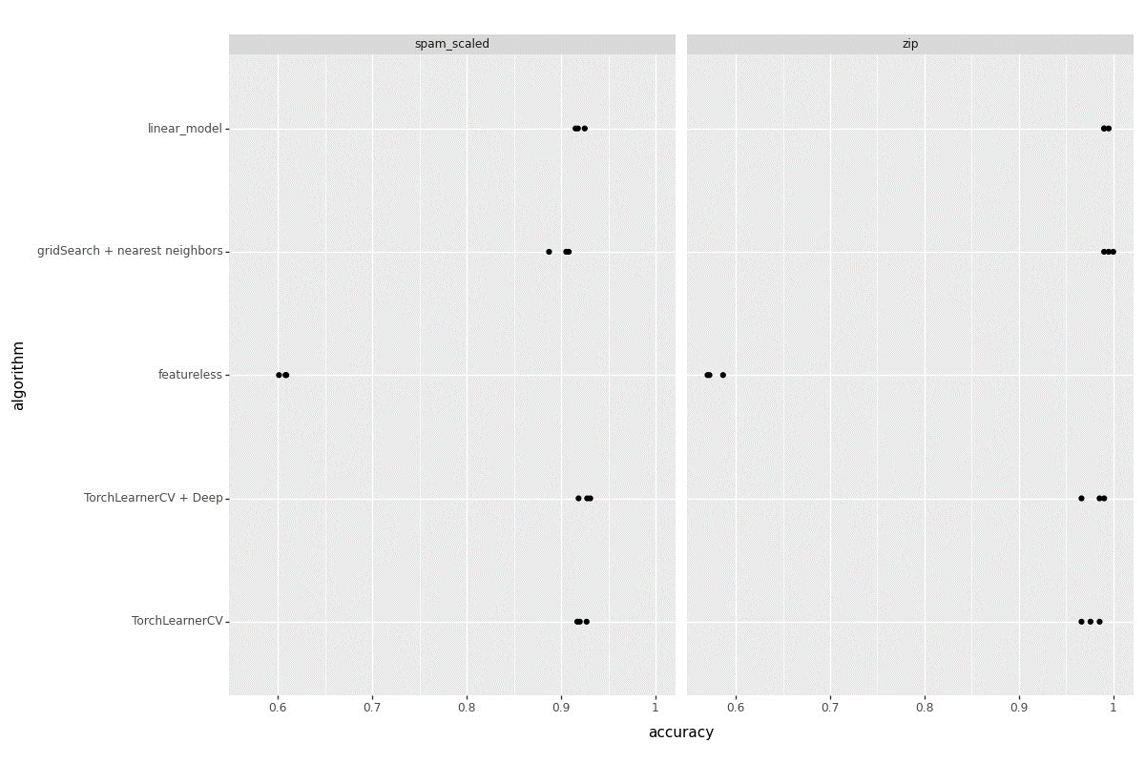

**>>> gg1 = p9.ggplot(zip_loss["TorchLearnerCV"], p9.aes(x ='epoch', y = 'loss_value', fill = 'setname')) + p9.facet_grid('.~validation_fold') + p9.geom_point() + p9.ggtitle("Zip Data(TorchLearner): Subtrain/Validation vs Epoch") #p9.geom_line(p9.aes(fill = 'setname'))**

**>>> gg1.save("valid_graph1.png", height = 8, width = 12)**

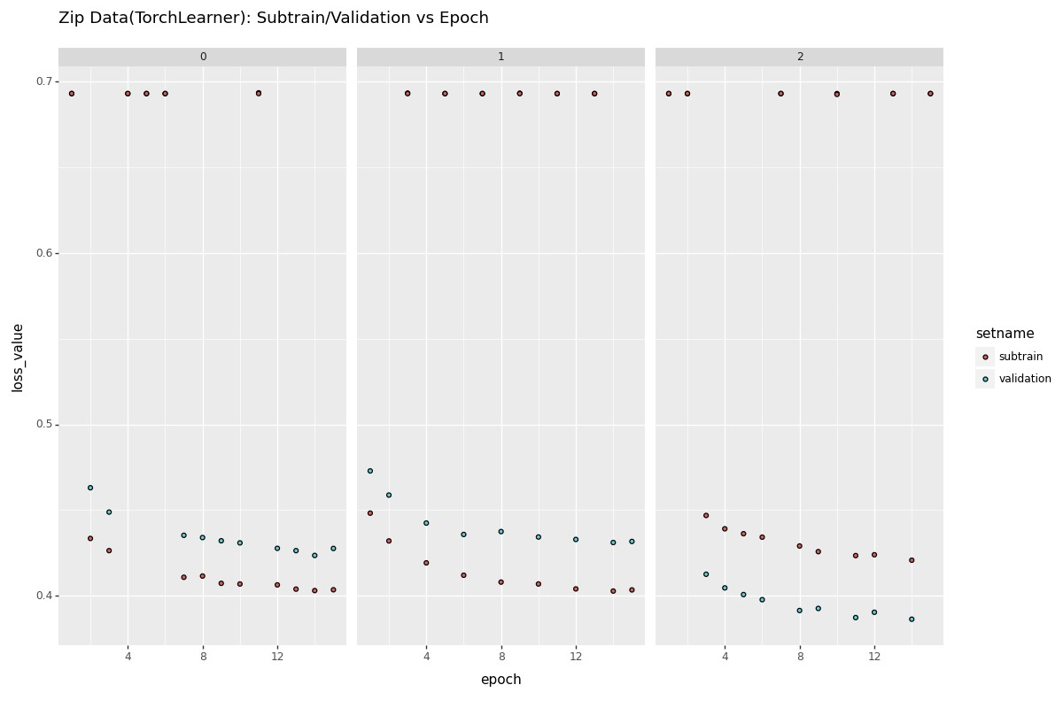

**>>> gg2 = p9.ggplot(zip_loss["TorchLearnerCV + Deep"], p9.aes(x ='epoch', y = 'loss_value', fill = 'setname')) + p9.facet_grid('.~validation_fold') + p9.geom_point() + p9.ggtitle("Zip Data(TorchLearner + Deep): Subtrain/Validation vs Epoch") #p9.geom_line(p9.aes(fill = 'setname'))**

**>>> gg2.save("c:/Users/Anudeep Kumar/OneDrive/Desktop/Fall 2023/CS599-Deep Learning/Homework/HW06/valid_graph2.png", height = 8, width = 12)**

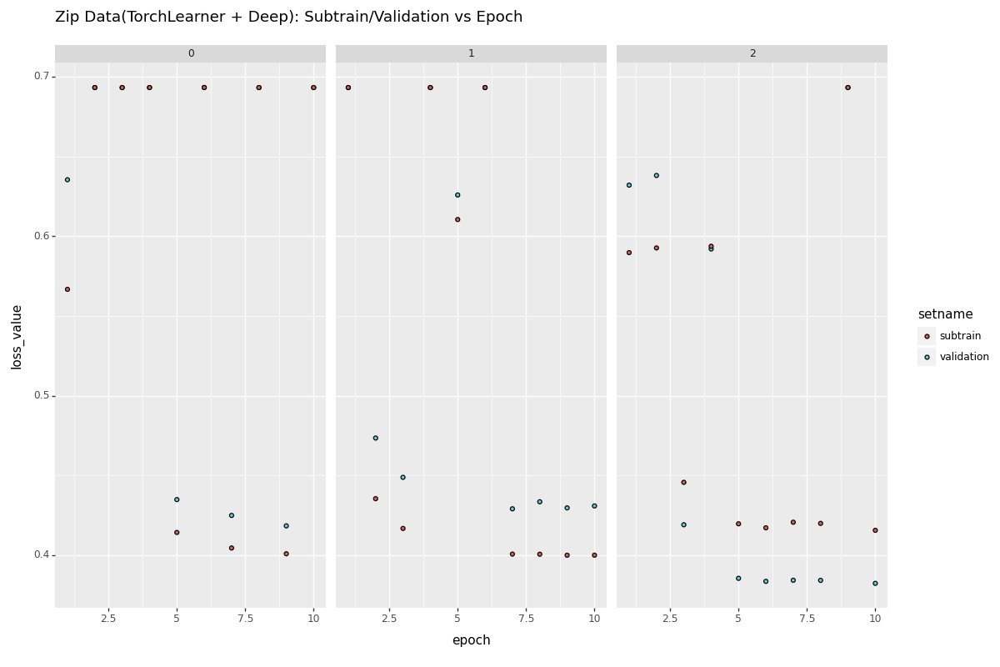

**>>> gg3 = p9.ggplot(spam_loss["TorchLearnerCV"], p9.aes(x ='epoch', y = 'loss_value', fill = 'setname')) + p9.facet_grid('.~validation_fold') + p9.geom_point() + p9.ggtitle("Spam_scaled Data(TorchLearner): Subtrain/Validation vs Epoch") #p9.geom_line(p9.aes(fill = 'setname'))**

**>>> gg3.save("valid_graph3.png", height = 8, width = 12)**

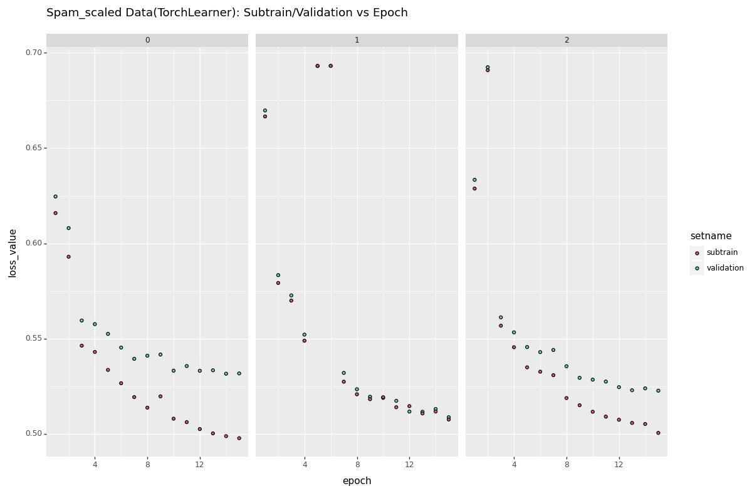

**>>> gg4 = p9.ggplot(spam_loss["TorchLearnerCV + Deep"], p9.aes(x ='epoch', y = 'loss_value', fill = 'setname')) \**

**... + p9.facet_grid('.~validation_fold') + p9.geom_point() + p9.ggtitle("spam_scaled Data(TorchLearner + Deep): Subtrain/Validation vs Epoch") #p9.geom_line(p9.aes(fill = 'setname'))**

**>>> gg4.save("valid_graph4.png", height = 8, width = 12)**

