**CS599 (Deep Learning)**

**Homework – 07**

1. **Python Code:**

import torch

import pandas as pd

import matplotlib

matplotlib.use("agg")

import numpy as np

import math

import plotnine as p9

from sklearn.model_selection import KFold, GridSearchCV, ParameterGrid

from sklearn.neighbors import KNeighborsClassifier

from sklearn.linear_model import LogisticRegressionCV

from sklearn.pipeline import make_pipeline

from sklearn.preprocessing import StandardScaler

from sklearn.metrics import accuracy_score

from collections import Counter

data_set_dict = {"zip": ("zip.test.gz", 0),

"spam": ("spam.data", 57)}

data_dict = {}

for data_name, (file_name, label_col_num) in data_set_dict.items():

data_df = pd.read_csv(file_name, sep=" ", header=None)

data_label_vec = data_df.iloc[:, label_col_num]

is_01 = data_label_vec.isin([0, 1])

data_01_df = data_df.loc[is_01, :]

is_label_col = data_df.columns == label_col_num

data_features = data_01_df.iloc[:, ~is_label_col]

data_labels = data_01_df.iloc[:, is_label_col]

data_dict[data_name] = (data_features, data_labels)

spam_features, spam_labels = data_dict.pop("spam")

spam_nrow, spam_ncol = spam_features.shape

spam_mean = spam_features.mean().to_numpy().reshape(1, spam_ncol)

spam_std = spam_features.std().to_numpy().reshape(1, spam_ncol)

spam_scaled = (spam_features - spam_mean)/spam_std

data_dict["spam_scaled"] = (spam_scaled, spam_labels)

{data_name:X.shape for data_name, (X,y) in data_dict.items()}

class Node:

def __repr__(self):

return "%s%s"%(self.__class__.__name__, self.value.shape)

class InitialNode(Node):

def __init__(self, value):

self.value = value

def backward(self):

pass

class Operation(Node):

def backward(self):

gradients = self.gradient()

for parent_node, grad in zip(self.parents, gradients):

if grad is not None and parent_node.value.shape != grad.shape:

raise ValueError(

"value%s not same shape as grad%s"%(

str(parent_node.value.shape),

str(grad.shape)))

parent_node.grad = grad

parent_node.backward()

class mm(Operation):

def __init__(self, feature_node, weight_node):

self.parents = [feature_node, weight_node]

self.value = np.matmul(feature_node.value, weight_node.value)

def gradient(self):

feature_node, weight_node = self.parents

return[

np.matmul(self.grad, weight_node.value.T),

np.matmul(feature_node.value.T, self.grad)]

class logistic_loss(Operation):

def __init__(self, pred_node, output_node):

self.parents = [pred_node, output_node]

output_vec = output_node.value

if not ((output_vec == 1) | (output_vec == -1)).all():

raise ValueError("Labels should be only -1 or 1")

self.value = np.log(1 + np.exp(-output_vec * pred_node.value))

def gradient(self):

pred_node, output_node = self.parents

# features X is b x p

# weights W is p x u = 1

# pred A is b x u = 1

# where b is batch size

# p is number of input features

# u is number of outputs

# grad_A(b x u) W(u x p)

pred_grad = -output_node.value/(

1 + np.exp(

output_node.value*

pred_node.value

)

)

return [pred_grad, None]

class CSV(torch.utils.data.Dataset):

def __init__(self, features, labels):

self.features = features

self.labels = labels

def __getitem__(self, item):

return self.features[item,:], self.labels[item]

def __len__(self):

return len(self.labels)

class AutoMLP:

def __init__(self, max_epochs, batch_size, step_size, units_per_layer):

self.units_per_layer = units_per_layer

self.max_epochs = max_epochs

self.batch_size = batch_size

self.step_size = step_size

self.weight_node = InitialNode(

np.repeat(0.0, self.units_per_layer[0]).reshape(self.units_per_layer[0], 1))

def get_pred_node(self, batch_features):

feature_node = InitialNode(np.array(batch_features))

pred_node = mm(feature_node, self.weight_node)

return pred_node

def take_step(self, batch_features, batch_labels):

label_node = InitialNode(np.array(batch_labels))

pred_vec = self.get_pred_node(batch_features)

loss_node = logistic_loss(pred_vec, label_node)

loss_node.backward()

gradient = self.weight_node.grad

self.weight_node.value -= gradient * self.step_size

return loss_node.value.mean()

def fit(self, train_features, test_features):

ds = CSV(train_features, test_features)

dl = torch.utils.data.DataLoader(

ds, batch_size = self.batch_size, shuffle = True)

train_df_list = []

for batch_features, batch_labels in dl:

loss_value = self.take_step(batch_features, batch_labels)

def decision_function(self, X):

pred_vec = self.get_pred_node(X)

return pred_vec.value.reshape(len(pred_vec.value),)

def predict(self, X):

pred_scores = self.decision_function(X)

return np.where(pred_scores > 0, 1, 0)

class AutoGradLearnerCV:

def __init__(self, max_epochs, batch_size, step_size, units_per_layer, n_splits):

self.units_per_layer = units_per_layer

self.max_epochs = max_epochs

self.step_size = step_size

self.batch_size = batch_size

self.n_splits = n_splits

def fit(self, train_features, train_labels):

best_model = None

train_nrow, train_ncol = train_features.shape

times_to_repeat = int(math.ceil(train_nrow/self.n_splits))

fold_id_vec = np.tile(np.arange(self.n_splits), times_to_repeat)[:train_nrow]

np.random.shuffle(fold_id_vec)

cv_data_list = []

for epoch in range(1, self.max_epochs + 1):

for validation_fold in range(self.n_splits):

is_split = {

"subtrain": fold_id_vec != validation_fold,

"validation": fold_id_vec == validation_fold

}

split_data_dict = {}

for set_name, is_set in is_split.items():

set_y = np.where(train_labels == 1, 1, -1).reshape(train_nrow, 1)

split_data_dict[set_name] = {

"n": len(set_y),

"X": train_features[is_set, :],

"y": set_y[is_set]}

learner = AutoMLP(self.max_epochs, self.batch_size, self.step_size, self.units_per_layer)

learner.fit(split_data_dict["subtrain"]["X"], split_data_dict["subtrain"]["y"])

for set_name, set_data in split_data_dict.items():

set_loss_value = learner.take_step(set_data["X"], set_data["y"])

cv_data_list.append(pd.DataFrame({

"set_name": [set_name],

"loss": float(set_loss_value),

"epoch": [epoch]

}))

self.cv_data = pd.concat(cv_data_list)

best_epoch = self.cv_data.groupby('epoch')["loss"].mean().idxmin()

best_learner = AutoMLP(best_epoch, self.batch_size, self.step_size, self.units_per_layer)

best_learner.fit(train_features, np.where(train_labels == 1, 1, -1).reshape(train_nrow, 1))

self.best_model = best_learner

return self.cv_data

def predict(self, test_features):

return self.best_model.predict(test_features)

accuracy_data_frames = []

loss_data_dict = {}

min_df_dict = {}

for data_name, (data_features, data_labels) in data_dict.items():

kf = KFold(n_splits=3, shuffle=True, random_state=3)

enum_obj = enumerate(kf.split(data_features))

for fold_num, index_tup in enum_obj:

zip_obj = zip(["train", "test"], index_tup)

split_data = {}

for set_name, set_indices in zip_obj:

split_data[set_name] = (data_features.iloc[set_indices, :].to_numpy(),

np.ravel(data_labels.iloc[set_indices]))

train_features, train_labels = split_data["train"]

nrow, ncol = train_features.shape

test_features, test_labels = split_data["test"]

#KNN Classifier

knn = KNeighborsClassifier()

hp_parameters = {"n_neighbors": list(range(1, 21))}

grid = GridSearchCV(knn, hp_parameters, cv=5)

grid.fit(train_features, train_labels)

best_n_neighbors = grid.best_params_['n_neighbors']

print("Best N-Neighbors = ", best_n_neighbors)

knn = KNeighborsClassifier(n_neighbors=best_n_neighbors)

knn.fit(train_features, train_labels)

knn_pred = knn.predict(test_features)

# Logistic Regression

pipe = make_pipeline(StandardScaler(), LogisticRegressionCV(cv=3, max_iter=2000))

pipe.fit(train_features, train_labels)

lr_pred = pipe.predict(test_features)

#Featureless

y_train_series = pd.Series(train_labels)

most_frequent_class = y_train_series.value_counts().idxmax()

print("Most Frequent Class = ", most_frequent_class)

# create a featureless baseline

featureless_pred = np.repeat(most_frequent_class, len(test_features))

#AutoGradLearnerCV

model_units = {

"linear": (ncol, 1),

"deep": (ncol, 100, 10, 1)

}

#AutoGradLearnerCV_linear

linear_learner = AutoGradLearnerCV(50, 10, 0.015, [ncol, 1], 3)

linear_loss = linear_learner.fit(train_features, train_labels)

ll_pred = linear_learner.predict(test_features)

#AutoGradLearnerCV_deep

deep_learner = AutoGradLearnerCV(50, 10, 0.01, [ncol, 100, 10, 1], 3)

deep_loss = deep_learner.fit(train_features, train_labels)

dl_pred = deep_learner.predict(test_features)

linear_loss = linear_loss.groupby(['set_name', 'epoch']).mean().reset_index()

deep_loss = deep_loss.groupby(['set_name', 'epoch']).mean().reset_index()

valid_df = linear_loss.query("set_name=='validation'")

index_min = valid_df["loss"].argmin()

min_df = valid_df.query("epoch==%s" % (index_min + 1))

valid_df_deep = deep_loss.query("set_name=='validation'")

index_min_deep = valid_df_deep["loss"].argmin()

min_df_deep = valid_df_deep.query("epoch==%s" % (index_min_deep + 1))

min_df_dict[data_name] = {'min_df linear': min_df,

'min_df deep': min_df_deep}

loss_data_dict[data_name] = {'AutoGradLearnerCV Linear': linear_loss,

'AutoGradLearnerCV Deep': deep_loss}

# store predict data in dict

pred_dict = {'gridSearch + nearest neighbors': knn_pred,

'linear_model': lr_pred,

'AutoGradLearnerCV Linear': ll_pred,

'AutoGradLearnerCV Deep': dl_pred,

'featureless': featureless_pred}

test_accuracy = {}

for algorithm, predictions in pred_dict.items():

#print(f"{algorithm}:", predictions.shape)

accuracy = np.mean(test_labels == predictions)

test_accuracy[algorithm] = accuracy

for algorithm, accuracy in test_accuracy.items():

print(f"{algorithm} Test Accuracy: {accuracy * 100}")

accuracy_df = pd.DataFrame({

"data_set": [data_name],

"fold_id": [fold_num],

"algorithm": [algorithm],

"accuracy": [test_accuracy[algorithm]]})

accuracy_data_frames.append(accuracy_df)

print(f"****************************End of {data_name}({fold_num})*****************************")

total_accuracy_df = pd.concat(accuracy_data_frames, ignore_index = True)

print(total_accuracy_df)

zip_loss = loss_data_dict["zip"]

spam_loss = loss_data_dict["spam_scaled"]

zip_min = min_df_dict["zip"]

spam_min = min_df_dict["spam_scaled"]

gg = p9.ggplot() +\

p9.geom_line(

p9.aes(

x = "epoch",

y= "loss",

color = "set_name"

),

data = zip_loss["AutoGradLearnerCV Linear"]) +\

p9.geom_point(

p9.aes(

x = "epoch",

y = "loss",

color = "set_name"

),

data = zip_min["min_df linear"]) +\

p9.ggtitle("Subtrain/Validation Loss vs Epochs(Zip Data - Linear)")

gg1 = p9.ggplot() +\

p9.geom_line(

p9.aes(

x = "epoch",

y= "loss",

color = "set_name"

),

data = zip_loss["AutoGradLearnerCV Deep"]) +\

p9.geom_point(

p9.aes(

x = "epoch",

y = "loss",

color = "set_name"

),

data = zip_min["min_df deep"]) +\

p9.ggtitle("Subtrain/Validation Loss vs Epochs(Zip Data - Deep)")

gg2 = p9.ggplot() +\

p9.geom_line(

p9.aes(

x = "epoch",

y= "loss",

color = "set_name"

),

data = spam_loss["AutoGradLearnerCV Linear"]) +\

p9.geom_point(

p9.aes(

x = "epoch",

y = "loss",

color = "set_name"

),

data = spam_min["min_df linear"]) +\

p9.ggtitle("Subtrain/Validation Loss vs Epochs(Spam_scaled Data - Linear)")

gg3 = p9.ggplot() +\

p9.geom_line(

p9.aes(

x = "epoch",

y= "loss",

color = "set_name"

),

data = spam_loss["AutoGradLearnerCV Deep"]) +\

p9.geom_point(

p9.aes(

x = "epoch",

y = "loss",

color = "set_name"

),

data = spam_min["min_df deep"]) +\

p9.ggtitle("Subtrain/Validation Loss vs Epochs(Spam_scaled Data - Deep)")

gg4 = p9.ggplot(total_accuracy_df, p9.aes(x ='accuracy', y = 'algorithm'))+\

p9.facet_grid('.~data_set') + p9.geom_point()

gg.save("Zip_linear_SV_graph.png", height = 8, width = 12)

gg1.save("Zip_deep_SV_graph.png", height = 8, width = 12)

gg2.save("Spam_linear_SV_graph.png", height = 8, width = 12)

gg3.save("Spam_deep_SV_graph.png", height = 8, width = 12)

gg4.save("Accuracy_graph.png", height = 8, width = 12)

1. **Output:**

**>>> for data_name, (data_features, data_labels) in data_dict.items():**

**... kf = KFold(n_splits=3, shuffle=True, random_state=3)**

**... enum_obj = enumerate(kf.split(data_features))**

**... for fold_num, index_tup in enum_obj:**

**... zip_obj = zip(["train", "test"], index_tup)**

**... split_data = {}**

**... for set_name, set_indices in zip_obj:**

**... split_data[set_name] = (data_features.iloc[set_indices, :].to_numpy(),**

**... np.ravel(data_labels.iloc[set_indices]))**

**... train_features, train_labels = split_data["train"]**

**... ...**

**...**

**... for algorithm, accuracy in test_accuracy.items():**

**... print(f"{algorithm} Test Accuracy: {accuracy * 100}")**

**... accuracy_df = pd.DataFrame({**

**... "data_set": [data_name],**

**... "fold_id": [fold_num],**

**... "algorithm": [algorithm],**

**... "accuracy": [test_accuracy[algorithm]]})**

**... accuracy_data_frames.append(accuracy_df)**

**... print(f"****************************End of {data_name}({fold_num})*****************************")**

Best N-Neighbors = 1

Most Frequent Class = 0

gridSearch + nearest neighbors Test Accuracy: 100.0

linear_model Test Accuracy: 99.51923076923077

AutoGradLearnerCV Linear Test Accuracy: 98.07692307692307

AutoGradLearnerCV Deep Test Accuracy: 99.51923076923077

featureless Test Accuracy: 58.65384615384615

****************************End of zip(0)*****************************

Best N-Neighbors = 1

Most Frequent Class = 0

gridSearch + nearest neighbors Test Accuracy: 99.51923076923077

linear_model Test Accuracy: 99.03846153846155

AutoGradLearnerCV Linear Test Accuracy: 98.5576923076923

AutoGradLearnerCV Deep Test Accuracy: 98.5576923076923

featureless Test Accuracy: 57.21153846153846

****************************End of zip(1)*****************************

Best N-Neighbors = 3

Most Frequent Class = 0

gridSearch + nearest neighbors Test Accuracy: 99.03381642512076

linear_model Test Accuracy: 99.03381642512076

AutoGradLearnerCV Linear Test Accuracy: 98.55072463768117

AutoGradLearnerCV Deep Test Accuracy: 98.55072463768117

featureless Test Accuracy: 57.00483091787439

****************************End of zip(2)*****************************

Best N-Neighbors = 5

Most Frequent Class = 0

gridSearch + nearest neighbors Test Accuracy: 90.28683181225554

linear_model Test Accuracy: 91.52542372881356

AutoGradLearnerCV Linear Test Accuracy: 91.13428943937419

AutoGradLearnerCV Deep Test Accuracy: 91.59061277705347

featureless Test Accuracy: 60.88657105606258

****************************End of spam_scaled(0)*****************************

Best N-Neighbors = 6

Most Frequent Class = 0

gridSearch + nearest neighbors Test Accuracy: 89.4393741851369

linear_model Test Accuracy: 91.78617992177314

AutoGradLearnerCV Linear Test Accuracy: 91.26466753585397

AutoGradLearnerCV Deep Test Accuracy: 91.39504563233378

featureless Test Accuracy: 60.104302477183836

****************************End of spam_scaled(1)*****************************

Best N-Neighbors = 5

Most Frequent Class = 0

gridSearch + nearest neighbors Test Accuracy: 90.01956947162427

linear_model Test Accuracy: 92.49836921069797

AutoGradLearnerCV Linear Test Accuracy: 92.4331376386171

AutoGradLearnerCV Deep Test Accuracy: 91.71559034572732

featureless Test Accuracy: 60.79582517938682

****************************End of spam_scaled(2)*****************************

**>>> total_accuracy_df = pd.concat(accuracy_data_frames, ignore_index = True)**

**>>> print(total_accuracy_df)**

data_set fold_id algorithm accuracy

0 zip 0 gridSearch + nearest neighbors 1.000000

1 zip 0 linear_model 0.995192

2 zip 0 AutoGradLearnerCV Linear 0.980769

3 zip 0 AutoGradLearnerCV Deep 0.995192

4 zip 0 featureless 0.586538

5 zip 1 gridSearch + nearest neighbors 0.995192

6 zip 1 linear_model 0.990385

7 zip 1 AutoGradLearnerCV Linear 0.985577

8 zip 1 AutoGradLearnerCV Deep 0.985577

9 zip 1 featureless 0.572115

10 zip 2 gridSearch + nearest neighbors 0.990338

11 zip 2 linear_model 0.990338

12 zip 2 AutoGradLearnerCV Linear 0.985507

13 zip 2 AutoGradLearnerCV Deep 0.985507

14 zip 2 featureless 0.570048

15 spam_scaled 0 gridSearch + nearest neighbors 0.902868

16 spam_scaled 0 linear_model 0.915254

17 spam_scaled 0 AutoGradLearnerCV Linear 0.911343

18 spam_scaled 0 AutoGradLearnerCV Deep 0.915906

19 spam_scaled 0 featureless 0.608866

20 spam_scaled 1 gridSearch + nearest neighbors 0.894394

21 spam_scaled 1 linear_model 0.917862

22 spam_scaled 1 AutoGradLearnerCV Linear 0.912647

23 spam_scaled 1 AutoGradLearnerCV Deep 0.913950

24 spam_scaled 1 featureless 0.601043

25 spam_scaled 2 gridSearch + nearest neighbors 0.900196

26 spam_scaled 2 linear_model 0.924984

27 spam_scaled 2 AutoGradLearnerCV Linear 0.924331

28 spam_scaled 2 AutoGradLearnerCV Deep 0.917156

29 spam_scaled 2 featureless 0.607958

**Accuracy Graph:**

**>>> gg4 = p9.ggplot(total_accuracy_df, p9.aes(x ='accuracy', y = 'algorithm'))+\**

**... p9.facet_grid('.~data_set') + p9.geom_point()**

**>>> gg4.save("Accuracy_graph.png", height = 8, width = 12)**

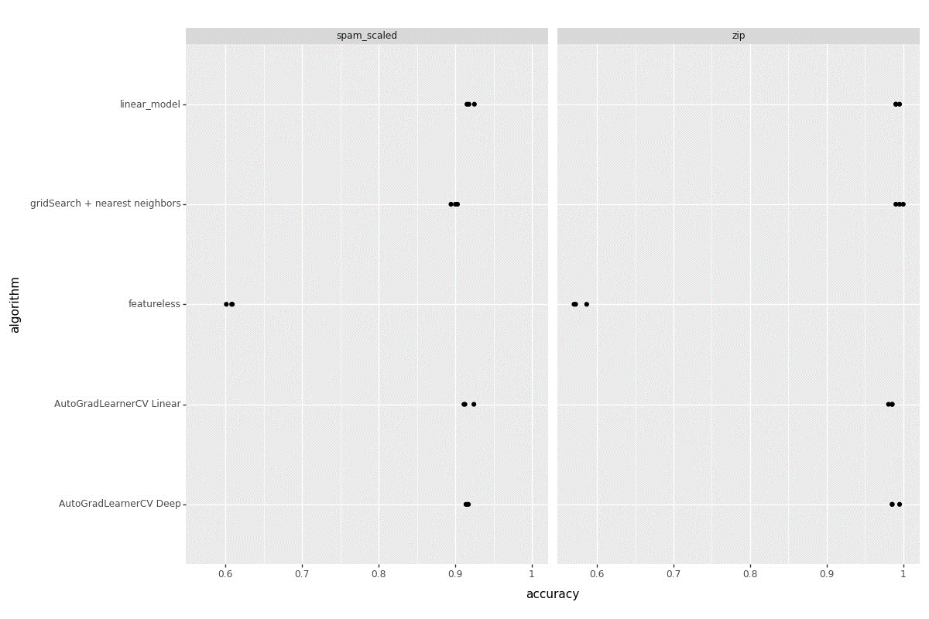

**Linear subtrain/validation Loss graph (Zip):**

**>>> gg = p9.ggplot() +\**

**... p9.geom_line(**

**... p9.aes(**

**... x = "epoch",**

**... y= "loss",**

**... color = "set_name"**

**... ),**

**... data = zip_loss["AutoGradLearnerCV Linear"]) +\**

**... p9.geom_point(**

**... p9.aes(**

**... x = "epoch",**

**... y = "loss",**

**... color = "set_name"**

**... ),**

**... data = zip_min["min_df linear"]) +\**

**... p9.ggtitle("Subtrain/Validation Loss vs Epochs(Zip Data - Linear)")**

**>>> gg.save("Zip_linear_SV_graph.png", height = 8, width = 12)**

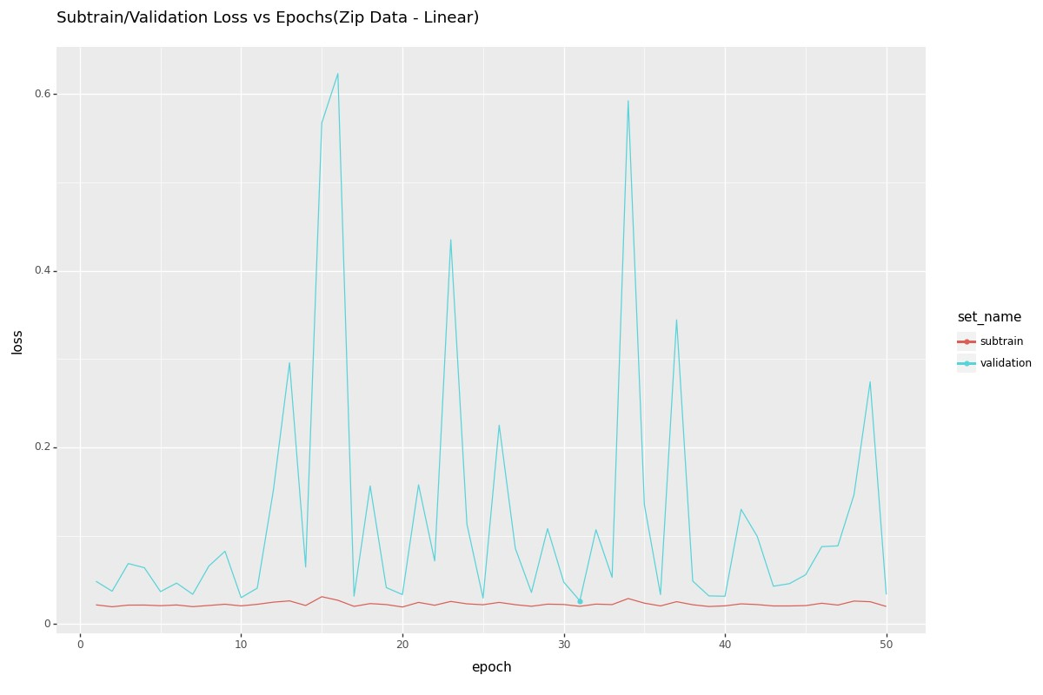

**Subtrain/Validation Loss Graph (Zip Data – Deep Model):**

**>>> gg1 = p9.ggplot() +\**

**... p9.geom_line(**

**... p9.aes(**

**... x = "epoch",**

**... y= "loss",**

**... color = "set_name"**

**... ),**

**... data = zip_loss["AutoGradLearnerCV Deep"]) +\**

**... p9.geom_point(**

**... p9.aes(**

**... x = "epoch",**

**... y = "loss",**

**... color = "set_name"**

**... ),**

**... data = zip_min["min_df deep"]) +\**

**... p9.ggtitle("Subtrain/Validation Loss vs Epochs(Zip Data - Deep)")**

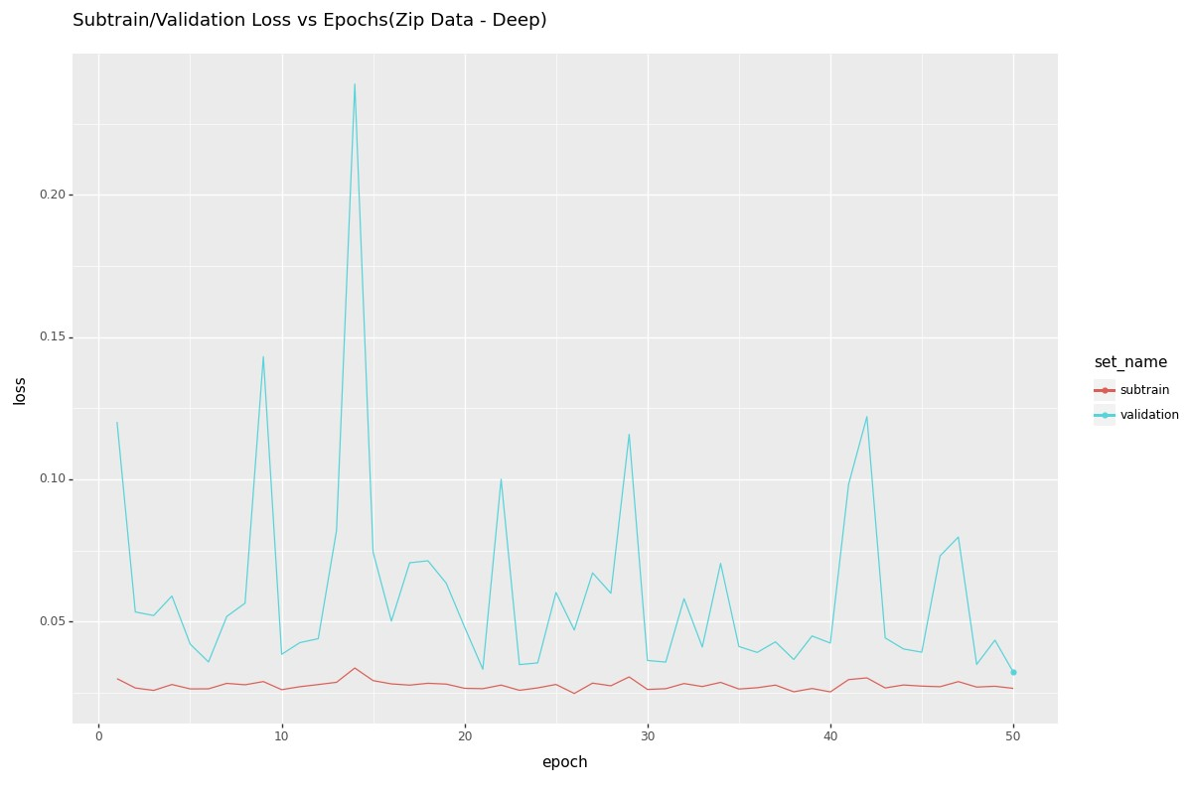

**Subtrain/Validation Loss Graph (Spam_scaled Data – Linear Model):**

**>>> gg2 = p9.ggplot() +\**

**... p9.geom_line(**

**... p9.aes(**

**... x = "epoch",**

**... y= "loss",**

**... color = "set_name"**

**... ),**

**... data = spam_loss["AutoGradLearnerCV Linear"]) +\**

**... p9.geom_point(**

**... p9.aes(**

**... x = "epoch",**

**... y = "loss",**

**... color = "set_name"**

**... ),**

**... data = spam_min["min_df linear"]) +\**

**... p9.ggtitle("Subtrain/Validation Loss vs Epochs(Spam_scaled Data - Linear)")**

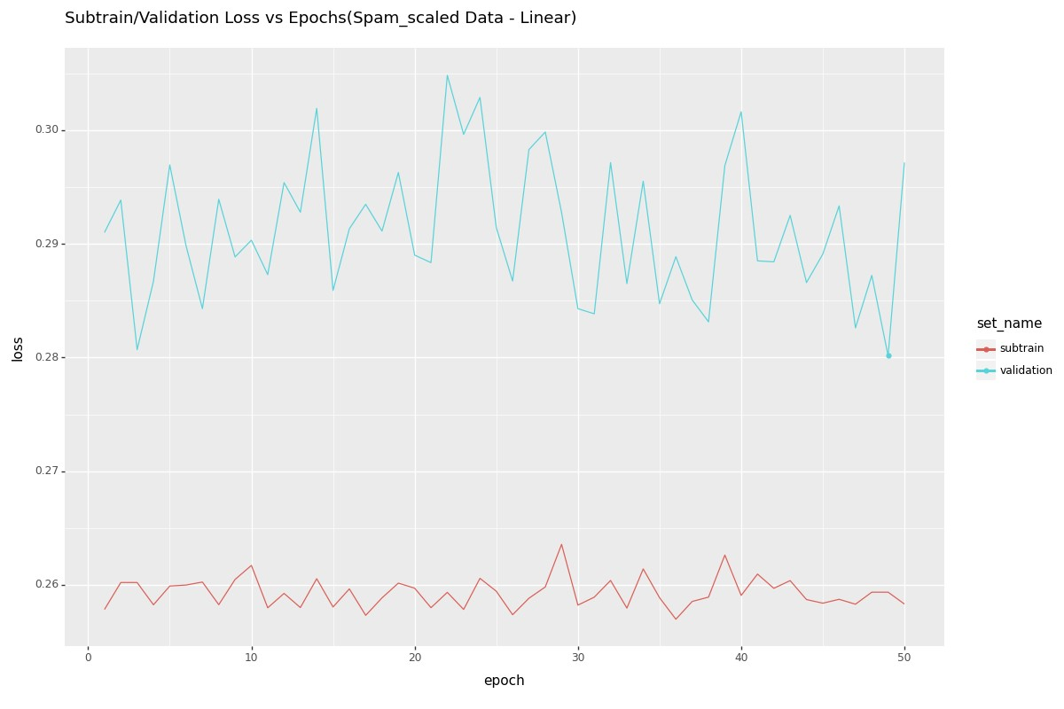

**Subtrain/Validation Loss Graph (Spam_scaled Data – Deep Model):**

