**CS599 (Deep Learning)**

**Homework – 09**

1. **Python Code:**

import torch

import pandas as pd

import matplotlib

import numpy as np

import math

matplotlib.use("agg")

from sklearn.model_selection import KFold, GridSearchCV, ParameterGrid

from sklearn.neighbors import KNeighborsRegressor

from sklearn.linear_model import LassoCV

from sklearn.pipeline import make_pipeline

from sklearn.preprocessing import StandardScaler

from sklearn.metrics import mean_squared_error

from collections import Counter

data_set_dict = {"forest_fires": ("forestfires.csv", ",", True),

"air_foil": ("airfoil_self_noise.tsv", "\t", False)}

data_dict = {}

hist_df_list = []

for data_name, (file_name, sep, log_trans) in data_set_dict.items():

data_df = pd.read_csv(file_name, sep = sep, header = 0)

data_nrow, data_ncol = data_df.shape

label_col_num = data_ncol - 1

data_label_vec = data_df.iloc[:, label_col_num]

if log_trans:

data_label_vec = np.log(data_label_vec + 1)

label_sd = math.sqrt(data_label_vec.var())

standard_label_vec = (

data_label_vec - data_label_vec.mean()

)/ label_sd

is_feature_col = (

np.arange(data_ncol) != label_col_num

) & (

data_df.dtypes != "object"

)

data_features = data_df.loc[:, is_feature_col]

feature_nrow, feature_ncol = data_features.shape

feature_mean = data_features.mean().to_numpy().reshape(1, feature_ncol)

feature_std = data_features.std().to_numpy().reshape(1, feature_ncol)

feature_scaled = (data_features - feature_mean)/feature_std

print("%s %s" %(data_name, data_features.shape))

input_tensor = torch.from_numpy(

feature_scaled.to_numpy()

).float()

output_tensor = torch.from_numpy(

standard_label_vec.to_numpy()

).float().reshape(data_nrow, 1)

data_dict[data_name] = (feature_scaled, standard_label_vec)

hist_df_list.append(pd.DataFrame({

"data_name": data_name,

"label": standard_label_vec})

)

hist_df = pd.concat(hist_df_list)

class TorchModel(torch.nn.Module):

def __init__(self, units_per_layer):

super(TorchModel, self).__init__()

seq_args = []

second_to_last = len(units_per_layer)-1

for layer_i in range(second_to_last):

next_i = layer_i+1

layer_units = units_per_layer[layer_i]

next_units = units_per_layer[next_i]

seq_args.append(torch.nn.Linear(layer_units, next_units))

if layer_i < second_to_last-1:

seq_args.append(torch.nn.ReLU())

self.stack = torch.nn.Sequential(*seq_args)

def forward(self, features):

return self.stack(features)

class CSV(torch.utils.data.Dataset):

def __init__(self, features, labels):

self.features = features

self.labels = labels

def __getitem__(self, item):

return self.features[item,:], self.labels[item]

def __len__(self):

return len(self.labels)

class TorchLearner:

def __init__(

self, units_per_layer, step_size=0.1,

batch_size=20, max_epochs=50):

self.max_epochs = max_epochs

self.batch_size=batch_size

self.model = TorchModel(units_per_layer)

self.loss_fun = torch.nn.MSELoss()

self.optimizer = torch.optim.SGD(

self.model.parameters(), lr=step_size)

def fit(self, split_data_dict):

ds = CSV(

split_data_dict["subtrain"]["X"],

split_data_dict["subtrain"]["y"])

dl = torch.utils.data.DataLoader(

ds, batch_size=self.batch_size, shuffle=True)

train_df_list = []

for epoch_number in range(self.max_epochs):

#print(epoch_number)

for batch_features, batch_labels in dl:

self.optimizer.zero_grad()

loss_value = self.loss_fun(

self.model(batch_features), batch_labels)

loss_value.backward()

self.optimizer.step()

for set_name, set_data in split_data_dict.items():

pred_vec = self.model(set_data["X"])

set_loss_value = self.loss_fun(pred_vec, set_data["y"])

train_df_list.append(pd.DataFrame({

"set_name":[set_name],

"loss":float(set_loss_value),

"epoch":[epoch_number]

}))

self.train_df = pd.concat(train_df_list)

def decision_function(self, test_features):

with torch.no_grad():

pred_vec = self.model(test_features)

return pred_vec.numpy()

def predict(self, test_features):

pred_scores = self.decision_function(test_features)

return pred_scores

class TorchLearnerCV:

def __init__(self, n_folds, units_per_layer=[data_ncol,1]):

self.units_per_layer = units_per_layer

self.n_folds = n_folds

def fit(self, train_features, train_labels):

train_nrow, train_ncol = train_features.shape

times_to_repeat=int(math.ceil(train_nrow/self.n_folds))

fold_id_vec = np.tile(torch.arange(self.n_folds), times_to_repeat)[:train_nrow]

np.random.shuffle(fold_id_vec)

cv_data_list = []

for validation_fold in range(self.n_folds):

is_split = {

"subtrain":fold_id_vec != validation_fold,

"validation":fold_id_vec == validation_fold

}

split_data_dict = {}

for set_name, is_set in is_split.items():

set_y = train_labels[is_set]

split_data_dict[set_name] = {

"X":train_features[is_set,:],

"y":set_y}

learner = TorchLearner(self.units_per_layer)

learner.fit(split_data_dict)

cv_data_list.append(learner.train_df)

self.cv_data = pd.concat(cv_data_list)

self.train_df = self.cv_data.groupby(["set_name","epoch"]).mean().reset_index()

#print(self.train_df)

valid_df = self.train_df.query("set_name=='validation'")

#print(valid_df)

best_epochs = valid_df["loss"].argmin()

self.min_df = valid_df.query("epoch==%s"%(best_epochs))

print("Best Epoch: ", best_epochs)

self.final_learner = TorchLearner(self.units_per_layer, max_epochs=(best_epochs + 1))

self.final_learner.fit({"subtrain":{"X":train_features,"y":train_labels}})

return self.cv_data

def predict(self, test_features):

return self.final_learner.predict(test_features)

test_loss_data_frames = []

loss_data_dict = {}

min_df_dict = {}

for data_name, (data_features, data_labels) in data_dict.items():

kf = KFold(n_splits=3, shuffle=True, random_state=3)

enum_obj = enumerate(kf.split(data_features))

for fold_num, index_tup in enum_obj:

zip_obj = zip(["train", "test"], index_tup)

split_data = {}

for set_name, set_indices in zip_obj:

split_data[set_name] = (torch.from_numpy(data_features.iloc[set_indices, :].to_numpy()).float(),

torch.from_numpy(np.ravel(data_labels.iloc[set_indices])).float())

#x = {data_name:X.shape for data_name, (X,y) in split_data.items()}

#print(f"{data_name}: ", x)

train_features, train_labels = split_data["train"]

nrow, ncol = train_features.shape

#print(f"{data_name}: ", nrow, ncol)

test_features, test_labels = split_data["test"]

#kneighbors

knn = KNeighborsRegressor()

hp_parameters = {"n_neighbors": list(range(1, 21))}

grid = GridSearchCV(knn, hp_parameters, cv=3)

grid.fit(train_features, train_labels)

best_n_neighbors = grid.best_params_['n_neighbors']

print("Best N-Neighbors = ", best_n_neighbors)

knn = KNeighborsRegressor(n_neighbors=best_n_neighbors)

knn.fit(train_features, train_labels)

knn_pred = knn.predict(test_features)

#print(test_labels)

#print(knn_pred)

#loss = mean_squared_error(test_labels, knn_pred)

#print(f"Knn Loss {data_name} : ", loss)

#linear model

pipe = make_pipeline(StandardScaler(), LassoCV(cv=3, max_iter=2000))

pipe.fit(train_features, train_labels)

lr_pred = pipe.predict(test_features)

#loss_linear = mean_squared_error(test_labels, lr_pred)

#print(f"Linear_loss {data_name} : ", loss_linear)

#Featureless

y_train_series = pd.Series(train_labels)

mean_train_label = y_train_series.mean()

print("Mean Train Label = ", mean_train_label)

# create a featureless baseline

featureless_pred = np.repeat(mean_train_label, len(test_features))

#featureless_loss = mean_squared_error(test_labels, featureless_pred)

#print(f"Featureless Loss {data_name} : ", featureless_loss)

#TorchLearnerCV

linear_learner = TorchLearnerCV(3, [ncol, 1])

#print("ncol:", ncol)

linear_loss = linear_learner.fit(train_features, train_labels.reshape(nrow,1))

ll_pred = linear_learner.predict(test_features)

#print(ll_pred)

#loss_torchlinear = mean_squared_error(test_labels, ll_pred)

#print(f"Torch Linear_loss {data_name} : ", loss_torchlinear)

#TorchLearnerCV + Deep

deep_learner = TorchLearnerCV(3, [ncol, 100, 10, 1])

deep_loss = deep_learner.fit(train_features, train_labels.reshape(nrow, 1))

dl_pred = deep_learner.predict(test_features)

#loss_deeplearner = mean_squared_error(test_labels, dl_pred)

#print(f"Torch Deep_loss {data_name} : ", loss_deeplearner)

linear_loss = linear_loss.groupby(['set_name', 'epoch']).mean().reset_index()

deep_loss = deep_loss.groupby(['set_name', 'epoch']).mean().reset_index()

valid_df = linear_loss.query("set_name=='validation'")

index_min = valid_df["loss"].argmin()

min_df = valid_df.query("epoch==%s" % index_min)

valid_df_deep = deep_loss.query("set_name=='validation'")

index_min_deep = valid_df_deep["loss"].argmin()

min_df_deep = valid_df_deep.query("epoch==%s" % index_min_deep)

min_df_dict[data_name] = {'min_df linear': min_df,

'min_df deep': min_df_deep}

loss_data_dict[data_name] = {'TorchLearnerCV Linear': linear_loss,

'TorchLearnerCV Deep': deep_loss}

# store predict data in dict

pred_dict = {'KNeighborsRegressor + GridSearchCV': knn_pred,

'LassoCV': lr_pred,

'TorchLearnerCV Linear': ll_pred,

'TorchLearnerCV Deep': dl_pred,

'featureless': featureless_pred}

test_square_loss = {}

for algorithm, predictions in pred_dict.items():

#print(f"{algorithm}:", predictions.shape)

test_loss = mean_squared_error(test_labels, predictions)

#accuracy = np.mean(test_labels == predictions)

test_square_loss[algorithm] = test_loss

for algorithm, test_loss in test_square_loss.items():

print(f"{algorithm} Test Square Loss: {test_loss}")

test_loss_df = pd.DataFrame({

"data_set": [data_name],

"fold_id": [fold_num],

"algorithm": [algorithm],

"test square loss": [test_square_loss[algorithm]]})

test_loss_data_frames.append(test_loss_df)

print(f"****************************End of {data_name}({fold_num})*****************************")

total_test_loss_df = pd.concat(test_loss_data_frames, ignore_index = True)

print(total_test_loss_df)

import plotnine as p9

gg = p9.ggplot(total_test_loss_df, p9.aes(x ='test square loss', y = 'algorithm'))+\

p9.facet_grid('.~data_set') + p9.geom_point()

gg.save("Test_square_loss.png", height = 8, width = 12)

forest_fires_loss = loss_data_dict["forest_fires"]

air_foil_loss = loss_data_dict["air_foil"]

forest_fires_min = min_df_dict["forest_fires"]

air_foil_min = min_df_dict["air_foil"]

gg1 = p9.ggplot() + p9.geom_line(p9.aes(x ='epoch', y = 'loss', color = 'set_name'), data = forest_fires_loss["TorchLearnerCV Linear"])\

+ p9.geom_point(p9.aes(x ='epoch', y = 'loss', color = 'set_name'), data = forest_fires_min["min_df linear"]) #p9.geom_line(p9.aes(fill = 'setname'))

gg1.save("Torch_validation_graph1.png", height = 8, width = 12)

gg2 = p9.ggplot() + p9.geom_line(p9.aes(x ='epoch', y = 'loss', color = 'set_name'), data = forest_fires_loss["TorchLearnerCV Deep"])\

+ p9.geom_point(p9.aes(x ='epoch', y = 'loss', color = 'set_name'), data = forest_fires_min["min_df deep"]) #p9.geom_line(p9.aes(fill = 'setname'))

gg2.save("Torch_validation_graph2.png", height = 8, width = 12)

gg3 = p9.ggplot() + p9.geom_line(p9.aes(x ='epoch', y = 'loss', color = 'set_name'), data = air_foil_loss["TorchLearnerCV Linear"])\

+ p9.geom_point(p9.aes(x ='epoch', y = 'loss', color = 'set_name'), data = air_foil_min["min_df linear"]) #p9.geom_line(p9.aes(fill = 'setname'))

gg3.save("Torch_validation_graph3.png", height = 8, width = 12)

gg4 = p9.ggplot() + p9.geom_line(p9.aes(x ='epoch', y = 'loss', color = 'set_name'), data = air_foil_loss["TorchLearnerCV Deep"])\

+ p9.geom_point(p9.aes(x ='epoch', y = 'loss', color = 'set_name'), data = air_foil_min["min_df deep"]) #p9.geom_line(p9.aes(fill = 'setname'))

gg4.save("Torch_validation_graph4.png", height = 8, width = 12)

1. **Output:**

**>>> for data_name, (data_features, data_labels) in data_dict.items():**

**... kf = KFold(n_splits=3, shuffle=True, random_state=3)**

**... enum_obj = enumerate(kf.split(data_features))**

**... for fold_num, index_tup in enum_obj:**

**... zip_obj = zip(["train", "test"], index_tup)**

**... split_data = {}**

**... for set_name, set_indices in zip_obj:**

**... split_data[set_name] = (torch.from_numpy(data_features.iloc[set_indices, :].to_numpy()).float(),**

**... torch.from_numpy(np.ravel(data_labels.iloc[set_indices])).float())**

**... #x = {data_name:X.shape for data_name, (X,y) in split_data.items()}**

**... ...**

**...**

**... for algorithm, test_loss in test_square_loss.items():**

**... print(f"{algorithm} Test Square Loss: {test_loss}")**

**... test_loss_df = pd.DataFrame({**

**... "data_set": [data_name],**

**... "fold_id": [fold_num],**

**... "algorithm": [algorithm],**

**... "test square loss": [test_square_loss[algorithm]]})**

**... test_loss_data_frames.append(test_loss_df)**

**... print(f"****************************End of {data_name}({fold_num})*****************************")**

Best N-Neighbors = 19

Mean Train Label = 0.0049645514

Best Epoch: 0

Best Epoch: 2

KNeighborsRegressor + GridSearchCV Test Square Loss: 1.0609387159347534

LassoCV Test Square Loss: 1.0739297224352429

TorchLearnerCV Linear Test Square Loss: 1.2798919677734375

TorchLearnerCV Deep Test Square Loss: 1.073811411857605

featureless Test Square Loss: 1.0739296674728394

****************************End of forest_fires(0)*****************************

Best N-Neighbors = 20

Mean Train Label = -0.019172536

Best Epoch: 0

Best Epoch: 3

KNeighborsRegressor + GridSearchCV Test Square Loss: 0.988243818283081

LassoCV Test Square Loss: 0.9922808202492903

TorchLearnerCV Linear Test Square Loss: 1.0052711963653564

TorchLearnerCV Deep Test Square Loss: 0.989805281162262

featureless Test Square Loss: 0.9922808408737183

****************************End of forest_fires(1)*****************************

Best N-Neighbors = 17

Mean Train Label = 0.014222353

Best Epoch: 10

Best Epoch: 0

KNeighborsRegressor + GridSearchCV Test Square Loss: 1.0026485919952393

LassoCV Test Square Loss: 0.9305249905775753

TorchLearnerCV Linear Test Square Loss: 1.1973176002502441

TorchLearnerCV Deep Test Square Loss: 0.9264524579048157

featureless Test Square Loss: 0.9305248856544495

****************************End of forest_fires(2)*****************************

Best N-Neighbors = 13

Mean Train Label = -0.034039237

Best Epoch: 42

Best Epoch: 44

KNeighborsRegressor + GridSearchCV Test Square Loss: 0.31644493341445923

LassoCV Test Square Loss: 0.47843713543411764

TorchLearnerCV Linear Test Square Loss: 0.5696210265159607

TorchLearnerCV Deep Test Square Loss: 0.1302846521139145

featureless Test Square Loss: 0.9787271022796631

****************************End of air_foil(0)*****************************

Best N-Neighbors = 9

Mean Train Label = 0.00056366913

Best Epoch: 44

Best Epoch: 49

KNeighborsRegressor + GridSearchCV Test Square Loss: 0.2813766300678253

LassoCV Test Square Loss: 0.48135759164756325

TorchLearnerCV Linear Test Square Loss: 0.6965237259864807

TorchLearnerCV Deep Test Square Loss: 0.2059951275587082

featureless Test Square Loss: 0.9960943460464478

****************************End of air_foil(1)*****************************

Best N-Neighbors = 11

Mean Train Label = 0.033475567

Best Epoch: 42

Best Epoch: 45

KNeighborsRegressor + GridSearchCV Test Square Loss: 0.3124180734157562

LassoCV Test Square Loss: 0.5237005567324898

TorchLearnerCV Linear Test Square Loss: 0.5518736839294434

TorchLearnerCV Deep Test Square Loss: 0.3650369644165039

featureless Test Square Loss: 1.0345804691314697

****************************End of air_foil(2)*****************************

**>>> total_test_loss_df = pd.concat(test_loss_data_frames, ignore_index = True)**

**>>> print(total_test_loss_df)**

data_set fold_id algorithm test square loss

0 forest_fires 0 KNeighborsRegressor + GridSearchCV 1.060939

1 forest_fires 0 LassoCV 1.073930

2 forest_fires 0 TorchLearnerCV Linear 1.279892

3 forest_fires 0 TorchLearnerCV Deep 1.073811

4 forest_fires 0 featureless 1.073930

5 forest_fires 1 KNeighborsRegressor + GridSearchCV 0.988244

6 forest_fires 1 LassoCV 0.992281

7 forest_fires 1 TorchLearnerCV Linear 1.005271

8 forest_fires 1 TorchLearnerCV Deep 0.989805

9 forest_fires 1 featureless 0.992281

10 forest_fires 2 KNeighborsRegressor + GridSearchCV 1.002649

11 forest_fires 2 LassoCV 0.930525

12 forest_fires 2 TorchLearnerCV Linear 1.197318

13 forest_fires 2 TorchLearnerCV Deep 0.926452

14 forest_fires 2 featureless 0.930525

15 air_foil 0 KNeighborsRegressor + GridSearchCV 0.316445

16 air_foil 0 LassoCV 0.478437

17 air_foil 0 TorchLearnerCV Linear 0.569621

18 air_foil 0 TorchLearnerCV Deep 0.130285

19 air_foil 0 featureless 0.978727

20 air_foil 1 KNeighborsRegressor + GridSearchCV 0.281377

21 air_foil 1 LassoCV 0.481358

22 air_foil 1 TorchLearnerCV Linear 0.696524

23 air_foil 1 TorchLearnerCV Deep 0.205995

24 air_foil 1 featureless 0.996094

25 air_foil 2 KNeighborsRegressor + GridSearchCV 0.312418

26 air_foil 2 LassoCV 0.523701

27 air_foil 2 TorchLearnerCV Linear 0.551874

28 air_foil 2 TorchLearnerCV Deep 0.365037

29 air_foil 2 featureless 1.034580

**Test Loss Square Graph:**

**>>> gg = p9.ggplot(total_test_loss_df, p9.aes(x ='test square loss', y = 'algorithm'))+\**

**... p9.facet_grid('.~data_set') + p9.geom_point()**

**>>> gg.save("Test_square_loss.png", height = 8, width = 12)**

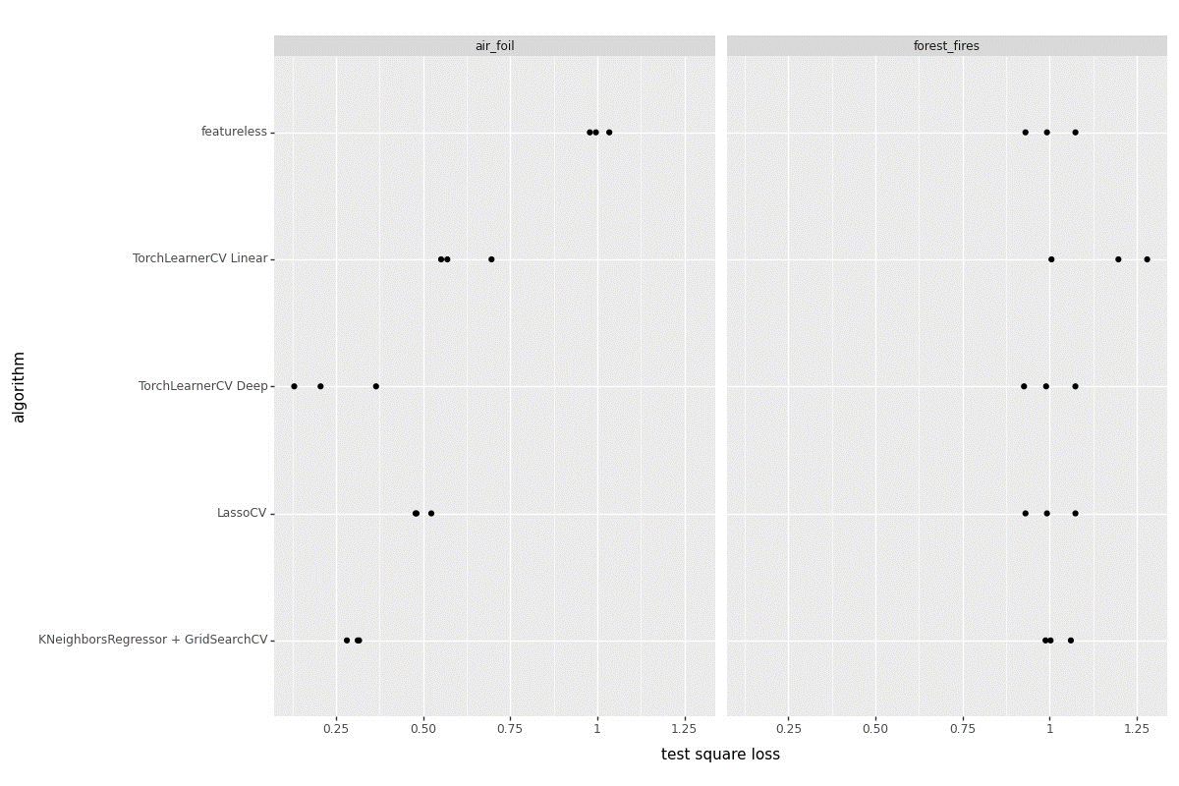

**Linear subtrain/validation loss graph (Forest Fires):**

**>>> gg1 = p9.ggplot() + p9.geom_line(p9.aes(x ='epoch', y = 'loss', color = 'set_name'), data = forest_fires_loss["TorchLearnerCV Linear"])\**

**... + p9.geom_point(p9.aes(x ='epoch', y = 'loss', color = 'set_name'), data = forest_fires_min["min_df linear"]) #p9.geom_line(p9.aes(fill = 'setname'))**

**>>> gg1.save("Torch_validation_graph1.png", height = 8, width = 12)**

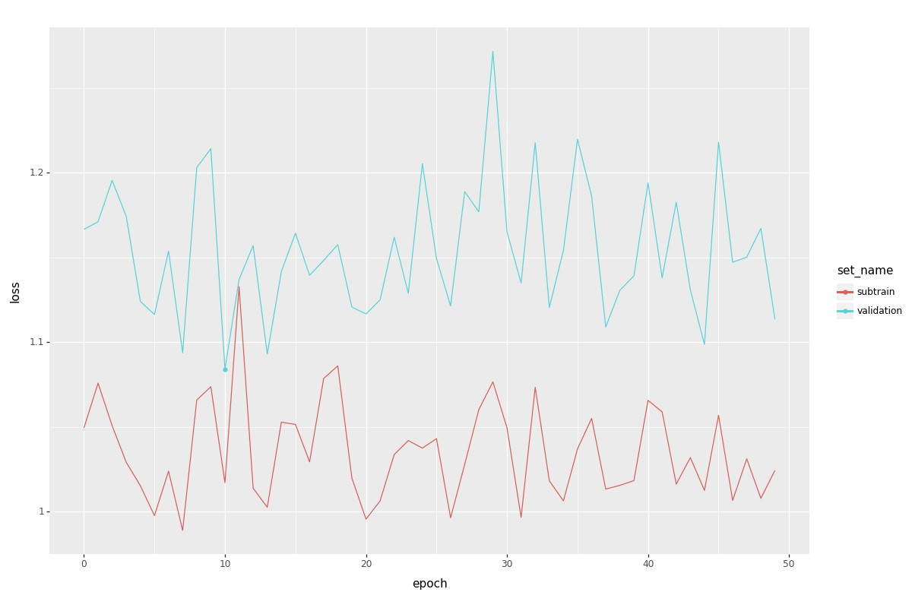

**Linear subtrain/validation loss graph (Air Foil):**

**>>> gg3 = p9.ggplot() + p9.geom_line(p9.aes(x ='epoch', y = 'loss', color = 'set_name'), data = air_foil_loss["TorchLearnerCV Linear"])\**

**... + p9.geom_point(p9.aes(x ='epoch', y = 'loss', color = 'set_name'), data = air_foil_min["min_df linear"]) #p9.geom_line(p9.aes(fill = 'setname'))**

**>>> gg3.save("Torch_validation_graph3.png", height = 8, width = 12)**

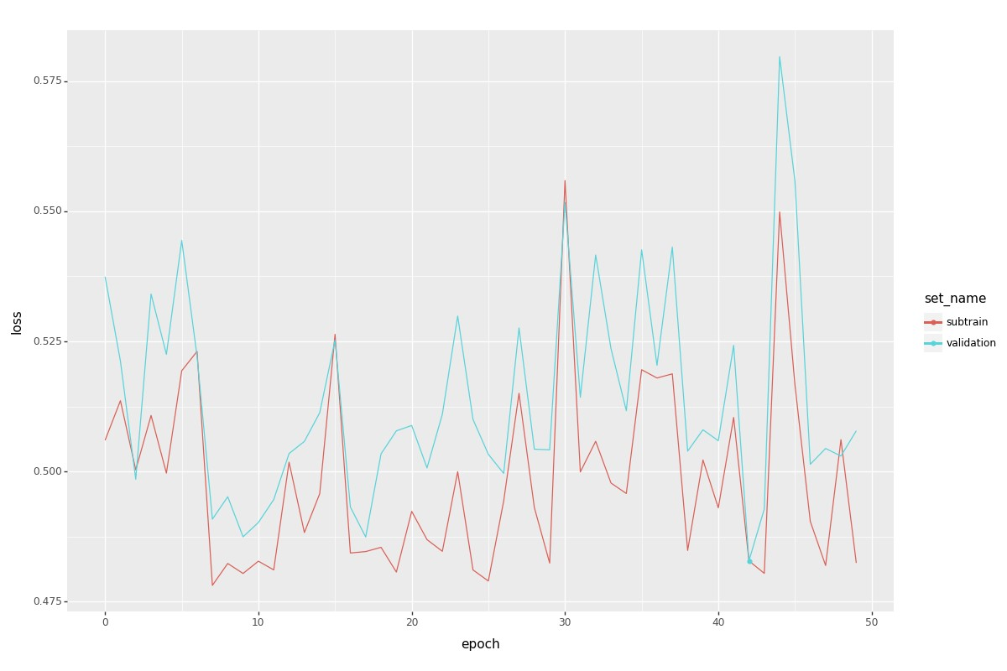

**Deep subtrain/validation loss graph (Forest Fires):**

**>>> gg2 = p9.ggplot() + p9.geom_line(p9.aes(x ='epoch', y = 'loss', color = 'set_name'), data = forest_fires_loss["TorchLearnerCV Deep"])\**

**... + p9.geom_point(p9.aes(x ='epoch', y = 'loss', color = 'set_name'), data = forest_fires_min["min_df deep"]) #p9.geom_line(p9.aes(fill = 'setname'))**

**>>> gg2.save("Torch_validation_graph2.png", height = 8, width = 12)**

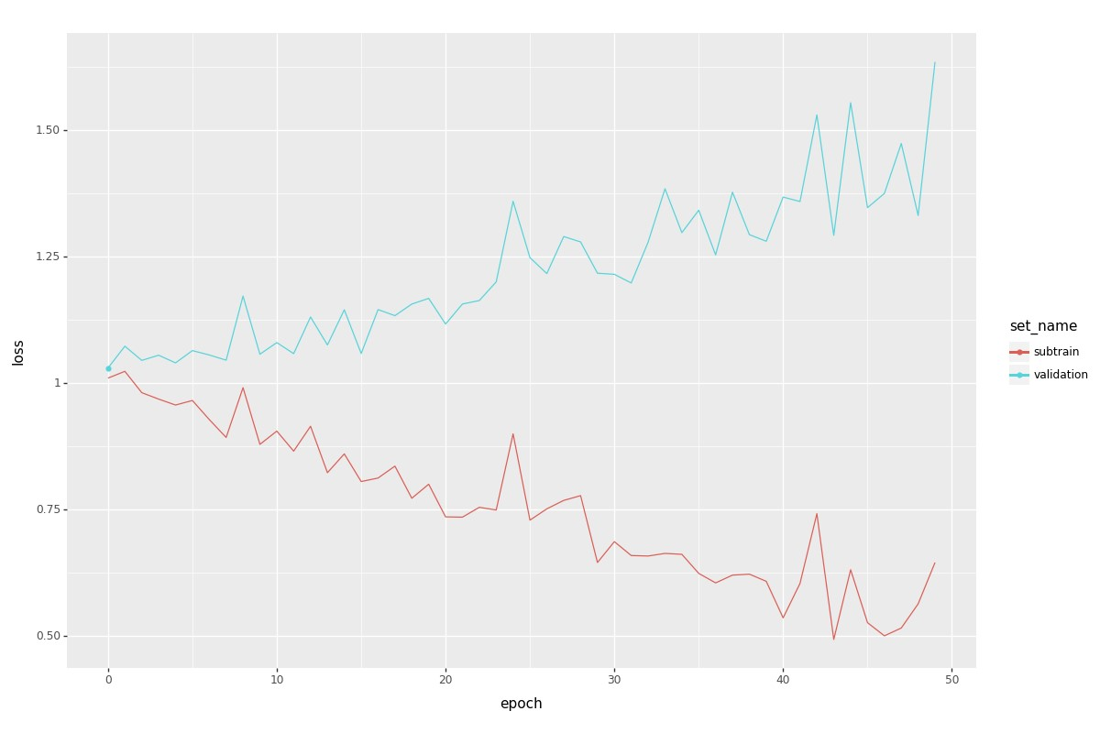

**Deep subtrain/validation loss graph (Air Foil):**

**>>> gg4 = p9.ggplot() + p9.geom_line(p9.aes(x ='epoch', y = 'loss', color = 'set_name'), data = air_foil_loss["TorchLearnerCV Deep"])\**

**... + p9.geom_point(p9.aes(x ='epoch', y = 'loss', color = 'set_name'), data = air_foil_min["min_df deep"]) #p9.geom_line(p9.aes(fill = 'setname'))**

**>>> gg4.save("Torch_validation_graph4.png", height = 8, width = 12)**

