**CS599 (Deep Learning)**

**Homework – 10**

1. **Python Code:**

import torch

import pandas as pd

import matplotlib

matplotlib.use("agg")

import numpy as np

import plotnine as p9

import math

import torchvision

from sklearn.model_selection import KFold, GridSearchCV, ParameterGrid

from sklearn.neighbors import KNeighborsClassifier

from sklearn.linear_model import LogisticRegressionCV

from sklearn.pipeline import make_pipeline

from sklearn.preprocessing import StandardScaler

from sklearn.metrics import accuracy_score

from collections import Counter

data_set_dict = {"zip": ("zip.test.gz", 0),

}

data_dict = {}

for data_name, (file_name, label_col_num) in data_set_dict.items():

data_df = pd.read_csv(file_name, sep=" ", header=None)

data_nrow, data_ncol = data_df.shape

data_label_vec = data_df.iloc[:, label_col_num]

is_label_col = data_df.columns == label_col_num

data_features = data_df.iloc[:, ~is_label_col]

data_labels = data_df.iloc[:, is_label_col]

print("%s %s" %(data_name, data_features.shape))

data_dict[data_name] = (

torch.from_numpy(data_features.to_numpy()).float(),

torch.from_numpy(data_labels.to_numpy()).flatten()

)

ds = torchvision.datasets.MNIST(

root="c:/Users/Anudeep Kumar/OneDrive/Desktop/Fall 2023/CS599-Deep Learning/Homework/HW10",

download=True,

transform=torchvision.transforms.ToTensor(),

train=False)

dl = torch.utils.data.DataLoader(ds, batch_size=len(ds), shuffle=False)

for mnist_features, mnist_labels in dl:

pass

mnist_features.flatten(start_dim=1)

mnist_labels.numpy()

data_dict["MNIST"] = (mnist_features.flatten(start_dim=1), mnist_labels)

class TorchModel(torch.nn.Module):

def __init__(self, units_per_layer):

super(TorchModel, self).__init__()

seq_args = []

second_to_last = len(units_per_layer)-1

for layer_i in range(second_to_last):

next_i = layer_i+1

layer_units = units_per_layer[layer_i]

next_units = units_per_layer[next_i]

seq_args.append(torch.nn.Linear(layer_units, next_units))

if layer_i < second_to_last-1:

seq_args.append(torch.nn.ReLU())

self.stack = torch.nn.Sequential(*seq_args)

def forward(self, features):

return self.stack(features)

class CSV(torch.utils.data.Dataset):

def __init__(self, features, labels):

self.features = features

self.labels = labels

def __getitem__(self, item):

return self.features[item,:], self.labels[item]

def __len__(self):

return len(self.labels)

class TorchLearner:

def __init__(

self, units_per_layer, step_size=0.1,

batch_size=20, max_epochs=100):

self.max_epochs = max_epochs

self.batch_size=batch_size

self.model = TorchModel(units_per_layer)

self.loss_fun = torch.nn.CrossEntropyLoss()

self.optimizer = torch.optim.SGD(

self.model.parameters(), lr=step_size)

def fit(self, split_data_dict):

ds = CSV(

split_data_dict["subtrain"]["X"],

split_data_dict["subtrain"]["y"])

dl = torch.utils.data.DataLoader(

ds, batch_size=self.batch_size, shuffle=True)

train_df_list = []

for epoch_number in range(self.max_epochs):

#print(epoch_number)

for batch_features, batch_labels in dl:

self.optimizer.zero_grad()

loss_value = self.loss_fun(

self.model(batch_features), batch_labels)

loss_value.backward()

self.optimizer.step()

for set_name, set_data in split_data_dict.items():

pred_vec = self.model(set_data["X"])

set_loss_value = self.loss_fun(pred_vec, set_data["y"])

train_df_list.append(pd.DataFrame({

"set_name":[set_name],

"loss":float(set_loss_value),

"epoch":[epoch_number]

}))

self.train_df = pd.concat(train_df_list)

def decision_function(self, test_features):

with torch.no_grad():

pred_vec = self.model(test_features)

return pred_vec

def predict(self, test_features):

pred_scores = self.decision_function(test_features)

_, predicted = torch.max(pred_scores, 1)

return predicted.numpy()

class TorchLearnerCV:

def __init__(self, n_folds, units_per_layer):

self.units_per_layer = units_per_layer

self.n_folds = n_folds

def fit(self, train_features, train_labels):

train_nrow, train_ncol = train_features.shape

times_to_repeat=int(math.ceil(train_nrow/self.n_folds))

fold_id_vec = np.tile(torch.arange(self.n_folds), times_to_repeat)[:train_nrow]

np.random.shuffle(fold_id_vec)

cv_data_list = []

for validation_fold in range(self.n_folds):

is_split = {

"subtrain":fold_id_vec != validation_fold,

"validation":fold_id_vec == validation_fold

}

split_data_dict = {}

for set_name, is_set in is_split.items():

set_y = train_labels[is_set]

split_data_dict[set_name] = {

"X":train_features[is_set,:],

"y":set_y}

learner = TorchLearner(self.units_per_layer)

learner.fit(split_data_dict)

cv_data_list.append(learner.train_df)

self.cv_data = pd.concat(cv_data_list)

self.train_df = self.cv_data.groupby(["set_name","epoch"]).mean().reset_index()

#print(self.train_df)

valid_df = self.train_df.query("set_name=='validation'")

#print(valid_df)

best_epochs = valid_df["loss"].argmin()

self.min_df = valid_df.query("epoch==%s"%(best_epochs))

print("Best Epoch: ", best_epochs)

self.final_learner = TorchLearner(self.units_per_layer, max_epochs=(best_epochs + 1))

self.final_learner.fit({"subtrain":{"X":train_features,"y":train_labels}})

return self.cv_data

def predict(self, test_features):

return self.final_learner.predict(test_features)

accuracy_data_frames = []

loss_data_dict = {}

min_df_dict = {}

for data_name, (data_features, data_labels) in data_dict.items():

kf = KFold(n_splits=3, shuffle=True, random_state=3)

enum_obj = enumerate(kf.split(data_features))

for fold_num, index_tup in enum_obj:

zip_obj = zip(["train", "test"], index_tup)

split_data = {}

for set_name, set_indices in zip_obj:

split_data[set_name] = (data_features, data_labels)

#x = {data_name:X.shape for data_name, (X,y) in split_data.items()}

#print(f"{data_name}: ", x)

train_features, train_labels = split_data["train"]

nrow, ncol = train_features.shape

print(f"{data_name}: ", nrow, ncol)

test_features, test_labels = split_data["test"]

#kneighbors

knn = KNeighborsClassifier()

hp_parameters = {"n_neighbors": list(range(1, 21))}

grid = GridSearchCV(knn, hp_parameters, cv=3)

grid.fit(train_features, train_labels)

best_n_neighbors = grid.best_params_['n_neighbors']

print("Best N-Neighbors = ", best_n_neighbors)

knn = KNeighborsClassifier(n_neighbors=best_n_neighbors)

knn.fit(train_features, train_labels)

knn_pred = knn.predict(test_features)

#print(knn_pred)

#loss = mean_squared_error(test_labels, knn_pred)

#print(f"Knn Loss {data_name} : ", loss)

#linear model

pipe = make_pipeline(StandardScaler(), LogisticRegressionCV(cv=3, max_iter=2000))

pipe.fit(train_features, train_labels)

lr_pred = pipe.predict(test_features)

#print(lr_pred)

#loss_linear = mean_squared_error(test_labels, lr_pred)

#print(f"Linear_loss {data_name} : ", loss_linear)

#Featureless

y_train_series = pd.Series(train_labels)

#mean_train_label = y_train_series.mean()

#print("Mean Train Label = ", mean_train_label)

# create a featureless baseline

most_frequent_label = y_train_series.value_counts().idxmax()

print("Most Frequent Label = ", most_frequent_label)

featureless_pred = np.repeat(most_frequent_label, len(test_features))

#featureless_loss = mean_squared_error(test_labels, featureless_pred)

#print(f"Featureless Loss {data_name} : ", featureless_loss)

#TorchLearnerCV

linear_learner = TorchLearnerCV(3, [ncol, 10])

#print("ncol:", ncol)

linear_loss = linear_learner.fit(train_features, train_labels)

ll_pred = linear_learner.predict(test_features)

#print(ll_pred)

#loss_torchlinear = mean_squared_error(test_labels, ll_pred)

#print(f"Torch Linear_loss {data_name} : ", loss_torchlinear)

#TorchLearnerCV + Deep

deep_learner = TorchLearnerCV(3, [ncol, 100, 10, 10])

deep_loss = deep_learner.fit(train_features, train_labels)

dl_pred = deep_learner.predict(test_features)

#print(dl_pred)

#loss_deeplearner = mean_squared_error(test_labels, dl_pred)

#print(f"Torch Deep_loss {data_name} : ", loss_deeplearner)

linear_loss = linear_loss.groupby(['set_name', 'epoch']).mean().reset_index()

deep_loss = deep_loss.groupby(['set_name', 'epoch']).mean().reset_index()

valid_df = linear_loss.query("set_name=='validation'")

index_min = valid_df["loss"].argmin()

min_df = valid_df.query("epoch==%s" % index_min)

valid_df_deep = deep_loss.query("set_name=='validation'")

index_min_deep = valid_df_deep["loss"].argmin()

min_df_deep = valid_df_deep.query("epoch==%s" % index_min_deep)

min_df_dict[data_name] = {'min_df linear': min_df,

'min_df deep': min_df_deep}

loss_data_dict[data_name] = {'TorchLearnerCV Linear': linear_loss,

'TorchLearnerCV Deep': deep_loss}

# store predict data in dict

pred_dict = {'KNeighborsClassifier + GridSearchCV': knn_pred,

'LogisticRegressionCV': lr_pred,

'TorchLearnerCV Linear': ll_pred,

'TorchLearnerCV Deep': dl_pred,

'featureless': featureless_pred}

test_accuracy = {}

for algorithm, predictions in pred_dict.items():

#print(f"{algorithm}:", predictions.shape)

#test_loss = mean_squared_error(test_labels, predictions)

accuracy = accuracy_score(test_labels, predictions)

test_accuracy[algorithm] = accuracy

for algorithm, accuracy in test_accuracy.items():

print(f"{algorithm} Test Accuracy: {accuracy * 100}")

accuracy_df = pd.DataFrame({

"data_set": [data_name],

"fold_id": [fold_num],

"algorithm": [algorithm],

"accuracy": [test_accuracy[algorithm]]})

accuracy_data_frames.append(accuracy_df)

print(f"****************************End of {data_name}({fold_num})*****************************")

total_accuracy_df = pd.concat(accuracy_data_frames, ignore_index = True)

print(total_accuracy_df)

import plotnine as p9

gg = p9.ggplot(total_accuracy_df, p9.aes(x ='accuracy', y = 'algorithm'))+\

p9.facet_grid('.~data_set') + p9.geom_point()

gg.save("c:/Users/Anudeep Kumar/OneDrive/Desktop/Fall 2023/CS599-Deep Learning/Homework/HW10/output.png", height = 8, width = 12)

zip_loss = loss_data_dict["zip"]

mnist_loss = loss_data_dict["MNIST"]

zip_min = min_df_dict["zip"]

mnist_min = min_df_dict["MNIST"]

gg1 = p9.ggplot() + p9.geom_line(p9.aes(x ='epoch', y = 'loss', color = 'set_name'), data = zip_loss["TorchLearnerCV Linear"])\

+ p9.geom_point(p9.aes(x ='epoch', y = 'loss', color = 'set_name'), data = zip_min["min_df linear"]) + p9.ggtitle("Subtrain/Validation Loss vs Epochs(zip Data - Linear)")

gg1.save("Torch_validation_graph1.png", height = 8, width = 12)

gg2 = p9.ggplot() + p9.geom_line(p9.aes(x ='epoch', y = 'loss', color = 'set_name'), data = zip_loss["TorchLearnerCV Deep"])\

+ p9.geom_point(p9.aes(x ='epoch', y = 'loss', color = 'set_name'), data = zip_min["min_df deep"]) + p9.ggtitle("Subtrain/Validation Loss vs Epochs(zip Data - Deep)")

gg2.save("Torch_validation_graph2.png", height = 8, width = 12)

gg3 = p9.ggplot() + p9.geom_line(p9.aes(x ='epoch', y = 'loss', color = 'set_name'), data = mnist_loss["TorchLearnerCV Linear"])\

+ p9.geom_point(p9.aes(x ='epoch', y = 'loss', color = 'set_name'), data = mnist_min["min_df linear"]) + p9.ggtitle("Subtrain/Validation Loss vs Epochs(MNIST Data - Linear)")

gg3.save("Torch_validation_graph3.png", height = 8, width = 12)

gg4 = p9.ggplot() + p9.geom_line(p9.aes(x ='epoch', y = 'loss', color = 'set_name'), data = mnist_loss["TorchLearnerCV Deep"])\

+ p9.geom_point(p9.aes(x ='epoch', y = 'loss', color = 'set_name'), data = mnist_min["min_df deep"]) + p9.ggtitle("Subtrain/Validation Loss vs Epochs(MNIST Data - Deep)")

gg4.save("Torch_validation_graph4.png", height = 8, width = 12)

1. **Output:**

**>>> for data_name, (data_features, data_labels) in data_dict.items():**

**... kf = KFold(n_splits=3, shuffle=True, random_state=3)**

**... enum_obj = enumerate(kf.split(data_features))**

**... for fold_num, index_tup in enum_obj:**

**... zip_obj = zip(["train", "test"], index_tup)**

**... split_data = {}**

**... for set_name, set_indices in zip_obj:**

**... split_data[set_name] = (data_features, data_labels)**

**... #x = {data_name:X.shape for data_name, (X,y) in split_data.items()}**

**... #print(f"{data_name}: ", x)**

**... ...**

**...**

**... for algorithm, accuracy in test_accuracy.items():**

**... print(f"{algorithm} Test Accuracy: {accuracy * 100}")**

**... accuracy_df = pd.DataFrame({**

**... "data_set": [data_name],**

**... "fold_id": [fold_num],**

**... "algorithm": [algorithm],**

**... "accuracy": [test_accuracy[algorithm]]})**

**... accuracy_data_frames.append(accuracy_df)**

**... print(f"****************************End of {data_name}({fold_num})*****************************")**

zip: 2007 256

Best N-Neighbors = 1

Most Frequent Label = 0

Best Epoch: 6

Best Epoch: 7

KNeighborsClassifier + GridSearchCV Test Accuracy: 100.0

LogisticRegressionCV Test Accuracy: 97.50871948181366

TorchLearnerCV Linear Test Accuracy: 93.47284504235176

TorchLearnerCV Deep Test Accuracy: 97.45889387144993

featureless Test Accuracy: 17.887394120577977

****************************End of zip(0)*****************************

zip: 2007 256

Best N-Neighbors = 1

Most Frequent Label = 0

Best Epoch: 7

Best Epoch: 6

KNeighborsClassifier + GridSearchCV Test Accuracy: 100.0

LogisticRegressionCV Test Accuracy: 97.50871948181366

TorchLearnerCV Linear Test Accuracy: 95.41604384653712

TorchLearnerCV Deep Test Accuracy: 96.81116093672148

featureless Test Accuracy: 17.887394120577977

****************************End of zip(1)*****************************

zip: 2007 256

Best N-Neighbors = 1

Most Frequent Label = 0

Best Epoch: 7

Best Epoch: 9

KNeighborsClassifier + GridSearchCV Test Accuracy: 100.0

LogisticRegressionCV Test Accuracy: 97.50871948181366

TorchLearnerCV Linear Test Accuracy: 94.22022919780767

TorchLearnerCV Deep Test Accuracy: 97.85749875435974

featureless Test Accuracy: 17.887394120577977

****************************End of zip(2)*****************************

MNIST: 10000 784

Best N-Neighbors = 3

Most Frequent Label = 1

Best Epoch: 18

Best Epoch: 11

KNeighborsClassifier + GridSearchCV Test Accuracy: 97.72999999999999

LogisticRegressionCV Test Accuracy: 94.57

TorchLearnerCV Linear Test Accuracy: 94.55

TorchLearnerCV Deep Test Accuracy: 99.99

featureless Test Accuracy: 11.35

****************************End of MNIST(0)*****************************

MNIST: 10000 784

Best N-Neighbors = 3

Most Frequent Label = 1

Best Epoch: 17

Best Epoch: 8

KNeighborsClassifier + GridSearchCV Test Accuracy: 97.72999999999999

LogisticRegressionCV Test Accuracy: 94.57

TorchLearnerCV Linear Test Accuracy: 94.62

TorchLearnerCV Deep Test Accuracy: 99.7

featureless Test Accuracy: 11.35

****************************End of MNIST(1)*****************************

MNIST: 10000 784

Best N-Neighbors = 3

Most Frequent Label = 1

Best Epoch: 14

Best Epoch: 8

KNeighborsClassifier + GridSearchCV Test Accuracy: 97.72999999999999

LogisticRegressionCV Test Accuracy: 94.57

TorchLearnerCV Linear Test Accuracy: 94.35

TorchLearnerCV Deep Test Accuracy: 99.47

featureless Test Accuracy: 11.35

****************************End of MNIST(2)*****************************

**>>> total_accuracy_df = pd.concat(accuracy_data_frames, ignore_index = True)**

**>>> print(total_accuracy_df)**

data_set fold_id algorithm accuracy

0 zip 0 KNeighborsClassifier + GridSearchCV 1.000000

1 zip 0 LogisticRegressionCV 0.975087

2 zip 0 TorchLearnerCV Linear 0.934728

3 zip 0 TorchLearnerCV Deep 0.974589

4 zip 0 featureless 0.178874

5 zip 1 KNeighborsClassifier + GridSearchCV 1.000000

6 zip 1 LogisticRegressionCV 0.975087

7 zip 1 TorchLearnerCV Linear 0.954160

8 zip 1 TorchLearnerCV Deep 0.968112

9 zip 1 featureless 0.178874

10 zip 2 KNeighborsClassifier + GridSearchCV 1.000000

11 zip 2 LogisticRegressionCV 0.975087

12 zip 2 TorchLearnerCV Linear 0.942202

13 zip 2 TorchLearnerCV Deep 0.978575

14 zip 2 featureless 0.178874

15 MNIST 0 KNeighborsClassifier + GridSearchCV 0.977300

16 MNIST 0 LogisticRegressionCV 0.945700

17 MNIST 0 TorchLearnerCV Linear 0.945500

18 MNIST 0 TorchLearnerCV Deep 0.999900

19 MNIST 0 featureless 0.113500

20 MNIST 1 KNeighborsClassifier + GridSearchCV 0.977300

21 MNIST 1 LogisticRegressionCV 0.945700

22 MNIST 1 TorchLearnerCV Linear 0.946200

23 MNIST 1 TorchLearnerCV Deep 0.997000

24 MNIST 1 featureless 0.113500

25 MNIST 2 KNeighborsClassifier + GridSearchCV 0.977300

26 MNIST 2 LogisticRegressionCV 0.945700

27 MNIST 2 TorchLearnerCV Linear 0.943500

28 MNIST 2 TorchLearnerCV Deep 0.994700

29 MNIST 2 featureless 0.113500

**Test Loss Square Graph:**

**>>> gg = p9.ggplot(total_accuracy_df, p9.aes(x ='accuracy', y = 'algorithm'))+\**

**... p9.facet_grid('.~data_set') + p9.geom_point()**

**>>> gg.save("Test_square_loss.png", height = 8, width = 12)**

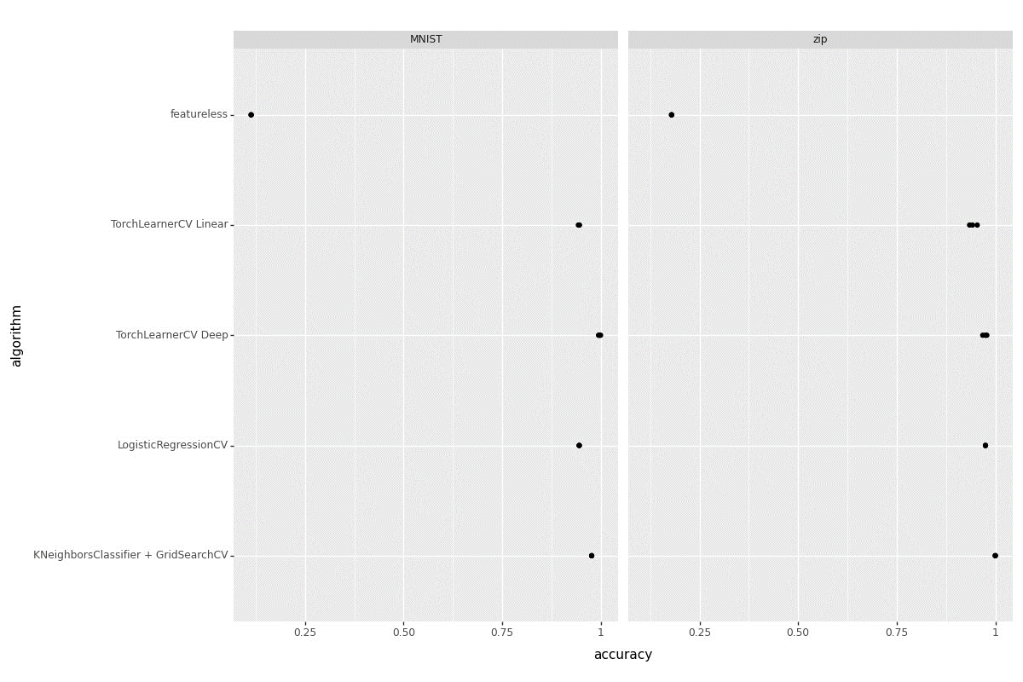

**Linear subtrain/validation loss graph (zip):**

**>>> gg1 = p9.ggplot() + p9.geom_line(p9.aes(x ='epoch', y = 'loss', color = 'set_name'), data = zip_loss["TorchLearnerCV Linear"])\**

**... + p9.geom_point(p9.aes(x ='epoch', y = 'loss', color = 'set_name'), data = zip_min["min_df linear"]) + p9.ggtitle("Subtrain/Validation Loss vs Epochs(zip Data - Linear)")**

**>>> gg1.save("Torch_validation_graph1.png", height = 8, width = 12)**

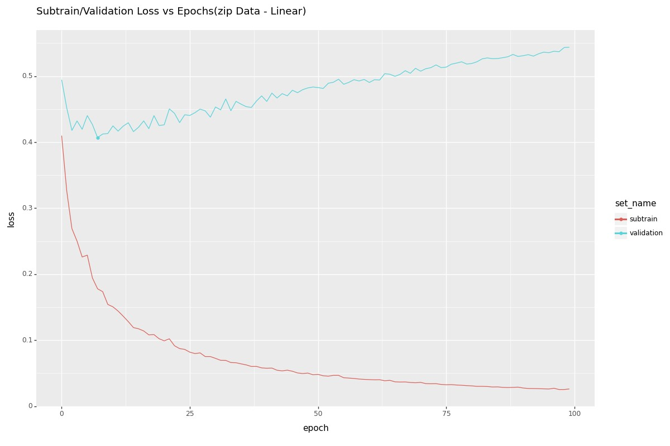

**Linear subtrain/validation loss graph (MNIST):**

**>>> gg3 = p9.ggplot() + p9.geom_line(p9.aes(x ='epoch', y = 'loss', color = 'set_name'), data = mnist_loss["TorchLearnerCV Linear"])\**

**... + p9.geom_point(p9.aes(x ='epoch', y = 'loss', color = 'set_name'), data = mnist_min["min_df linear"]) + p9.ggtitle("Subtrain/Validation Loss vs Epochs(MNIST Data - Linear)")**

**>>> gg3.save("Torch_validation_graph3.png", height = 8, width = 12)**

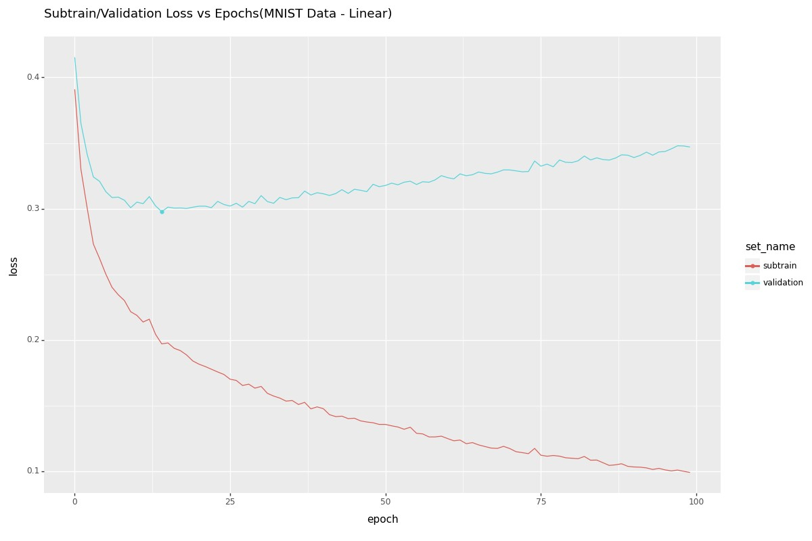

**Deep subtrain/validation loss graph (zip):**

**>>> gg2 = p9.ggplot() + p9.geom_line(p9.aes(x ='epoch', y = 'loss', color = 'set_name'), data = zip_loss["TorchLearnerCV Deep"])\**

**... + p9.geom_point(p9.aes(x ='epoch', y = 'loss', color = 'set_name'), data = zip_min["min_df deep"]) + p9.ggtitle("Subtrain/Validation Loss vs Epochs(zip Data - Deep)")**

**>>> gg2.save("Torch_validation_graph2.png", height = 8, width = 12)**

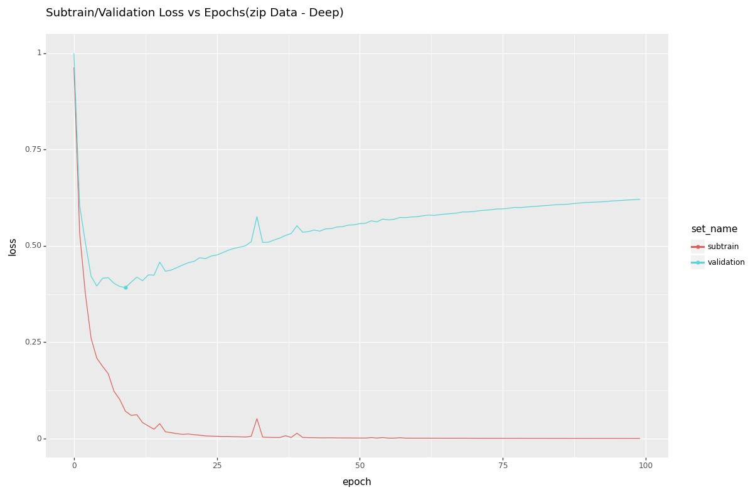

**Deep subtrain/validation loss graph (MNIST):**

**>>> gg4 = p9.ggplot() + p9.geom_line(p9.aes(x ='epoch', y = 'loss', color = 'set_name'), data = mnist_loss["TorchLearnerCV Deep"])\**

**... + p9.geom_point(p9.aes(x ='epoch', y = 'loss', color = 'set_name'), data = mnist_min["min_df deep"]) + p9.ggtitle("Subtrain/Validation Loss vs Epochs(MNIST Data - Deep)")**

**>>> gg4.save("Torch_validation_graph4.png", height = 8, width = 12)**

