**CS599 (Deep Learning)**

**Homework – 14**

1. **Python Code:**

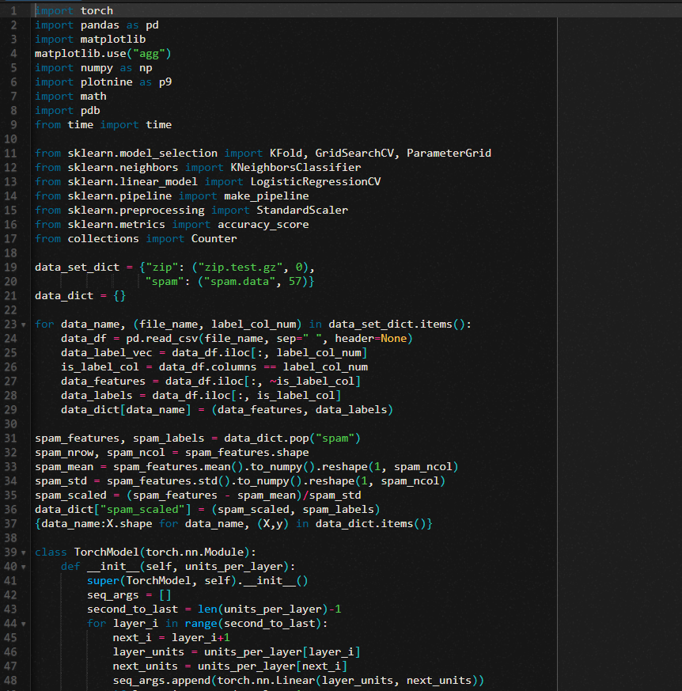

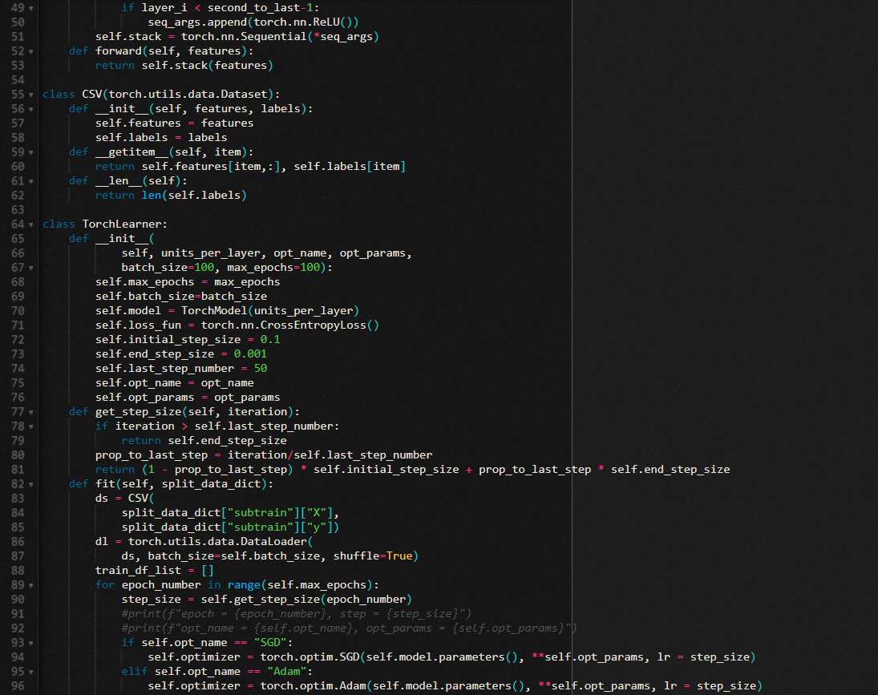

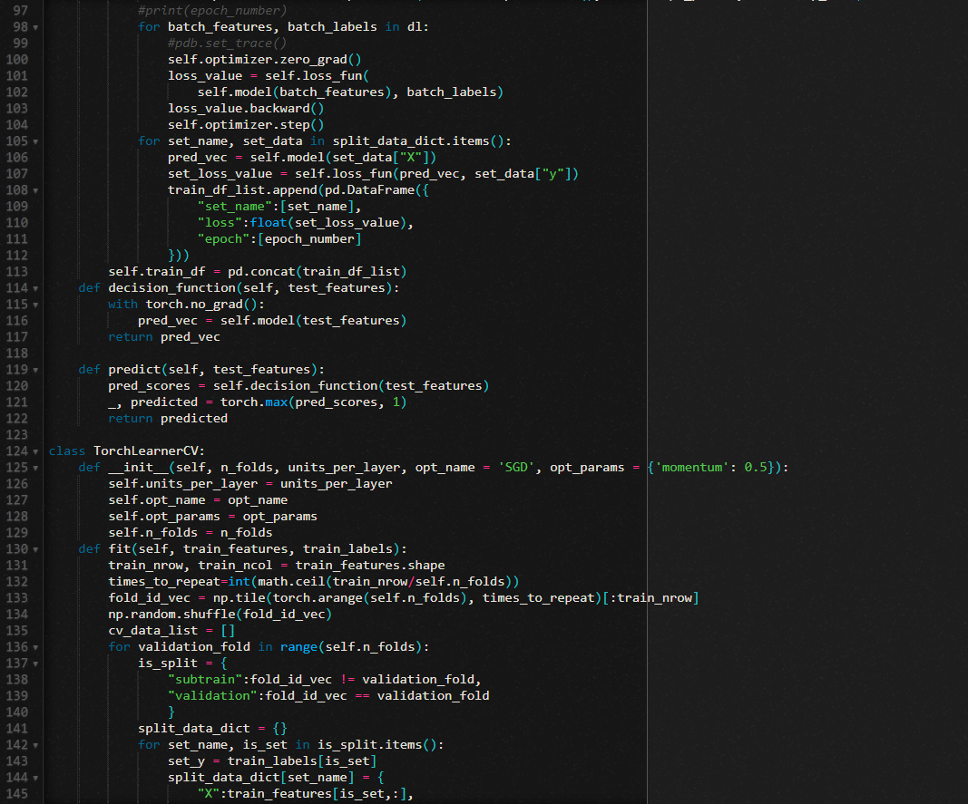

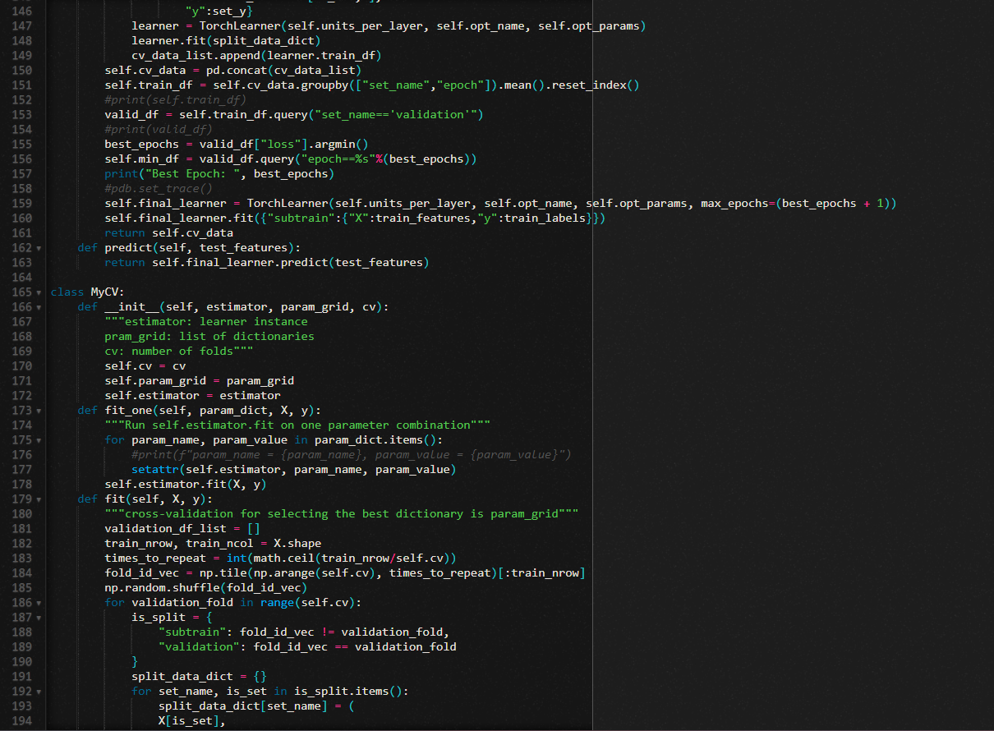

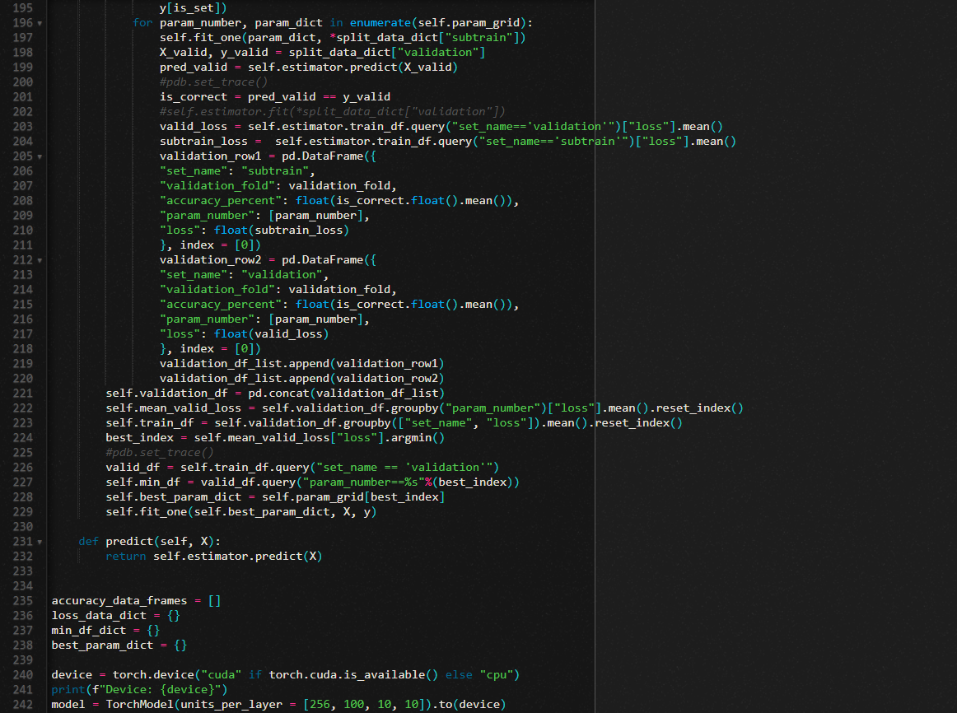

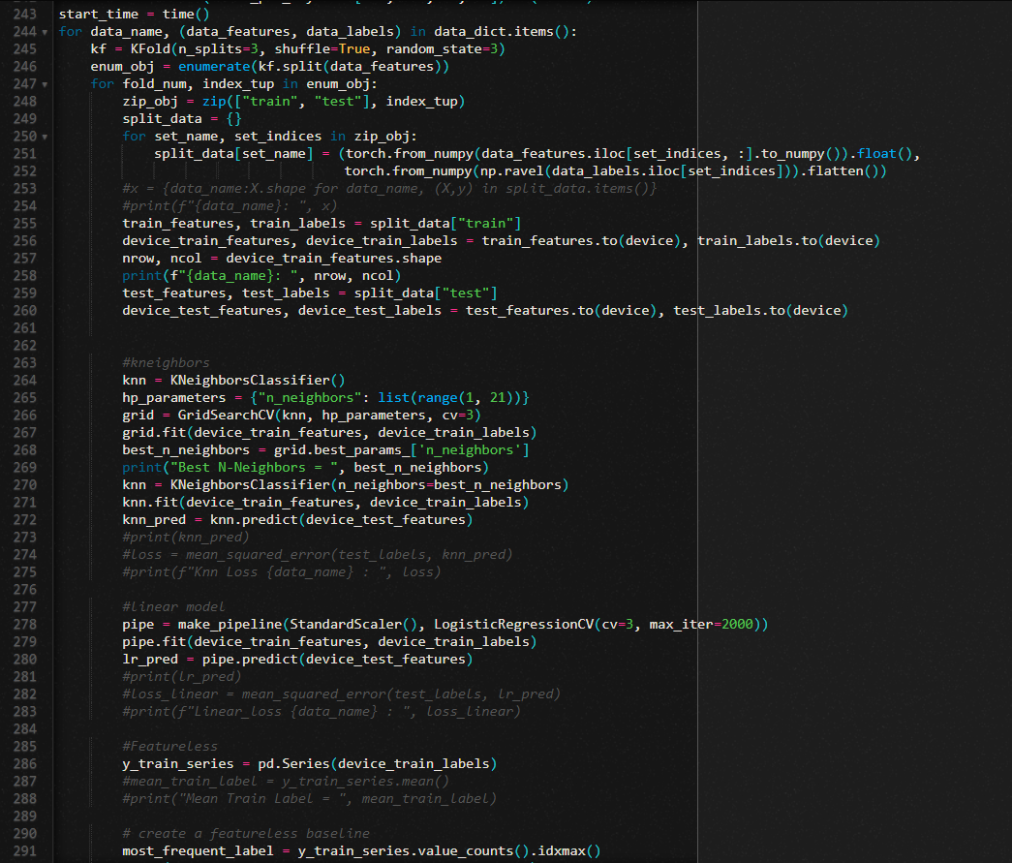

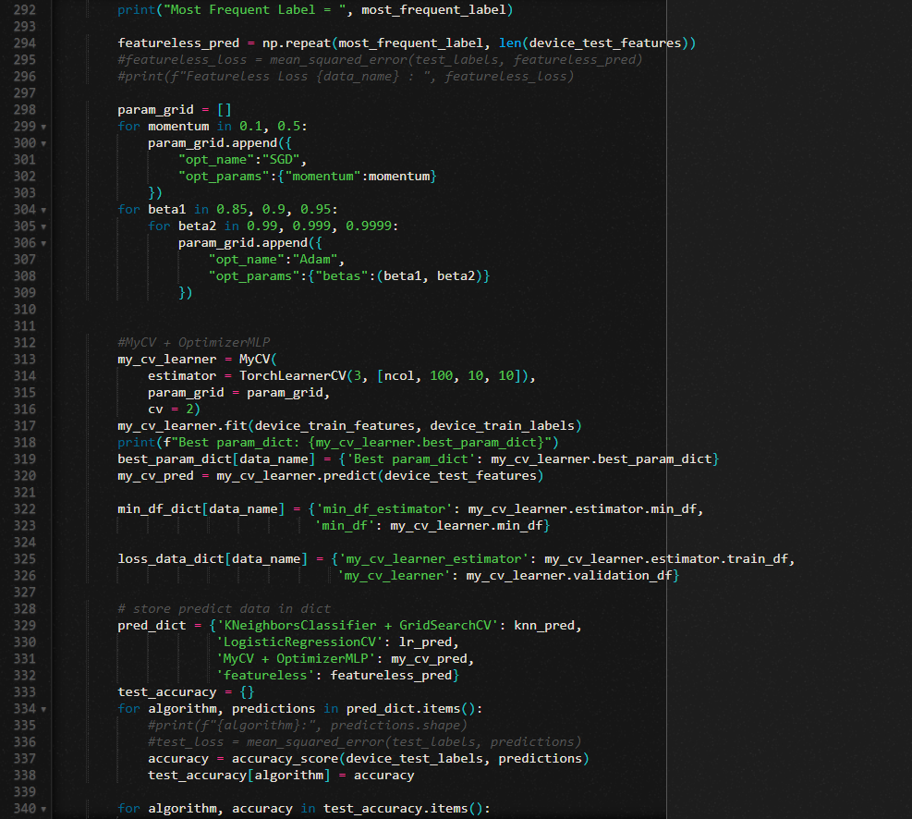

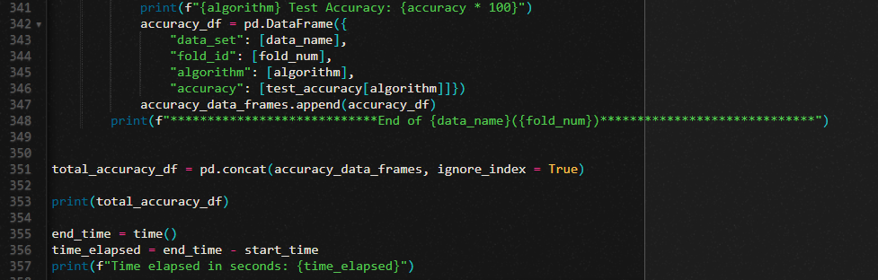

1. **Output:**

**(cs599fall2023) [sd2554@wind ~ ]$ time srun -t 1:00:00 --gres=gpu:tesla:1 --mem=8GB python HW14.py**

Device: cpu

zip: 1338 256

Best N-Neighbors = 1

Most Frequent Label = 0

Best Epoch: 17

Best Epoch: 10

Best Epoch: 15

Best Epoch: 16

Best Epoch: 13

Best Epoch: 12

Best Epoch: 22

Best Epoch: 0

Best Epoch: 11

Best Epoch: 37

Best Epoch: 12

Best Epoch: 11

Best Epoch: 11

Best Epoch: 40

Best Epoch: 10

Best Epoch: 0

Best Epoch: 0

Best Epoch: 1

Best Epoch: 2

Best Epoch: 26

Best Epoch: 0

Best Epoch: 29

Best Epoch: 6

Best param_dict: {'opt_name': 'SGD', 'opt_params': {'momentum': 0.1}}

KNeighborsClassifier + GridSearchCV Test Accuracy: 90.5829596412556

LogisticRegressionCV Test Accuracy: 89.8355754857997

MyCV + OptimizerMLP Test Accuracy: 89.53662182361734

featureless Test Accuracy: 18.53512705530643

****************************End of zip(0)*****************************

zip: 1338 256

Best N-Neighbors = 1

Most Frequent Label = 0

Best Epoch: 8

Best Epoch: 7

Best Epoch: 0

Best Epoch: 22

Best Epoch: 14

Best Epoch: 3

Best Epoch: 25

Best Epoch: 2

Best Epoch: 21

Best Epoch: 36

Best Epoch: 4

Best Epoch: 12

Best Epoch: 10

Best Epoch: 3

Best Epoch: 0

Best Epoch: 0

Best Epoch: 0

Best Epoch: 0

Best Epoch: 0

Best Epoch: 0

Best Epoch: 3

Best Epoch: 1

Best Epoch: 7

Best param_dict: {'opt_name': 'SGD', 'opt_params': {'momentum': 0.1}}

KNeighborsClassifier + GridSearchCV Test Accuracy: 91.18086696562034

LogisticRegressionCV Test Accuracy: 88.34080717488789

MyCV + OptimizerMLP Test Accuracy: 89.53662182361734

featureless Test Accuracy: 17.638266068759343

****************************End of zip(1)*****************************

zip: 1338 256

Best N-Neighbors = 1

Most Frequent Label = 0

Best Epoch: 13

Best Epoch: 10

Best Epoch: 0

Best Epoch: 0

Best Epoch: 0

Best Epoch: 1

Best Epoch: 2

Best Epoch: 0

Best Epoch: 0

Best Epoch: 0

Best Epoch: 8

Best Epoch: 9

Best Epoch: 11

Best Epoch: 3

Best Epoch: 7

Best Epoch: 0

Best Epoch: 0

Best Epoch: 0

Best Epoch: 34

Best Epoch: 5

Best Epoch: 12

Best Epoch: 2

Best Epoch: 7

Best param_dict: {'opt_name': 'SGD', 'opt_params': {'momentum': 0.5}}

KNeighborsClassifier + GridSearchCV Test Accuracy: 89.98505231689087

LogisticRegressionCV Test Accuracy: 89.98505231689087

MyCV + OptimizerMLP Test Accuracy: 88.49028400597906

featureless Test Accuracy: 17.48878923766816

****************************End of zip(2)*****************************

spam_scaled: 3067 57

Best N-Neighbors = 4

Most Frequent Label = 0

Best Epoch: 7

Best Epoch: 3

Best Epoch: 0

Best Epoch: 0

Best Epoch: 0

Best Epoch: 1

Best Epoch: 0

Best Epoch: 0

Best Epoch: 1

Best Epoch: 0

Best Epoch: 0

Best Epoch: 10

Best Epoch: 8

Best Epoch: 1

Best Epoch: 0

Best Epoch: 0

Best Epoch: 0

Best Epoch: 2

Best Epoch: 3

Best Epoch: 1

Best Epoch: 0

Best Epoch: 0

Best Epoch: 4

Best param_dict: {'opt_name': 'SGD', 'opt_params': {'momentum': 0.1}}

KNeighborsClassifier + GridSearchCV Test Accuracy: 88.72229465449804

LogisticRegressionCV Test Accuracy: 91.52542372881356

MyCV + OptimizerMLP Test Accuracy: 93.93741851368969

featureless Test Accuracy: 60.88657105606258

****************************End of spam_scaled(0)*****************************

spam_scaled: 3067 57

Best N-Neighbors = 5

Most Frequent Label = 0

Best Epoch: 3

Best Epoch: 3

Best Epoch: 0

Best Epoch: 0

Best Epoch: 1

Best Epoch: 0

Best Epoch: 0

Best Epoch: 0

Best Epoch: 1

Best Epoch: 0

Best Epoch: 1

Best Epoch: 8

Best Epoch: 7

Best Epoch: 0

Best Epoch: 1

Best Epoch: 1

Best Epoch: 2

Best Epoch: 2

Best Epoch: 1

Best Epoch: 5

Best Epoch: 0

Best Epoch: 1

Best Epoch: 10

Best param_dict: {'opt_name': 'SGD', 'opt_params': {'momentum': 0.1}}

KNeighborsClassifier + GridSearchCV Test Accuracy: 90.80834419817471

LogisticRegressionCV Test Accuracy: 91.78617992177314

MyCV + OptimizerMLP Test Accuracy: 94.0677966101695

featureless Test Accuracy: 60.104302477183836

****************************End of spam_scaled(1)*****************************

spam_scaled: 3068 57

Best N-Neighbors = 9

Most Frequent Label = 0

Best Epoch: 7

Best Epoch: 3

Best Epoch: 0

Best Epoch: 1

Best Epoch: 2

Best Epoch: 0

Best Epoch: 0

Best Epoch: 0

Best Epoch: 3

Best Epoch: 0

Best Epoch: 0

Best Epoch: 3

Best Epoch: 3

Best Epoch: 1

Best Epoch: 0

Best Epoch: 1

Best Epoch: 0

Best Epoch: 0

Best Epoch: 0

Best Epoch: 1

Best Epoch: 2

Best Epoch: 1

Best Epoch: 6

Best param_dict: {'opt_name': 'SGD', 'opt_params': {'momentum': 0.1}}

KNeighborsClassifier + GridSearchCV Test Accuracy: 90.54142204827136

LogisticRegressionCV Test Accuracy: 92.49836921069797

MyCV + OptimizerMLP Test Accuracy: 92.82452707110241

featureless Test Accuracy: 60.79582517938682

****************************End of spam_scaled(2)*****************************

data_set fold_id algorithm accuracy

0 zip 0 KNeighborsClassifier + GridSearchCV 0.905830

1 zip 0 LogisticRegressionCV 0.898356

2 zip 0 MyCV + OptimizerMLP 0.895366

3 zip 0 featureless 0.185351

4 zip 1 KNeighborsClassifier + GridSearchCV 0.911809

5 zip 1 LogisticRegressionCV 0.883408

6 zip 1 MyCV + OptimizerMLP 0.895366

7 zip 1 featureless 0.176383

8 zip 2 KNeighborsClassifier + GridSearchCV 0.899851

9 zip 2 LogisticRegressionCV 0.899851

10 zip 2 MyCV + OptimizerMLP 0.884903

11 zip 2 featureless 0.174888

12 spam_scaled 0 KNeighborsClassifier + GridSearchCV 0.887223

13 spam_scaled 0 LogisticRegressionCV 0.915254

14 spam_scaled 0 MyCV + OptimizerMLP 0.939374

15 spam_scaled 0 featureless 0.608866

16 spam_scaled 1 KNeighborsClassifier + GridSearchCV 0.908083

17 spam_scaled 1 LogisticRegressionCV 0.917862

18 spam_scaled 1 MyCV + OptimizerMLP 0.940678

19 spam_scaled 1 featureless 0.601043

20 spam_scaled 2 KNeighborsClassifier + GridSearchCV 0.905414

21 spam_scaled 2 LogisticRegressionCV 0.924984

22 spam_scaled 2 MyCV + OptimizerMLP 0.928245

23 spam_scaled 2 featureless 0.607958

**Time elapsed in seconds: 2025.400666475296**

**real 33m48.993s**

**user 0m0.011s**

**sys 0m0.010s**

**(cs599fall2023) [sd2554@wind ~ ]$ time srun -t 1:00:00 --mem=8GB python HW14.py**

**srun: job 6702290 queued and waiting for resources**

**srun: job 6702290 has been allocated resources**

**Device: cpu**

zip: 1338 256

Best N-Neighbors = 1

Most Frequent Label = 0

Best Epoch: 9

Best Epoch: 4

Best Epoch: 16

Best Epoch: 4

Best Epoch: 0

Best Epoch: 5

Best Epoch: 15

Best Epoch: 0

Best Epoch: 6

Best Epoch: 3

Best Epoch: 14

Best Epoch: 11

Best Epoch: 11

Best Epoch: 8

Best Epoch: 33

Best Epoch: 19

Best Epoch: 46

Best Epoch: 37

Best Epoch: 0

Best Epoch: 0

Best Epoch: 1

Best Epoch: 4

Best Epoch: 10

Best param_dict: {'opt_name': 'SGD', 'opt_params': {'momentum': 0.1}}

KNeighborsClassifier + GridSearchCV Test Accuracy: 90.5829596412556

LogisticRegressionCV Test Accuracy: 89.8355754857997

MyCV + OptimizerMLP Test Accuracy: 89.53662182361734

featureless Test Accuracy: 18.53512705530643

****************************End of zip(0)*****************************

zip: 1338 256

Best N-Neighbors = 1

Most Frequent Label = 0

Best Epoch: 15

Best Epoch: 6

Best Epoch: 9

Best Epoch: 3

Best Epoch: 11

Best Epoch: 18

Best Epoch: 22

Best Epoch: 2

Best Epoch: 1

Best Epoch: 4

Best Epoch: 25

Best Epoch: 11

Best Epoch: 9

Best Epoch: 10

Best Epoch: 1

Best Epoch: 4

Best Epoch: 0

Best Epoch: 0

Best Epoch: 1

Best Epoch: 1

Best Epoch: 0

Best Epoch: 2

Best Epoch: 11

Best param_dict: {'opt_name': 'SGD', 'opt_params': {'momentum': 0.1}}

KNeighborsClassifier + GridSearchCV Test Accuracy: 91.18086696562034

LogisticRegressionCV Test Accuracy: 88.34080717488789

MyCV + OptimizerMLP Test Accuracy: 89.98505231689087

featureless Test Accuracy: 17.638266068759343

****************************End of zip(1)*****************************

zip: 1338 256

Best N-Neighbors = 1

Most Frequent Label = 0

Best Epoch: 10

Best Epoch: 9

Best Epoch: 11

Best Epoch: 11

Best Epoch: 1

Best Epoch: 6

Best Epoch: 3

Best Epoch: 0

Best Epoch: 21

Best Epoch: 18

Best Epoch: 19

Best Epoch: 17

Best Epoch: 7

Best Epoch: 13

Best Epoch: 2

Best Epoch: 0

Best Epoch: 39

Best Epoch: 2

Best Epoch: 34

Best Epoch: 2

Best Epoch: 18

Best Epoch: 10

Best Epoch: 13

Best param_dict: {'opt_name': 'SGD', 'opt_params': {'momentum': 0.1}}

KNeighborsClassifier + GridSearchCV Test Accuracy: 89.98505231689087

LogisticRegressionCV Test Accuracy: 89.98505231689087

MyCV + OptimizerMLP Test Accuracy: 91.03139013452915

featureless Test Accuracy: 17.48878923766816

****************************End of zip(2)*****************************

spam_scaled: 3067 57

Best N-Neighbors = 4

Most Frequent Label = 0

Best Epoch: 8

Best Epoch: 7

Best Epoch: 1

Best Epoch: 5

Best Epoch: 2

Best Epoch: 3

Best Epoch: 0

Best Epoch: 2

Best Epoch: 3

Best Epoch: 0

Best Epoch: 0

Best Epoch: 5

Best Epoch: 4

Best Epoch: 0

Best Epoch: 0

Best Epoch: 0

Best Epoch: 1

Best Epoch: 0

Best Epoch: 0

Best Epoch: 7

Best Epoch: 1

Best Epoch: 0

Best Epoch: 6

Best param_dict: {'opt_name': 'SGD', 'opt_params': {'momentum': 0.1}}

KNeighborsClassifier + GridSearchCV Test Accuracy: 88.72229465449804

LogisticRegressionCV Test Accuracy: 91.52542372881356

MyCV + OptimizerMLP Test Accuracy: 93.67666232073012

featureless Test Accuracy: 60.88657105606258

****************************End of spam_scaled(0)*****************************

spam_scaled: 3067 57

Best N-Neighbors = 5

Most Frequent Label = 0

Best Epoch: 9

Best Epoch: 5

Best Epoch: 0

Best Epoch: 0

Best Epoch: 1

Best Epoch: 0

Best Epoch: 1

Best Epoch: 2

Best Epoch: 1

Best Epoch: 0

Best Epoch: 0

Best Epoch: 3

Best Epoch: 1

Best Epoch: 0

Best Epoch: 0

Best Epoch: 1

Best Epoch: 1

Best Epoch: 5

Best Epoch: 0

Best Epoch: 0

Best Epoch: 1

Best Epoch: 1

Best Epoch: 4

Best param_dict: {'opt_name': 'SGD', 'opt_params': {'momentum': 0.1}}

KNeighborsClassifier + GridSearchCV Test Accuracy: 90.80834419817471

LogisticRegressionCV Test Accuracy: 91.78617992177314

MyCV + OptimizerMLP Test Accuracy: 93.08996088657105

featureless Test Accuracy: 60.104302477183836

****************************End of spam_scaled(1)*****************************

spam_scaled: 3068 57

Best N-Neighbors = 9

Most Frequent Label = 0

Best Epoch: 4

Best Epoch: 4

Best Epoch: 0

Best Epoch: 1

Best Epoch: 2

Best Epoch: 1

Best Epoch: 0

Best Epoch: 1

Best Epoch: 0

Best Epoch: 0

Best Epoch: 0

Best Epoch: 8

Best Epoch: 6

Best Epoch: 1

Best Epoch: 0

Best Epoch: 1

Best Epoch: 0

Best Epoch: 2

Best Epoch: 1

Best Epoch: 0

Best Epoch: 0

Best Epoch: 0

Best Epoch: 8

Best param_dict: {'opt_name': 'SGD', 'opt_params': {'momentum': 0.1}}

KNeighborsClassifier + GridSearchCV Test Accuracy: 90.54142204827136

LogisticRegressionCV Test Accuracy: 92.49836921069797

MyCV + OptimizerMLP Test Accuracy: 91.78082191780823

featureless Test Accuracy: 60.79582517938682

****************************End of spam_scaled(2)*****************************

data_set fold_id algorithm accuracy

0 zip 0 KNeighborsClassifier + GridSearchCV 0.905830

1 zip 0 LogisticRegressionCV 0.898356

2 zip 0 MyCV + OptimizerMLP 0.895366

3 zip 0 featureless 0.185351

4 zip 1 KNeighborsClassifier + GridSearchCV 0.911809

5 zip 1 LogisticRegressionCV 0.883408

6 zip 1 MyCV + OptimizerMLP 0.899851

7 zip 1 featureless 0.176383

8 zip 2 KNeighborsClassifier + GridSearchCV 0.899851

9 zip 2 LogisticRegressionCV 0.899851

10 zip 2 MyCV + OptimizerMLP 0.910314

11 zip 2 featureless 0.174888

12 spam_scaled 0 KNeighborsClassifier + GridSearchCV 0.887223

13 spam_scaled 0 LogisticRegressionCV 0.915254

14 spam_scaled 0 MyCV + OptimizerMLP 0.936767

15 spam_scaled 0 featureless 0.608866

16 spam_scaled 1 KNeighborsClassifier + GridSearchCV 0.908083

17 spam_scaled 1 LogisticRegressionCV 0.917862

18 spam_scaled 1 MyCV + OptimizerMLP 0.930900

19 spam_scaled 1 featureless 0.601043

20 spam_scaled 2 KNeighborsClassifier + GridSearchCV 0.905414

21 spam_scaled 2 LogisticRegressionCV 0.924984

22 spam_scaled 2 MyCV + OptimizerMLP 0.917808

23 spam_scaled 2 featureless 0.607958

**Time elapsed in seconds: 2051.2660534381866**

**real 34m14.617s**

**user 0m0.011s**

**sys 0m0.009s**

* Both CPU & GPU have similar accuracy.