1 What is aws
Cloud computing provides developers and IT departments with the ability to focus on what matters most by avoiding work like procurement, maintenance, and capacity planning.
Cloud computing is the on-demand delivery of IT resources over the internet with primarily pay-as-you-go pricing.
Some repetitive common tasks don’t differentiate your business, like installing virtual machines (VMs) or storing backups. By removing these tasks, you can focus on what is strategically unique to your business and let AWS handle the time-consuming tasks that don’t separate you from your competitors, we refer to this as removing "undifferentiated heavy lifting". That's where AWS fits into all of this.
AWS provides cloud computing services.

Six advantages of cloud computing
Pay-as-you-go
Benefit from massive economies of scale
Stop guessing capacity
Increase speed and agility
Realize cost savings
Go global in minutes

2-AWS global infrastructure
Availability zone (AZ) are clusters of data centers
Regions are clusters of AZs. AWS Regions are named after the location where they reside.
When you decide which AWS Region to host your applications and workloads, consider four main aspects: latency, price, service availability, and compliance.
Edge locations are global locations where content is cached.
Amazon CloudFront delivers your content through a worldwide network of edge locations. When a user requests content that is being served with CloudFront, the request is routed to the location that provides the lowest latency. So that content is delivered with the best possible performance.
3-Interacting with AWS
Every action that you make in AWS is an API call that is authenticated and authorized. In AWS, you can make API calls to services and resources through the AWS Management Console, AWS Command Line Interface (AWS CLI), or AWS SDKs.
For pyhon use import bot03

4-Security and the AWS Shared Responsibility Model
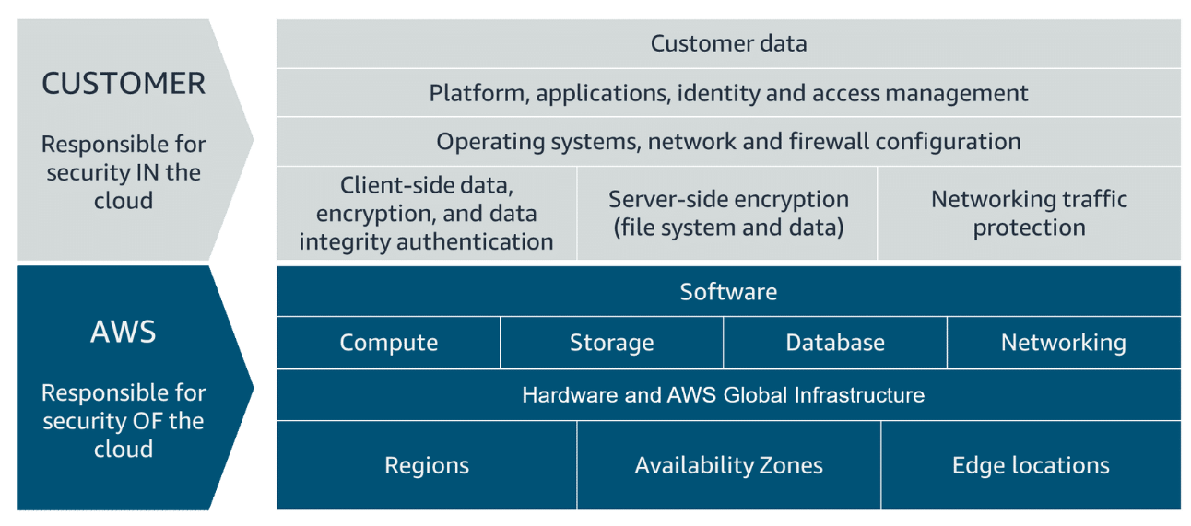
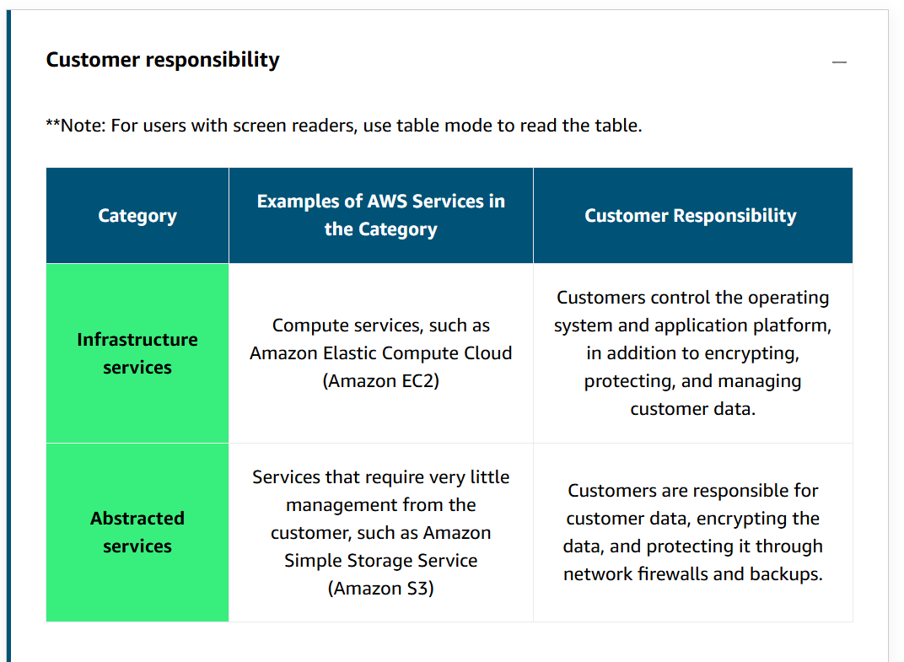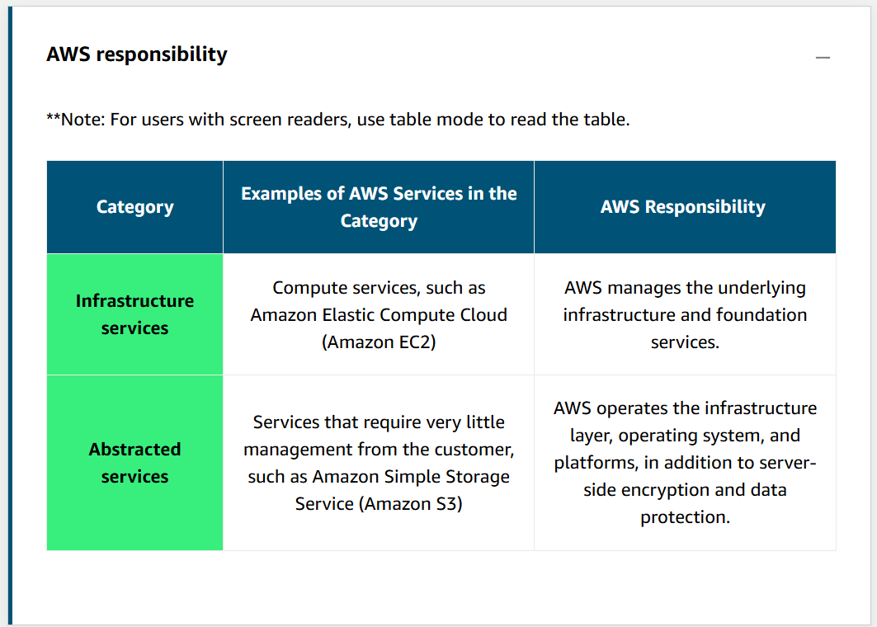
5-Protecting the AWS Root User
When you first create an AWS account, you begin with a single sign-in identity that has complete access to all AWS services and resources in the account. This identity is called the AWS root user and is accessed by signing in with the email address and password that were used to create the account.
The AWS root user has two sets of credentials associated with it. One set of credentials is the email address and password that were used to create the account. This allows you to access the AWS Management Console. The second set of credentials is called access keys, which allow you to make programmatic requests from the AWS Command Line Interface (AWS CLI) or AWS API.

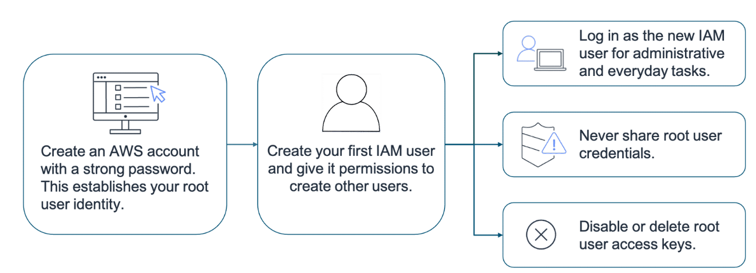
MFA requires two or more authentication methods to verify an identity.
If you activate MFA on your root user, you must present a piece of identifying information from both the something you know category and the something you have category. The first piece of identifying information the user enters is an email and password combination. The second piece of information is a temporary numeric code provided by an MFA device.
AWS supports a variety of MFA mechanisms, such as virtual MFA devices, hardware time-based one-time password (TOTP) tokens, and FIDO security keys.

6-AWS Identity and Access Management
Authentication ensures that the user is who they say they are. User names and passwords are the most common types of authentication. But you might also work with other forms, such as token-based authentication or biometric data
Authorization is the process of giving users permission to access AWS resources and services. Authorization determines whether a user can perform certain actions, such as read, edit, delete, or create resources. Authorization answers the question, “What actions can you perform?”
AWS Identity and Access Management (IAM) is an AWS service that helps you manage access to your AWS account and resources. It also provides a centralized view of who and what are allowed inside your AWS account (authentication), and who and what have permissions to use and work with your AWS resources (authorization). You can also provide granular access
IAM is global and not specific to any one Region.
IAM supports MFA
An IAM user represents a person or service that interacts with AWS
An IAM group is a collection of users
Users can belong to many groups.
Groups cannot belong to groups.
The root user can perform all actions on all resources inside an AWS account by default
To manage access and provide permissions to AWS services and resources, you create IAM policies and attach them to an IAM identity.
A policy has four major JSON elements: Version, Effect, Action, and Resource.
- The Version element defines the version of the policy language. It specifies the language syntax rules that are needed by AWS to process a policy. To use all the available policy features, include "Version": "2012-10-17" before the "Statement" element in your policies.
- The Effect element specifies whether the policy will allow or deny access. In this policy, the Effect is "Allow", which means you’re providing access to a particular resource.
- The Action element describes the type of action that should be allowed or denied. In the example policy, the action is "*". This is called a wildcard, and it is used to symbolize every action inside your AWS account.
- The Resource element specifies the object or objects that the policy statement covers. In the policy example, the resource is the wildcard "*". This represents all resources inside your AWS console.

Policies can be applied to AWS identities like users and groups to assign permissions. They also, however, can be applied to another AWS identity, IAM roles.
An IAM role is an identity that can be assumed by someone or something who needs temporary access to AWS credentials.
IAM roles are identities in AWS that like an IAM user also have associated AWS credentials used to sign requests. However, IAM users have usernames and passwords as well as static credentials whereas IAM roles do not have any login credentials like a username and password and the credentials used to sign requests are programmatically acquired, temporary in nature, and automatically rotated.
roles are assumed programmatically.
To learn more about each best practice, expand each of the following six categories.
-Lock down the AWS root user
-Follow the principle of least privilege. Least privilege is a standard security principle that advises you to grant only the necessary permissions
-Use IAM appropriately
-Use IAM roles when possible
-Consider using an identity provider
-Regularly review and remove unused users, roles, and other credentials

