DNS

The Domain Name System (DNS) translates human readable domain names to machine readable IP addresses.
Web browsers interact through Internet Protocol (IP) addresses.
DNS translates domain names to IP addresses so browsers can load Internet resources.
1. After hitting the URL, the browser cache is checked. As browser maintains its DNS records for some amount of time for the websites you have visited earlier. Hence, firstly, DNS query runs here to find the IP address associated with the domain name.
2. The second place where DNS query runs in OS cache followed by router cache.
3. If in the above steps, a DNS query does not get resolved, then it takes the help of resolver server. Resolver server is nothing but your ISP (Internet service provider). The query is sent to ISP where DNS query runs in ISP cache.
The DNS system is a hierarchy of duplicated database servers worldwide that begin with the "root servers" for the top-level domains (.com, .net, .org, etc.). The root servers point to the "authoritative" servers located in ISPs, as well as in large companies, that turn the names into IP addresses; the process known as "name resolution."
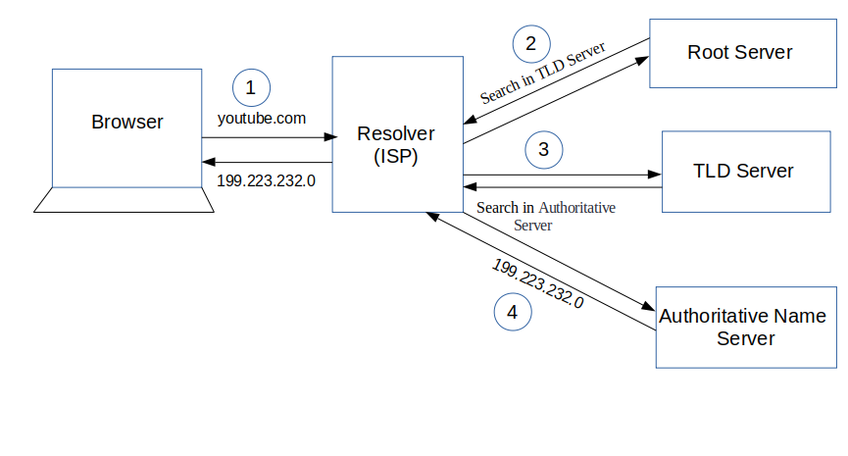
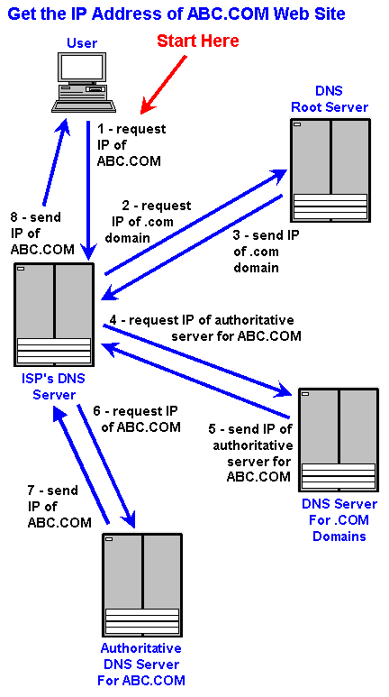

The process of DNS resolution involves converting a hostname into an IP address.
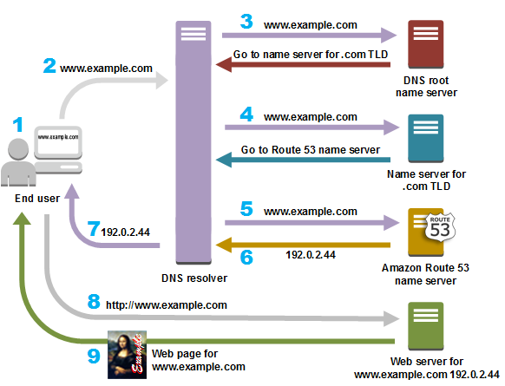

- A user opens a web browser, enters www.example.com in the address bar, and presses Enter.
- The request for www.example.com is routed to a DNS resolver, which is typically managed by the user's Internet service provider (ISP), such as a cable Internet provider, a DSL broadband provider, or a corporate network.
- The DNS resolver for the ISP forwards the request for www.example.com to a DNS root name server.
- The DNS resolver for the ISP forwards the request for www.example.com again, this time to one of the TLD name servers for .com domains. The name server for .com domains responds to the request with the names of the four Amazon Route 53 name servers that are associated with the example.com domain.
- The DNS resolver for the ISP chooses an Amazon Route 53 name server and forwards the request for www.example.com to that name server.
- The Amazon Route 53 name server looks in the example.com hosted zone for the www.example.com record, gets the associated value, such as the IP address for a web server, 192.0.2.44, and returns the IP address to the DNS resolver.
- The DNS resolver for the ISP finally has the IP address that the user needs. The resolver returns that value to the web browser. The DNS resolver also caches (stores) the IP address for example.com for an amount of time that you specify so that it can respond more quickly the next time someone browses to example.com. For more information, see time to live (TTL).
- The web browser sends a request for www.example.com to the IP address that it got from the DNS resolver. This is where your content is, for example, a web server running on an Amazon EC2 instance or an Amazon S3 bucket that's configured as a website endpoint.
- The web server or other resource at 192.0.2.44 returns the web page for www.example.com to the web browser, and the web browser displays the page.
How DNS adds efficiency
DNS is organized in a hierarchy that helps keep things running quickly and smoothly.
The initial request for the IP address is made to a recursive resolver. The recursive resolver knows which other DNS servers it needs to ask to resolve the name of a site (networkworld.com) with its IP address. This search leads to a root server, which knows all the information about top-level domains, such as .com, .net, .org and all of those country domains like .cn (China) and .uk (United Kingdom). Root servers are located all around the world, so the system usually directs you to the closest one geographically.
Once the request reaches the correct root server, it goes to a top-level domain (TLD) name server, which stores the information for the second-level domain, the words used before you get to the .com, .org, .net (for example, that information for networkworld.com is “networkworld”). The request then goes to the Domain Name Server, which holds the information about the site and its IP address. Once the IP address is discovered, it is sent back to the client, which can now use it to visit the website. All of this takes mere milliseconds.
Recursive resolver --- > root server --- > Top Lever Domain TLD server,

What is DNS caching?
DNS information is shared among many servers. But information for sites visited recently is also cached locally on client computers. Chances are that you use google.com several times a day. Instead of your computer querying the DNS name server for the IP address of google.com every time, that information is saved on your computer so it doesn’t have to access a DNS server to resolve the name with its IP address. Additional caching can occur on the routers used to connect clients to the internet, as well as on the servers of the user’s Internet Service Provider (ISP). With so much caching going on, the number of queries that actually make it to DNS name servers is a lot lower than it would seem.
8.8.8.8 DNS
If you want an alternative, you can instead point your computer to a public DNS server that will act as a recursive resolver. One of the most prominent public DNS servers is Google's; its IP address is 8.8.8.8.
DNS reflection attacks
DNS reflection attacks can swamp victims with high-volume messages from DNS resolver servers. Attackers request large DNS files from all the open DNS resolvers they can find and do so using the spoofed IP address of the victim. When the resolvers respond, the victim receives a flood of unrequested DNS data that overwhelms their machines.
DNS cache poisoning
DNS cache poisoning can divert users to malicious Web sites. Attackers manage to insert false address records into the DNS so when a potential victim requests an address resolution for one of the poisoned sites, the DNS responds with the IP address for a different site, one controlled by the attacker. Once on these phony sites, victims may be tricked into giving up passwords or suffer malware downloads.
DNS resource exhaustion
DNS resource exhaustion attacks can clog the DNS infrastructure of ISPs, blocking the ISP’s customers from reaching sites on the internet. This can be done by attackers registering a domain name and using the victim’s name server as the domain’s authoritative server. So if a recursive resolver can’t supply the IP address associated with the site name, it will ask the name server of the victim. Attackers generate large numbers of requests for their domain and toss in non-existent subdomains to boot, which leads to a torrent of resolution requests being fired at the victim’s name server, overwhelming it.
What is DNSSec?
DNS Security Extensions is an effort to make communication among the various levels of servers involved in DNS lookups more secure. It was devised by the Internet Corporation for Assigned Names and Numbers (ICANN), the organization in charge of the DNS system.
DNS over HTTPS: A new privacy landscape
As of this writing, DNS is on the verge of one of its biggest shifts in its history. Google and Mozilla, who together control the lion's share of the browser market, are encouraging a move towards DNS over HTTPS, or DoH, in which DNS requests are encrypted by the same HTTPS protocol that already protects most web traffic. In Chrome's implementation, the browser checks to see if the DNS servers support DoH, and if they don't, it reroutes DNS requests to Google's 8.8.8.8.
The Domain Namespace
The DNS namespace governs public hostnames used on the Internet. The namespace is a tree structure, with each node in the tree having a textual label and zero or more DNS resource records (RR) describing the domain.
The domain name consists of the label, together with the label of its parent nodes, separated by a dot (as in “example.com”). The domain namespace is divided into zones, and each zone is delegated to a specific legal entity for administration and management.

DNS Resolver or recursive resolver - It is a server designed to receive queries from client machines through applications such as web browsers or network devices. It is responsible for making additional requests in order to satisfy the client’s DNS query.
1 The resolver looks for the required DNS resource record in its local cache or that of the operating system on the local device.
2 If not found, it looks for a direct reference to the authoritative name server of the domain’s DNS zone.
3 Failing that, it performs a recursive query - the resolver contacts a DNS Root Server and receives details of a TLD Name Server for relevant TLD, e.g. “.com”.
4 Via the TLD Name Server, it receives details of the Authoritative Name Server, and asks it for the IP that matches the requested hostname.
Authoritative DNS: The authoritative name server is the last stop in a DNS query. It holds the DNS Master File for the DNS zone it manages, which contains the trusted, correct resource records for all domains in the zone.
In some cases, the authoritative name server routes the DNS resolver to another name server that contains specific records for a subdomain, for example, support.example.com. If a CNAME or ALIAS record is used, the name server redirects the DNS resolver to another hostname, for which the requested hostname is an alias, and the DNS resolution process starts over.
DNS Message Format
DNS communication occurs via two types of messages: queries and replies. Both DNS query format and reply format consist of the following sections:
1 The header section contains Identification; Flags; Number of questions; Number of answers; Number of authority resource records (RRs); and Number of additional resource records.
2 The flag field contains sections of one or four bits, indicating type of message, whether the name server is authoritative; whether the query is recursive or not, whether request was truncated, and status.
3 The question section contains the domain name and type of record (A, AAAA, MX, TXT, etc.) being resolved. Each label in the domain name is prefixed by its length.
4 The answer section has the resource records of the queried name.
DNS Transport Protocol
DNS uses the User Datagram Protocol (UDP) on port 53 to serve DNS queries. UDP is preferred because it is fast and has low overhead. A DNS query is a single UDP request from the DNS client followed by a single UDP reply from the server.
If a DNS response is larger than 512 bytes, or if a DNS server is managing tasks like zone transfers (transferring DNS records from primary to secondary DNS server), the Transmission Control Protocol (TCP) is used instead of UDP, to enable data integrity checks.
DNS Master Files (Zone Files)
A DNS Master File is a text file stored on a DNS name server, which defines the DNS information for a single DNS zone. The file contains the following data:
Global Time to Live (TTL) - how long records should be kept in local DNS cache.
Start of Authority (SOA) record—primary authoritative name server for the zone.
One or more resource records - see more details below.

DNS Resource Records
Resource Records are used to store hostnames, IP addresses and other information in DNS name servers. A record is made up of the following fields:
Name, ttl, record class, record type, record data

Name is an alphanumeric identifier of the DNS record
TTL (time to live) specifies how long the record should be kept in local cache
Record class indicates the namespace—typically IN, the Internet namespace
Record type is the DNS record type—for example an A, CNAME, MX
Record data contains the DNS values, for example the IP address for a hostname

The most common DNS record types supported by the DNS protocol:

Name Server records (NS)—specifies the authoritative name server for a DNS zone
IPv4 Address Mapping records (A)—a hostname and its IPv4 address
IPv6 Address records (AAAA)—a hostname and its IPv6 address
Canonical Name records (CNAME)—points a hostname to an alias
Mail eXchanger record (MX)—specifies an SMTP email server for the domain

?????
Recursive DNS: Clients typically do not make queries directly to authoritative DNS services. Instead, they generally connect to another type of DNS service known a resolver, or a recursive DNS service. A recursive DNS service acts like a hotel concierge: while it doesn't own any DNS records, it acts as an intermediary who can get the DNS information on your behalf. If a recursive DNS has the DNS reference cached, or stored for a period of time, then it answers the DNS query by providing the source or IP information. If not, it passes the query to one or more authoritative DNS servers to find the information.
Root nameserver - The root server is the first step in translating (resolving) human readable host names into IP addresses. Typically it serves as a reference to other more specific locations.
TLD nameserver - The top level domain server (TLD), This nameserver is the next step in the search for a specific IP address, and it hosts the last portion of a hostname (In example.com, the TLD server is “com”).
Authoritative nameserver - This final nameserver in which a specific name can be translated into its definition. The authoritative nameserver is the last stop in the nameserver query. If the authoritative name server has access to the requested record, it will return the IP address for the requested hostname back to the DNS Recursor (the librarian) that made the initial request.

One way to think about the difference is the recursive resolver is at the beginning of the DNS query and the authoritative nameserver is at the end.
The recursive resolver is the computer that responds to a recursive request from a client and takes the time to track down the DNS record. It does this by making a series of requests until it reaches the authoritative DNS nameserver for the requested record (or times out or returns an error if no record is found). Luckily, recursive DNS resolvers do not always need to make multiple requests in order to track down the records needed to respond to a client; caching is a data persistence process that helps short-circuit the necessary requests by serving the requested resource record earlier in the DNS lookup.
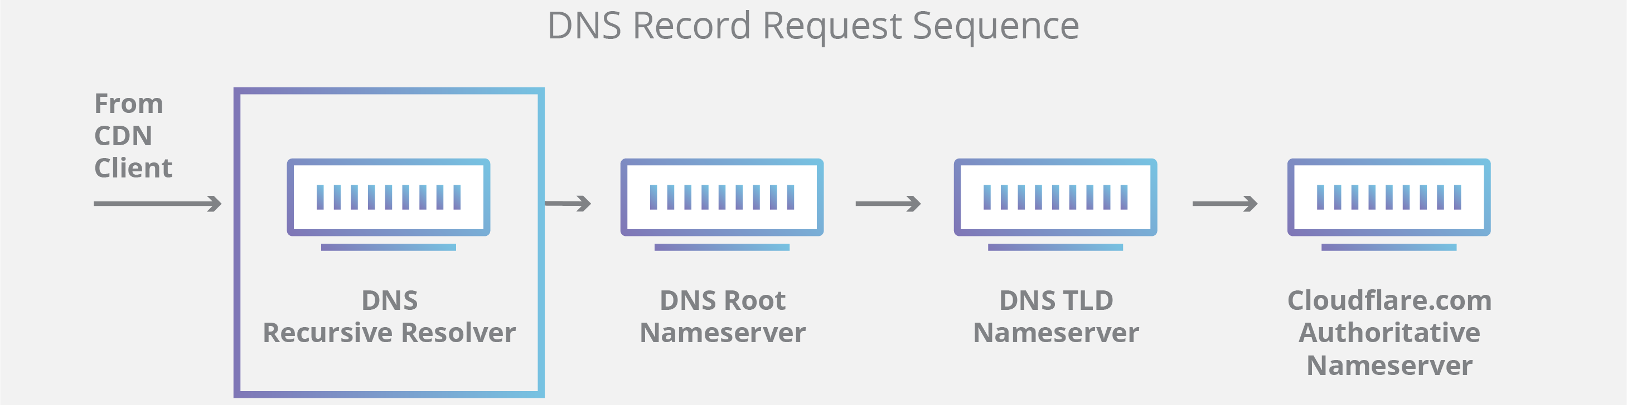

Put simply, an authoritative DNS server is a server that actually holds, and is responsible for, DNS resource records. This is the server at the bottom of the DNS lookup chain that will respond with the queried resource record, ultimately allowing the web browser making the request to reach the IP address needed to access a website or other web resources. An authoritative nameserver can satisfy queries from its own data without needing to query another source, as it is the final source of truth for certain DNS records.

It’s worth mentioning that in instances where the query is for a subdomain such as foo.example.com or blog.cloudflare.com, an additional nameserver will be added to the sequence after the authoritative nameserver, which is responsible for storing the subdomain’s CNAME record.

What are the steps in a DNS lookup?
For most situations, DNS is concerned with a domain name being translated into the appropriate IP address. To learn how this process works, it helps to follow the path of a DNS lookup as it travels from a web browser, through the DNS lookup process, and back again. Let's take a look at the steps.

Note: Often DNS lookup information will be cached either locally inside the querying computer or remotely in the DNS infrastructure. There are typically 8 steps in a DNS lookup. When DNS information is cached, steps are skipped from the DNS lookup process which makes it quicker. The example below outlines all 8 steps when nothing is cached.

The 8 steps in a DNS lookup:
1 A user types ‘example.com’ into a web browser and the query travels into the Internet and is received by a DNS recursive resolver.
2 The resolver then queries a DNS root nameserver (.).
3 The root server then responds to the resolver with the address of a Top Level Domain (TLD) DNS server (such as .com or .net), which stores the information for its domains. When searching for example.com, our request is pointed toward the .com TLD.
4 The resolver then makes a request to the .com TLD.
5 The TLD server then responds with the IP address of the domain’s nameserver, example.com.
6 Lastly, the recursive resolver sends a query to the domain’s nameserver.
7 The IP address for example.com is then returned to the resolver from the nameserver.
8 The DNS resolver then responds to the web browser with the IP address of the domain requested initially.
Once the 8 steps of the DNS lookup have returned the IP address for example.com, the browser is able to make the request for the web page:

9 The browser makes a HTTP request to the IP address.
10 The server at that IP returns the webpage to be rendered in the browser (step 10).

The DNS resolver is the first stop in the DNS lookup, and it is responsible for dealing with the client that made the initial request. The resolver starts the sequence of queries that ultimately leads to a URL being translated into the necessary IP address.

Note: A typical uncached DNS lookup will involve both recursive and iterative queries.

It's important to differentiate between a recursive DNS query and a recursive DNS resolver. The query refers to the request made to a DNS resolver requiring the resolution of the query. A DNS recursive resolver is the computer that accepts a recursive query and processes the response by making the necessary requests.

