HTTPS
HTTPS uses an encryption protocol to encrypt communications.
The protocol is called Transport Layer Security (TLS), although formerly it was known as Secure Sockets Layer (SSL).
This protocol secures communications by using what’s known as an asymmetric public key infrastructure. This type of security system uses two different keys to encrypt communications between two parties:
The private key - this key is controlled by the owner of a website and it’s kept private. This key lives on a web server and is used to decrypt information encrypted by the public key.
The public key - this key is available to everyone who wants to interact with the server in a way that’s secure. Information that’s encrypted by the public key can only be decrypted by the private key.
HTTPS prevents websites from having their information broadcast in a way that’s easily viewed by anyone snooping on the network. When information is sent over regular HTTP, the information is broken into packets of data that can be easily “sniffed” using free software. This makes communication over an unsecure medium, such as public Wi-Fi, highly vulnerable to interception. In fact, all communications that occur over HTTP occur in plain text, making them highly accessible to anyone with the correct tools, and vulnerable to on-path attacks.
In websites without HTTPS, it is possible for Internet service providers (ISPs) or other intermediaries to inject content into webpages without the approval of the website owner. This commonly takes the form of advertising, where an ISP looking to increase revenue injects paid advertising into the webpages of their customers. Unsurprisingly, when this occurs, the profits for the advertisements and the quality control of those advertisements are in no way shared with the website owner. HTTPS eliminates the ability of unmoderated third parties to inject advertising into web content.
HTTPS is not a separate protocol from HTTP. It is simply using TLS/SSL encryption over the HTTP protocol. HTTPS occurs based upon the transmission of TLS/SSL certificates, which verify that a particular provider is who they say they are.
When a user connects to a webpage, the webpage will send over its SSL certificate which contains the public key necessary to start the secure session. The two computers, the client and the server, then go through a process called an SSL/TLS handshake, which is a series of back-and-forth communications used to establish a secure connection.
TLS is an encryption protocol designed to secure Internet communications. A TLS handshake is the process that kicks off a communication session that uses TLS encryption. During a TLS handshake, the two communicating sides exchange messages to acknowledge each other, verify each other, establish the encryption algorithms they will use, and agree on session keys. TLS handshakes are a foundational part of how HTTPS works.
A TLS handshake takes place whenever a user navigates to a website over HTTPS and the browser first begins to query the website's origin server. A TLS handshake also happens whenever any other communications use HTTPS, including API calls and DNS over HTTPS queries.

TLS handshakes occur after a TCP connection has been opened via a TCP handshake.
During the course of a TLS handshake, the client and server together will do the following:
- Specify which version of TLS (TLS 1.0, 1.2, 1.3, etc.) they will use
- Decide on which cipher suites (see below) they will use
- Authenticate the identity of the server via the server’s public key and the SSL certificate authority’s digital signature
- Generate session keys in order to use symmetric encryption after the handshake is complete

TLS handshakes are a series of datagrams, or messages, exchanged by a client and a server. A TLS handshake involves multiple steps, as the client and server exchange the information necessary for completing the handshake and making further conversation possible.
The exact steps within a TLS handshake will vary depending upon the kind of key exchange algorithm used and the cipher suites supported by both sides. The RSA key exchange algorithm is used most often. It goes as follows:

1 The 'client hello' message: The client initiates the handshake by sending a "hello" message to the server. The message will include which TLS version the client supports, the cipher suites supported, and a string of random bytes known as the "client random."
2 The 'server hello' message: In reply to the client hello message, the server sends a message containing the server's SSL certificate, the server's chosen cipher suite, and the "server random," another random string of bytes that's generated by the server.
3 Authentication: The client verifies the server's SSL certificate with the certificate authority that issued it. This confirms that the server is who it says it is, and that the client is interacting with the actual owner of the domain.
4 The premaster secret: The client sends one more random string of bytes, the "premaster secret." The premaster secret is encrypted with the public key and can only be decrypted with the private key by the server. (The client gets the public key from the server's SSL certificate.)
5 Private key used: The server decrypts the premaster secret.
6 Session keys created: Both client and server generate session keys from the client random, the server random, and the premaster secret. They should arrive at the same results.
7 Client is ready: The client sends a "finished" message that is encrypted with a session key.
8 Server is ready: The server sends a "finished" message encrypted with a session key.
9 Secure symmetric encryption achieved: The handshake is completed, and communication continues using the session keys.

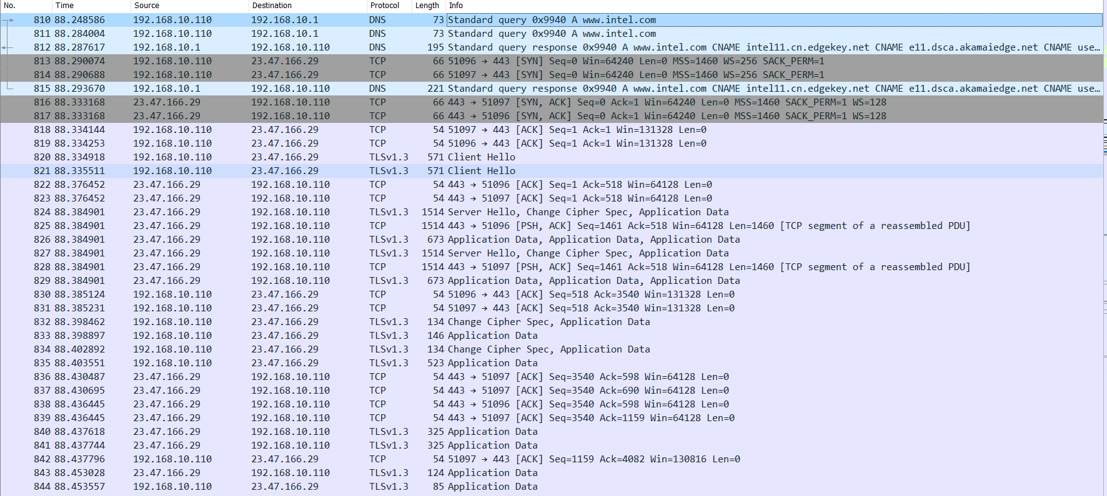

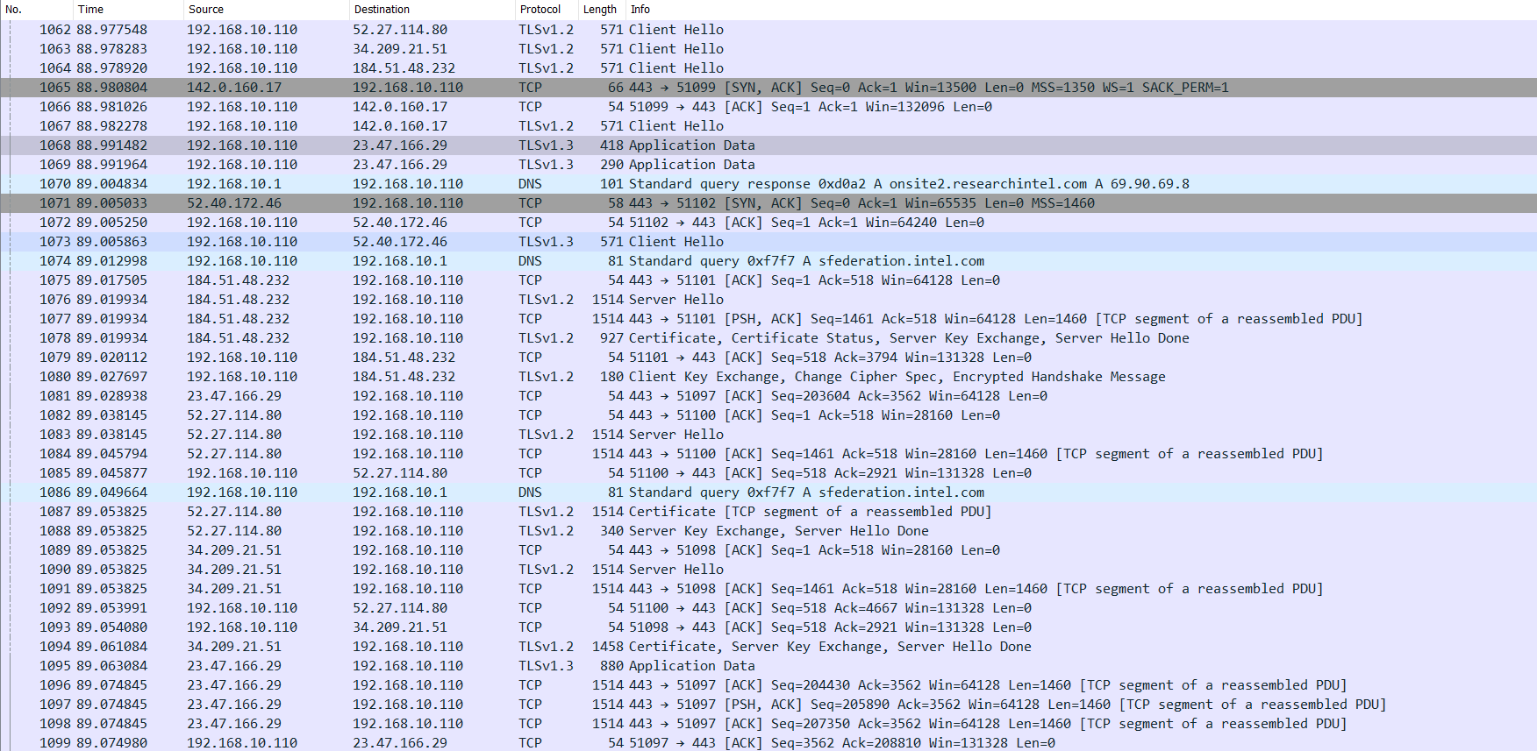
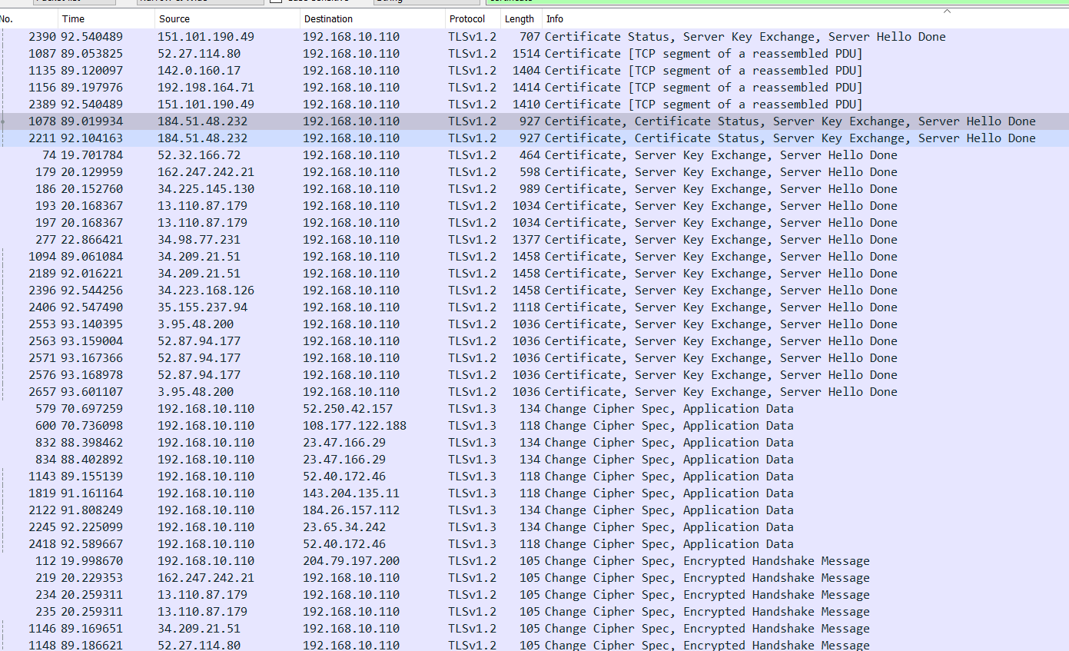

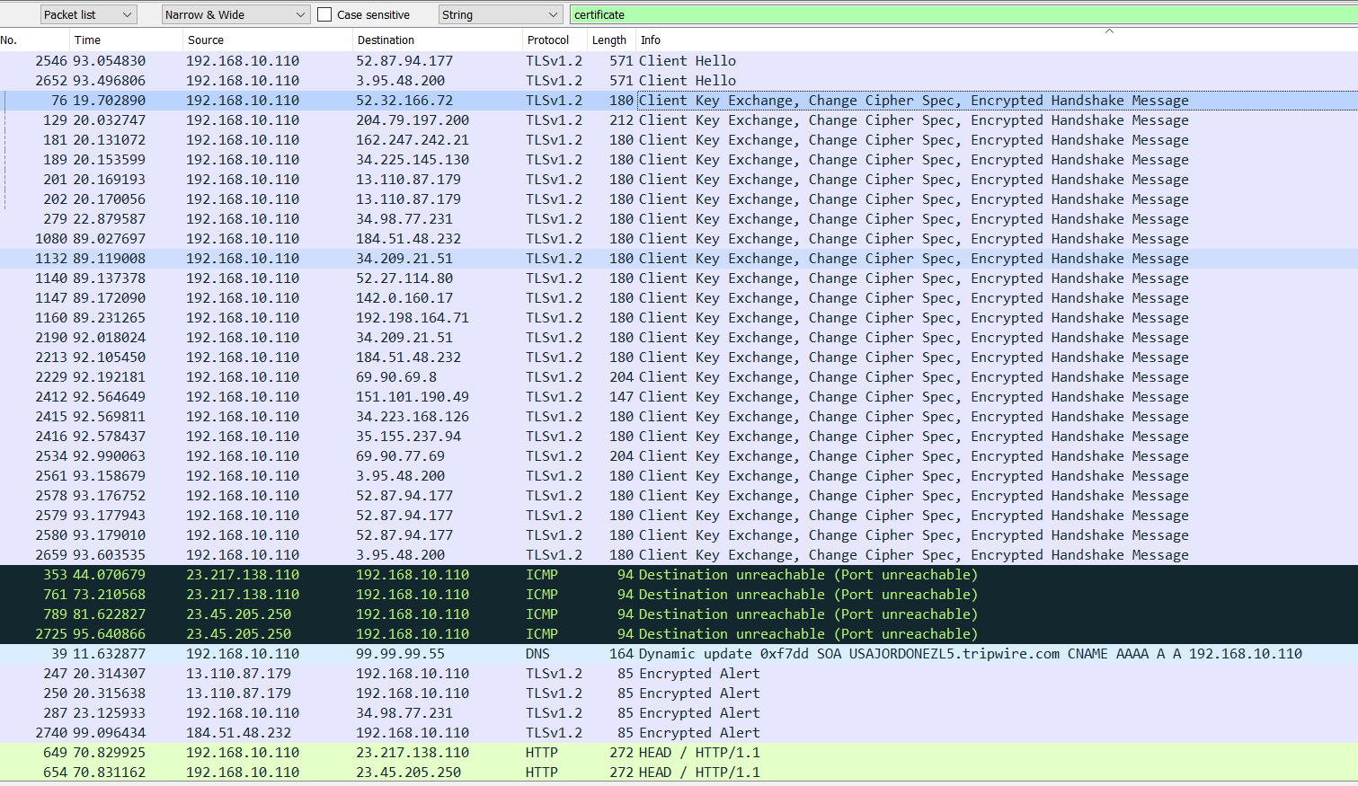

All TLS handshakes make use of asymmetric encryption (the public and private key), but not all will use the private key in the process of generating session keys. For instance, an ephemeral Diffie-Hellman handshake proceeds as follows:

Client hello: The client sends a client hello message with the protocol version, the client random, and a list of cipher suites.
Server hello: The server replies with its SSL certificate, its selected cipher suite, and the server random. In contrast to the RSA handshake described above, in this message the server also includes the following (step 3):
Server's digital signature: The server uses its private key to encrypt the client random, the server random, and its DH parameter*. This encrypted data functions as the server's digital signature, establishing that the server has the private key that matches with the public key from the SSL certificate.
Digital signature confirmed: The client decrypts the server's digital signature with the public key, verifying that the server controls the private key and is who it says it is. Client DH parameter: The client sends its DH parameter to the server.
Client and server calculate the premaster secret: Instead of the client generating the premaster secret and sending it to the server, as in an RSA handshake, the client and server use the DH parameters they exchanged to calculate a matching premaster secret separately.
Session keys created: Now, the client and server calculate session keys from the premaster secret, client random, and server random, just like in an RSA handshake.
Client is ready:
Same as an RSA handshake.
Server is ready
Secure symmetric encryption achieved
*DH parameter: DH stands for Diffie-Hellman. The Diffie-Hellman algorithm uses exponential calculations to arrive at the same premaster secret. The server and client each provide a parameter for the calculation, and when combined they result in a different calculation on each side, with results that are equal.

To read more about the contrast between ephemeral Diffie-Hellman handshakes and other kinds of handshakes, and how they achieve forward secrecy, see What is Keyless SSL?

What is a cipher suite?
A cipher suite is a set of encryption algorithms for use in establishing a secure communications connection. (An encryption algorithm is a set of mathematical operations performed on data for making data appear random.) There are a number of cipher suites in wide use, and an essential part of the TLS handshake is agreeing upon which cipher suite will be used for that handshake.

*****************************************************

SSL Certificate
SSL certificates are what enable websites to move from HTTP to HTTPS, which is more secure. An SSL certificate is a data file hosted in a website's origin server. SSL certificates make SSL/TLS encryption possible, and they contain the website's public key and the website's identity, along with related information. Devices attempting to communicate with the origin server will reference this file to obtain the public key and verify the server's identity. The private key is kept secret and secure.
SSL certificates include:
- The domain name that the certificate was issued for
- Which person, organization, or device it was issued to
- Which certificate authority issued it
- The certificate authority's digital signature
- Associated subdomains
- Issue date of the certificate
- Expiration date of the certificate
- The public key (the private key is kept secret)
The public and private keys used for SSL are essentially long strings of characters used for encrypting and decrypting data. Data encrypted with the public key can only be decrypted with the private key, and vice versa.
A website needs an SSL certificate in order to keep user data secure, verify ownership of the website, prevent attackers from creating a fake version of the site, and gain user trust.
Encryption: SSL/TLS encryption is possible because of the public-private key pairing that SSL certificates facilitate. Clients (such as web browsers) get the public key necessary to open a TLS connection from a server's SSL certificate.

Authentication: SSL certificates verify that a client is talking to the correct server that actually owns the domain. This helps prevent domain spoofing and other kinds of attacks.
HTTPS: Most crucially for businesses, an SSL certificate is necessary for an HTTPS web address. HTTPS is the secure form of HTTP, and HTTPS websites are websites that have their traffic encrypted by SSL/TLS.

