Abstraction is a process of hiding the implementation details and showing only functionality to the user.
There are two ways to achieve abstraction in java; Abstract class (0 to 100%) and Interface (100%)

Abstract class. It can have abstract and non-abstract methods. It needs to be extended and its method implemented. It cannot be instantiated.
An abstract class must be declared with an abstract keyword.
It can have abstract and non-abstract methods.
It cannot be instantiated.
It can have constructors and static methods also.
It can have final methods which will force the subclass not to change the body of the method.
An interface in Java is a blueprint of a class. It has static constants and abstract methods.

The interface in Java is a mechanism to achieve abstraction.
The interface is a fully un-implemented class used for declaring a set of operations of an object. So, you can consider it is a pure abstract class that allows you to define only public static final variables and public abstract methods.
There can be only abstract methods in the Java interface, not method body. It is used to achieve abstraction and multiple inheritance in Java.
Interfaces can have abstract methods and variables. It cannot have a method body.
Java Interface also represents the IS-A relationship.
It cannot be instantiated just like the abstract class.
Since Java 8, we can have default and static methods in an interface.
Since Java 9, we can have private methods in an interface.
Why use Java interface? There are mainly three reasons to use interface.
It is used to achieve abstraction.
By interface, we can support the functionality of multiple inheritance.
It can be used to achieve loose coupling.

The relationship between classes and interfaces
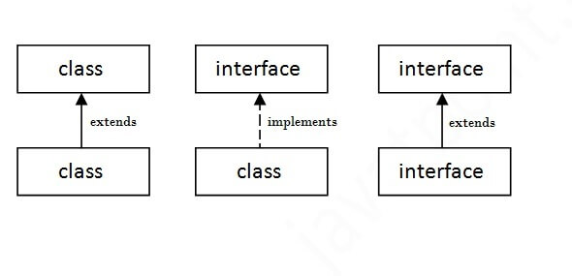
What is the purpose of interfaces in java?
An interface in Java is a specification of method prototypes. Whenever you need to guide the programmer or, make a contract specifying how the methods and fields of a type should be you can define an interface.
To create an object of this type you need to implement this interface, provide body for all the abstract methods of the interface and obtain the object of the implementing class.
All the methods of the interface are public and abstract
Provides communication − One of the uses of the interface is to provide communication. Through interface you can specify how you want the methods and fields of a particular type.
Multiple inheritance − Java doesn’t support multiple inheritance, using interfaces you can achieve multiple inheritance
Abstraction − Abstraction is a process of hiding the implementation details from the user, only the functionality will be provided to the user. In other words, the user will have the information on what the object does instead of how it does it. Since all the methods of the interface are abstract and user doesn’t know how a method is written except the method signature/prototype. Using interfaces, you can achieve (complete) abstraction.
Loose coupling − Coupling refers to the dependency of one object type on another, if two objects are completely independent of each other and the changes done in one doesn’t affect the other both are said to be loosely coupled.

A constructor is a block of codes similar to the method. It is called when an instance of the class is created. At the time of calling constructor, memory for the object is allocated in the memory.
It is a special type of method which is used to initialize the object.
Every time an object is created using the new() keyword, at least one constructor is called.
It calls a default constructor if there is no constructor available in the class. In such case, Java compiler provides a default constructor by default.
There are two types of constructors in Java: no-arg constructor, and parameterized constructor.
Note: It is called constructor because it constructs the values at the time of object creation. It is not necessary to write a constructor for a class. It is because java compiler creates a default constructor if your class doesn't have any.
Rules for creating Java constructor
Constructor name must be the same as its class name
A Constructor must have no explicit return type
A Java constructor cannot be abstract, static, final, and synchronized

