depth of field DoF
Depth of field is the distance between the closest and farthest objects in a photo
In a photograph with a narrow DoF, only a small slice of the image is in focus. Conversely, with a large DoF, much more of the scene is sharp.
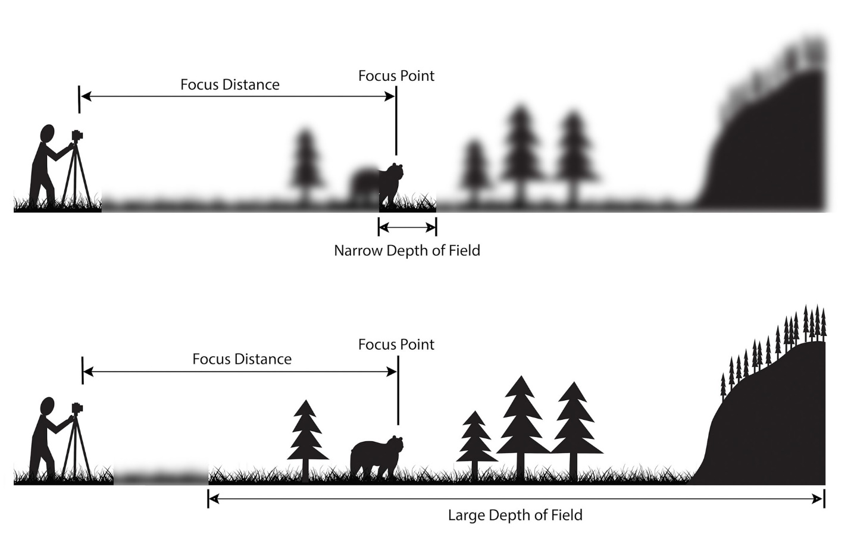

Shooting with a shallow depth of field is “having a plane that’s in focus, and everything else is out of focus,”
“The more light that gets in, the more you get that shallow depth of field effect.”
Shallow depth of field is achieved by shooting photographs with a low f-number, or f-stop — from 1.4 to about 5.6 — to let in more light.
With a smaller f-stop number — a wider aperture — more light enters your camera. This means your shutter speed should be fast enough to avoid overexposure or blowing out the whites in your photograph.
the longer your focal length, the shallower your depth of field.
Another method of getting a shallow depth of field is to increase the distance between the camera, your subject, and your background.
I suggest bracketing: Shoot a few shots, one at an f-stop of 1.2, one at f/1.8, and one at f/2.0, and so on.
Avoid using a wide-angle lens when shooting shallow depth of field images. Wide angle lenses are better suited to deep depth of field, allowing you to get your entire scene in focus. Landscape photography is one area in which sharp focus and deep depth of field are desirable. Don’t set yourself up for failure, and instead use a longer focal length.

Aperture

Aperture is the opening in your lens that lets light pass through to the sensor.

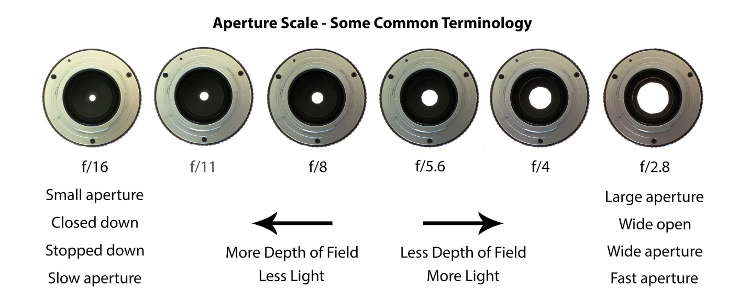
Large apertures, which correlate to small f-stop numbers, produce a very shallow depth of field. On the other hand, small apertures, or large f-stop numbers, produce images with a large depth of field.

Focal Length of the Lens
Wide-angle lenses (short focal lengths) have a deeper depth of field than telephoto lenses (long focal lengths). Well, not exactly! It isn’t quite as cut and dry as that. If you take an image and do not change the camera-subject distance, this is true. You can see this illustrated in these two sets of images below. The top set is shot at a focal length of 70mm. The bottom set at 105mm. Both sets were taken at a distance of 2m from the subject. Notice how for each pair of images shot at the same aperture, the DoF is larger for the narrower focal length lens.
the longer focal length has a narrow angle of view. Thus, a smaller

