SOAP is a protocol
REST is an architectural style

A REST API can actually utilize the SOAP protocol, just like it can use HTTP. So, right off the bat, they’re going to be packaged differently, function differently, and be used in different scenarios.
In the simplest of terms an API is a piece of software that plugs one application directly into the data and services of another by granting it access to specific parts of a server. APIs let two pieces of software communicate, they’re the basis for everything we do on mobile, and they allow us to streamline IT architectures, power savvier marketing efforts, and make easier to share data sets.
REST (Representational State Transfer) is truly a “web services” API.
REST APIs are based on URIs (Uniform Resource Identifier, of which a URL is a specific type) and the HTTP protocol, and use JSON for a data format, which is super browser-compatible. (It could also theoretically use the SOAP protocol, as we mentioned above.)
REST APIs can be simple to build and scale, but they can also be massive and complicated—it’s all in how they’re built, added on to, and what they’re designed to do.
Reasons you may want to build an API to be RESTful include resource limitations, fewer security requirements, browser client compatibility, discoverability, data health, and scalability—things that really apply to web services.
- REST is all about simplicity, thanks to HTTP protocols.
- REST APIs facilitate client-server communications and architectures. If it’s RESTful, it’s built on this client-server principle, with round trips between the two passing payloads of information.
- REST APIs use a single uniform interface. This simplifies how applications interact with the API by requiring they all interface in the same way, through the same portal. This has advantages and disadvantages; check with your developer to see if this will affect implementation changes down the road.
- REST is optimized for the web. Using JSON as its data format makes it compatible with browsers.
- REST is known for excellent performance and scalability. But, like any technology, it can get bogged down or bog down your app. That’s why languages like GraphQL have come along to address problems even REST can’t solve.
SOAP (Simple Object Access Protocol) is its own protocol, and is a bit more complex by defining more standards than REST—things like security and how messages are sent. These built-in standards do carry a bit more overhead, but can be a deciding factor for organizations that require more comprehensive features in the way of security, transactions, and ACID (Atomicity, Consistency, Isolation, Durability) compliance. For the sake of this comparison, we should point out that many of the reasons SOAP is a good choice rarely apply to web services scenarios, which make it more ideal for enterprise-type situations.
Reasons you may want to build an application with a SOAP API include higher levels of security (e.g., a mobile application interfacing with a bank), messaging apps that need reliable communication, or ACID compliance.
- SOAP has tighter security. WS-Security, in addition to SSL support, is a built-in standard that gives SOAP some more enterprise-level security features, if you have a requirement for them.
- Successful/retry logic for reliable messaging functionality. Rest doesn’t have a standard messaging system and can only address communication failures by retrying. SOAP has successful/retry logic built in and provides end-to-end reliability even through SOAP intermediaries.
- SOAP has built-in ACID compliance. ACID compliance reduces anomalies and protects the integrity of a database by prescribing exactly how transactions can interact with the database. ACID is more conservative than other data consistency models, which is why it’s typically favored when handling financial or otherwise sensitive transactions.

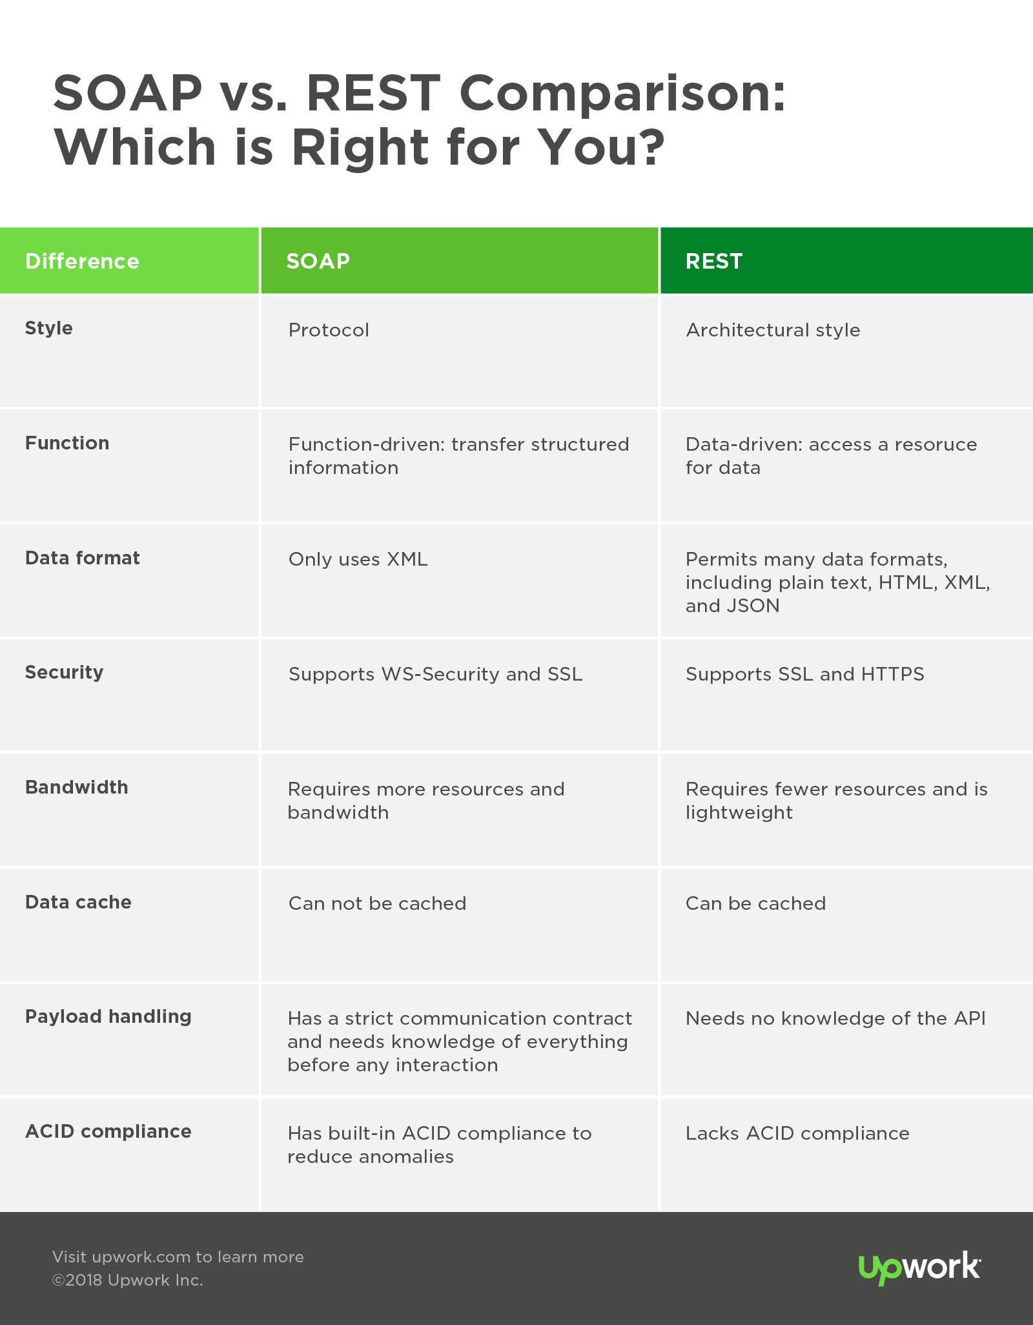

- SOAP is a protocol. REST is an architectural style. An API is designed to expose certain aspects of an application’s business logic on a server, and SOAP uses a service interface to do this while REST uses URIs.
- REST APIs access a resource for data (a URI); SOAP APIs perform an operation. REST is an architecture that’s more data-driven; SOAP is a standardized protocol for transferring structured information that’s more function-driven.
- REST permits many different data formats including plain text, HTML, XML, and JSON, which is a great fit for data and yields more browser compatibility; SOAP only uses XML.
- Security is handled differently. SOAP supports WS-Security, which is great at the transport level and a bit more comprehensive than SSL, and more ideal for integration with enterprise-level security tools. Both support SSL for end-to-end security, and REST can use the secure version of the HTTP protocol, HTTPS.
- SOAP requires more bandwidth; REST requires fewer resources (depending on the API). There’s a little more overhead with SOAP out of the gate, on account of the envelope-style of payload transport. Because REST is used primarily for web services, its being lightweight is an advantage in those scenarios.
- REST calls can be cached, SOAP-based calls cannot be cached. Data can be marked as cacheable, which means it can be reused by the browser later without having to initiate another request back to the server. This saves time and resources.
- An API is built to handle your app’s payload, and REST and SOAP do this differently. A payload is data sent over the internet, and when a payload is “heavy,” it requires more resources. REST tends to use HTTP and JSON, which lighten the payload; SOAP relies more on XML.
SOAP is tightly coupled with the server; REST is coupled to a lesser degree. In programming, the more layers of abstraction between two pieces of technology, the less control you have over their interaction, but there’s also less complexity and it’s easier to make updates to one or the other without blowing up the whole relationship. The same goes for APIs and how closely they interact with a server. This is a key difference between SOAP and REST to consider. SOAP is very closely coupled with the server, having a strict communication contract with it that makes it more difficult to make changes or updates. A client interacting with a REST API needs no knowledge of the API, but a client interacting with a SOAP API needs knowledge about everything it will be using before it can even initiate an interaction.
//////////////
Basic access authentication
In the context of an HTTP transaction, basic access authentication is a method for an HTTP user agent (e.g. a web browser) to provide a user name and password when making a request. In basic HTTP authentication, a request contains a header field in the form of Authorization: Basic <credentials>, where credentials is the Base64 encoding of ID and password joined by a single colon :.
HTTP Basic authentication (BA) implementation is the simplest technique for enforcing access controls to web resources because it does not require cookies, session identifiers, or login pages; rather, HTTP Basic authentication uses standard fields in the HTTP header.
The BA mechanism does not provide confidentiality protection for the transmitted credentials. They are merely encoded with Base64 in transit and not encrypted or hashed in any way. Therefore, basic authentication is typically used in conjunction with HTTPS to provide confidentiality.

Because the BA field has to be sent in the header of each HTTP request, the web browser needs to cache credentials for a reasonable period of time to avoid constantly prompting the user for their username and password. Caching policy differs between browsers.
HTTP does not provide a method for a web server to instruct the client to "log out" the user. However, there are a number of methods to clear cached credentials in certain web browsers. One of them is redirecting the user to a URL on the same domain, using credentials that are intentionally incorrect. However, this behavior is inconsistent between various browsers and browser versions.[1] Microsoft Internet Explorer offers a dedicated JavaScript method to clear cached credentials:[2]

///////////
What Is Swagger?
Swagger allows you to describe the structure of your APIs so that machines can read them. The ability of APIs to describe their own structure is the root of all awesomeness in Swagger. Why is it so great? Well, by reading your API’s structure, we can automatically build beautiful and interactive API documentation. We can also automatically generate client libraries for your API in many languages and explore other possibilities like automated testing. Swagger does this by asking your API to return a YAML or JSON that contains a detailed description of your entire API. This file is essentially a resource listing of your API which adheres to OpenAPI Specification. The specification asks you to include information like:
- What are all the operations that your API supports?
- What are your API’s parameters and what does it return?
- Does your API need some authorization?
- And even fun things like terms, contact information and license to use the API.

