SaaS
Software as a Service – new method for delivering software using the internet

What are the different layers in cloud computing? Explain working of them.
There are 3 layers in the hierarchy of cloud computing.
Infrastructure as a service (IaaS):It provides cloud infrastructure in terms of hardware as like memory, processor, speed etc.
Platform as a service (PaaS):It provides cloud application platform for the developer.
Software as a service (SaaS)::It provides the cloud applications to users directly without installing anything on the system. These applications remains on cloud.

The following are the main components of AWS are:
Simple Storage Service: S3 is a service of aws that stores the files. It is object-based storage, i.e., you can store the images, word files, pdf files, etc. The size of the file that can be stored in S3 is from 0 Bytes to 5 TB. It is an unlimited storage medium, i.e., you can store the data as much you want. S3 contains a bucket which stores the files. A bucket is like a folder that stores the files. It is a universal namespace, i.e., name must be unique globally. Each bucket must have a unique name to generate the unique DNS address.
Elastic Compute Cloud: Elastic Compute Cloud is a web service that provides resizable compute capacity in the cloud. You can scale the compute capacity up and down as per the computing requirement changes. It changes the economics of computing by allowing you to pay only for the resources that you actually use.
Elastic Block Store: It provides a persistent block storage volume for use with EC2 instances in aws cloud. EBS volume is automatically replicated within its availability zone to prevent the component failure. It offers high durability, availability, and low-latency performance required to run your workloads.
CloudWatch: It is a service which is used to monitor all the AWS resources and applications that you run in real time. It collects and tracks the metrics that measure your resources and applications. If you want to know about the CloudWatch in detail, then click on the below link: Click here
Identity Access Management: It is a service of aws used to manage users and their level of access to the aws management console. It is used to set users, permissions, and roles. It allows you to grant permission to the different parts of the aws platform. If you want to know about the IAM, then click the below link: Click here
Simple Email Service: Amazon Simple Email Service is a cloud-based email sending service that helps digital marketers and application developers to send marketing, notification, and transactional emails. This service is very reliable and cost-effective for the businesses of all the sizes that want to keep in touch with the customers.
Route53: It is a highly available and scalable DNS (Domain Name Service) service. It provides a reliable and cost-effective way for the developers and businesses to route end users to internet applications by translating domain names into numeric IP addresses. If you want to know more about Route53 in detail, then click on the link given below: Click here

What are Key-pairs?
An Amazon EC2 uses public key cryptography which is used to encrypt and decrypt the login information. In public key cryptography, the public key is used to encrypt the information while at the receiver's side, a private key is used to decrypt the information. The combination of a public key and the private key is known as key-pairs. Key-pairs allows you to access the instances securely.

What is CloudFront?
CloudFront is a computer delivery network which consists of distributed servers that delivers web pages and web content to a user based on the geographic locations of a user.

What are Regions and Availability Zones in aws?
Regions: A region is a geographical area which consists of 2 or more availability zones. A region is a collection of data centers which are completely isolated from other regions.
Availability zones: An Availability zone is a data center that can be somewhere in the country or city. Data center can have multiple servers, switches, firewalls, load balancing. The things through which you can interact with the cloud reside inside the Data center.

AWS Global Infrastructure
- AWS is a cloud computing platform which is globally available.
- Global infrastructure is a region around the world in which AWS is based. Global infrastructure is a bunch of high-level IT services which is shown below:
- AWS is available in 19 regions, and 57 availability zones in December 2018 and 5 more regions 15 more availability zones for 2019.
The following are the components that make up the AWS infrastructure:
- Availability Zones
- Region
- Edge locations
- Regional Edge Caches
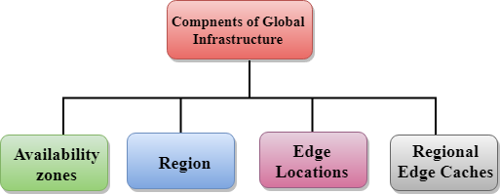

Availability zone as a Data Center
- An availability zone is a facility that can be somewhere in a country or in a city. Inside this facility, i.e., Data Centre, we can have multiple servers, switches, load balancing, firewalls. The things which interact with the cloud sits inside the data centers.
- An availability zone can be a several data centers, but if they are close together, they are counted as 1 availability zone.
Region
- A region is a geographical area. Each region consists of 2 more availability zones.
- A region is a collection of data centers which are completely isolated from other regions.
- A region consists of more than two availability zones connected to each other through links.
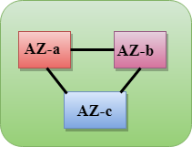
- Availability zones are connected through redundant and isolated metro fibers.
Edge Locations
- Edge locations are the endpoints for AWS used for caching content.
- Edge locations consist of CloudFront, Amazon's Content Delivery Network (CDN).
- Edge locations are more than regions. Currently, there are over 150 edge locations.
- Edge location is not a region but a small location that AWS have. It is used for caching the content.
- Edge locations are mainly located in most of the major cities to distribute the content to end users with reduced latency.
- For example, some user accesses your website from Singapore; then this request would be redirected to the edge location closest to Singapore where cached data can be read.
Regional Edge Cache
- AWS announced a new type of edge location in November 2016, known as a Regional Edge Cache.
- Regional Edge cache lies between CloudFront Origin servers and the edge locations.
- A regional edge cache has a large cache than an individual edge location.
- Data is removed from the cache at the edge location while the data is retained at the Regional Edge Caches.
- When the user requests the data, then data is no longer available at the edge location. Therefore, the edge location retrieves the cached data from the Regional edge cache instead of the Origin servers that have high latency.

Amazon S3 Concepts
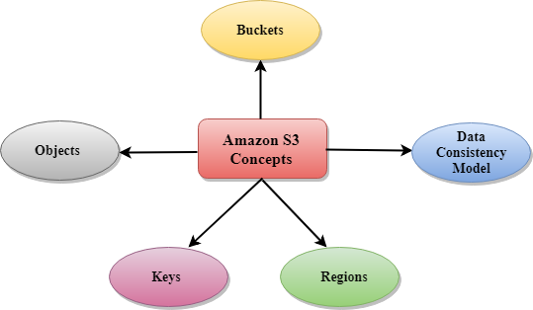
- Buckets
- Objects
- Keys
- Regions
- Data Consistency Model

- Buckets
  - A bucket is a container used for storing the objects.
  - Every object is incorporated in a bucket.
  - For example, if the object named photos/tree.jpg is stored in the treeimage bucket, then it can be addressed by using the URL http://treeimage.s3.amazonaws.com/photos/tree.jpg.
  - A bucket has no limit to the amount of objects that it can store. No bucket can exist inside of other buckets.
  - S3 performance remains the same regardless of how many buckets have been created.
  - The AWS user that creates a bucket owns it, and no other AWS user cannot own it. Therefore, we can say that the ownership of a bucket is not transferrable.
  - The AWS account that creates a bucket can delete a bucket, but no other AWS user can delete the bucket.
- Objects
  - Objects are the entities which are stored in an S3 bucket.
  - An object consists of object data and metadata where metadata is a set of name-value pair that describes the data.
  - An object consists of some default metadata such as date last modified, and standard HTTP metadata, such as Content type. Custom metadata can also be specified at the time of storing an object.
  - It is uniquely identified within a bucket by key and version ID.
- Key
  - A key is a unique identifier for an object.
  - Every object in a bucket is associated with one key.
  - An object can be uniquely identified by using a combination of bucket name, the key, and optionally version ID.
  - For example, in the URL http://jtp.s3.amazonaws.com/2019-01-31/Amazons3.wsdl where "jtp" is the bucket name, and key is "2019-01-31/Amazons3.wsdl"
- Regions
  - You can choose a geographical region in which you want to store the buckets that you have created.
  - A region is chosen in such a way that it optimizes the latency, minimize costs or address regulatory requirements.
  - Objects will not leave the region unless you explicitly transfer the objects to another region.
- Data Consistency Model
Amazon S3 replicates the data to multiple servers to achieve high availability.
Two types of model:
  - Read-after-write consistency for PUTS of new objects.
    - For a PUT request, S3 stores the data across multiple servers to achieve high availability.
    - A process stores an object to S3 and will be immediately available to read the object.
    - A process stores a new object to S3, it will immediately list the keys within the bucket.
    - It does not take time for propagation, the changes are reflected immediately.
  - Eventual consistency for overwrite PUTS and DELETES
    - For PUTS and DELETES to objects, the changes are reflected eventually, and they are not available immediately.
    - If the process replaces an existing object with the new object, you try to read it immediately. Until the change is fully propagated, the S3 might return prior data.
    - If the process deletes an existing object, immediately try to read it. Until the change is fully propagated, the S3 might return the deleted data.
    - If the process deletes an existing object, immediately list all the keys within the bucket. Until the change is fully propagated, the S3 might return the list of the deleted key.

ASP – Application Server Providers – will host a charge a subscription , pay for the amount of usage or meter pricing
Multi tenant
Subscription concept, subscription business model
Opex (Operating expenses which can written off) vs capex ( Capital expenses will have to depreciate)
SaaS is opex
SaaS saves money and time
SaaS speed of deployment
SaaS offer usage (trial or POC) and testing before buying
SaaS is growing as software is growing super fast. Mobile growth

Pricing
1 pay as you go
2 per user pricing
3 tier pricing
4 flat-rate pricing
5 feature based pricing
6 bundling
7 freemium pricing
8 Hybid pricing – combination of all prices

AWS docker kubernetes

Docker is a software platform that allows you to build, test, and deploy applications quickly. Docker packages software into standardized units called containers that have everything the software needs to run including libraries, system tools, code, and runtime. Using Docker, you can quickly deploy and scale applications into any environment and know your code will run.

Docker works by providing a standard way to run your code. Docker is an operating system for containers. Similar to how a virtual machine virtualizes (removes the need to directly manage) server hardware, containers virtualize the operating system of a server. Docker is installed on each server and provides simple commands you can use to build, start, or stop containers.
AWS services such as AWS Fargate, Amazon ECS, Amazon EKS, and AWS Batch make it easy to run and manage Docker containers at scale.

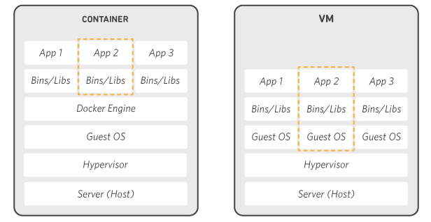

Q: What is the difference between Docker and a virtual machine?
Virtual machines (VMs) virtualize (or remove the need to directly manage) server hardware while containers virtualize the operating system of a server. Docker is an operating system (or runtime) for containers. The Docker Engine is installed on each server you want to run containers on and provides a simple set of commands you can use to build, start, or stop containers.
AWS provides support for both Docker open-source and commercial solutions.

Amazon ECS is a highly scalable, high-performance container orchestration service to run Docker containers on the AWS cloud.
AWS Fargate is a technology for Amazon ECS that lets you run Docker containers without deploying or managing infrastructure.

Amazon EKS makes it easy to run Kubernetes on AWS without needing to install and operate Kubernetes masters.
Amazon ECR is a highly available and secure private container repository that makes it easy to store and manage Docker container images
AWS Identity and Access Management (IAM) is a web service for securely controlling access to AWS services. With IAM, you can centrally manage users, security credentials such as access keys, and permissions that control which AWS resources users and applications can access.
Service of AWS
Compute
Storage and content delivery
Database
Networking
Developer tools
Management tools
Security & identity
Analytics
Internet of things IoT
Game development
Mobile services
Application services
Enterprise accplications
….
Global infrastructure
regions have availability zones (like a data center) , regions are connected by the AWS global network, with high bandwidth and fully redundant, does not use internet.
Pricing ; compute, storage, outbound data transfer

Kubernetes
Kubernetes is a portable, extensible, open-source platform for managing containerized workloads and services.
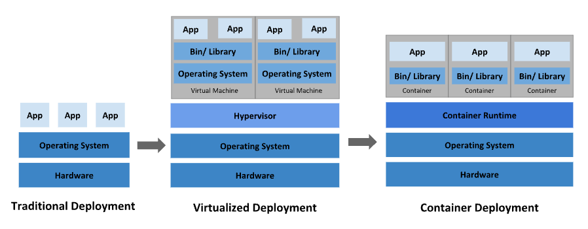
Traditional deployment era: Early on, organizations ran applications on physical servers.
Virtualized deployment era: It allows you to run multiple Virtual Machines (VMs) on a single physical server's CPU. Virtualization allows applications to be isolated between VMs and provides a level of security as the information of one application cannot be freely accessed by another application.
Container deployment era: Containers are similar to VMs, but they have relaxed isolation properties to share the Operating System (OS) among the applications. Therefore, containers are considered lightweight. Similar to a VM, a container has its own filesystem, share of CPU, memory, process space, and more. As they are decoupled from the underlying infrastructure, they are portable across clouds and OS distributions.
Containers are a good way to bundle and run your applications.
That's how Kubernetes comes to the rescue! Kubernetes provides you with a framework to run distributed systems resiliently.
Kubernetes provides you with:
Service discovery and load balancing Kubernetes can expose a container using the DNS name or using their own IP address. If traffic to a container is high, Kubernetes is able to load balance and distribute the network traffic so that the deployment is stable.
Storage orchestration Kubernetes allows you to automatically mount a storage system of your choice, such as local storages, public cloud providers, and more.
Automated rollouts and rollbacks You can describe the desired state for your deployed containers using Kubernetes, and it can change the actual state to the desired state at a controlled rate. For example, you can automate Kubernetes to create new containers for your deployment, remove existing containers and adopt all their resources to the new container.
Automatic bin packing You provide Kubernetes with a cluster of nodes that it can use to run containerized tasks. You tell Kubernetes how much CPU and memory (RAM) each container needs. Kubernetes can fit containers onto your nodes to make the best use of your resources.
Self-healing Kubernetes restarts containers that fail, replaces containers, kills containers that don't respond to your user-defined health check, and doesn't advertise them to clients until they are ready to serve.
Secret and configuration management Kubernetes lets you store and manage sensitive information, such as passwords, OAuth tokens, and SSH keys. You can deploy and update secrets and application configuration without rebuilding your container images, and without exposing secrets in your stack configuration.
Kubernetes Components
When you deploy Kubernetes, you get a cluster. A Kubernetes cluster consists of a set of worker machines, called nodes, that run containerized applications. Every cluster has at least one worker node.
The worker node(s) host the Pods that are the components of the application workload. The control plane manages the worker nodes and the Pods in the cluster. In production environments, the control plane usually runs across multiple computers and a cluster usually runs multiple nodes, providing fault-tolerance and high availability.
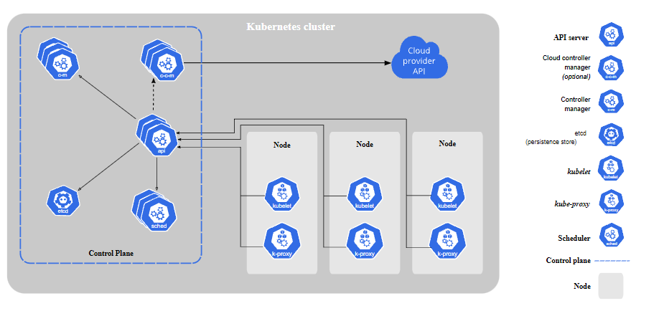
Control Plane Components
The control plane's components make global decisions about the cluster (for example, scheduling), as well as detecting and responding to cluster events (for example, starting up a new pod when a deployment's replicas field is unsatisfied).

Control plane components can be run on any machine in the cluster. However, for simplicity, set up scripts typically start all control plane components on the same machine, and do not run user containers on this machine. See Creating Highly Available clusters with kubeadm for an example control plane setup that runs across multiple VMs.

Docker
Use containers to Build, Share and Run your applications
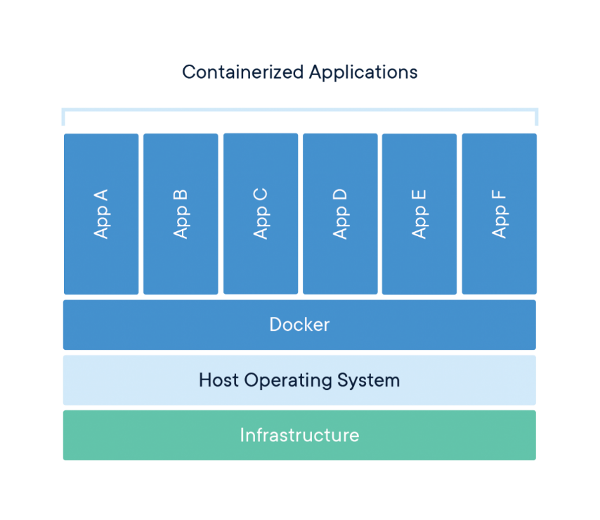
A container is a standard unit of software that packages up code and all its dependencies so the application runs quickly and reliably from one computing environment to another.
A Docker container image is a lightweight, standalone, executable package of software that includes everything needed to run an application: code, runtime, system tools, system libraries and settings.
Container images become containers at runtime and in the case of Docker containers - images become containers when they run on Docker Engine. Available for both Linux and Windows-based applications, containerized software will always run the same, regardless of the infrastructure.
Containers isolate software from its environment and ensure that it works uniformly despite differences for instance between development and staging.
Docker containers that run on Docker Engine:
Standard: Docker created the industry standard for containers, so they could be portable anywhere
Lightweight: Containers share the machine’s OS system kernel and therefore do not require an OS per application, driving higher server efficiencies and reducing server and licensing costs
Secure: Applications are safer in containers and Docker provides the strongest default isolation capabilities in the industry
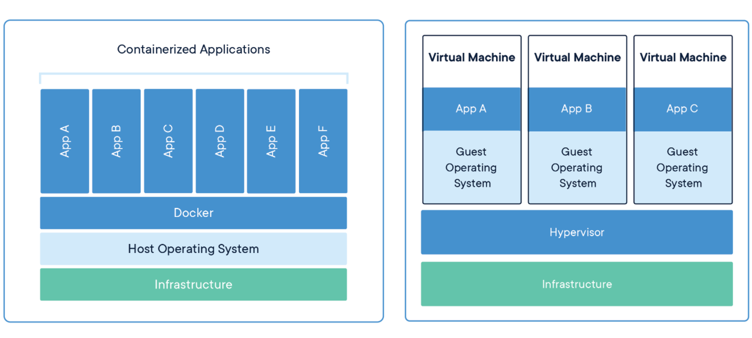
CONTAINERS
Containers are an abstraction at the app layer that packages code and dependencies together. Multiple containers can run on the same machine and share the OS kernel with other containers, each running as isolated processes in user space. Containers take up less space than VMs (container images are typically tens of MBs in size), can handle more applications and require fewer VMs and Operating systems.
VIRTUAL MACHINES
Virtual machines (VMs) are an abstraction of physical hardware turning one server into many servers. The hypervisor allows multiple VMs to run on a single machine. Each VM includes a full copy of an operating system, the application, necessary binaries and libraries - taking up tens of GBs. VMs can also be slow to boot.
-----
Docker Desktop is a one-click-install application for your OS environment that lets you build, share, and run containerized applications and microservices.
It provides a straightforward GUI (Graphical User Interface) that lets you manage your containers, applications, and images directly from your machine.
Docker Desktop reduces the time spent on complex setups so you can focus on writing code. It takes care of port mappings, file system concerns, and other default settings, and is regularly updated with bug fixes and security updates.

Docker Desktop integrates with your preferred development tools and languages, and gives you access to a vast ecosystem of trusted images and templates via Docker Hub. This empowers teams to accelerate development, automate builds, enable CI/CD workflows, and collaborate securely through shared repositories.
Features of Docker Desktop:
-Ability to containerize and share any application on any cloud platform, in multiple languages and frameworks.
-Quick installation and setup of a complete Docker development environment.
-Includes the latest version of Kubernetes.
-On Windows, the ability to toggle between Linux and Windows containers to build applications.
-Fast and reliable performance with native Windows Hyper-V virtualization.
-Ability to work natively on Linux through WSL 2 on Windows machines.
-Volume mounting for code and data, including file change notifications and easy access to running containers on the localhost network.
What is included on Docker Desktop:
-Docker Engine
-Docker CLI client
-Docker Scout
-Docker Build
-Docker Compose
-Ask Gordon
-Docker Extensions
-Docker Content Trust
-Kubernetes
-Credential Helper
Hyper-V and WSL (Windows Subsystem for Linux) are different technologies for running Linux environments on Windows. Hyper-V is a full-fledged virtualization platform that allows you to run other operating systems within virtual machines, while WSL provides a Linux environment within Windows without requiring a separate virtual machine.

