TLC
TLC is a log collection product - audit logger used for compliance, need to use normalization rules
SIEM product - database and correlation
TLC collects logs, classifies events, correlate changes and events, and responds to events by actions
TLC managers can be configured for; Collection, classification (application of tags), normalization, and correlation
A Collector is a module that either actively gathers or passively listens for log messages. To communicate with Log Sources, each Collector employs an appropriate protocol.
For Advanced File, SSL and TCP port 5670 are required. If Tripwire Axon Agent for TLC is installed on a Windows, AIX, or Linux system, this Collector may be used to gather log messages from any log-generating application running on the host system.
For Advanced Windows, SSL and TCP port 5670 are required. If Tripwire Axon Agent for TLC is installed on a Windows system, this Collector may be used to gather the system's Windows Event Logs.
For Check Point, OPSEC and LEA protocols and TCP port 18184 and UDP port 18184 are required. This type listens for log messages from a Check Point Manager.
For Cisco IDS, SDEE and TCP port 443 are required. This type gathers log messages from Cisco IDS sensors.
For Database, for MySQL TCP port 3306 is required. For MS-SQL TCP port 1433 is required. And for PostgreSQL TCP port 5432 is required. This type gathers log messages from an application that logs to an External Database.
For File, SMB requires TCP ports 135 to o139 and 445. SFTP requires TCP port 22. And FTP requires TCP port 21. This type gathers or receives log messages from Log Sources that store messages in an ASCII log file. Note that TLC can also collect compressed .zip and .tar.gz log files.
For Network, Syslog requires UDP port 514, and TCP ports 1468 and 6514. SNMP requires TCP port 162 and UDP port 162. This type listens for Syslog and SNMP-based messages from network devices.
For Oracle Database, TCP/IP requires port 1521. This type gathers log messages from Oracle database audit logs.
For WinLog, WMI requires TCP ports 135 and 1024 to 65535. This type gathers log messages from Windows Event Logs. However, for the collection of log messages from Windows Event Logs, Tripwire recommends the use of the Advanced Windows Collector, rather than the WinLog Collector.

There are two types of rules: Normalization and Correlation rules. Log messages first enter the TLC environment from a Log Source in a raw form (a string of unparsed text). TLC can store these log messages in the Audit Logger without changing their format. However, if messages will be stored in a TLC database or examined by a Correlation Engine they must be normalized.
Normalization is a process that uses the regular expression contained in a Normalization Rule to parse a raw log message and put it into a format which allows it to be stored in a TLC database.
A Correlation Rule is used to examine log messages and look for events of interest. Correlation Rules will be discussed later

install sql, sql studio, zulu
create a new user for tlc on ms sql
get license and perhaps add a second nic ( depending on license ip)
the autlogger file should go to another drive
install tlc manager - may install ms visual C++ 2013 and 2010 spi redistributable packages
put license under root dir, after install and before clicking the conf wizard, when done click on start
install console
when installing a remote console use the certificate name used on the manager, communication settings and the port
go to mgr and events database, and click on test connection

----
click on conf manager, resources, locations, add - home base,
then click on manager, double click manager, settings, change location to home base,
email,
ASK Customer? network collector, un-check enable autodiscovery
audit logger, click on separate data locations if you have multiple locations and want separate log and reporting
ensure audit logger is on another driver like D
then apply save, right click on primary manager and push to update
to quickly backup tlc goto data dir and copy tlc.vdb4 to somewhere

configure all manager tabs
to add users go to user administraion mgr, always specify email address

examine global settings, left pane, resources, then administration manager, then global settings
false positives, etc, session timeout (set it), manager audit logger, set gb storage tp 15%? 10%?
The events database is where correlated events go
all events go to the audit-logger
configure primary manager with installed modules, collectors, audit logger,
---
install axon agents or ip360 tcl
different collectors -
TLC network collector - for ip360 and agentless network devices for syslog
TLC WinLog collector -WMI legacy option. uses pull/push. dont use, as it is not reliable and only logs for main window, and not encrypted
TLC File Collector text based log file - ingest log application files
Advanced Windows collector - for tcl windows axon agent
Advanced file collector - Linux TLC axon agent
Download content every quarter, Options, import tlc content, Update
for te log and ip360 use tcp 1468
if you turn on the feature to select which events got to the event logger TLC will be out of compliance
Linux agents do not show under auto-discover
All assets must show under Monitored Assets , except linux agents
go to audit logger and run raw queries

create asset groups
The most efficient method to assign rules to TLC Assets is to place the Assets in Asset Groups, then assign the Normalization Rules to the Asset Groups. Txxxxxxxxxxxxxxxxxxxxxxxxxxxxxxxxxxxxxxxxxxxxxxxxxxxxxxxxxxxxxxxxxx
Module 3
add nodes to asset groups
---DONE with log collection---goto audit logger and run queries
Go to resources, correlation, rules and add to correlation engine
Authentication
NERC v3-v5
System audit
User audit
--DONE with correlation

add normalization rules to asset groups, goto asset groups, windows, and double click , add normalization rules, add windows 2006 and xp

add systems to asset groups
if we are missing normalization rules goto options, and browse file
move assets to asset groups and assign normalization rules to groups
--DONE with normalization

under conf mgr, under TE server, configure te server to be able to get te server for asset view
for TE TLC network collector collect syslog or TE application log files
Adv windows collector is for OS events
If you want TE log application events to go to any windows machine, on the asset group for windows, chose the system and add to TE group ( so that TE normalization rules are applied)
To check if a windows machine has TE audit data, go to audit logger, query, event name contains TE
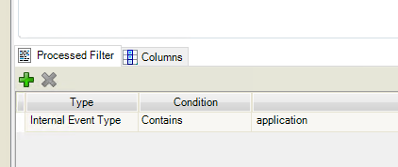
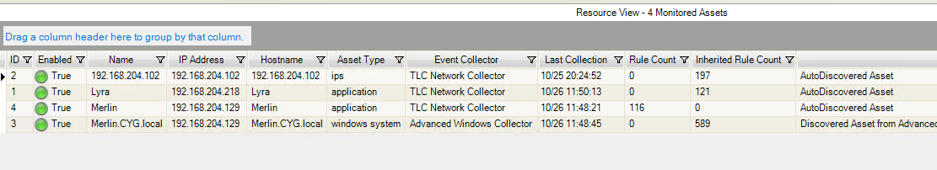
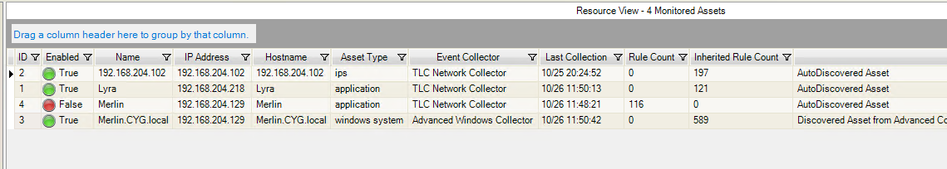

Bug - audit logger reports are missing. Options, import TLC content, under tasks, reports, queries
click on Tasks for event databases and Audit logger queries and reports, NERC v5 , and import

for ease of use, click on view, tabbed forms
then click on options, settings,
Misc - and click on - resol... limit... open dash...display mgr on tcl console
table settings - click on display source ip...

go to C:\Program Files\Tripwire\Tripwire Log Center Manager\Tripwire Axon Access Point\config
and add bridge

Adding the Resources, tripwire enterprise console gives you – recommend doing

correlation rules is the brain of TLC
5) databases or correlation engines, or auto logger ( output destinations)
Conf-mgr, databases,
Check on databases
1 create database – event database
name normalize_evt, enter db server, type Event database, ip, port, name normalized_evt,
2 create database – event database
name auditloggerdb, enter db server, type Event database, ip, port, name auditloggerdb,
3 create database – firewall database 9cant get loaded and big, purge frequently)
Name firewall_evt, enter db server type Firewall database, name firewall_evt,

the existing Events database is used by the correlation engine, all (correlated events from the correlation engine) events go here. Should be called incidents as multiple events could be reported as one single event, ex multiple logon failure followed by a successful logon
the mormalized-evt is used for all normalized events that are defined as an output of an asset. DO NOT point firewalls
the firewall_evt is used for firewalls ( could generate a ton of entries, purge frequently)
ensure all assets have output destinations, as Correlation engine, plus any database as normilaze_evt for non firewalls
go to resources, correlation, rules, select authentication or other rules, and add to correlation engine

go to conf mgr, then resources, then correlation, then correlation, then engine, then open engine

look all rules and add email or notification to which ever rules makes sense

now purging to maintain to database growth go to task mgr,
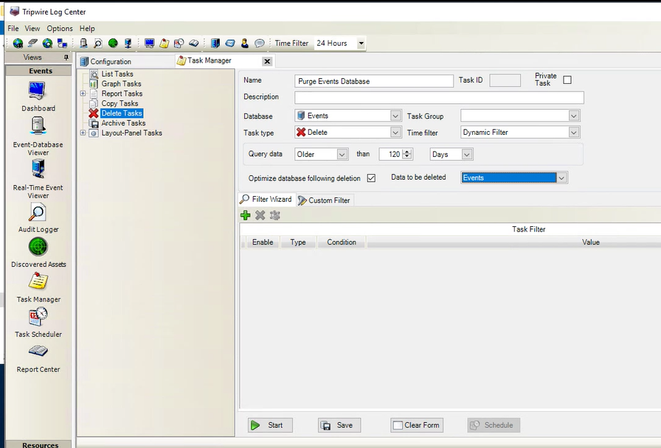
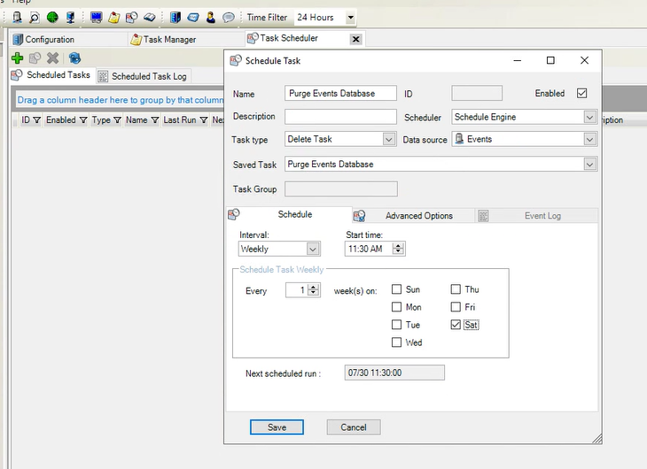

create an archive task for events database, task manager, add
Archive Events Database, , database vents, Output report, type, evebts by destination host grouped, click on advanced options event threshold _999

Archive Events database, task type archive task, data base source Events

TW-daily normalized events purge, choose normanilze_evt, task group - db maintenance, task type - Delete, Task filter DB Maintenance,
Older , 3(for fw) or 7 days (for windows) . This does not affect audit logger, just databases)
click on save
copy the task name and add it to the scheduler, then change task type to delete task, and choose ours
do that to all databases
TW-daily CE events purge, database events, DB Maintenance, Delete, Dynamic filter, older 3 months
The Events database will also have the correlation engine events and incidents.
then click on schedule and schedule it
go to audit logger, archive, then add a task
name TW-Audit Logger Archive, choose audit loger as AL, location ALL, choose AL output path, , choose different drive to archive and set output path, then 90 days or 1 year
Create the scheduled task; TW-Audit Logger Archive, Archive task, audit logger, daily and clieck on enable top right
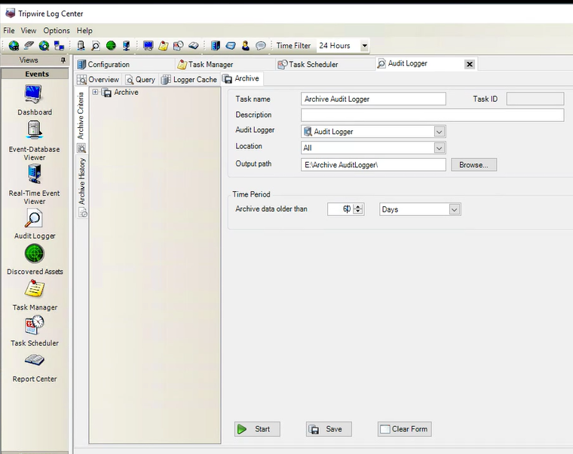
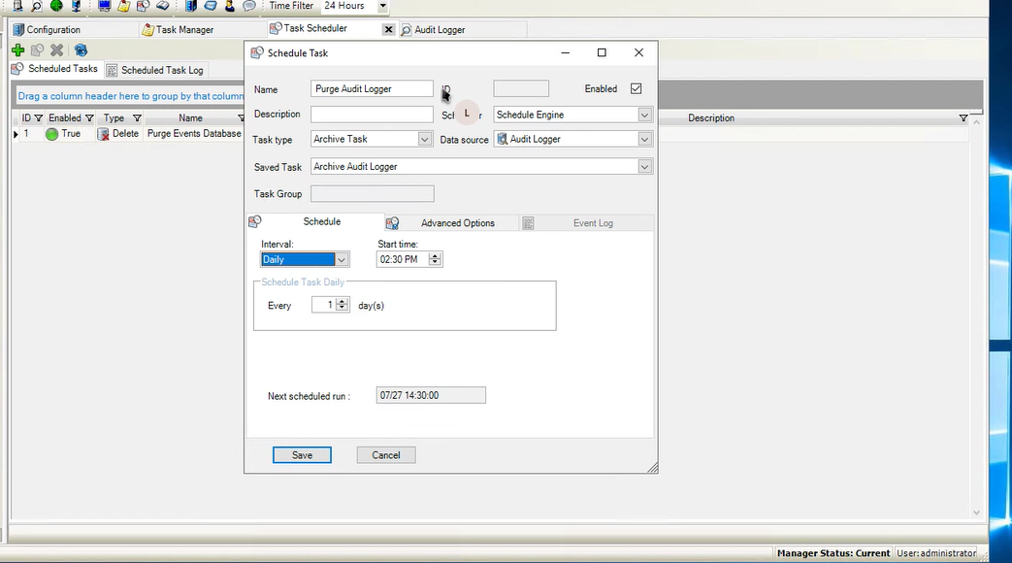

Real time event viewer is for auditLogger, change collector to adv win cool

Open a rule, then output email and add to the subject
Subject: TLC - Correlation Rule Name
Rule ID: <evt_rid>
Event Name: <evt_name>
Event Time: <evt_time>
Sensor: <hst_name>
Account Name: <evt_user>
Source IP: <evt_srcip>
Destination IP: <dvc_ip>
Event ID: <eventid>
Message: <message>

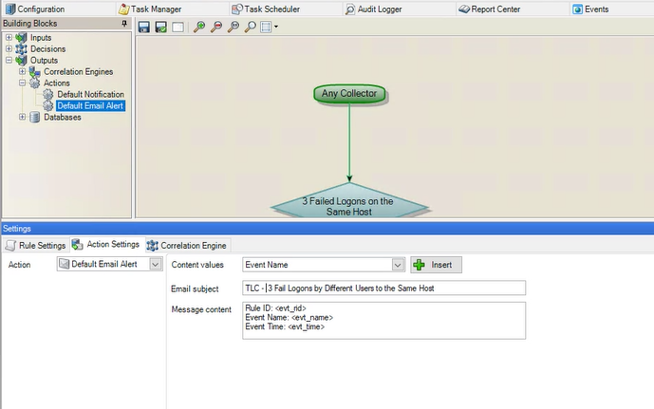

Firewall and Event databases are optimized differently - firewall is particularly well optimized for showing firewall events/the volume of events from firewall rules. As for splitting the Events DB - there's not necessarily a NEED to do so, but by doing so you can store events of different types separately to allow for faster searches/different retention needs- e.g. you might have a DB storing events that have been correlated (of which you'll get very few) for a longer period of time, and a shorter retention DB for normalised events that you use to help build context for investigations, etc.
The "Events" based SQL schema is used for correlated events. This same schema type, with a different database name (for example "Normalized_events") can be used for a few of their high value assets (not all assets as it is a performance issue). When the Normalized_Event database is applied as an output destination for an asset our asset group, TLC will only send all properly normalized log events to this database.
The same "Events Database Viewer" queries work on this schema type as well, so it can be visualized in TLC, just like the "Events" database.
Most customers only have an Events database. In fact, a SQL database is not 100% required for TLC to work, however, it does add value to the installation to retain those correlated incidents. I can tell the customer had a PS engagement IF they have the Normalized_events database in their environment.
Tripwire recommends creating a scheduled task in TLC to archive/delete data out of these databases per their compliance needs, while ensuring the box is checked to "Optimize Database post deletion"
6) create the assets, go to asset and create an asset, Cisco ASA number1. TLC network collector,
or create multiple assets
add output destination, all assets must have syslog - correlation engine, add to firewall db, advance tab add timezone ( all events are store in utc )
enable the generate a log mess if no mess received in x min for critical machines ( but not all)
synchronous connection method is better - more accurate, micro timing issue
for a windows machine, use output destination of windows event log for - correlation engine and also normalize_evt database
7) push updates to mgr

for nerc, options, browse, and get NERC correlation rules with output db events
and tasks/reports
conf mgr, then correlation rules,

show and pick authentication rules,
for non nerc 1012, 1011, 1005,8002
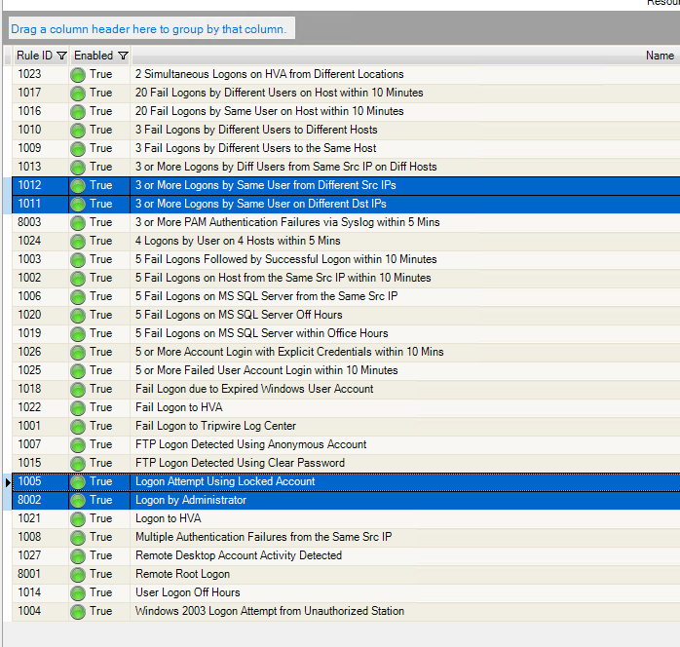
for nerc choose NERC rules chose all nerc, then assign to correlation engine

internal rules, 5002, 5001, 5005, 5009
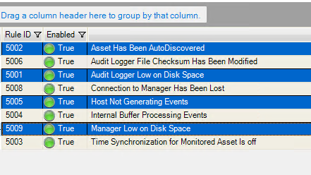
Pick those and assign to correlation engine
Correlation List – is a list of things
Nerc authorized cca users, populate list or use AD
Nerc default account
Nerc monitored assets, change field tyope to asset view saved filter and tad to TE asset filter, chose assets
Nerc terminated emp contractors, if AD is enabled choose it and then users

For non nerc change
Authorized users, high value asssets , hv asset ips, term emp work/contr

7 steps to create an asset
1) conf mgr, primary mgr, installed modules, make sure we hve the collector installed
2) normalization rules, ensure we have norm rules, best practice assign norm rules to asset groups not assets
go to asset groups and add your groups, vne, cisco ASA, TE, windows, then add norm rules
3) create asset groups
4) add locations and assign to assets
Done as part of log collection
Got to conf mgr, on all assets and configure Norm rules generate mess if no (int rule 5005)
For ad use 1 hr, wks 5 hrs

now go to event database viewer, normilize_evt databse and click on events,
if events are present that means normalization and correllation is working, correlation means alerted on events of interest and also leans autologger is working
click on audit logger, overview to see if it is collecting, and also query , start, click on reports and show
also save AL queries
report center is only for TLC not collection of data
for reports go to dashboard, then change display data and layout

under configuration mgr, correlation, normalized-messagefields, create a filter to filter our chatty messages
use firewall db as output destination (for chatty fw)

industry standard common event framework - used to store an event that does not have a raw format
click on list event process to see them processed

to create new reports, go to task manager, then report task, choose an existing report , change parameters and save it

audit logger is the one that gives me the most reports
show reports
show dashboards – Primary manager, then +, tehn add text panels, and choose , collector eps, Mgr srver sttus, Ststus pf Avd coll Assets, Shced tasks
per user per console

////

create task reports, on a database task type search, you can use use rule IDs
bad password, db normalize_evt, task group user audit, task type search, dynamic filter,
output - report, type - events by user - detailed
rule is = 81009

create panel layout byt using task type layout panel and time filter desktop time filter, then under the
events database viewer, you could add that panel

add a panels, you can use differnt outputs, and types
add one for top users,
event database, user audit
layout pnael , desktop time filter
text panel, top users
advanced options - hcange to 15

use the custom filter - copy from wizard to see/modify the sql query

dashboards,
- performance dashboard, primary manager then select new layout, add a time graph panels
audit logger status, collector buffers
correlation eng status, event process status
if no line (buffer) appers or peak and valleys that is ok
if a buffer line gors to 20kk and stay theew, tlc is not processing events fast enough
save the layout

- text panel, status of avd collector assets,
save as advance collector status

if the customer is not using advance collector status, then create a new one
- text panel, windows host status

go to the events database view, add a new layout,
map panels, source IP and dest ip maps
save as maps

to setup archive audit lgger

on the audit logger, create a new task, add a task to archive to 90 days
TW-Audit Logger Archive
audit logger, 90 days
save and then add to task scehduler
type - archive task, audit logger
if the customer desires to get back the archives data or folder, find the data or folder and drop under the
tlc, progrsm files, tripwire, tipwire, audit loggrrer jop, restore.
TLC will restore that automatically. if it can not be resrore, it will move it to the die notrestored

recommend on audit logger, query, 10 30 mins per day looking at data
you can save the query

correlation rules are used to look for events, single or sequence the events database receive these events from
correlation engine
if you open the rule, you can change it to say add an email alert

under configuration, actions, create a user action for each rule group
and use threshold of 20 per hours

which correlation rules should we activate
if we have a vuln scanner and we are colleting, do not use vuln, herbleed, shellsock,
important are user audit, activate all except off hours, ( add email action)
ask the customer which ones to activate and email action?

Collectors -
assets have a collector configured

first/second manager shares the tcldvb4 file every hour.

-----------------------------------------------TLC integration with Ip360
admincli on ip360 configure TLC
on tlc, import the content zipped file from TWCC, under content for TLC, choose latest content

choode advanced file collector,

To collect VnE operational logs, complete the following steps:
Step 1. Configure the Tripwire VnE Manager (on the next page)
Step 2. Import Tripwire-defined Normalization Rules (on page 15)
Step 3. Add the Advanced File Collector (on page 17)
Step 4. Create a Monitored Asset for the VnE Manager (on page 18)

To collect IP360 scan results, complete the following steps:
Step 1. Configure the TLC Manager (on page 21)
Step 2. Create a Monitored Asset for the VnE Manager (on page 23)
Step 3. Create a Monitored Asset for each IP360 Log Source (on page 25)
Step 4. Collect IP360 Scan Results (on page 26)

