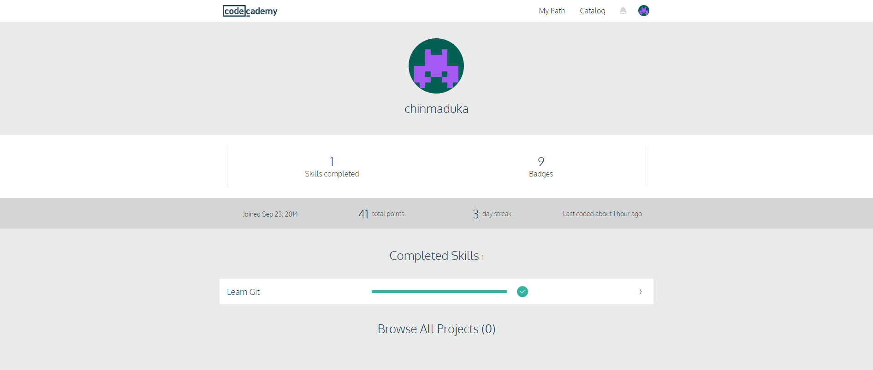

Task #2 of project one enhanced my comprehension level of the fundamental concepts involved in utilizing the GitHub application. The Codecademy course enhanced my knowledge by providing thorough hands on application of the GitHub software. This preliminary segment of the course introduced basic Git terminology, such as git init, which is a command that instructs that GitHub repository to begin monitoring modifications constructed on a given project. The course provided instructions on how to commit changes to the GitHub repository based on standard conventions. The course also provided information on commands that allows the user to review earlier versions of a committed transaction.

As the course progressed, I acquired a better understanding on the functionalities provided by the GitHub repository. I learned how to backtrack data stored on the repository for situations where an individual wanted to retract changes created to a file stored on the GitHub repository. I also learned about the reset functionality that allows users to retract changes made to a working directory. I learned how to merge branch files to the head file in the repository. Finally, I acquired information about functionality that users might utilize in a GitHub team environment. This segment of the course informed me of commands I may use in remote locations, such as the fetch, push and clone commands. The clone command allows administrative users to replicate data in a similar branch for multiple users to access remotely.