Task 5 was a very rigorous segment in the project. I encountered several obstacles along the way. I did not have any previous knowledge in the Fortran77 legacy system’s source code prior to attempting to reverse engineer the system to a presentable Java code. I also found it complicated to correlate the requirement to the Fortran77 source code. However, the workflow diagram was extremely beneficial in the exercise.

I believe this exercise provided me with an efficient application of an industry related software-testing environment. I discovered that the Java software-testing environment requires additional Java plug-ins in order to implement efficient test. Unfortunately, during this test I did not have the opportunity to implement the Javadoc Generator because my Java source code possessed several syntactical errors. However, I did capture an image of my attempt to run the Javadoc Generator.

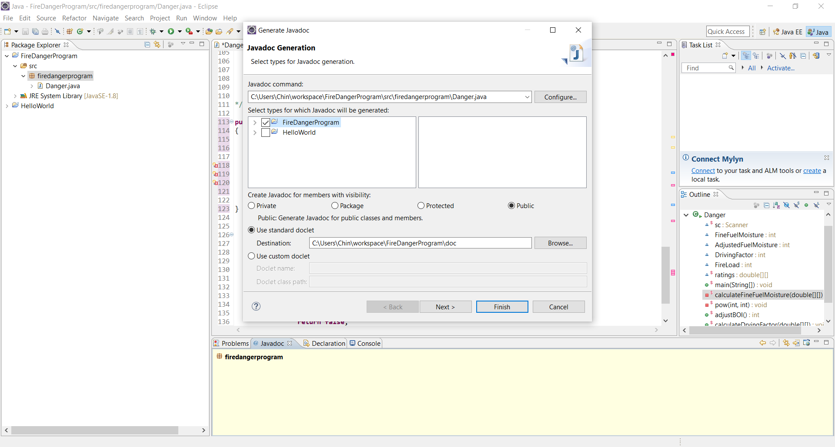

Concluding this project enhanced my understanding of a software-testing environment. I learned that a typical software tester must first understand the previous code, develop a feasible code in the new environment, and utilize several tools to effectively document, test and maintain the new system. I believe I can develop effective testing environments based on the knowledge I have acquired through this project.