PROJECTS — SOFTWARE / WEBSITE DOCUMENTATION
Eneh Chinonso Emmanuella — Personal Portfolio Website
Field | Detail
Project | Eneh Chinonso Emmanuella — Personal Portfolio
URL
Pagination (this document) | 4 pages — see Section 0.1 below
Technology | Frontend: HTML5, CSS3 (static site, no JavaScript or backend present in current build)
Application Type | Static website — no database connected
Included in this document | Screenshots, Description & Overview, Workflows, Other Details

Note: the current build uses only HTML and CSS with no JavaScript or database layer, so the Technology and Application Type fields above reflect the actual code rather than a MERN-stack setup. Update these fields if the project is later extended with JavaScript, an API, or a database.

0.1 Document Pagination
- Page 1 — Cover / metadata
- Page 2 — Home/Landing Page section: overview, screenshots, Menu Section (1.1) with items 1.1.1–1.1.5
- Page 3 — Hero, Projects, Contact, Footer sub-sections (1.2–1.5)
- Page 4 — About Page section (2.0–2.3), screenshot, and start of Site Map (3.0)
- Page 5 — Site Map (continued) and Other Details (4.0)

1.0 Home / Landing Page (index.html)
The Home/Landing page is the entry point of the site. It includes the Menu (navbar), Hero section, Hero showcase video, Projects grid, Contact form, and Footer, all in a single HTML file.

Screenshot — Landing / Home Page
[ Screenshot Placeholder — Landing / Home Page (top of page) ]
Insert actual screenshot here b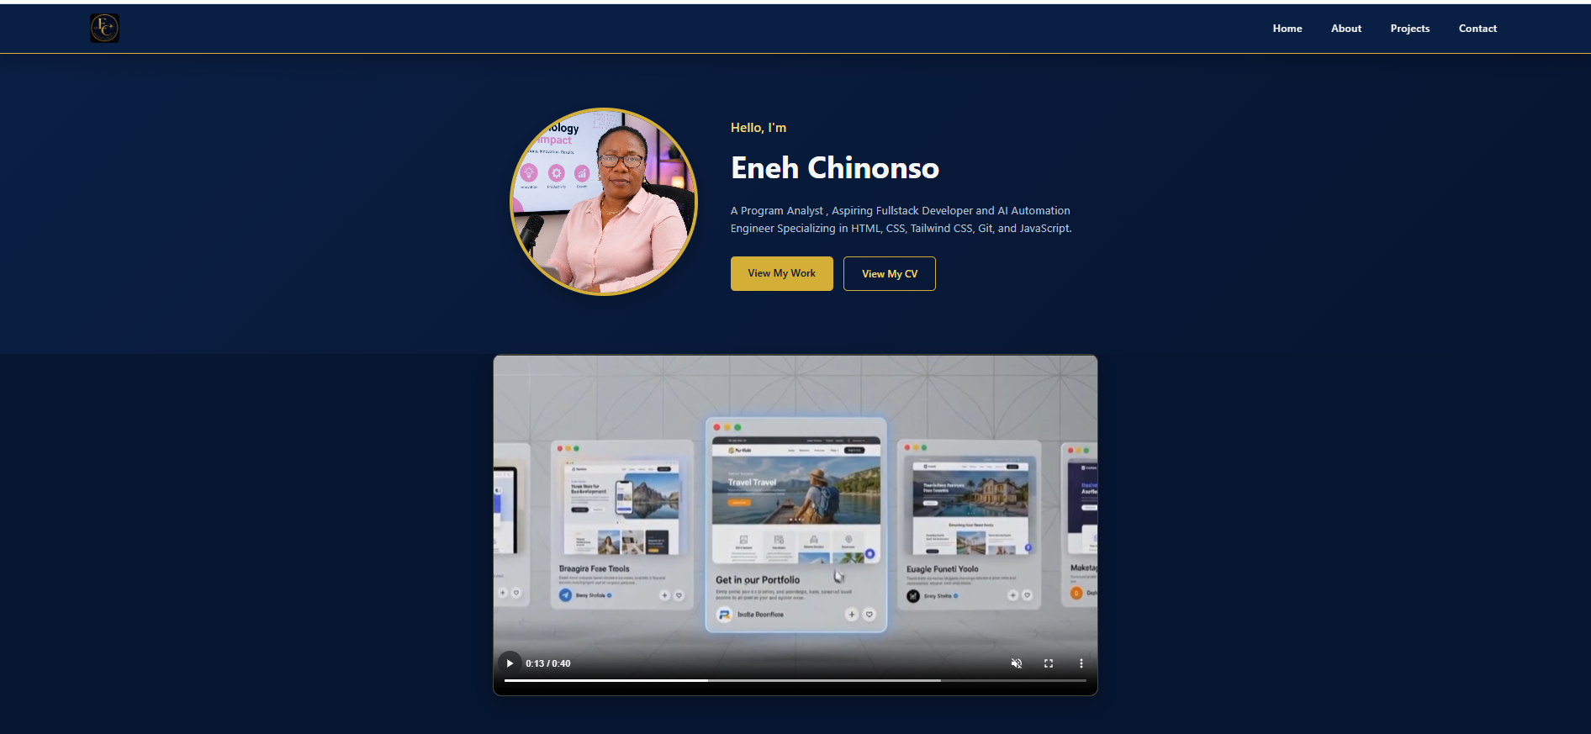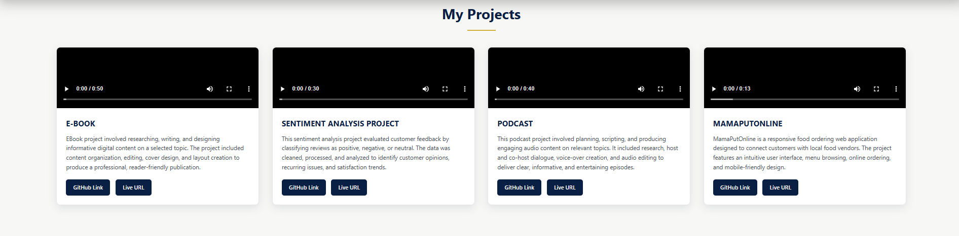efore submitting

Screenshot — Contact Section
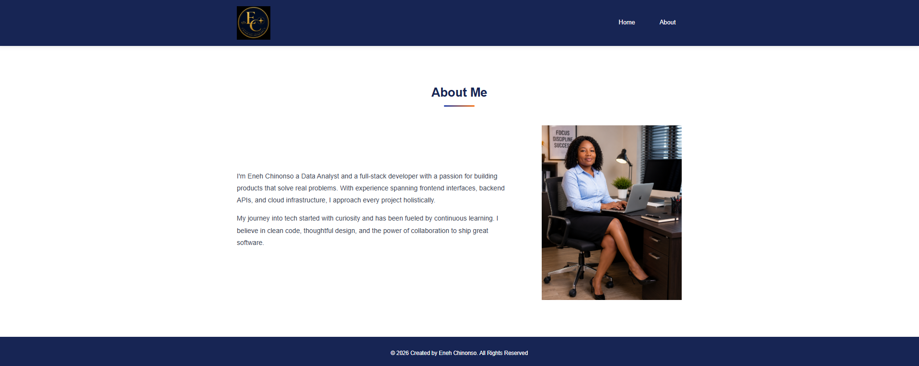

1.1 Menu Section

Overview
This section sits at the very top of the landing/home page and occupies 100% of the page width. It is presented as a dark, borderless bar. The corporate logo sits at the extreme left, while four clickable navigation links sit toward the right: Home, About, Projects, and Contact.

Comment 1 — This section sits on top of the landing page.
Comment 2 — The section spans the full width of the page in a single dark bar with no visible borders.
Comment 3 — The logo sits at the top-left corner while the remaining menu items sit on the right-hand side.
Comment 4 — Apart from the logo, each item is clickable. Home and About navigate to separate pages; Projects and Contact scroll to in-page anchor sections rather than opening new pages.

1.1.1 – 1.1.5 Menu Items
1.1.1 Eneh Chinonso Logo — brand mark, top-left corner, not a link target
1.1.2 Home — anchor link to the top of the current (Home) page
1.1.3 About — link to the separate About page (about.html)
1.1.4 Projects — anchor link scrolling down to the Projects grid (#projects) on the same page
1.1.5 Contact — anchor link scrolling down to the Contact form (#contact) on the same page

1.2 Hero Section
Directly below the menu, the Hero section introduces the site owner. It uses a two-column layout: a portrait photo on one side, and on the other a greeting heading ("Hello, I'm"), the full name as the main heading, a short paragraph describing the role and tech stack, and two call-to-action buttons — "View My Work" (scrolls to Projects) and "View My CV" (opens the résumé PDF in a new tab).

1.3 Projects Section (#projects)
Below the Hero video, a responsive grid presents four project cards: E-Book, Sentiment Analysis, Podcast, and MamaPutOnline. Each card contains a demo video with a poster image, a short description of the project, and two buttons — GitHub Link and Live URL.

1.4 Contact Section (#contact)
This section contains a form with Name, Email, and Message fields plus a Send Message button, alongside a contact block listing an email address and social links (LinkedIn, GitHub, TikTok).

1.5 Footer
A single-line footer with the copyright notice appears at the bottom of the page and is consistent across both pages of the site.

2.0 About Page (about.html)
The About page is a separate HTML file reached via the Home/Landing page's menu. It reuses the same menu pattern as the Home page and presents a short biography alongside a profile photo.

Screenshot — About Page
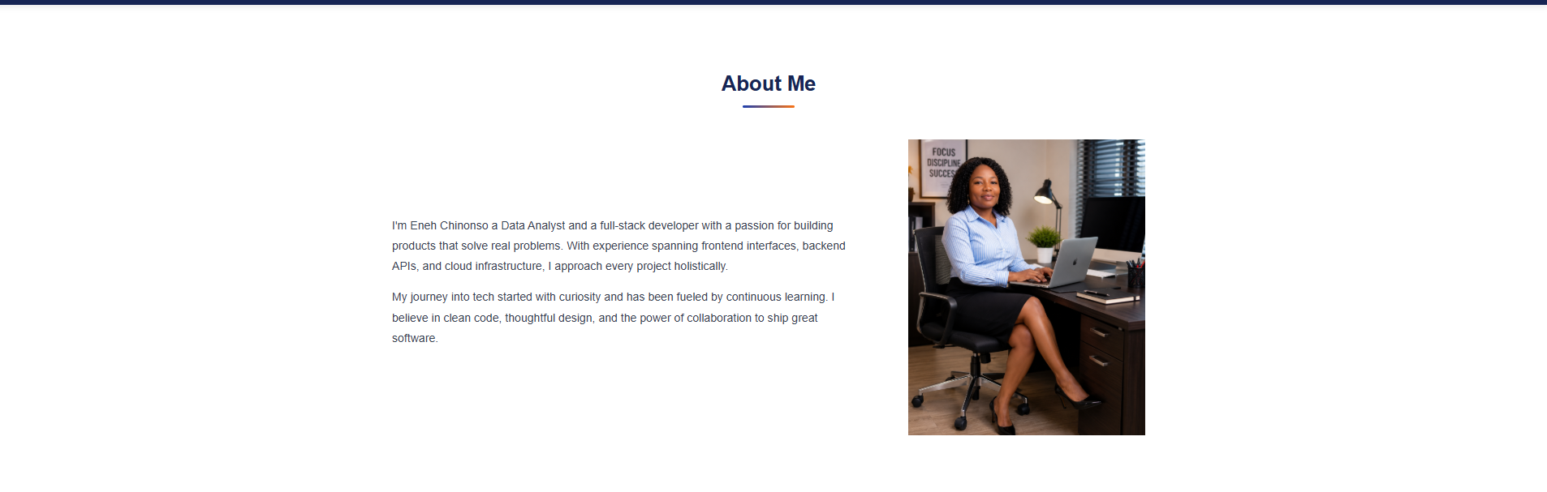

2.1 Menu Section
Same navbar pattern as the Home page: logo at top-left, links at top-right. On this page, only Home and About are visible; Projects and Contact links are present in the code but currently commented out, since those sections live on the Home page rather than here.

2.2 About Section (#about)
Two paragraphs of biography describing background and approach to development, displayed alongside a profile photograph.

2.3 Footer
Matches the Home page footer — same copyright notice and styling.

3.0 Site Map / Page Structure
The site consists of 2 HTML files. Projects and Contact are presented as in-page sections on the Home/Landing page rather than separate files, so they are documented here as sub-sections (1.3 and 1.4 above) instead of standalone numbered pages.
# | Page / Section | File | Type
1.0 | Home / Landing Page | index.html | Standalone page
1.1 | Menu Section | index.html | Component on page 1.0
1.2 | Hero Section | index.html | Component on page 1.0
1.3 | Projects Section | index.html (#projects) | In-page anchor, not a separate file
1.4 | Contact Section | index.html (#contact) | In-page anchor, not a separate file
1.5 | Footer | index.html | Component on page 1.0
2.0 | About Page | about.html | Standalone page

4.0 Other Details
- Number of standalone HTML files: 2 (index.html, about.html)
- Number of navigable sections (pages + anchors): 4 — Home, About, Projects, Contact
- No JavaScript interactivity or backend/database is present in the current build
- Known outstanding items (placeholder links, unwired contact form, inconsistent stylesheets) are tracked separately in the companion Software Documentation file

