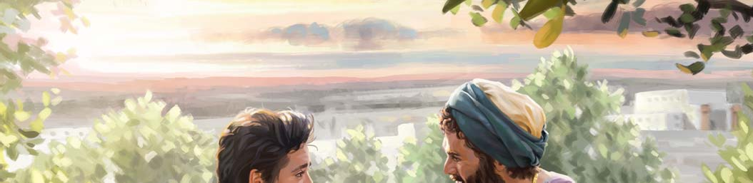
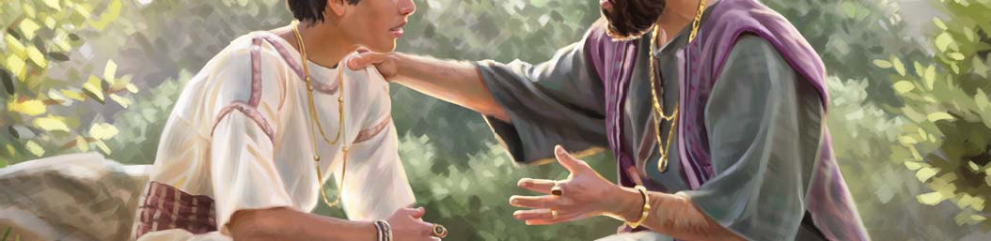
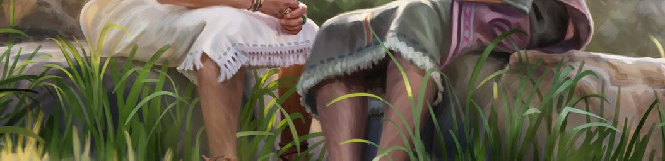
OUR CHRISTIAN LIFE AND MINISTRY

M EET I N G WOR K BOOK

JANUARY-FEBRUARY 2025

JANUARY 6 - 12 | PSALMS 127- 134 2
Song 134 and Prayer | Opening Comments (1 min.)

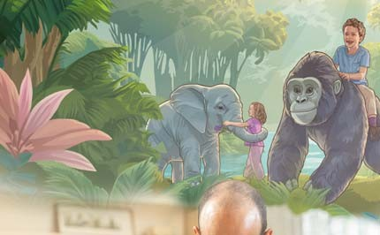

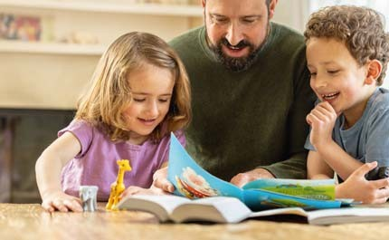
FROM GOD’S WORD
TREASURES
______________________________________________________________________________________________________________________________________________________________________________________________________________________________________________________________________________________________________________________________________________________________________________________________________________________________________________________________________________________________________________________________________________________________________________________________________________________________________________________________________________________________________________________________________________________________________________________________________________________________________________________________________________________________________________________________________________________________________________________________________________________________________________________________________________________________________________________________________________________________________________________________________________________________________________________________________________________________________________________________________________________________________________________________________________________________________________________________________________________________________________________________________________________________________________________________________________________________________________________________________________________________________________________________________________________________________________________________________________________________________________________________________________________________________________________________________________________________________________
1. Parents—Continue to Care for Your Precious Inheritance (10 min.)
Parents can count on Jehovah’s help to care for the needs of their family (Ps 127:1, 2)
Children are a precious gift from Jehovah (Ps 127:3; w21.08 5 ˚9)
Train each child according to his individual needs (Ps 127:4; w19.12 27 ˚20)
Jehovah appreciates it when parents *
rely on him and do their best to
care for their children

- Spiritual Gems (10 min.)
Ps 128:3—Why does the psalmist compare sons to the shoots, or slips, of an olive tree? (it-1 543)

What spiritual gems from this week’s Bible reading would you like to share?

- Bible Reading (4 min.)
Ps 132:1-18 (th study 2)

APPLY YOURSELF
TO THE FIELD MINISTRY

______________________________________________________________________________________________________________________________________________________________________________________________________________________________________________________________________________________________________________________________________________________________________________________________________________________________________________________________________________________________________________________________________________________________________________________________________________________________________________________________________________________________________________________________________________________________________________________________________________________________________________________________________________________________________________________________________________________________________________________________________________________________________________________________________________________________________________________________________________________________________________________________________________________________________________________________________________________________________________________________________________________________________________________________________________________________________________________________________________________________________________________________________________________________________________________________________________________________________________________________________________________________________________________________________________________________________________________________________________________________________________________________________________________________________________________________________________________________________________
- Starting a Conversation (3 min.) INFORMAL WITNESSING. (lmd lesson 1 point 3)
- Starting a Conversation (4 min.)
INFORMAL WITNESSING. The person expresses a belief that conflicts with a Bible teaching. (lmd lesson 5 point 4)
- Making Disciples (5 min.)
lff lesson 16 points 4-5. Discuss with your student the arrangements you have made for his study while you are away. (lmd lesson 10 point 4)

3

LIVING
i
AS CHRISTIANS
___________________________________________________________________________________________________________________________________________________________________________________________________________________________________________________________________________________________________________________________________________________________________________________________________________________________________________________________________________________________________________________________________________________________________________________________________________________________________________________________________________________________________________________________________________________________________________________________________________________________________________________________________________________________________________________________________________________________________________________________________________________________________________________________________________________________________________________________________________________________________________________________________________________________________________________________________________________________________________________________________________________________________________________________________________________________________________________________________________________________________________________________________________________________________________________________________________________________________________________________________________________________________________________________________________________________________________________________________________________________________________________________________________________________________________________________________________________________________________________________________________________________________________________________________________________________________________________________________________________________________________________________________________________________________________________________________________________________________________________________________________________________________________________________________________________________________________________________________________________________________________________________________________________________________________________________________________________________________________________________________________________________________________________________________________________________________________________________________________________________________________________________________________________________________________________________________________________________________________________________________________________________________________________________________________________________________________________________________________________________________________________________________________________________________________________________________________________________________________________________________________________________________________________________________________________________________________________________________________________________________________________________________________________________________________________________________________________________________________________________________________________________________________________________________________________________________________________________________________________________________________________________________________________________________________________________________________________________________________________________________________________________________________________________________________________________________________________________________________________________________________________________________________________________________________________________________________________________________________________________________________________________________________________________________________________________________
Song 13
- Parents—Are You Using This Powerful Teaching Tool? (15 min.) Discussion.
Jehovah’s organization has published a great deal of material to help parents teach their children about Jehovah. Still, one of the most powerful tools that parents possess is their good example.—De 6:5-9.
By your example, you can teach your children to . . .
- make good decisions regarding entertainment, alcohol, and the use of social media
- put spiritual things first
- treat a marriage mate with love and respect
Jesus used this powerful tool to teach his disciples.
Read John 13:13-15. Then ask the audience:
  - Why do you think Jesus’ method of teaching by example was effective?


As a parent, your actions can reinforce the things that you teach your child orally. Your good example also builds respect for what you teach and can motivate your children to listen.
Play the VIDEO Teaching Our Children by Example. Then ask the audience:
  - What important lessons did Brother and Sister Garcia teach their daughters?

  - How does this video motivate you to continue setting a good example for your children?

- Congregation Bible Study (30 min.)
bt chap. 20 ˚13-20

Song 2 and Prayer | Opening Comments (1 min.)

TREASURES

FROM GOD’S WORD
______________________________________________________________________________________________________________________________________________________________________________________________________________________________________________________________________________________________________________________________________________________________________________________________________________________________________________________________________________________________________________________________________________________________________________________________________________________________________________________________________________________________________________________________________________________________________________________________________________________________________________________________________________________________________________________________________________________________________________________________________________________________________________________________________________________________________________________________________________________________________________________________________________________________________________________________________________________________________________________________________________________________________________________________________________________________________________________________________________________________________________________________________________________________________________________________________________________________________________________________________________________________________________________________________________________________________________________________________________________________________________________________________________________________________________________________________________________________________________

“Our Lord Is Greater Than All Other Gods” (10 min.)
Jehovah has demonstrated his control over all creation (Ps 135:5, 6; it-2 661 ˚4-5)
He defends his people (Ex 14:29-31; Ps 135:14)
He is there for us when we are down (Ps 136:23; w21.11 6 ˚16)

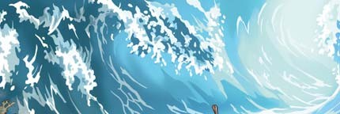
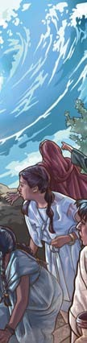
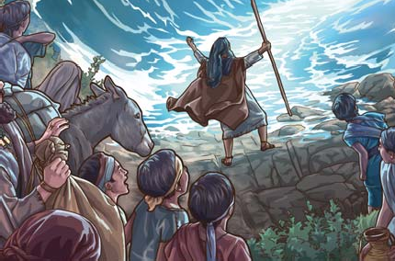
- Spiritual Gems (10 min.)
Ps 135:1, 5—Why is the expression “Jah” often used in the Bible? (it-1 1248)

What spiritual gems from this week’s Bible reading would you like to share?

- Bible Reading (4 min.)
Ps 135:1-21 (th study 11)

APPLY YOURSELF

TO THE FIELD MINISTRY
______________________________________________________________________________________________________________________________________________________________________________________________________________________________________________________________________________________________________________________________________________________________________________________________________________________________________________________________________________________________________________________________________________________________________________________________________________________________________________________________________________________________________________________________________________________________________________________________________________________________________________________________________________________________________________________________________________________________________________________________________________________________________________________________________________________________________________________________________________________________________________________________________________________________________________________________________________________________________________________________________________________________________________________________________________________________________________________________________________________________________________________________________________________________________________________________________________________________________________________________________________________________________________________________________________________________________________________________________________________________________________________________________________________________________________________________________________________________________________
- Starting a Conversation (3 min.)
INFORMAL WITNESSING. Exchange contact information with a person who shows
- Following Up (4 min.)
HOUSE TO HOUSE. Invite the person to a meeting. (lmd lesson 9 point 4)
- Explaining Your Beliefs (5 min.)
Demonstration. ijwfq article 7—Theme: Are Jehovah’s Witnesses Christians? (th study 12)

LIVING
i
AS CHRISTIANS
______________________________________________________________________________________________________________________________________________________________________________________________________________________________________________________________________________________________________________________________________________________________________________________________________________________________________________________________________________________________________________________________________________________________________________________________________________________________________________________________________________________________________________________________________________________________________________________________________________________________________________________________________________________________________________________________________________________________________________________________________________________________________________________________________________________________________________________________________________________________________________________________________________________________________________________________________________________________________________________________________________________________________________________________________________________________________________________________________________________________________________________________________________________________________________________________________________________________________________________________________________________________________________________________________________________________________________________________________________________________________________________________________________________________________________________________________________________________________________
Song 10
- Local Needs (15 min.)
- Congregation Bible Study (30 min.)
bt chap. 21 ˚1-7, box on p. 166

TREASURES

FROM GOD’S WORD
_______________________________________________________________________________________________________________________________________________________________________________________________________________________________________________________________________________________________________________________________________________________________________________________________________________________________________________________________________________________________________________________________________________________________________________________________________________________________________________________________________________________________________________________________________________________________________________________________________________________________________________________________________________________________________________________________________________________________________________________________________________________________________________________________________________________________________________________________________________________________________________________________________________________________________________________________________________________________________________________________________________________________________________________________________________________________________________________________________________________________________________________________________________________________________________________________________________________________________________________________________________________________________________________________________________________________________________________________________________________________________________________________________________________________________________________________________________________________________________

Do Not Let Nervousness Hold You Back
(10 min.)
We want to praise Jehovah with all our heart (Ps 138:1)
When you feel nervous about participating in a meeting, rely on Jehovah for help (Ps 138:3)
Being nervous can be a good sign (Ps 138:6; w19.01 10 ˚10)
_
TIP: Keeping our comments brief can help reduce our anxiety.—w23.04 21 ˚7.

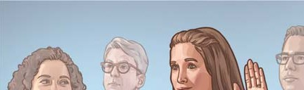


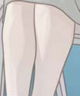
- Spiritual Gems (10 min.)
Ps 139:21, 22—Are Christians required to forgive everyone? (it-1 862 ˚4)

What spiritual gems from this week’s Bible reading would you like to share?

- Bible Reading (4 min.)
Ps 139:1-18 (th study 2)

APPLY YOURSELF

TO THE FIELD MINISTRY
_______________________________________________________________________________________________________________________________________________________________________________________________________________________________________________________________________________________________________________________________________________________________________________________________________________________________________________________________________________________________________________________________________________________________________________________________________________________________________________________________________________________________________________________________________________________________________________________________________________________________________________________________________________________________________________________________________________________________________________________________________________________________________________________________________________________________________________________________________________________________________________________________________________________________________________________________________________________________________________________________________________________________________________________________________________________________________________________________________________________________________________________________________________________________________________________________________________________________________________________________________________________________________________________________________________________________________________________________________________________________________________________________________________________________________________________________________________________________________________
- Starting a Conversation (3 min.)
PUBLIC WITNESSING. (lmd lesson 2 point 3)
- Making Disciples (4 min.)
PUBLIC WITNESSING. Offer and demonstrate a Bible study. (lmd lesson 10 point 3)
- Talk (5 min.)
ijwyp article 105—Theme: How Can I Over- come Shyness? (th study 16)

LIVING
i
AS CHRISTIANS
______________________________________________________________________________________________________________________________________________________________________________________________________________________________________________________________________________________________________________________________________________________________________________________________________________________________________________________________________________________________________________________________________________________________________________________________________________________________________________________________________________________________________________________________________________________________________________________________________________________________________________________________________________________________________________________________________________________________________________________________________________________________________________________________________________________________________________________________________________________________________________________________________________________________________________________________________________________________________________________________________________________________________________________________________________________________________________________________________________________________________________________________________________________________________________________________________________________________________________________________________________________________________________________________________________________________________________________________________________________________________________________________________________________________________________________________________________________________________________
Song 59

You Can Thrive in Your Ministry Despite Being Shy (15 min.)
Discussion. (See p. 16.)
- Congregation Bible Study (30 min.)
bt chap. 21 ˚8-13, box on p. 169

Song 44 and Prayer | Opening Comments (1 min.)




2. Spiritual Gems (10 min.)
FROM GOD’S WORD
TREASURES
______________________________________________________________________________________________________________________________________________________________________________________________________________________________________________________________________________________________________________________________________________________________________________________________________________________________________________________________________________________________________________________________________________________________________________________________________________________________________________________________________________________________________________________________________________________________________________________________________________________________________________________________________________________________________________________________________________________________________________________________________________________________________________________________________________________________________________________________________________________________________________________________________________________________________________________________________________________________________________________________________________________________________________________________________________________________________________________________________________________________________________________________________________________________________________________________________________________________________________________________________________________________________________________________________________________________________________________________________________________________________________________________________________________________________________________________________________________________________________
1. Act in Harmony With Your Pleas for Help (10 min.)
Be willing to accept advice or counsel (Ps 141:5; w22.02 12 ˚13-14)
Meditate on Jehovah’s acts of deliverance (Ps 143:5; w10 3/15 32 ˚4)
Strive to see things as Jehovah does (Ps 143:10; w15 3/15 32 ˚2)
_
Psalms 140-143 contain not only David’s pleas for help but also expressions that show that he acted in harmony with his pleas.
Ps 140:3—Why does David liken the tongue of evil men to that of a serpent? (it-2 1151)

What spiritual gems from this week’s Bible reading would you like to share?
APPLY YOURSELF
TO THE FIELD MINISTRY

______________________________________________________________________________________________________________________________________________________________________________________________________________________________________________________________________________________________________________________________________________________________________________________________________________________________________________________________________________________________________________________________________________________________________________________________________________________________________________________________________________________________________________________________________________________________________________________________________________________________________________________________________________________________________________________________________________________________________________________________________________________________________________________________________________________________________________________________________________________________________________________________________________________________________________________________________________________________________________________________________________________________________________________________________________________________________________________________________________________________________________________________________________________________________________________________________________________________________________________________________________________________________________________________________________________________________________________________________________________________________________________________________________________________________________________________________________________________________________
- Starting a Conversation (4 min.)
INFORMAL WITNESSING. Initiate a conversation after helping a person in a practical way. (lmd lesson 3 point 5)
- Following Up (3 min.)
PUBLIC WITNESSING. The person tells you that he is busy. (lmd lesson 7 point 3)
- Explaining Your Beliefs (5 min.)
Demonstration. ijwfq article 21—Theme: Why Don’t Jehovah’s Witnesses Accept Blood Transfusions? (th study 7)

LIVING
i
AS CHRISTIANS
___________________________________________________________________________________________________________________________________________________________________________________________________________________________________________________________________________________________________________________________________________________________________________________________________________________________________________________________________________________________________________________________________________________________________________________________________________________________________________________________________________________________________________________________________________________________________________________________________________________________________________________________________________________________________________________________________________________________________________________________________________________________________________________________________________________________________________________________________________________________________________________________________________________________________________________________________________________________________________________________________________________________________________________________________________________________________________________________________________________________________________________________________________________________________________________________________________________________________________________________________________________________________________________________________________________________________________________________________________________________________________________________________________________________________________________________________________________________________________________________________________________________________________________________________________________________________________________________________________________________________________________________________________________________________________________________________________________________________________________________________________________________________________________________________________________________________________________________________________________________________________________________________________________________________________________________________________________________________________________________________________________________________________________________________________________________________________________________________________________________________________________________________________________________________________________________________________________________________________________________________________________________________________________________________________________________________________________________________________________________________________________________________________________________________________________________________________________________________________________________________________________________________________________________________________________________________________________________________________________________________________________________________________________________________________________________________________________________________________________________________________________________________________________________________________________________________________________________________________________________________________________________________________________________________________________________________________________________________________________________________________________________________________________________________________________________________________________________________________________________________________________________________________________________________________________________________________________________________________________________________________________________________________________________________________________________________
Song 141
- Be Prepared for Situations That Require Medical or Surgical Care (15 min.) Discussion.

Jehovah promises to be “a help that is readily found in times of distress.” (Ps 46:1) Situations that require medical or surgical care can be distressing. However, Jehovah has provided everything we need to be prepared for such events. For example, his organization has provided the durable power of attorney (DPA), the Identity Card,* and other medical information documents# as well as the Hospital Liaison Committees (HLC). These provisions help us to obey God’s law regarding blood.—Ac 15:28, 29.
Play the VIDEO Are You Prepared for Medical Situations?
Then ask the audience:

  - How have some benefited from filling out a DPA?
ARE YOU PREPARED?
- Put your decisions in writing on your DPA
- Contact the HLC as soon as possible
- Be prepared to inform your doctor of your stand on blood transfusions, on the use of
blood fractions, and on procedures involving the use of your own blood.
—See lff lesson 39

  - How have some benefited from the document
Information for Expectant Mothers (S-401)?

  - Why is it best to contact the HLC as soon as possible in any situation that requires a hospital stay, a surgery,
or a therapy, such as cancer treatment, even if it seems that the situation might not involve the blood issue?

* Baptized publishers can obtain from the literature servant a DPA for themselves as well as an Identity Card for their minor children.

# Information for Expectant Mothers (S-401), Information for Patients Requiring Surgery or Chemotherapy (S-407), and
Information for Parents Whose Child Requires Medical Treatment (S-55) can be requested from the elders when needed.

- Congregation Bible Study (30 min.)
bt chap. 21 ˚14-22

Song 145 and Prayer | Opening Comments (1 min.)

TREASURES

FROM GOD’S WORD
______________________________________________________________________________________________________________________________________________________________________________________________________________________________________________________________________________________________________________________________________________________________________________________________________________________________________________________________________________________________________________________________________________________________________________________________________________________________________________________________________________________________________________________________________________________________________________________________________________________________________________________________________________________________________________________________________________________________________________________________________________________________________________________________________________________________________________________________________________________________________________________________________________________________________________________________________________________________________________________________________________________________________________________________________________________________________________________________________________________________________________________________________________________________________________________________________________________________________________________________________________________________________________________________________________________________________________________________________________________________________________________________________________________________________________________________________________________________________________

“Happy Is the People Whose God Is Jehovah!” (10 min.)
Jehovah blesses those who rely on him (Ps 144:11-15; w18.04 32 ˚3-4)
We rejoice in our hope (Ps 146:5; w22.10 28
˚16-17)
Those whose God is Jehovah will be happy forever (Ps 146:10; w18.01 26 ˚19-20)

When we serve Jehovah faithfully, *
we can be happy even though we
have problems




- Spiritual Gems (10 min.)
Ps 145:15, 16—How should these verses affect the way we treat animals? (it-1 111 ˚9)

What spiritual gems from this week’s Bible reading would you like to share?
APPLY YOURSELF
TO THE FIELD MINISTRY

______________________________________________________________________________________________________________________________________________________________________________________________________________________________________________________________________________________________________________________________________________________________________________________________________________________________________________________________________________________________________________________________________________________________________________________________________________________________________________________________________________________________________________________________________________________________________________________________________________________________________________________________________________________________________________________________________________________________________________________________________________________________________________________________________________________________________________________________________________________________________________________________________________________________________________________________________________________________________________________________________________________________________________________________________________________________________________________________________________________________________________________________________________________________________________________________________________________________________________________________________________________________________________________________________________________________________________________________________________________________________________________________________________________________________________________________________________________________________________
- Starting a Conversation (4 min.)
HOUSE TO HOUSE. The person tells you that he is a university student. (lmd lesson 1 point 5)
- Following Up (4 min.)
INFORMAL WITNESSING. Feature a video from the Teaching Toolbox. (lmd lesson 7 point 4)
- Talk (4 min.)
lmd appendix A point 7—Theme: A Wife Should Deeply Respect Her Husband. (th study 1)

LIVING
i
AS CHRISTIANS
___________________________________________________________________________________________________________________________________________________________________________________________________________________________________________________________________________________________________________________________________________________________________________________________________________________________________________________________________________________________________________________________________________________________________________________________________________________________________________________________________________________________________________________________________________________________________________________________________________________________________________________________________________________________________________________________________________________________________________________________________________________________________________________________________________________________________________________________________________________________________________________________________________________________________________________________________________________________________________________________________________________________________________________________________________________________________________________________________________________________________________________________________________________________________________________________________________________________________________________________________________________________________________________________________________________________________________________________________________________________________________________________________________________________________________________________________________________________________________________________________________________________________________________________________________________________________________________________________________________________________________________________________________________________________________________________________________________________________________________________________________________________________________________________________________________________________________________________________________________________________________________________________________________________________________________________________________________________________________________________________________________________________________________________________________________________________________________________________________________________________________________________________________________________________________________________________________________________________________________________________________________________________________________________________________________________________________________________________________________________________________________________________________________________________________________________________________________________________________________________________________________________________________________________________________________________________________________________________________________________________________________________________________________________________________________________________________________________________________________________________________________________________________________________________________________________________________________________________________________________________________________________________________________________________________________________________________________________________________________________________________________________________________________________________________________________________________________________________________________________________________________________________________________________________________________________________________________________________________________________________________________________________________________________________________________________________
Song 59
- Jehovah Wants You to Be Happy (10 min.) Discussion.
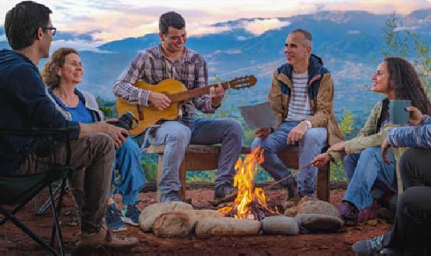
Jehovah is the happy God. (1Ti 1:11) He has given us many wonderful gifts that show us how much he loves us and wants us to be happy. (Ec 3:12, 13) Consider two of these gifts—food and sound.
Play the VIDEO Creation Proves That Jehovah Wants Us to Rejoice—Delicious Food and Delightful Sounds. Then ask the audience:
  - How do the gifts of food and sound convince you that Jehovah wants you to be happy?

Read Psalm 32:8. Then ask the audience:
  - How does knowing that Jehovah wants you to be happy motivate you to listen to the direction he provides in the Bible and through his organization?

- Local Needs (5 min.)
- Congregation Bible Study (30 min.)
bt chap. 22 ˚1-6

Song 12 and Prayer | Opening Comments (1 min.)

TREASURES

FROM GOD’S WORD
______________________________________________________________________________________________________________________________________________________________________________________________________________________________________________________________________________________________________________________________________________________________________________________________________________________________________________________________________________________________________________________________________________________________________________________________________________________________________________________________________________________________________________________________________________________________________________________________________________________________________________________________________________________________________________________________________________________________________________________________________________________________________________________________________________________________________________________________________________________________________________________________________________________________________________________________________________________________________________________________________________________________________________________________________________________________________________________________________________________________________________________________________________________________________________________________________________________________________________________________________________________________________________________________________________________________________________________________________________________________________________________________________________________________________________________________________________________________________________

We Have Many Reasons to Praise Jah
(10 min.)
He cares for us as individuals (Ps 147:3, 4;
w17.07 18 ˚5-6)
He is empathetic and uses his power to help us (Ps 147:5; w17.07 18 ˚7)
He gives us the privilege of being part of his people (Ps 147:19, 20; w17.07 21 ˚18)
_
ASK YOURSELF, ‘What else moves me to praise Jehovah?’

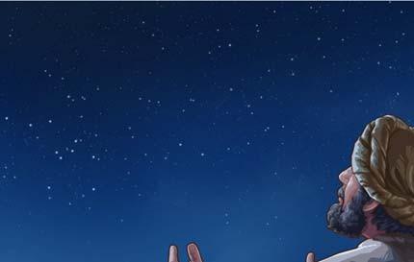

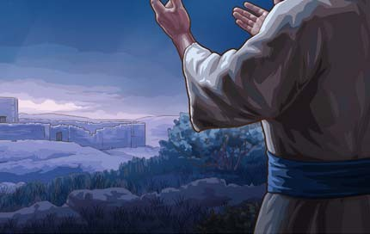
- Spiritual Gems (10 min.)
Ps 148:1, 10—In what sense do “winged birds” praise Jehovah? (it-1 316)

What spiritual gems from this week’s Bible reading would you like to share?
- Bible Reading (4 min.)
Ps 148:1–149:9 (th study 11)

APPLY YOURSELF

TO THE FIELD MINISTRY
___________________________________________________________________________________________________________________________________________________________________________________________________________________________________________________________________________________________________________________________________________________________________________________________________________________________________________________________________________________________________________________________________________________________________________________________________________________________________________________________________________________________________________________________________________________________________________________________________________________________________________________________________________________________________________________________________________________________________________________________________________________________________________________________________________________________________________________________________________________________________________________________________________________________________________________________________________________________________________________________________________________________________________________________________________________________________________________________________________________________________________________________________________________________________________________________________________________________________________________________________________________________________________________________________________________________________________________________________________________________________________________________________________________________________________________________________________________________________________________________________________________________________________________________________________________________________________________________________________________________________________________________________________________________________________________________________________________________________________________________________________________________________________________________________________________________________________________________________________________________________________________________________________________________________________________________________________________________________________________________________________________________________________________________________________________________________________________________________________________________________________________________________________________________________________________________________________________________________________________________________________________________________________________________________________________________________________________________________________________________________________________________________________________________________________________________________________________________________________________________________________________________________________________________________________________________________________________________________________________________________________________________________________________________________________________________________________________________________________________________________________________________________________________________________________________________________________________________________________________________________________________________________________________________________________________________________________________________________________________________________________________________________________________________________________________________________________________________________________________________________________________________________________________________________________________________________________________________________________________________________________________________________________________________________________________________________
- Starting a Conversation (3 min.)

HOUSE TO HOUSE. The person tells you that he is dealing with a chronic illness. (lmd lesson 2 point 5)
- Starting a Conversation (4 min.)
INFORMAL WITNESSING. Look for an opportu- nity to tell the person something that you learned at a recent meeting. (lmd lesson 4 point 3)
- Talk (5 min.)
w19.03 10 ˚7-11—Theme: Listen to Jesus
—Preach the Good News. See picture. (th study 14)

LIVING
i
AS CHRISTIANS
___________________________________________________________________________________________________________________________________________________________________________________________________________________________________________________________________________________________________________________________________________________________________________________________________________________________________________________________________________________________________________________________________________________________________________________________________________________________________________________________________________________________________________________________________________________________________________________________________________________________________________________________________________________________________________________________________________________________________________________________________________________________________________________________________________________________________________________________________________________________________________________________________________________________________________________________________________________________________________________________________________________________________________________________________________________________________________________________________________________________________________________________________________________________________________________________________________________________________________________________________________________________________________________________________________________________________________________________________________________________________________________________________________________________________________________________________________________________________________________________________________________________________________________________________________________________________________________________________________________________________________________________________________________________________________________________________________________________________________________________________________________________________________________________________________________________________________________________________________________________________________________________________________________________________________________________________________________________________________________________________________________________________________________________________________________________________________________________________________________________________________________________________________________________________________________________________________________________________________________________________________________________________________________________________________________________________________________________________________________________________________________________________________________________________________________________________________________________________________________________________________________________________________________________________________________________________________________________________________________________________________________________________________________________________________________________________________________________________________________________________________________________________________________________________________________________________________________________________________________________________________________________________________________________________________________________________________________________________________________________________________________________________________________________________________________________________________________________________________________________________________________________________________________________________________________________________________________________________________________________________________________________________________________________________________________________________
Song 159
- Annual Service Report (15 min.) Discussion.

After reading the announcement from the branch office regarding the annual service report, invite the audience to highlight other positive aspects of the 2024 Service Year Report of Jehovah’s Witnesses World- wide. Interview publishers, selected in advance, who had encouraging experiences in the ministry during the past year.

- Congregation Bible Study (30 min.)
bt chap. 22 ˚7-14, boxes on pp. 174, 177

Song 88 and Prayer | Opening Comments (1 min.)

TREASURES

FROM GOD’S WORD
______________________________________________________________________________________________________________________________________________________________________________________________________________________________________________________________________________________________________________________________________________________________________________________________________________________________________________________________________________________________________________________________________________________________________________________________________________________________________________________________________________________________________________________________________________________________________________________________________________________________________________________________________________________________________________________________________________________________________________________________________________________________________________________________________________________________________________________________________________________________________________________________________________________________________________________________________________________________________________________________________________________________________________________________________________________________________________________________________________________________________________________________________________________________________________________________________________________________________________________________________________________________________________________________________________________________________________________________________________________________________________________________________________________________________________________________________________________________________________

Youths—To Whom Will You Listen?
(10 min.)
[Play the VIDEO Introduction to Proverbs.] Be wise and listen to your parents (Pr 1:8;
w17.11 29 ˚16-17; see cover picture)
Do not listen to those who do what is bad (Pr 1:10, 15; w05 2/15 19-20 ˚11-12)

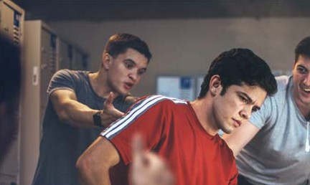


- Spiritual Gems (10 min.)
Pr 1:22—When used in the Bible, to whom are the words “fool” and “foolish” generally referring? (it-1 846)

What spiritual gems from this week’s Bible reading would you like to share?
- Bible Reading (4 min.)
Pr 1:1-23 (th study 10)

APPLY YOURSELF

TO THE FIELD MINISTRY
___________________________________________________________________________________________________________________________________________________________________________________________________________________________________________________________________________________________________________________________________________________________________________________________________________________________________________________________________________________________________________________________________________________________________________________________________________________________________________________________________________________________________________________________________________________________________________________________________________________________________________________________________________________________________________________________________________________________________________________________________________________________________________________________________________________________________________________________________________________________________________________________________________________________________________________________________________________________________________________________________________________________________________________________________________________________________________________________________________________________________________________________________________________________________________________________________________________________________________________________________________________________________________________________________________________________________________________________________________________________________________________________________________________________________________________________________________________________________________________________________________________________________________________________________________________________________________________________________________________________________________________________________________________________________________________________________________________________________________________________________________________________________________________________________________________________________________________________________________________________________________________________________________________________________________________________________________________________________________________________________________________________________________________________________________________________________________________________________________________________________________________________________________________________________________________________________________________________________________________________________________________________________________________________________________________________________________________________________________________________________________________________________________________________________________________________________________________________________________________________________________________________________________________________________________________________________________________________________________________________________________________________________________________________________________________________________________________________________________________________________________________________________________________________________________________________________________________________________________________________________________________________________________________________________________________________________________________________________________________________________________________________________________________________________________________________________________________________________________________________________________________________________________________________________________________________________________________________________________________________________________________________________________________________________________________________________
- Starting a Conversation (2 min.)
PUBLIC WITNESSING. The person wants to argue with you. (lmd lesson 6 point 5)
- Starting a Conversation (2 min.)
PUBLIC WITNESSING. Exchange contact information with a person who shows interest. (lmd lesson 1 point 5)
- Following Up (2 min.)
INFORMAL WITNESSING. Tell a person about our Bible study program, and give him a Bible course contact card. (lmd lesson 9 point 5)
- Making Disciples (5 min.)
lff lesson 16 point 6. Use an article from the “Explore” section with a student who wonders whether Jesus’ miracles really happened. (th study 3)

LIVING
i
AS CHRISTIANS
___________________________________________________________________________________________________________________________________________________________________________________________________________________________________________________________________________________________________________________________________________________________________________________________________________________________________________________________________________________________________________________________________________________________________________________________________________________________________________________________________________________________________________________________________________________________________________________________________________________________________________________________________________________________________________________________________________________________________________________________________________________________________________________________________________________________________________________________________________________________________________________________________________________________________________________________________________________________________________________________________________________________________________________________________________________________________________________________________________________________________________________________________________________________________________________________________________________________________________________________________________________________________________________________________________________________________________________________________________________________________________________________________________________________________________________________________________________________________________________________________________________________________________________________________________________________________________________________________________________________________________________________________________________________________________________________________________________________________________________________________________________________________________________________________________________________________________________________________________________________________________________________________________________________________________________________________________________________________________________________________________________________________________________________________________________________________________________________________________________________________________________________________________________________________________________________________________________________________________________________________________________________________________________________________________________________________________________________________________________________________________________________________________________________________________________________________________________________________________________________________________________________________________________________________________________________________________________________________________________________________________________________________________________________________________________________________________________________________________________________________________________________________________________________________________________________________________________________________________________________________________________________________________________________________________________________________________________________________________________________________________________________________________________________________________________________________________________________________________________________________________________________________________________________________________________________________________________________________________________________________________________________________________________________________________________________________
Song 89
- Local Needs (15 min.)

- Congregation Bible Study (30 min.)
bt chap. 22 ˚15-21

Song 35 and Prayer | Opening Comments (1 min.)

TREASURES

FROM GOD’S WORD
______________________________________________________________________________________________________________________________________________________________________________________________________________________________________________________________________________________________________________________________________________________________________________________________________________________________________________________________________________________________________________________________________________________________________________________________________________________________________________________________________________________________________________________________________________________________________________________________________________________________________________________________________________________________________________________________________________________________________________________________________________________________________________________________________________________________________________________________________________________________________________________________________________________________________________________________________________________________________________________________________________________________________________________________________________________________________________________________________________________________________________________________________________________________________________________________________________________________________________________________________________________________________________________________________________________________________________________________________________________________________________________________________________________________________________________________________________________________________________

Why Put Your Heart Into Personal Study? (10 min.)
To show appreciation for the truth (Pr 2:3, 4; w22.08 18 ˚16)
To help you make good decisions (Pr 2:5-7; w22.10 19 ˚3-4)
To strengthen your faith (Pr 2:11, 12;
w16.09 23 ˚2-3)
_
ASK YOURSELF, ‘How could I improve my personal study routine?’

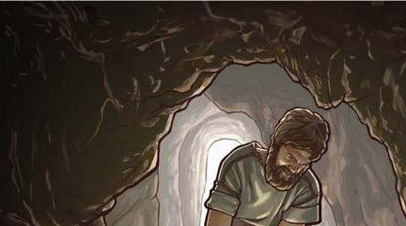

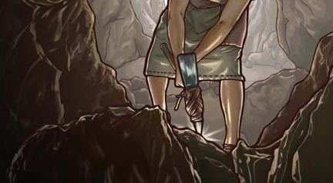
- Spiritual Gems (10 min.)
Pr 2:7—In what way is Jehovah “a shield for those walking in integrity”? (it-1 1211 ˚4)

What spiritual gems from this week’s Bible reading would you like to share?

- Bible Reading (4 min.)
Pr 2:1-22 (th study 12)
APPLY YOURSELF
TO THE FIELD MINISTRY

______________________________________________________________________________________________________________________________________________________________________________________________________________________________________________________________________________________________________________________________________________________________________________________________________________________________________________________________________________________________________________________________________________________________________________________________________________________________________________________________________________________________________________________________________________________________________________________________________________________________________________________________________________________________________________________________________________________________________________________________________________________________________________________________________________________________________________________________________________________________________________________________________________________________________________________________________________________________________________________________________________________________________________________________________________________________________________________________________________________________________________________________________________________________________________________________________________________________________________________________________________________________________________________________________________________________________________________________________________________________________________________________________________________________________________________________________________________________________________
- Starting a Conversation (4 min.)
HOUSE TO HOUSE. Show a person how to find information on jw.org that is helpful to married couples. (lmd lesson 1 point 3)
- Following Up (3 min.)
INFORMAL WITNESSING. Offer a magazine on a topic that the person showed interest in
during your last conversation. (lmd lesson 9 point 3)
- Talk (5 min.)
lmd appendix A point 8—Theme:
A Husband and a Wife Should Be Loyal to Each Other. (th study 13)

LIVING
i
AS CHRISTIANS
___________________________________________________________________________________________________________________________________________________________________________________________________________________________________________________________________________________________________________________________________________________________________________________________________________________________________________________________________________________________________________________________________________________________________________________________________________________________________________________________________________________________________________________________________________________________________________________________________________________________________________________________________________________________________________________________________________________________________________________________________________________________________________________________________________________________________________________________________________________________________________________________________________________________________________________________________________________________________________________________________________________________________________________________________________________________________________________________________________________________________________________________________________________________________________________________________________________________________________________________________________________________________________________________________________________________________________________________________________________________________________________________________________________________________________________________________________________________________________________________________________________________________________________________________________________________________________________________________________________________________________________________________________________________________________________________________________________________________________________________________________________________________________________________________________________________________________________________________________________________________________________________________________________________________________________________________________________________________________________________________________________________________________________________________________________________________________________________________________________________________________________________________________________________________________________________________________________________________________________________________________________________________________________________________________________________________________________________________________________________________________________________________________________________________________________________________________________________________________________________________________________________________________________________________________________________________________________________________________________________________________________________________________________________________________________________________________________________________________________________________________________________________________________________________________________________________________________________________________________________________________________________________________________________________________________________________________________________________________________________________________________________________________________________________________________________________________________________________________________________________________________________________________________________________________________________________________________________________________________________________________________________________________________________________________________________________
Song 96
- Are You a Treasure Hunter? (15 min.) Discussion.
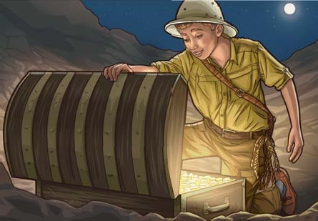
Young ones, do you like the idea of searching for a hid- den treasure? If so, the Bible invites you to hunt for the most valuable treasure in the universe—the knowledge of God! (Pr 2:4, 5) You can find this treasure by making time to read the Bible regularly and by digging into the accounts that you read. Doing so can be enjoyable and rewarding!
  - What questions can you ask yourself as you read the Bible? (w24.02 32 ˚2-3)


  - What tools can you use to find the answers?

The video series Learn From Jehovah’s Friends can help you to learn how to meditate on what you read in the Bible.
Play the VIDEO Learn From Jehovah’s Friends—Abel.
Read Genesis 4:2-4 and Hebrews 11:4. Then ask the audience:
  - How did Abel show that he was Jehovah’s friend?
TIP
When reading the Bible, do some research on the people, places, and things that you read about, even those that you think you know well. When you study the Bible in that way, what you read comes to life!

  - How did Abel build his faith in Jehovah?

  - How can you build your faith?

- Congregation Bible Study (30 min.)
bt chap. 23 ˚1-8 and intro to section 8

- You Can Thrive in Your Ministry Despite Being Shy (15 min.) Discussion.
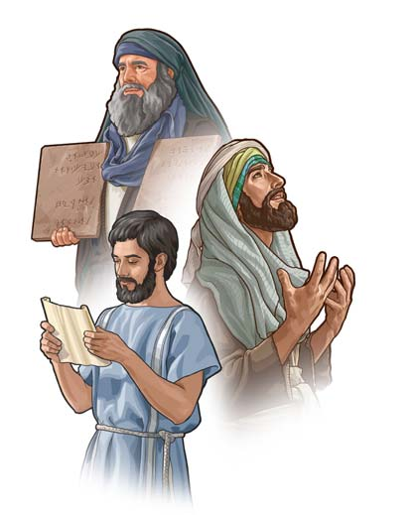
Would you describe yourself as someone who is shy? Do you generally prefer to go unnoticed? Do you get a knot in your stomach at the thought of talking to others? At times, being shy can hold us back from doing things that we would like to do. However, many who have struggled with shyness have been able to reach out and even thrive in their ministry. What can we learn from their example?
Play the VIDEO Giving My All Despite Being Shy. Then ask the audience:
  - How has Sister Lee benefited from applying her grandmother’s advice to “put everything into serving Jehovah”?

The Bible indicates that Moses, Jeremiah, and Timothy may have struggled with shyness. (Ex 3:11; 4:10; Jer 1: 6-8; 1Ti 4:12) Still, they were able to accomplish great things in Jehovah’s service because he was with them. (Ex 4:12; Jer 20:11; 2Ti 1:6-8)
Read Isaiah 43:1, 2. Then ask the audience:
  - What promise does Jehovah make to his worshippers?

How can Jehovah help those who are shy to thrive in their ministry today?
Play the VIDEO How Your Baptism Leads to More Happiness—Excerpt.
Then ask the audience:
  - How has Sister Jackson felt Jehovah’s power and support in her ministry?

  - How can the ministry help a person who is shy?

Cover picture: Solomon’s son listening to his father’s loving discipline

˘ 2024 Christian Congregation of Jehovah’s Witnesses. Our Christian Life and Ministry—Meeting Workbook (ISSN 2380-3487) is published by Christian Congregation of Jehovah’s Witnesses; A. E. Shuster, President; Luther W. Georges, Secretary-Treasurer; 675 Red Mills Road, Wallkill, NY 12589-3292. Printed in Canada.
mwb25.01-E 241115

Vol. 10, No. 1

