HUMAN RESOURCES ANALYTICS
Workforce Retention, Performance & Turnover Analysis
A Data-Driven Report for Strategic Human Resource Decision-Making

Prepared for: Human Resources Management
BY: Onwuka Augustina Chinonye
Dataset: HR Employee Records (311 employees, 2006–2018)
Source: Kaggle — Human Resources Data Set (Rhuebner)
Tools: Microsoft Power BI
Date: July 2026

Table of Contents
Table of Contents 2
1. Executive Summary 1
2. Business Problem / Problem Statement 1
3. Aims and Objectives 2
3.1 Aim 2
3.2 Objectives 2
4. Data Description 2
4.1 Structure 2
4.2 Key Fields Retained 3
5. Data Preparation / Cleaning 3
6. Feature Engineering 4
6.1 Calculated Columns 4
6.2 DAX Measures (Power BI Data Model) 4
7. Methodology 5
8. Key Findings / Insights 5
9. Visualization 9
9.1 Turnover and Termination Drivers 9
9.2 Recruitment Source Effectiveness 9
9.3 Tenure-Based Attrition Risk 10
9.4 Performance and Compensation 10
9.5 Satisfaction, Engagement, and Retention 12
10. Conclusion 12
11. Recommendations 13

1. Executive Summary
This report presents a comprehensive analysis of the organization's Human Resources dataset covering 311 employees over the period 2006–2018. It was commissioned to address a core gap identified by HR management: the absence of a structured, data-driven understanding of why employees leave, which parts of the business are most exposed to turnover, and which levers recruitment, compensation, management, or engagement, most influence retention and performance.
The analysis draws on a cleaned dataset of 311 employee records across 26 retained fields, engineered features (tenure, age bands, attrition flags, performance scores), and an interactive Power BI dashboard built to allow HR to monitor these metrics on an ongoing basis.
Headline numbers:
311  Total Employees | 33.4%  Attrition Rate | 66.6%  Retention Rate | 4.11 / 5  Avg. Engagement Score

Three findings stand out. First, turnover is heavily concentrated: Production and Software Engineering carry the highest turnover rates (39.7% and 36.4% respectively), and together with IT/IS account for the bulk of all departures. Second, tenure, not satisfaction is the strongest behavioural signal of attrition risk: employees in their first year are far more likely to leave (roughly 90% attrition among sub-1-year tenure records) than employees with five or more years of service, while self-reported satisfaction and engagement scores show almost no statistical relationship with whether an employee stays or leaves. Third, recruitment channel quality varies enormously Employee Referral and Website hires are retained at far higher rates than Google Search or Diversity Job Fair hires, at broadly similar performance levels meaning the recruiting mix is a controllable lever HR can pull to reduce attrition without changing pay or management.
The report concludes with a set of prioritized, actionable recommendations spanning onboarding and early-tenure support, department-specific retention plans for Production, manager coaching for high-turnover managers, and a shift in recruiting spend toward higher-retention sources.

2. Business Problem / Problem Statement
As articulated by HR management, the organization collects extensive employee data, demographics, job roles, salaries, performance scores, recruitment sources, and employment history but lacks a structured analysis of what that data says about workforce stability. In the manager's own words, without such analysis it is difficult to determine:
- Why employees leave the organization
- Which departments experience the highest turnover
- Whether compensation and engagement levels are competitive
- How recruitment sources affect employee quality and retention
- Which workforce trends require immediate managerial attention
As a result, decisions on recruitment, retention strategy, employee development, and workforce planning have historically been made without sufficient data-driven insight. This report was commissioned to close that gap: to mine the existing HR dataset for patterns, quantify risk areas, and support strategic HR decision-making with evidence rather than intuition.

3. Aims and Objectives

3.1 Aim
To analyze the human resources dataset in order to evaluate workforce trends, employee performance, and retention patterns, and to generate actionable insights that support effective talent management, employee satisfaction, and organizational performance.

3.2 Objectives
- Data Cleaning & Preparation: clean and organize employee records to ensure consistency and accuracy in demographic, salary, and employment-related information.
- Workforce Demographic Analysis: analyse employee demographics such as age, gender, marital status, department, and position distribution.
- Employee Retention & Turnover Analysis: evaluate turnover patterns and identify factors associated with resignations or terminations.
- Performance Evaluation Analysis: assess performance ratings across departments, positions, and managers.
- Compensation & Salary Analysis: examine salary distribution and compare compensation across roles, departments, and employee groups.
- Recruitment Source Effectiveness Analysis: analyse recruitment channels to determine which sources attract and retain high-performing employees.
- Employee Engagement & Satisfaction Analysis: explore indicators related to satisfaction, engagement, and work environment.
- Strategic Insight Generation: provide actionable recommendations for improving retention, recruitment, workforce planning, and performance management.

4. Data Description
The dataset used is the Human Resources Data Set published on Kaggle by rhuebner, a widely used HR analytics dataset representing a fictitious mid-sized organization's employee records from 2006 to 2018.

4.1 Structure
Attribute | Detail
Original size | 311 rows × 36 columns
Cleaned size | 311 rows × 30 columns
Grain | One row per employee
Time span | Hire dates 2006–2018; termination dates through late 2018
Active employees | 207 (66.6%)
Terminated employees | 104 (33.4%)

4.2 Key Fields Retained
Category | Fields
Identity & demographics | Employee_Name, EmpID, DOB, Gender, MaritalStatus, RaceDesc, CitizenDesc, State, Zip
Employment | DateofHire, DateofTermination, TermReason, EmploymentStatus, Termd
Job & structure | Department, Position, PositionID, ManagerName, ManagerID
Compensation | Salary
Performance | PerformanceScore, PerfScoreID, LastPerformanceReview_Date, SpecialProjectsCount
Recruitment | RecruitmentSource, FromDiversityJobFairID
Engagement & conduct | EngagementSurvey, EmpSatisfaction, DaysLateLast30, Absences

Six departments are represented, heavily weighted toward Production (209 of 311 employees, 67%), followed by IT/IS (50), Sales (31), Software Engineering (11), Admin Offices (9), and Executive Office (1).

5. Data Preparation / Cleaning
Cleaning was performed in Power Query prior to loading the model. The dataset was reduced from 36 columns to 26 columns and the following steps were applied:
- Removed redundant ID columns: MaritalStatusID, MarriedID, GenderID, EmpStatusID, DeptID, DOB (raw) and HispanicLatino were dropped where a cleaner, human-readable equivalent field already existed, avoiding duplicate encodings of the same information.
- Standardized text values: the Position field contained "Data Analyst" duplicated with inconsistent trailing/leading spaces; all position labels were trimmed and standardized so identical roles group correctly.
- Corrected Date of Birth (DOB) parsing errors: dates such as "07/10/83" were being misread once converted to a Date type. The column was split and the century was reconstructed (adding 19 to the two-digit year), correctly restoring dates such as "07/10/1983".
- Preserved legitimate blanks: DateofTermination is blank for 207 records. these represent employees who are still actively employed, not missing data, and were intentionally left blank so downstream logic (e.g., the Termd flag) can treat them as active.
- Imputed a missing manager ID: eight rows under Manager "Webster Butler" had a blank ManagerID. The correct ID was located from other rows referencing the same manager name and back-filled to restore referential integrity between Manager Name and ManagerID.
- Cleaned anomalous TermReason entries: a handful of joke/placeholder text values in the TermReason column were identified, trimmed of extra whitespace, and standardized into consistent category labels.
- Years Worked column had a hidden date bug : it was calculated against TODAY(), so tenure for active employees kept increasing every time the file was opened instead of reflecting a fixed point in time. I corrected this by replacing the "current date" reference with a fixed anchor date (28/02/2019, the latest activity date in the dataset) so tenure is now calculated as DateofHire to DateofTermination for exited employees, or DateofHire to the fixed anchor date for active employees.
- De-duplicated records and re-validated row counts to confirm no employee appeared more than once after cleaning.
Net effect: the analysis-ready table contains 311 rows and 30 columns, with consistent text formatting, corrected dates, complete manager references, and no duplicate records.

6. Feature Engineering
Beyond cleaning, several calculated columns and DAX measures were engineered to support the KPIs and visuals required by the analysis:

6.1 Calculated Columns
Feature | Logic / Purpose
Termd | Binary flag: 1 if DateofTermination is populated, 0 if active. Powers all turnover/retention/attrition calculations.
Employee Age | Derived from DOB; used for demographic segmentation.
Employee Age (groups) | Age banded into ranges (e.g., 20-33, 34-45, 46-56, 57+) for group-level comparison.
Years Worked | Tenure in years from DateofHire to termination (or current date if active).
Years Worked (groups) | Tenure banded (0-1, 1-3, 3-5, 5-10, 10+ years) to analyze attrition risk by career stage.
EmpSatisfaction / EngagementSurvey | Retained as-is; used to test the relationship between sentiment and retention.

6.2 DAX Measures (Power BI Data Model)
The following explicit measures were written to power the KPI cards and visuals:
Measure | DAX Logic
Attrition Rate | DIVIDE(COUNT of Termd = 1, Total employee count)
Retention Rate | DIVIDE(COUNT of Termd = 0, Total employee count)
Active Employees | COUNTROWS filtered where DateofTermination is blank
Terminated Employees | COUNTROWS filtered where DateofTermination is not blank
Average Headcount | Ratio of currently active EmpIDs to terminated EmpIDs, used as a stability proxy
Average Salary / Total Salary | AVERAGE and SUM of Salary
Avg Female Salary / Avg Male Salary / Salary Gap | Salary averaged by Gender, with an explicit variance measure for pay-equity monitoring
Average Performance | AVERAGE of PerfScoreID (1 = PIP … 4 = Exceeds)
Average Employee Tenure | AVERAGE of Years Worked, filtered to active employees only

These measures were used consistently across both dashboard pages so that every visual reflects the same underlying definitions of attrition, retention, and tenure.

7. Methodology
The analysis followed a standard end-to-end analytics workflow:
- Data acquisition: sourced the 311-record HR dataset from Kaggle (rhuebner).
- Data cleaning: performed in Power Query as detailed in Section 5, reducing the table from 36 to 30 columns.
- Feature engineering: built calculated columns and DAX measures in the Power BI data model (Section 6) to support KPI reporting.
- Exploratory & statistical analysis: cross-tabulated turnover, performance, salary, and satisfaction across department, recruitment source, manager, tenure band, and year using both Power BI visuals and Python (pandas) for validation of every headline figure quoted in this report.
- Dashboard construction: built a two-page interactive Power BI report ("HR Analysis" and "Workforce Performance") with KPI cards, bar charts, line/scatter charts, and pivot tables, cross-filterable by department, gender, and recruitment source slicers.
- Insight synthesis: mapped each of the 11 questions raised by HR management (Section 2) to a specific analysis, quantified the finding, and paired it with a business implication and recommendation (Section 8).
Where a KPI could be interpreted more than one way (for example, tenure for currently active staff), the calculation basis is stated explicitly next to the figure so results can be reproduced.

8. Key Findings / Insights
The eleven questions below are the exact questions raised by HR management (Section 2). Each is answered with the underlying figures, its business implication, and a corresponding recommendation.
Q1. Which departments experience the highest employee turnover rates?
Production has both the largest headcount (209 employees, 67% of the workforce) and the highest turnover rate at 39.7% (83 of 209 terminated). Software Engineering, though a small team of 11, has the second-highest rate at 36.4% (4 of 11). Admin Offices (22.2%) and IT/IS (20.0%) are mid-range, while Sales sits lowest among substantive departments at 16.1%, and the single-person Executive Office has none.
Business implication: Because Production accounts for two-thirds of the entire workforce, even a moderate improvement in its turnover rate would have an outsized impact on overall attrition and hiring cost.
Recommendation: Prioritize a Production-specific retention initiative (exit interviews, supervisor coaching, workload review) before broader company-wide programs, since it will move the overall attrition number the most.
Q2. What are the most common factors associated with employee resignations or terminations?
Among the 104 terminated employees, the leading stated reasons are: taking another position (20 cases), general unhappiness (14), seeking more money (11), career change (9), work hours (8), attendance (7), relocation out of area (5), and return to school (5). Voluntary, career-motivated departures (another position, more money, career change) together account for roughly 40 of the 104 exits — noticeably more than involuntary causes such as performance (4) or no-call/no-show (4).
Business implication: Most attrition is voluntary and opportunity-driven rather than performance-driven, meaning it is largely preventable through competitive pay, career pathing, and engagement rather than discipline.
Recommendation: Introduce structured stay interviews (one-on-one conversation) and career development programs that provide employees with opportunities for promotions, cross-functional transfers, job rotation and benchmark pay for roles where "more money" and "another position" are recurring exit reasons.
Q3. Which recruitment sources produce the highest-performing and longest-serving employees?
Retention varies sharply by source at broadly similar performance levels (average performance scores cluster tightly between 2.8 and 3.2 across all channels). Website hires are retained best (92.3% retention, n=13), followed by Employee Referral (83.9%, n=31) and LinkedIn (76.3%, n=76). Google Search (38.8% retention, n=49) and Diversity Job Fair (44.8%, n=29) show the weakest retention, and the single On-Line Web Application hire did not stay.
Business implication: Since performance is similar across sources but retention is not, recruitment channel choice can significantly reduce attrition without a low-cost. The organization can hire equally capable people who are simply more likely to stay.
Recommendation: Shift recruiting spend and effort toward Employee Referral and direct Website applications, and audit the sourcing/screening process used for Google Search and Diversity Job Fair candidates to understand why early attrition is higher there.
Q4. How does employee performance vary across departments and job roles?
Average performance (on the 1–4 PerfScoreID scale, where 4 = Exceeds) is fairly consistent across the business: Software Engineering (3.09) and IT/IS (3.06) lead, followed by Executive Office and Admin Offices (3.00 each), Production (2.97), and Sales, which is lowest at 2.84.
Business implication: The performance spread across departments is narrow, suggesting there is no single underperforming department. Sales is a mild outlier worth monitoring rather than an urgent concern because Sales also has the highest absenteeism (11.6 days/year) and highest lateness (0.65 days late/month) of any department (Q6)
Recommendation: Continue standard performance management in Sales, but pair it with the turnover and absenteeism findings (Q1, Q6) rather than treating it as an isolated performance problem.
Q5. Are there noticeable salary differences across gender, department, or position?
Company-wide, average salary is $70,629 for men versus $67,787 for women — a 4.0% gap (5.5% if the single high-salary Executive Office record is excluded). The gap is not uniform: it favours men in Production ($60,459 vs $59,620, a small gap) and IT/IS ($99,007 vs $94,593), is roughly reversed in Sales ($66,291 for men vs $72,017 for women) and Software Engineering ($92,689 vs $96,906), and Admin Offices is close to parity.
Business implication: A moderate, department-dependent pay gap exists rather than a uniform, organization-wide one, which points to role-mix and tenure differences as likely (though unconfirmed) drivers rather than blanket pay discrimination.
Recommendation: Commission a formal pay-equity audit that controls for role, tenure, and performance within each department before drawing conclusions about causation, and monitor the Salary Gap DAX measure already built into the dashboard on a recurring basis.
Q6. Which employee groups have the highest levels of absenteeism or disciplinary issues?
Sales has the highest average absences per employee (11.6 days) and the highest average days late in the last 30 days (0.65), followed by IT/IS (10.4 absences) and Production (10.1 absences, 0.47 days late). Admin Offices and Executive Office show the lowest absenteeism (8.7 and 10.0 respectively) with effectively no lateness.
Business implication: Sales combines the lowest average performance score (Q4) with the highest absenteeism and lateness, which is a pattern worth investigating together rather than as separate issues — it may point to engagement or workload problems specific to that team.
Recommendation: Review Sales team workload, incentive structure, and manager support directly; absenteeism and lateness data should be pulled into the same conversation as the department's performance review.
Q7. What is the relationship between employee satisfaction/engagement and retention?
Contrary to expectation, self-reported satisfaction and engagement show almost no measurable relationship with whether an employee stays or leaves. Average satisfaction is 3.89 for active employees versus 3.88 for terminated employees; average engagement is 4.12 versus 4.09. The correlation between EmpSatisfaction and the attrition flag is -0.005, and between EngagementSurvey and attrition is -0.018 — both statistically negligible.
Business implication: Survey-based sentiment data, as currently collected, is not predictive of who actually leaves. Relying on satisfaction scores alone as an early-warning system for attrition would miss the great majority of at-risk employees.
Recommendation: Do not treat satisfaction/engagement scores as a retention early-warning system on their own; instead prioritize the more predictive structural signals identified in this report tenure stage (Q8/Q10), department (Q1), and recruitment source (Q3) and consider redesigning the engagement survey to capture more actionable, specific drivers.
Q8. Is there a relationship between years at company and likelihood of attrition? Are newer employees more likely to leave?
Yes, tenure is the single strongest attrition signal in the dataset. Recalculating tenure accurately (hire date to termination date, or to the dataset's final activity date for active staff), attrition is 90% among employees with under 1 year of tenure, 65.4% for 1–3 years, 32.4% for 3–5 years, 19.4% for 5–10 years, and 0% for employees with 10+ years of service. Risk drops sharply and consistently the longer an employee stays.
Business implication: Early tenure, particularly the first year is by far the highest-risk period for departure. This is a classic onboarding/early-engagement problem rather than a long-term retention problem.
Recommendation: Invest disproportionately in first-year onboarding, 30/60/90-day check-ins, and early mentorship; a small improvement in first-year retention will have a much larger effect on overall attrition than efforts aimed at long-tenured staff.
Q9. Which managers or departments consistently achieve stronger employee performance outcomes?
Among managers with at least five direct reports, Jennifer Zamora's team has both the strongest average performance (3.14) and one of the lowest turnover rates (14.3%), followed by Simon Roup and Janet King (~3.11–3.12 average performance). At the other end, John Smith's team has the lowest average performance (2.71), while Webster Butler (61.9% turnover) and Amy Dunn (61.9% turnover) show the highest attrition among their direct reports despite mid-range performance scores.
Business implication: High performance and low turnover tend to travel together but are not identical some managers (e.g., Webster Butler) retain average performers poorly, which is a management/retention issue distinct from a performance issue.
Recommendation: Use manager-level turnover and performance figures as a coaching input: pair high-turnover managers with mentoring from managers like Jennifer Zamora, and investigate the specific drivers behind Webster Butler's and Amy Dunn's above-average attrition.
Q10. Are newer employees leaving the organization faster than long-serving employees?
Yes, this mirror and confirms Q8. The average tenure of terminated employees is 3.5 years versus 5.5 years for currently active employees, and the attrition curve declines steadily and sharply from 90% (under 1 year) to 0% (10+ years) as shown in Section 9's tenure chart. There is no evidence of a "long-tenure flight risk" pattern in this dataset. risk is concentrated almost entirely in the early career stage.
Business implication: Retention strategy should be weighted toward the first three years of employment rather than spread evenly across all tenure stages.
Recommendation: Set a formal retention target and ownership for the 0–3-year tenure band specifically, since this is where nearly all controllable attrition risk sits.
Q11. What workforce trends should management prioritize to improve employee retention, productivity, and organizational performance?
Bringing the findings together, five trends stand out for prioritization: (1) Production's scale and above-average turnover make it the single largest lever on overall attrition; (2) attrition is overwhelmingly an early-tenure phenomenon, not a long-service one; (3) recruitment source quality varies widely at similar performance levels, making sourcing mix a controllable, low-cost lever; (4) satisfaction and engagement survey scores, as currently measured, do not predict who leaves and should not be relied on alone; and (5) a modest, department-dependent gender pay gap exists and warrants a controlled audit.
Business implication: These five trends collectively explain most of the retention and performance variation visible in the dataset, and each is actionable without requiring new data collection.
Recommendation: Sequence action in this order for maximum impact per unit of effort: (1) first-year onboarding and early check-ins, (2) Production-specific retention plan, (3) rebalance recruiting spend toward Referral/Website sources, (4) manager coaching for high-turnover managers, (5) pay-equity audit.

9. Visualization
A two-page interactive Power BI dashboard ("HR Analysis" and "Next Page") was built on top of the cleaned data model, using the DAX measures in Section 6 and cross-filterable by Department, Gender, and Recruitment Source slicers. Page 1 focuses on turnover, termination drivers, recruitment quality, performance, and absenteeism; Page 2 focuses on tenure-based attrition risk, manager effectiveness, salary trends, and the satisfaction/engagement relationship with retention. The charts below reproduce the core visuals from the dashboard for this report.

9.1 Turnover and Termination Drivers
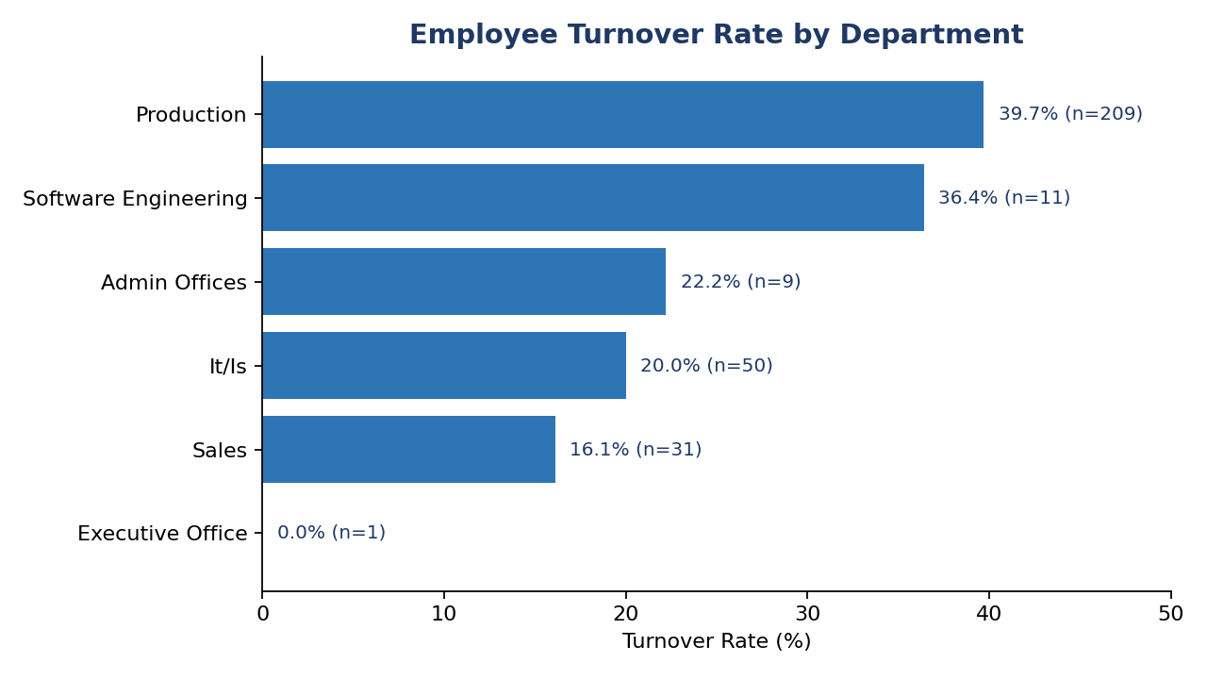
Figure 1. Employee turnover rate by department (Production and Software Engineering carry the highest risk).
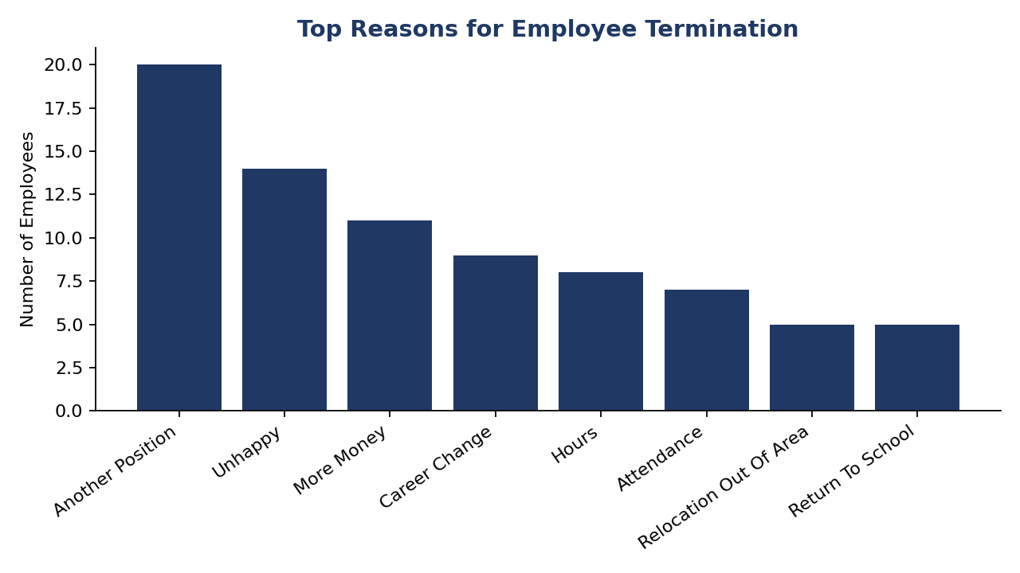
Figure 2. Top stated reasons for termination — voluntary, opportunity-driven reasons dominate.

9.2 Recruitment Source Effectiveness
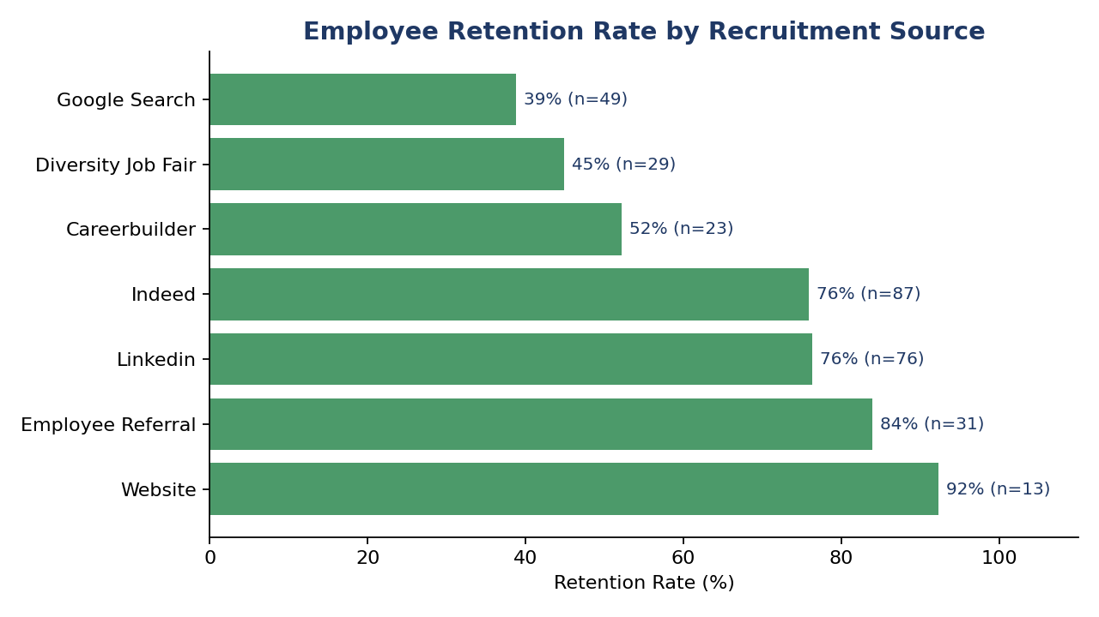
Figure 3. Retention rate by recruitment source — Website and Employee Referral outperform Google Search and Diversity Job Fair.

9.3 Tenure-Based Attrition Risk
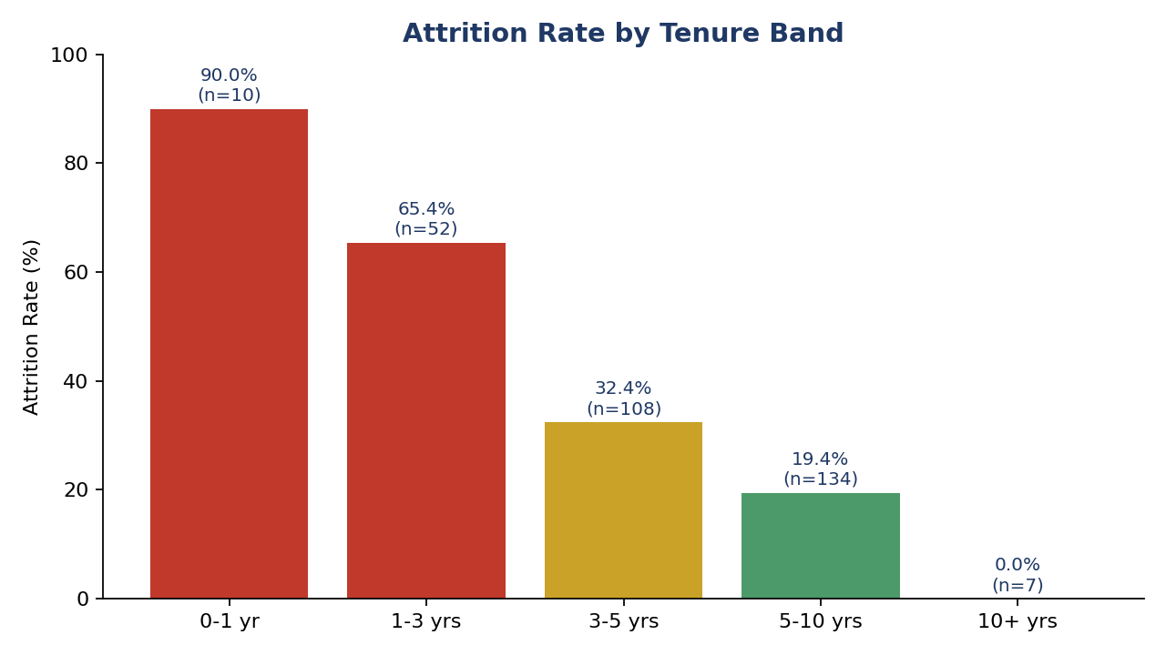
Figure 4. Attrition rate by tenure band, recalculated on hire-to-termination (or last-activity) dates — risk falls sharply after year one.

9.4 Performance and Compensation
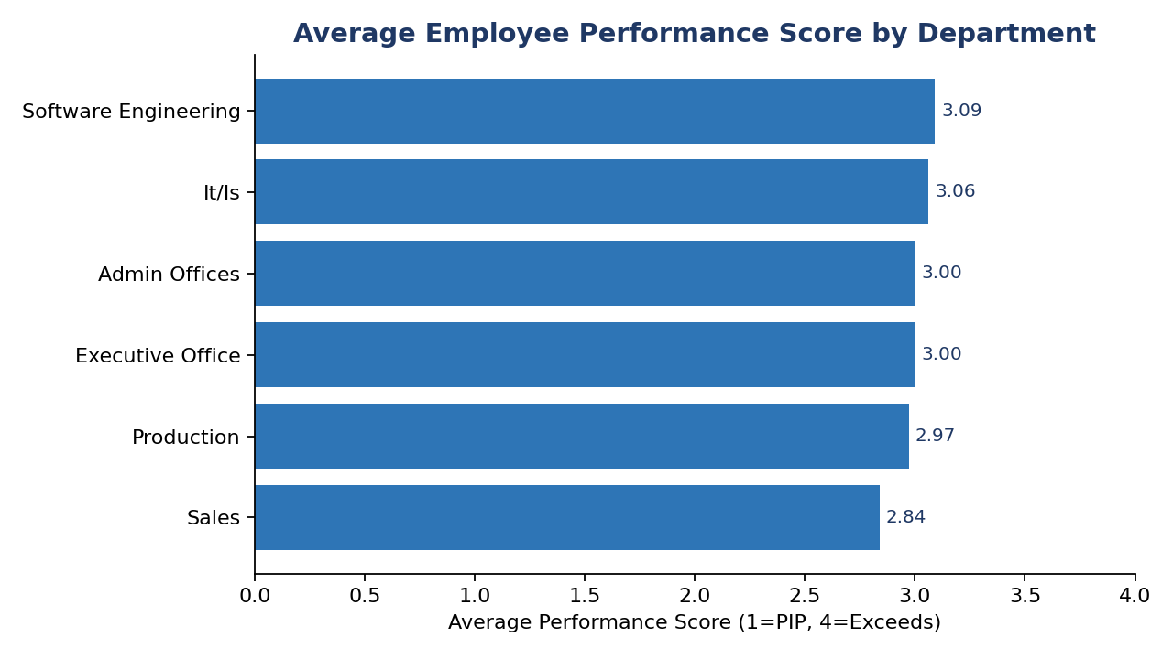
Figure 5. Average employee performance score by department.
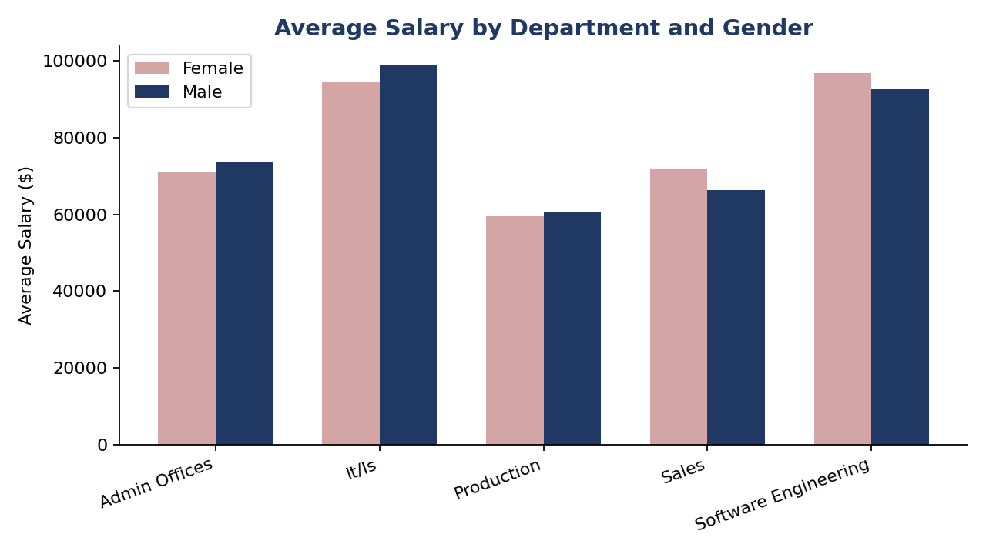
Figure 6. Average salary by department and gender.

9.5 Satisfaction, Engagement, and Retention
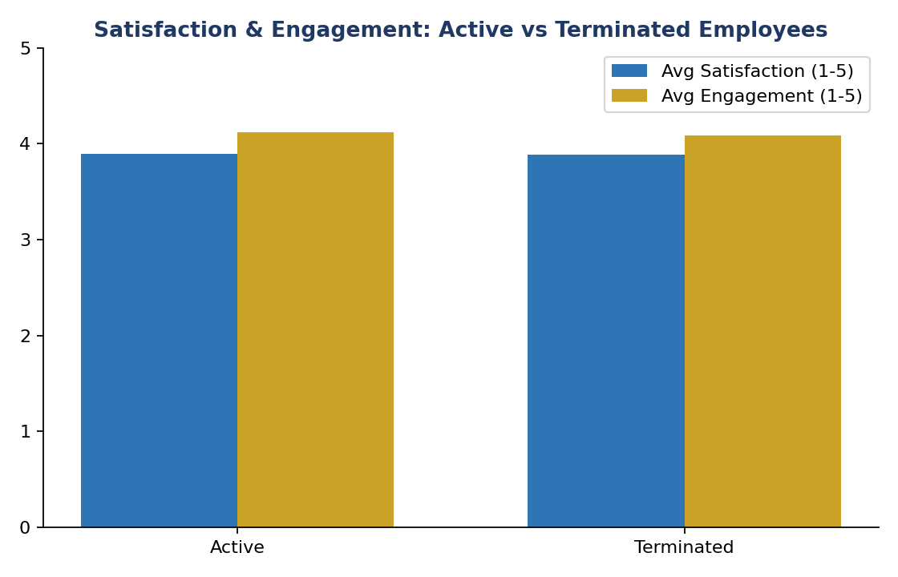
Figure 8. Average satisfaction and engagement scores are nearly identical between active and terminated employees, confirming Q7's finding.

10. Conclusion
This analysis converts three years' worth of accumulated HR data into a clear, evidence-based picture of workforce stability. The organization's overall attrition rate of 33.4% is driven disproportionately by a small number of identifiable, addressable factors rather than being evenly spread across the workforce: it is concentrated in Production, concentrated in the first year of employment, and materially shaped by which recruitment channel an employee was hired through. Compensation shows a modest, department-dependent gender gap rather than a uniform one, and notably self-reported satisfaction and engagement scores are not reliable predictors of who will leave, meaning HR's early-warning capability should not rely on survey data alone.
Taken together, these findings answer every question originally posed by HR management (Section 2) with quantified, reproducible evidence, and translate directly into a small number of high-leverage actions rather than a diffuse list of generic HR best practices.

11. Recommendations
Recommendations are ordered by expected impact relative to effort, based on the findings in Section 8.
- Fix the first year tenure: Build a structured onboarding path with 30/60/90-day check-ins and assigned mentors. the data shows this is where the overwhelming majority of preventable attrition occurs (90% attrition under 1 year of tenure vs. 0% at 10+ years).
- Launch a Production retention plan: As the department with both the largest headcount and the highest turnover (39.7%), even a modest improvement here moves the company-wide attrition number more than any other single intervention.
- Rebalance recruiting spend toward higher-retention sources: Increase investment in Employee Referral and direct Website applications; audit the screening and expectation-setting process for Google Search and Diversity Job Fair candidates, where performance is comparable but retention is far weaker.
- Coach high-turnover managers: Use manager-level turnover and performance data as a routine input to people-manager development, pairing managers with above-average attrition (e.g., Webster Butler, Amy Dunn) with peer mentoring from managers who combine strong performance and low turnover (e.g., Jennifer Zamora).
- Commission a controlled pay-equity audit: Investigate the department-level gender pay gap (particularly in IT/IS and Production) after controlling for role, tenure, and performance, using the Salary Gap measure already built into the dashboard for ongoing monitoring.
- Redesign the engagement/satisfaction survey: Since current scores do not predict attrition, work with HR to identify more specific, actionable questions (e.g., career growth, workload, manager relationship) that could serve as genuine early-warning indicators.
- Review Sales workload and incentive structure: Sales combines the lowest average performance score with the highest absenteeism and lateness, investigate whether this reflects workload, incentive design, or management support rather than individual performance alone.
- Operationalize the dashboard: Keep the Power BI report refreshed on a recurring cadence and assign ownership of the KPI cards (Attrition Rate, Retention Rate, Salary Gap, Average Tenure) to HR leadership so these findings continue to be monitored, not just reported once.

End of report. Prepared using Microsoft Power BI on the cleaned HR Employee Records dataset (311 employees, 2006–2018).

