XAUUSD FOREX ROBOT

Development Blueprint &
Strategy Specification
  - Rule-Based MetaTrader 5 Expert Advisor for Gold (XAUUSD)

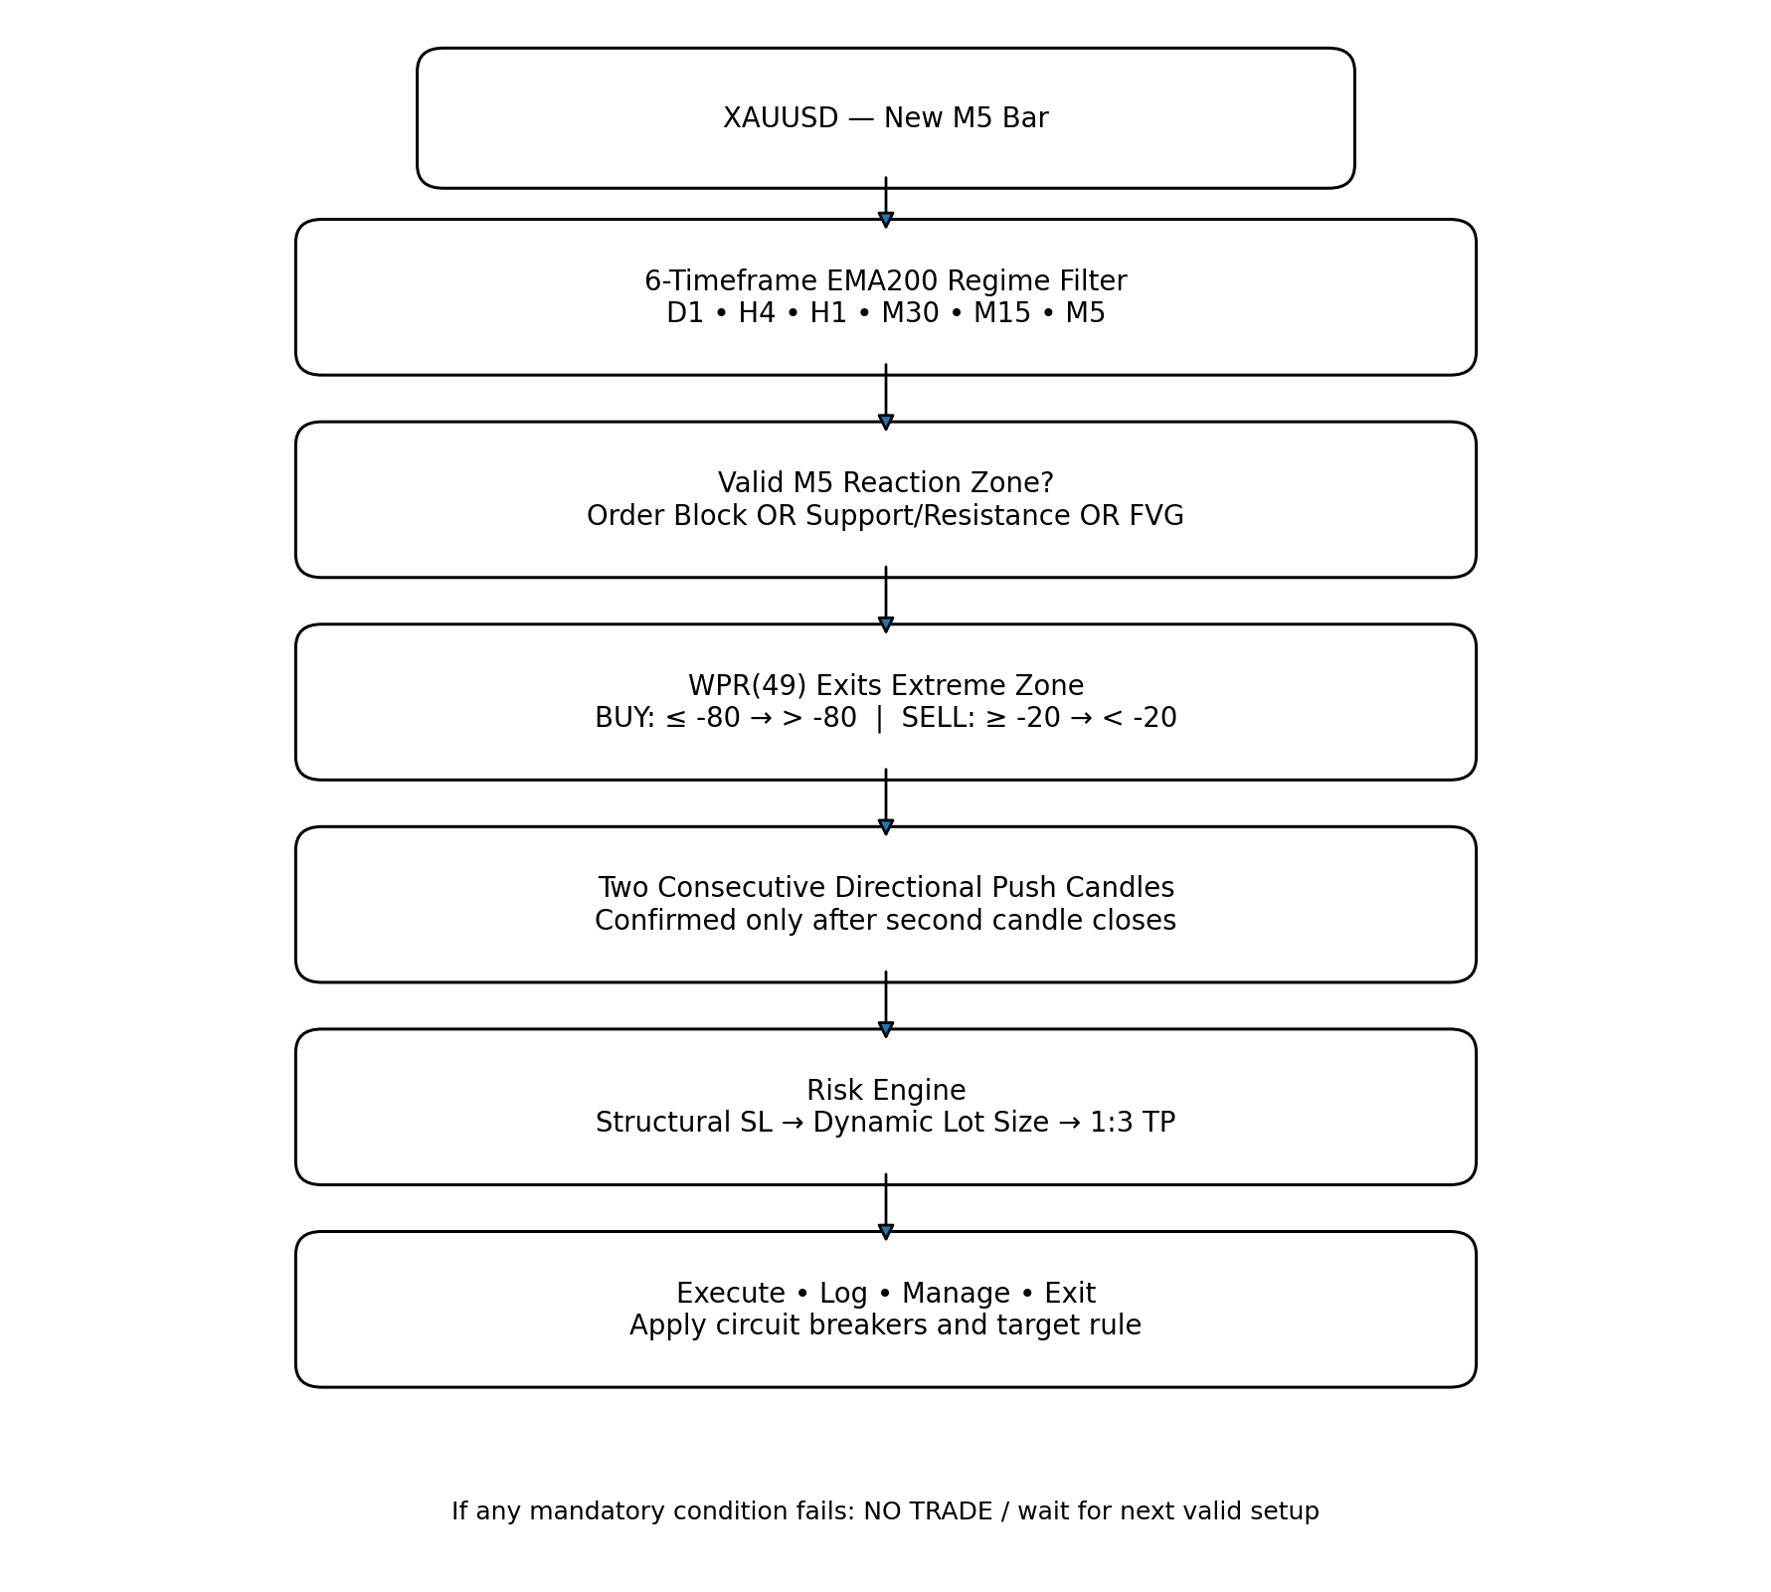
Version 1.1 | September 2026
Purpose
This document converts the agreed trading concept into a testable software blueprint. It is a research and engineering specification, not a claim of profitability. The strategy must prove itself through robust historical, out-of-sample, and forward testing before any meaningful live capital is used.

Contents
1. Executive Summary
2. Strategy Objectives and Design Principles
3. Complete Trading Rules
4. Finalized Zone, Reaction, and Confirmation Rules
5. Risk Management and Position Sizing
6. Software Architecture
7. Expert Advisor State Machine
8. Development Roadmap
9. Backtesting and Validation Framework
10. Optimization Without Overfitting
11. Paper Trading and Controlled Live Testing
12. Deployment and Monitoring
13. Configuration Parameters
14. Logging, Analytics, and Performance Metrics
15. Acceptance Tests
16. Major Risks and Analytical Advice
17. Code-Ready Status and Implementation Priorities
18. Reference Basis for v1.1 Rules

1. Executive Summary
The proposed robot is a deterministic, rule-based XAUUSD trading system. It uses a six-timeframe 200-EMA regime filter to define direction, executes only on the M5 timeframe, waits for price to react from at least one approved technical zone, then requires a Williams %R (49) exit from an extreme zone and two consecutive directional push candles before entering.
The core design principle is separation of responsibilities: market regime decides whether BUY or SELL setups are allowed; the M5 zone engine identifies areas of interest; momentum and candle behavior confirm the reaction; and the risk engine determines the stop, lot size, and 1:3 reward target.
Key decision already agreed
Do not fix the robot at 0.01 lots. The lot size should be calculated dynamically from the structural stop-loss distance and a configurable percentage of the INITIAL account balance. The original 5% risk setting remains an important test case, but 0.5%, 1%, 2%, 3%, and 5% should be compared before selecting a production risk setting.

2. Strategy Objectives and Design Principles
- Instrument: XAUUSD only for Strategy v1.1.
- Execution timeframe: M5 only.
- Directional bias: strict six-timeframe EMA200 alignment.
- Entry philosophy: trend-aligned reaction from a valid M5 zone, confirmed by WPR(49) and two push candles.
- Reward model: fixed 1:3 risk-to-reward target for the baseline strategy.
- Sizing model: stop-distance-based dynamic lot sizing.
- Capital model: risk is calculated from initial account balance, not continuously compounded balance.
- Validation philosophy: parameters must be tested out-of-sample; no assumption of profitability.
- Implementation philosophy: keep execution logic deterministic and explainable; do not add AI/ML to version 1.1

Design Constraints
- All trading decisions must use closed-bar data unless a rule explicitly requires tick-level behavior.
- The EA must avoid look-ahead bias in all timeframes.
- Every rejected setup must be explainable from a logged rule failure.
- Broker-specific XAUUSD specifications must be read dynamically: tick size, tick value, volume step, minimum lot, maximum lot, and stop-distance constraints.

3. Complete Trading Rules

3.1 Multi-Timeframe EMA200 Trend Filter
At each new M5 bar, the robot evaluates the most recently CLOSED candle on D1, H4, H1, M30, M15, and M5 against that timeframe's EMA(200). Using closed bars prevents the direction filter from changing because an unfinished higher-timeframe candle moves intrabar.
Regime | Rule | Action
BUY regime | Closed price > EMA200 on D1, H4, H1, M30, M15, and M5 | BUY setups allowed; SELL setups blocked
SELL regime | Closed price < EMA200 on all six timeframes | SELL setups allowed; BUY setups blocked
Mixed regime | Any timeframe violates alignment | No new trade

3.2 M5 Reaction Zones
A setup may originate from ANY ONE of the following M5 zone types. They are alternatives, not mandatory simultaneous conditions:
- Order Block (OB): last opposite-color M5 candle before displacement of at least 1.0 × ATR(14) within the following 3 candles, with a close through the most recent confirmed swing in the displacement direction.
- Support/Resistance: confirmed 2-left / 2-right M5 pivot swing occurring within the previous 20 closed M5 candles; the pivot is expanded into a zone of ±0.10 × ATR(14).
- Fair Value Gap (FVG): three-candle wick imbalance between Candle 1 and Candle 3 with a minimum gap size of 0.10 × ATR(14).
The EA should record confluence separately. A trade may be valid with one zone type, while overlapping zones receive a higher confluence score for later analysis.

3.3 Williams %R (49) Confirmation
Direction | Extreme Condition | Required Exit
BUY | WPR(49) was at or below -80 | A closed M5 value moves above -80
SELL | WPR(49) was at or above -20 | A closed M5 value moves below -20

WPR(49) does not have to exit the extreme on the first zone-touch candle. The required extreme may occur no earlier than 2 M5 bars before the first zone touch; after a valid reaction, WPR must close out of the extreme within the 5-bar setup lifetime.

3.4 Two Consecutive Push Candles
Baseline directional rules:
Direction | Baseline Rule | Execution
BUY | Candle 1 bullish with body/range ≥ 60%; Candle 2 bullish with body/range ≥ 60%; Candle 2 closes above Candle 1 high | Enter only after Candle 2 closes
SELL | Candle 1 bearish with body/range ≥ 60%; Candle 2 bearish with body/range ≥ 60%; Candle 2 closes below Candle 1 low | Enter only after Candle 2 closes

Final v1.1 push rule: each push candle must close in the trade direction and have a real body of at least 60% of its total high-low range. For BUY, Push Candle 2 must close above Push Candle 1 high; for SELL, Push Candle 2 must close below Push Candle 1 low. A qualifying reaction candle may also count as Push Candle 1.

3.5 Entry Sequence
- A new M5 bar forms; all signal decisions use closed M5 bars.
- Determine the six-timeframe EMA200 regime.
- If mixed: reject all new entries.
- If aligned: update eligible M5 OB, support/resistance, and FVG zones using the finalized v1.1 rules.
- Price touches/enters a valid zone and, within the touch candle or next 2 M5 candles, closes back outside the zone in the expected direction.
- Arm the setup for exactly 5 M5 bars after the valid reaction; cancel it if the zone invalidates or the timer expires.
- Within that window, WPR(49) must close out of the appropriate extreme; the extreme may have begun no earlier than 2 M5 bars before first zone touch.
- Two consecutive directional push candles must form: body/range ≥ 60% on both; Push 2 closes beyond Push 1 high/low in the trade direction.
- After Push Candle 2 closes, validate spread, margin, one-position rule, daily limits, 15% peak-equity drawdown lock, cooldown, and 10× balance target state.
- Calculate structural stop beyond the farther of the zone boundary or reaction extreme plus max(0.10 × ATR14, 2 × spread); then calculate dynamic lot size and exact 3R take-profit.
- Submit order and write the full setup snapshot to the trade log.

4. Finalized Zone, Reaction, and Confirmation Rules
Strategy Specification v1.1 freezes the previously discretionary zone and reaction concepts into deterministic rules. These are the coding defaults; neighboring values may still be tested during robustness analysis without changing the baseline specification.

4.1 Fair Value Gap (FVG)
Use three CLOSED M5 candles C1, C2, and C3.
- Bullish FVG: Low(C3) > High(C1). Zone = [High(C1), Low(C3)].
- Bearish FVG: High(C3) < Low(C1). Zone = [High(C3), Low(C1)].
- Minimum FVG size: gap width must be at least 0.10 × ATR(14) on M5 at the time the FVG is confirmed.
- A partial fill does not invalidate the FVG.
- Bullish FVG invalidation: an M5 candle closes below the far/lower FVG boundary. Bearish FVG invalidation: an M5 candle closes above the far/upper FVG boundary.
- First reaction only. After the first valid reaction attempt completes, expires, or is traded, retire that FVG from new-entry eligibility.
- Untouched FVG expires after 96 M5 bars (8 hours).

4.2 Order Block (OB)
An Order Block is not merely the last opposite-color candle before price moves. The following displacement and structural-break conditions are mandatory.
- Bullish OB: the last bearish M5 candle before bullish displacement of at least 1.0 × ATR(14) within the following 3 M5 candles, and that displacement must close above the most recent confirmed M5 swing high.
- Bearish OB: the last bullish M5 candle before bearish displacement of at least 1.0 × ATR(14) within the following 3 M5 candles, and that displacement must close below the most recent confirmed M5 swing low.
- OB zone boundaries use the entire qualifying candle, high-to-low, including wicks.
- Bullish OB invalidation: an M5 candle closes below the OB low. Bearish OB invalidation: an M5 candle closes above the OB high. A wick alone does not invalidate the OB.
- FVG creation is NOT required for an OB to exist; OB + FVG is recorded as additional confluence.
- First reaction only. Retire the OB after its first valid reaction attempt completes, expires, or is traded.
- Untouched OB expires after 96 M5 bars (8 hours).

4.3 Support and Resistance
Support and resistance are based on confirmed pivot swings, not a continuously moving highest-high / lowest-low line.
- Confirmed swing high: the pivot high is greater than the highs of the 2 closed bars immediately before it and the 2 bars immediately after it.
- Confirmed swing low: the pivot low is lower than the lows of the 2 closed bars immediately before it and the 2 bars immediately after it.
- Eligible pivots must occur within the previous 20 CLOSED M5 candles.
- Convert each pivot price into a zone of ±0.10 × ATR(14).
- Resistance uses confirmed swing-high zones; support uses confirmed swing-low zones.
- First reaction only. Untouched S/R zone expires after 96 M5 bars (8 hours).

4.4 Valid Zone Reaction
- BUY: price touches or enters bullish OB / support / bullish FVG, then within the touch candle or next 2 M5 candles closes back above the zone's near/upper boundary.
- SELL: price touches or enters bearish OB / resistance / bearish FVG, then within the touch candle or next 2 M5 candles closes back below the zone's near/lower boundary.
- If price closes through the zone's far invalidation boundary before the reaction completes, cancel the setup and invalidate that zone where applicable.
- Once a valid reaction is confirmed, start the 5-bar setup timer.

4.5 WPR(49) Timing Relative to the Zone
- BUY requires WPR(49) to have reached ≤ -80 and then close > -80.
- SELL requires WPR(49) to have reached ≥ -20 and then close < -20.
- The relevant extreme may begin no earlier than 2 M5 bars before the first zone touch; older extremes cannot qualify the setup.
- The WPR exit must be completed before entry and before the 5-bar post-reaction setup timer expires.

4.6 Two Push Candles
- Each push candle must close in the trade direction and have |Close - Open| / (High - Low) ≥ 0.60.
- BUY: Push Candle 2 must close above Push Candle 1 high.
- SELL: Push Candle 2 must close below Push Candle 1 low.
- A valid reaction candle may simultaneously count as Push Candle 1 if it satisfies the push-candle rule and WPR sequencing permits the setup.

4.7 Confluence Scoring
- OB, FVG, and S/R remain alternatives: at least one valid zone is sufficient.
- Record a confluence score equal to the number of overlapping eligible zone types at the reaction location: 1, 2, or 3.
- Do not require a minimum score above 1 in baseline v1.1; analyze score-based performance later.
Code-ready definitions
Strategy Specification v1.1 now freezes FVG, Order Block, Support/Resistance, reaction, WPR timing, push-candle, stop-buffer, setup-expiry, and zone-aging rules into deterministic defaults. These definitions should be implemented exactly first, then stress-tested around neighboring values.

5. Risk Management and Position Sizing

5.1 Risk Percentage
The production EA should expose RiskPercentInitialBalance as an input. The original strategy value is 5%, but that value must be compared with lower settings before deployment.
Risk | Interpretation | Role in Testing
0.5% | Very conservative baseline | Drawdown control / robustness
1.0% | Conservative | Potential production candidate
2.0% | Moderate | Growth vs. drawdown comparison
3.0% | Aggressive | Stress-test candidate
5.0% | Original concept; aggressive early in account life | Primary original-strategy test

5.2 Fixed Initial-Balance Risk Model
Dollar risk per trade = Initial Account Balance × Risk Percentage. This amount remains fixed as the balance grows unless the user deliberately changes the model.
Start Balance | Configured Risk | Risk $ | Current Balance | Effective Current Risk
$1,000 | 5% | $50 | $1,000 | 5.00%
$1,000 | 5% | $50 | $2,000 | 2.50%
$1,000 | 5% | $50 | $5,000 | 1.00%
$1,000 | 5% | $50 | $10,000 | 0.50%

5.3 Dynamic Lot Sizing
Fixed 0.01 lots is NOT the primary position-sizing model. The structural stop determines stop distance; the risk engine then calculates volume so the money at risk matches the configured risk budget.
Conceptual formula
Lot Size = Risk Budget ÷ Monetary Loss Per Lot at the Proposed Stop Distance.
In MQL5, use broker-reported tick size/tick value and volume constraints rather than assuming a universal XAUUSD point value.

- Round lot size DOWN to the broker's allowed volume step so risk is not exceeded.
- Reject the trade if the minimum permitted lot would exceed the risk cap.
- Reject the trade if required margin is unavailable.
- Record theoretical risk and broker-normalized risk for auditability.

5.4 Stop-Loss and Take-Profit
- BUY: base stop reference is the LOWER of the zone far boundary or reaction extreme low; place SL below that reference by Buffer = max(0.10 × ATR(14), 2 × current spread).
- SELL: base stop reference is the HIGHER of the zone far boundary or reaction extreme high; place SL above that reference by Buffer = max(0.10 × ATR(14), 2 × current spread).
- Baseline take-profit: exactly 3 × stop distance from entry (3R).
- Do not add break-even or trailing-stop logic to baseline v1.1; test those later as separate variants.

5.5 Account Target and Circuit Breakers
- Target multiplier: 10× the initial CLOSED account balance.
- Target rule: after a trade closes, if closed account balance ≥ 10 × initial balance, set TargetReached = TRUE, cancel pending setups, and block all new positions until manual reset. Do not trigger the target from floating equity.
- Maximum trades per broker trading day: 3.
- Maximum losing trades per broker trading day: 2; after the second realized loss, block new entries until the next broker trading day.
- Daily realized loss limit: -2R; once reached or exceeded, block new entries until the next broker trading day.
- Peak-equity circuit breaker: if current equity falls 15% or more below the running equity peak, disable new entries and require manual review/re-enable.
- Maximum spread: trade only if spread ≤ 10% of proposed SL distance AND spread ≤ 0.15 × ATR(14). Both tests must pass.
- One XAUUSD position at a time for baseline v1.1.
- Cooldown: after any trade closes, wait 3 M5 bars (15 minutes) and require a new valid zone/reaction sequence before another entry.

6. Software Architecture
Recommended platform: MetaTrader 5 with the live Expert Advisor written in MQL5. A separate Python research layer can analyze exported trade logs, run statistical tests, compare configurations, and generate diagnostics. This keeps execution deterministic while retaining strong analytical capability.
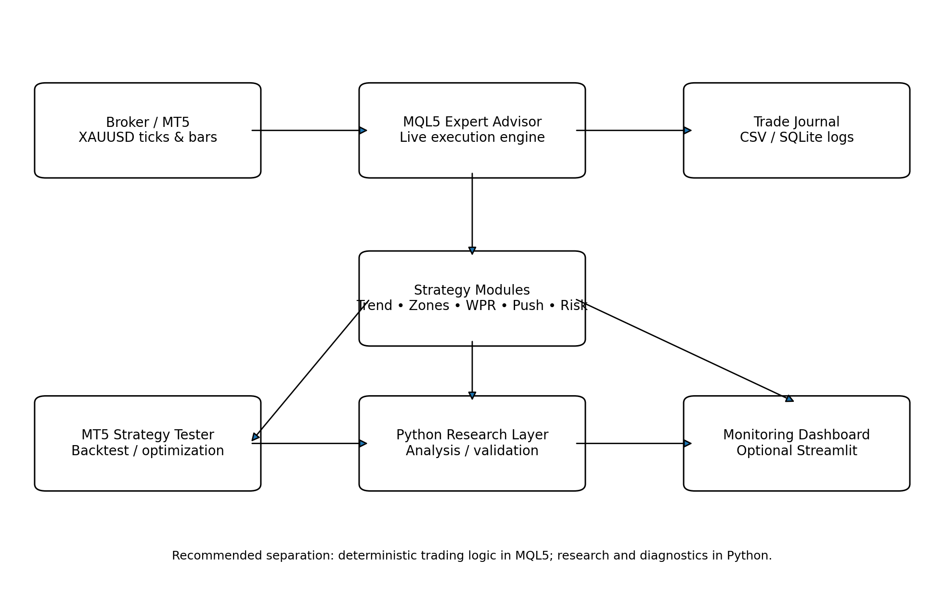

6.1 MQL5 EA Modules
Module | Responsibility
MarketData | Loads multi-timeframe bars, broker symbol properties, spread, tick size/value, and trading session state.
TrendFilter | Calculates EMA200 on six timeframes and returns BUY / SELL / MIXED regime.
ZoneEngine | Detects, stores, ages, scores, and invalidates FVG, OB, and S/R zones.
ReactionEngine | Determines when price has interacted with and reacted from a valid zone.
MomentumEngine | Tracks WPR(49) extreme state and confirmed exit.
PushCandleEngine | Identifies the required two-candle directional confirmation.
SetupStateMachine | Arms, advances, expires, or cancels setups in the correct sequence.
RiskEngine | Computes structural SL, risk budget, lot size, TP, margin, and normalized broker volume.
ExecutionEngine | Submits, validates, modifies, and closes orders; prevents duplicates.
SafetyEngine | Applies spread, daily limits, drawdown, trade frequency, target, and one-position rules.
Logger | Writes every signal, rejection, order, fill, exit, zone score, and metric snapshot.

6.2 Python Research Layer
- Pandas / NumPy for trade-log analysis.
- Matplotlib for equity curves, drawdown curves, distributions, and robustness charts.
- SciPy / statsmodels where statistical testing is useful.
- Optional SQLite database for larger experiment histories.
- Optional Streamlit dashboard for peer demonstration and monitoring.
Python should not be required for live order execution in v1. Keeping the live EA self-contained reduces operational failure points.

7. Expert Advisor State Machine
State | Meaning | Next Action
IDLE | No active setup | Wait for aligned regime and valid zone
ZONE_FOUND | Eligible zone identified | Wait for touch/entry and a qualifying directional close within 2 M5 candles
REACTION_ARMED | Price reacted from zone | Start fixed 5-bar setup-expiry counter; enforce WPR timing
WPR_CONFIRMED | WPR exited extreme | Wait for push candles
PUSH_1 | First directional push closed | Wait for qualifying Push 2 close beyond Push 1 high/low
READY | Second push closed | Run exact spread, cooldown, daily-limit, drawdown, target, margin, and risk checks
IN_TRADE | Position open | Manage fixed SL/TP and logging
COOLDOWN | Trade closed or setup cancelled | Wait 3 M5 bars and require a completely new valid setup

A state-machine design prevents rules from being checked out of order. For example, the robot should not recognize two bullish candles first and later retroactively discover that price was near an old order block.

8. Development Roadmap
Phase | Deliverable
Phase 0 — v1.1 Specification Frozen | All FVG, OB, S/R, reaction, WPR timing, push-candle, SL buffer, setup-expiry, spread, cooldown, drawdown, and target rules are now deterministic and code-ready.
Phase 1 — Research Prototype | Implement rule calculations in Python or a lightweight MQL5 indicator to visually label historical setups and confirm that the rules match the intended chart behavior.
Phase 2 — MQL5 Signal EA | Build all detection modules and logging without placing orders. Run on historical/forward charts to compare machine decisions with expected behavior.
Phase 3 — Risk & Execution | Add structural SL, dynamic volume, 3R target, order placement, and broker constraint handling.
Phase 4 — Backtest Harness | Create repeatable Strategy Tester profiles and export standardized trade/signal logs.
Phase 5 — Robust Validation | Run in-sample, out-of-sample, walk-forward, parameter sensitivity, spread/slippage, and Monte Carlo sequence tests.
Phase 6 — Demo Account | Forward-test on a broker demo account under live spreads, session transitions, news spikes, connection interruptions, and VPS conditions.
Phase 7 — Controlled Live Pilot | Only after acceptance criteria are met; use the lowest justified risk setting and strict safety limits.
Phase 8 — Monitoring & Presentation | Build a dashboard showing regime, zones, setup state, risk, trades, expectancy, drawdown, and experiment comparisons.

9. Backtesting and Validation Framework

9.1 Required Data
- High-quality XAUUSD historical data with realistic bid/ask or spread modeling.
- Sufficient history to include trending, ranging, high-volatility, low-volatility, crisis, and normal periods.
- Correct broker trading hours, symbol specification, and daylight-saving/session behavior where relevant.
- M5 base data plus synchronized higher-timeframe bars derived without look-ahead.

9.2 Test Segmentation
- In-sample: used to develop and sanity-check definitions.
- Validation: used for parameter comparison without repeatedly modifying rules.
- Out-of-sample: untouched period used for final evaluation.
- Walk-forward: repeat development/validation across rolling chronological windows.
Never randomly shuffle time-series data for the core strategy validation.

9.3 Mandatory Performance Metrics
Metric | Why It Matters
Net return | Total strategy growth over the test period.
Win rate | Percentage of trades reaching 3R before SL.
Expectancy (R) | Average R gained or lost per trade.
Profit factor | Gross profit divided by gross loss.
Maximum drawdown | Worst peak-to-trough decline; both money and percentage.
Consecutive losses | Worst losing streak and distribution of streak lengths.
Trades/month | Signal frequency and practical opportunity rate.
Long vs short | Separate BUY and SELL performance.
Zone type | OB vs S/R vs FVG and confluence combinations.
Session | Performance by market session / time-of-day window.
Spread/slippage sensitivity | Effect of worse execution assumptions.
Target probability | How often simulations reach 10× before hitting defined drawdown/stop conditions.

9.4 1:3 Reward Mathematics
Ignoring transaction costs, a fixed 1:3 payoff has a theoretical break-even win rate of 25%. Real break-even is higher once spread, commission, slippage, gaps, and imperfect fills are included. The strategy therefore needs a sufficient margin above break-even, not merely a backtest near 25%.

10. Optimization Without Overfitting
Parameters should be tested in broad ranges and judged by stability, not by the single highest historical profit.
Parameter | Candidate Range | Purpose
Risk % | Default research matrix: 0.5, 1, 2, 3, 5 | Compare growth vs drawdown; 5% remains original-strategy variant
Setup expiry | Default 5 bars; test 3/5/8/10 | Robustness around 25-minute baseline
Push body ratio | Default 0.60; test 0.50–0.75 | Reject weak candles while checking sensitivity
Impulse threshold | Default ≥ 1.0 × ATR14 within 3 bars + swing break | OB displacement quality
FVG minimum size | Default ≥ 0.10 × ATR14 | Remove micro-imbalances
S/R algorithm | Default 2-left/2-right pivot, 20-bar eligibility, ±0.10 ATR zone | Test neighboring pivot/zone definitions only after baseline
SL buffer | Default max(0.10 × ATR14, 2 × spread) | Volatility- and execution-aware stop buffer
Session filter | Off in baseline; test All/London/NY/overlap | Evaluate time-of-day edge without changing v1.1 baseline
Spread cap | Default: ≤10% SL distance AND ≤0.15 × ATR14 | Avoid execution costs consuming too much R

Selection rule
Prefer a broad plateau of good performance across neighboring parameter values. Avoid a narrow 'magic' setting that collapses when moved slightly; that is a common sign of overfitting.

11. Paper Trading and Controlled Live Testing

11.1 Demo / Forward Test
- Run exactly the same compiled EA intended for live use.
- Use realistic broker symbol specifications and spreads.
- Verify no duplicate orders, stale setups, or timeframe synchronization errors.
- Test restart recovery after MT5/VPS interruption.
- Compare live forward signals with the EA's internal logs.
- Record missed trades, rejected trades, slippage, spread spikes, and order errors.

11.2 Live Pilot Gate
Do not move to meaningful capital because a backtest is profitable. The live pilot should begin only after the strategy meets predefined acceptance criteria across out-of-sample and forward testing. The initial live risk should be the lowest level justified by evidence, not automatically 5%.

12. Deployment and Monitoring
- Host MetaTrader 5 and the EA on a reliable Windows VPS close to the broker's infrastructure when practical.
- Enable terminal auto-start and EA restart after reboot.
- Persist initial account balance and strategy state safely so a restart does not reset the risk reference.
- Use daily log rotation and retain all trade/signal logs.
- Monitor connection state, broker trade permissions, spread, open position state, and EA heartbeat.
- Create alerts for order rejection, maximum drawdown, daily loss lockout, and target reached.
- Optional: export data to a Streamlit dashboard for a visual portfolio/demo presentation.

Recommended Demo Dashboard
- Current XAUUSD price and six EMA200 regime lights.
- Active M5 zone(s) and confluence score.
- WPR(49) state: normal / oversold / overbought / exit confirmed.
- Setup state-machine status.
- Current risk budget, proposed SL distance, and calculated lot size.
- Equity curve, drawdown curve, win rate, expectancy, profit factor, and trade count.
- Performance by OB/FVG/S&R and by confluence score.
- Backtest vs forward-test comparison.

13. Configuration Parameters
Input | Initial / Test Value | Purpose
Symbol | XAUUSD | v1.1 fixed instrument
ExecutionTF | M5 | Trade setup timeframe
EMA_Period | 200 | Applied to D1/H4/H1/M30/M15/M5
WPR_Period | 49 | Williams %R period
WPR_Oversold | -80 | BUY extreme threshold
WPR_Overbought | -20 | SELL extreme threshold
WPR_MaxLeadBars | 2 | Extreme may begin no earlier than 2 M5 bars before first zone touch
ATR_Period | 14 | M5 volatility normalization
OB_DisplacementATR | 1.0 | Minimum displacement within next 3 M5 candles
OB_DisplacementBars | 3 | Window for qualifying displacement
OB_RequireSwingBreak | True | Mandatory structure break
OB_Boundary | Full candle high-low | Includes wicks
ZoneMaxAgeBars | 96 | Untouched zone expires after 8 hours
FirstReactionOnly | True | Retire zone after first valid reaction attempt
SR_Lookback | 20 | Eligible pivot must lie in prior 20 closed M5 bars
SR_PivotLeft | 2 | Confirmed pivot bars to the left
SR_PivotRight | 2 | Confirmed pivot bars to the right
SR_ZoneATR | 0.10 | Pivot zone = ±0.10 × ATR14
FVG_MinATR | 0.10 | Minimum FVG width
ReactionMaxBars | 2 | Reaction close must occur by touch candle + next 2 bars
SetupExpiryBars | 5 | 25-minute post-reaction setup lifetime
PushBodyRatio | 0.60 | Minimum body ÷ total range on both push candles
Push2BreaksPush1 | True | BUY close > Push1 high; SELL close < Push1 low
SL_Buffer | max(0.10×ATR14, 2×spread) | Added beyond farther zone/reaction extreme
RiskPercentInitialBalance | Test: 0.5/1/2/3/5 | Production value chosen only after validation
RewardRisk | 3.0 | TP = exactly 3R
MaxOpenPositions | 1 | One XAUUSD position at a time
MaxTradesPerDay | 3 | Daily circuit breaker
MaxLossesPerDay | 2 | Daily circuit breaker
DailyLossLimit | -2R realized | Daily circuit breaker
MaxPeakEquityDrawdown | 15% | Manual-review lockout
MaxSpreadVsSL | 0.10 | Spread ≤ 10% of proposed SL distance
MaxSpreadATR | 0.15 | Spread ≤ 0.15 × ATR14
CooldownBars | 3 | 15 minutes after any trade closes
TargetMultiplier | 10.0 | Based on CLOSED account balance
UseSessionFilter | Off | Experimental, not baseline v1.1
UseNewsFilter | Off | Experimental, not baseline v1.1

14. Logging, Analytics, and Performance Metrics
Every potential setup should be logged, not only executed trades. This allows the strategy to explain why it did or did not act.
- Timestamp and broker server time
- Six timeframe prices and EMA200 values
- Regime result
- Zone IDs, type, boundaries, age, and confluence score
- Reaction timestamp and reaction rule details
- WPR values before and after the extreme exit
- Push candle OHLC, body size, range, and strength metrics
- Proposed entry, structural stop, stop distance, 3R target
- Initial balance, current balance/equity, configured risk %, risk dollars
- Raw calculated volume and broker-normalized volume
- Spread, margin requirement, slippage/fill price
- Safety checks and any rejection reason
- Trade outcome in money, percentage, and R

15. Acceptance Tests
Test | Pass Condition
EMA alignment | BUY only when all six previous CLOSED timeframe bars are strictly above EMA200; SELL only when all are strictly below.
No look-ahead | Unfinished higher-timeframe candles may not change a closed-bar regime decision.
Bullish FVG | Low(C3) > High(C1) and gap ≥ 0.10 × ATR14; zone boundaries match C1 high and C3 low.
Bearish FVG | High(C3) < Low(C1) and gap ≥ 0.10 × ATR14; zone boundaries match C3 high and C1 low.
FVG invalidation | Partial fill stays valid; close through far boundary invalidates.
Bullish OB | Last bearish candle only qualifies if next 3 bars deliver ≥1.0 ATR bullish displacement and close above latest confirmed swing high.
Bearish OB | Last bullish candle only qualifies if next 3 bars deliver ≥1.0 ATR bearish displacement and close below latest confirmed swing low.
OB invalidation | Wick alone does not invalidate; M5 close beyond far edge does.
S/R pivot | Pivot uses exact 2-left/2-right rule and must be within previous 20 closed M5 bars; zone width = ±0.10 ATR14.
Zone age | Untouched OB/FVG/S&R is ineligible after 96 M5 bars.
Reaction BUY | After touch/entry, qualifying close above near/upper boundary occurs no later than next 2 M5 candles.
Reaction SELL | After touch/entry, qualifying close below near/lower boundary occurs no later than next 2 M5 candles.
WPR BUY | Relevant extreme ≤ -80 begins no earlier than 2 bars before touch and later closes > -80 before setup expiry.
WPR SELL | Relevant extreme ≥ -20 begins no earlier than 2 bars before touch and later closes < -20 before setup expiry.
Push candles | Both body/range ≥0.60; Push 2 closes beyond Push 1 high/low in trade direction; entry waits for Push 2 close.
Setup expiry | No entry after 5 post-reaction M5 bars without a new valid setup.
First reaction only | Same zone cannot generate a second independent entry after its first reaction attempt is completed/retired.
Stop BUY | SL is below lower(zone far edge, reaction low) by max(0.10 ATR14, 2×spread).
Stop SELL | SL is above higher(zone far edge, reaction high) by max(0.10 ATR14, 2×spread).
Risk cap | Broker-normalized lot size is rounded down and must not intentionally exceed initial-balance risk budget.
Minimum lot | Reject trade if broker minimum volume would exceed risk cap.
Spread filter | Both spread ≤10% of proposed SL distance and spread ≤0.15 ATR14 must pass.
1:3 TP | TP distance equals exactly 3 × validated stop distance for baseline v1.1.
One position | No second XAUUSD position while one is open.
Daily trades | Fourth trade of a broker trading day is blocked.
Daily losses | After second realized losing trade, new entries are blocked until next broker trading day.
Daily -2R | Once daily realized P/L reaches or breaches -2R, new entries are blocked.
15% drawdown | At ≥15% decline from running equity peak, new entries disable until manual review/re-enable.
Cooldown | After any trade closes, no new entry for 3 completed M5 bars and a new zone/reaction is required.
10× target | Target uses closed balance only; once balance ≥10× initial balance, pending setups cancel and new entries remain blocked until manual reset.
Restart | EA restart preserves initial-balance reference, running equity peak, lock states, target state, and safely reconciles any existing position.
Logging | Every ready-state trade or rejection records deterministic reason codes and the complete rule snapshot.

16. Major Risks and Analytical Advice
Risk / Issue | Advice
5% early-account risk | Aggressive. Under a fixed initial-dollar-risk model it becomes less aggressive as the account grows, but early losing streaks can still cause severe drawdown. Keep 5% as a research variant, not an automatic live setting.
Over-defining confluence | Requiring OB + FVG + S/R simultaneously could starve the system of trades. Keep them as alternatives and record confluence score.
OB/FVG/S&R model risk | Definitions are now deterministic, but these concepts are not universally standardized. Treat the v1.1 definitions as hypotheses that must survive out-of-sample testing.
Push-candle threshold risk | v1.1 fixes body/range at 60% and requires Push 2 to break Push 1 high/low. Test neighboring thresholds for robustness rather than optimizing to a single best value.
XAUUSD execution costs | Gold can experience rapid spread expansion and slippage. Backtests must stress worse-than-normal execution.
News volatility | Do not assume news filtering improves results. Build it as a later experiment and compare.
Overfitting | Avoid selecting rules because they maximize one historical period. Favor parameter stability and out-of-sample persistence.
1000% target fixation | 10× is a closed-balance research target/kill switch, not evidence of system quality. Evaluate drawdown, expectancy, robustness, and probability of target-before-lockout.
AI/ML complexity | Not justified in v1. Establish a reliable deterministic baseline first; only add ML for a clearly defined measurable prediction problem.

17. Code-Ready Status and Implementation Priorities
Strategy Specification v1.1 is code-ready: the previously ambiguous discretionary concepts have been frozen into explicit machine rules. The remaining work is implementation and empirical validation, not further interpretation of the trading rules.

17.1 Immediate Implementation Priorities
1. Implement the six-timeframe closed-bar EMA200 regime filter and verify higher-timeframe synchronization.
2. Implement FVG, OB, and 2-left/2-right S/R zone engines exactly as specified in Section 4.
3. Implement zone aging, first-reaction-only retirement, reaction timing, WPR sequencing, and the 5-bar setup state machine.
4. Implement the 60% push-candle rule and Push 2 structural break requirement.
5. Implement structural SL, dynamic lot sizing, exact 3R target, and broker volume normalization.
6. Implement spread, daily trade/loss, -2R, 15% drawdown, cooldown, one-position, and 10× closed-balance locks.
7. Create machine-readable logging for every setup state transition, rejection reason, order, fill, and exit.

17.2 Validation Priorities
- Validate that the coded signals visually match the written specification before enabling order placement.
- Backtest the baseline defaults first; then vary one rule family at a time around the default to test stability.
- Keep 0.5%, 1%, 2%, 3%, and 5% risk as separate capital-management experiments; do not choose live risk from intuition.
- Keep session and news filters OFF in baseline v1.1 and evaluate them later as isolated experiments.
- Require out-of-sample, walk-forward, spread/slippage stress tests, and demo forward testing before any controlled live pilot.

17.3 Definition of Done for the Coding Phase
- Every rule in Sections 3–5 has a deterministic automated test.
- No setup can enter out of sequence or survive beyond its defined lifetime.
- No normalized position size intentionally exceeds the configured initial-balance risk cap.
- All safety locks remain correct after terminal/EA restart.
- Backtest logs contain enough data to independently reconstruct why each trade was taken or rejected.
Implementation sequence
1) Build the deterministic signal engine → 2) visually verify machine signals against the written v1.1 rules → 3) add risk and execution → 4) run baseline backtests → 5) run robustness, out-of-sample, walk-forward, spread/slippage, and Monte Carlo tests → 6) demo forward-test → 7) only then consider a controlled live pilot.

Strategy Logic — Compact Pseudocode
On each NEW M5 BAR:
restore/check safety state
if TargetReached or DrawdownLock or DailyLock:
return
regime = closed_bar_EMA200_alignment(D1,H4,H1,M30,M15,M5)
if regime == MIXED:
return
update_ATR14_and_zones()
expire_untouched_zones_after_96_bars()
if no_active_setup:
zone = eligible_first_reaction_OB_or_SR_or_FVG(regime)
if zone_touched and directional_close_away_within_2_bars:
arm_setup_for_5_bars(zone)
if active_setup:
if zone_invalidated or setup_age > 5 bars:
retire_setup_and_zone()
return
require_WPR_extreme_not_older_than_2_bars_before_touch()
require_WPR49_exit_extreme()
if qualifying_push1 and qualifying_push2:
# both body/range >= 0.60; push2 breaks push1 high/low
SL = beyond_farther(zone_boundary, reaction_extreme)
+ max(0.10*ATR14, 2*spread) buffer
risk_budget = initial_balance * risk_percent
volume = broker_normalized_volume_risking_no_more_than(risk_budget)
TP = exact_3R_target(entry, SL)
if spread <= 0.10*SL_distance
and spread <= 0.15*ATR14
and open_positions == 0
and trades_today < 3
and losses_today < 2
and daily_realized_R > -2
and peak_equity_drawdown < 15%
and cooldown_3_bars_complete
and closed_balance < 10*initial_balance:
place_trade(volume, SL, TP)
retire_setup_and_zone()
else:
log_rejection_reason()

18. Reference Basis for v1.1 Rules
The standardized parts of v1.1 are grounded primarily in established indicator, volatility, risk-management, and MetaTrader documentation. Order Block and Fair Value Gap terminology is less standardized; therefore, the exact OB/FVG thresholds in this blueprint are deliberate engineering definitions to be empirically validated, not universal market laws.
- CME Group — Proper Position Size and Position/Risk Management: logical stop placement, defined risk, and sizing from risk rather than arbitrary fixed volume. https://www.cmegroup.com/education/courses/trade-and-risk-management/proper-position-size
- Fidelity — Average True Range (ATR): volatility-adaptive thresholds and stop concepts. https://www.fidelity.com/learning-center/trading-investing/technical-analysis/technical-indicator-guide/atr
- Fidelity — Williams %R: conventional -20 overbought and -80 oversold zones and caution against isolated use. https://www.fidelity.com/learning-center/trading-investing/technical-analysis/technical-indicator-guide/williams-r
- TradingView — Williams %R documentation: conventional 0 to -20 overbought and -80 to -100 oversold interpretation. https://www.tradingview.com/support/solutions/43000501985-williams-r-r/
- MetaQuotes MQL5 — Symbol Properties: broker-reported tick value, tick size, volume minimum/maximum/step, and related execution properties. https://www.mql5.com/en/docs/constants/environment_state/marketinfoconstants
- Smart Money Concepts / ICT references were used only to compare common OB/FVG conventions. Because these concepts are not universally standardized, v1.1 freezes its own objective definitions and requires out-of-sample validation.
END OF BLUEPRINT — Strategy Specification v1.1

