**Build and Deploy hadoop word count program using Maven**

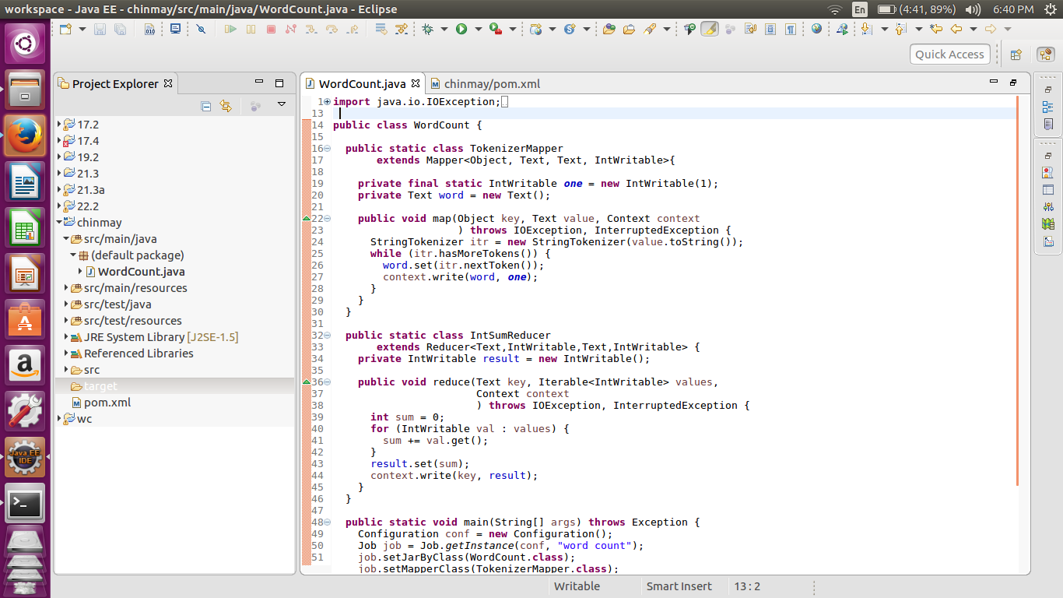

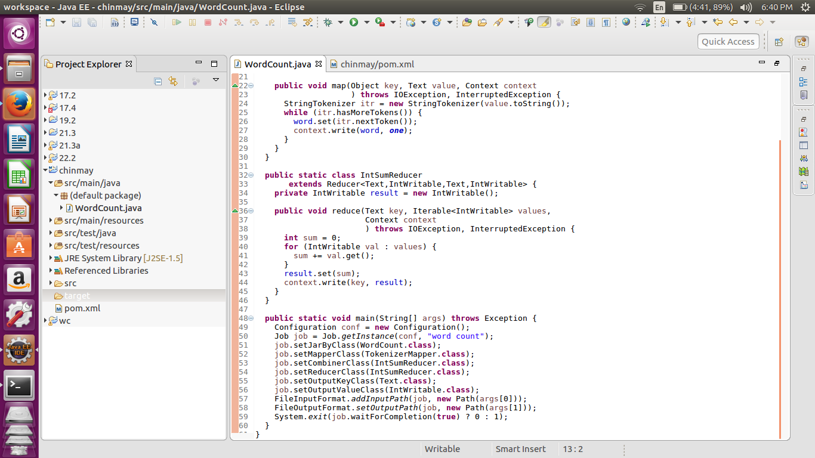

**//pom.xml**

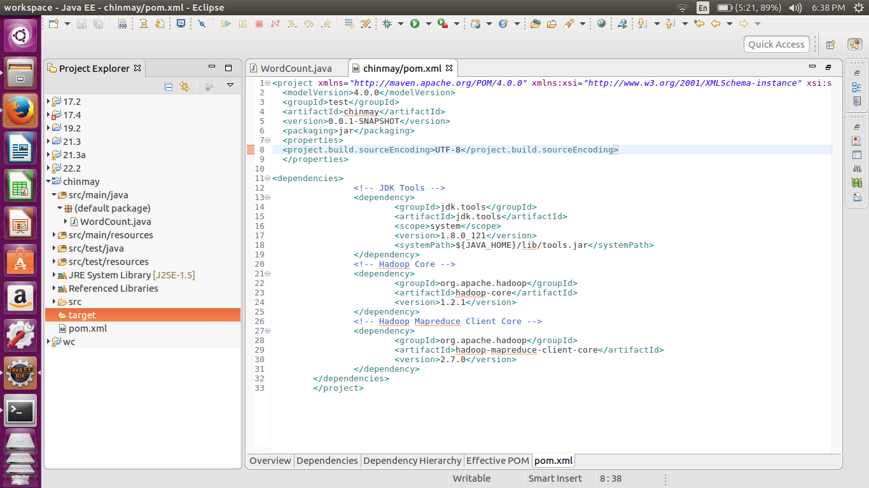

**In the pom.xml file we are adding dependencies of the jdk,Hadoop ,map reduce client.**

**Once the maven project is created.**

**In the terminal we have changed directory to the workspace where the project was created.**

**In the folder we have executed the command** *mvn clean install* **.This will generate the** 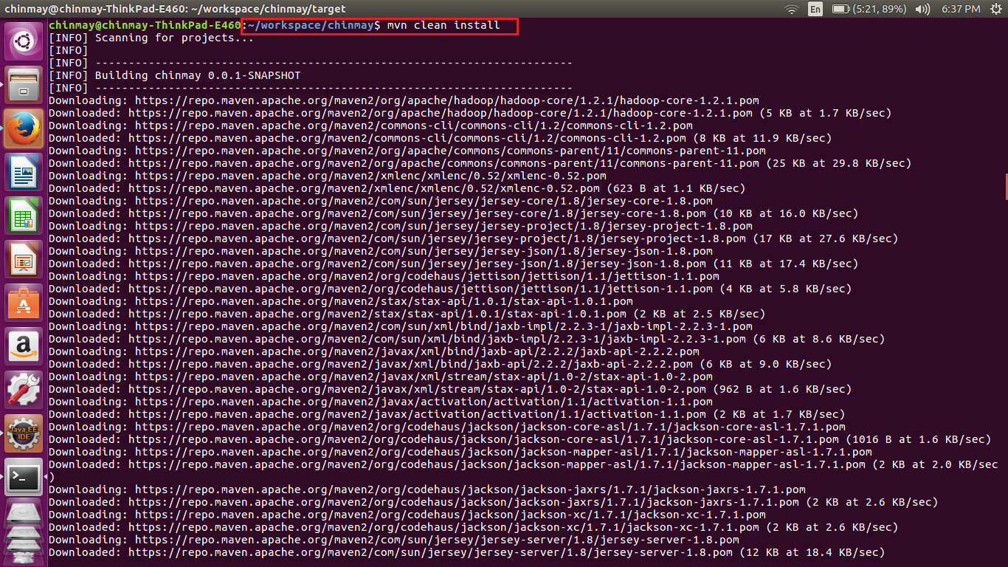

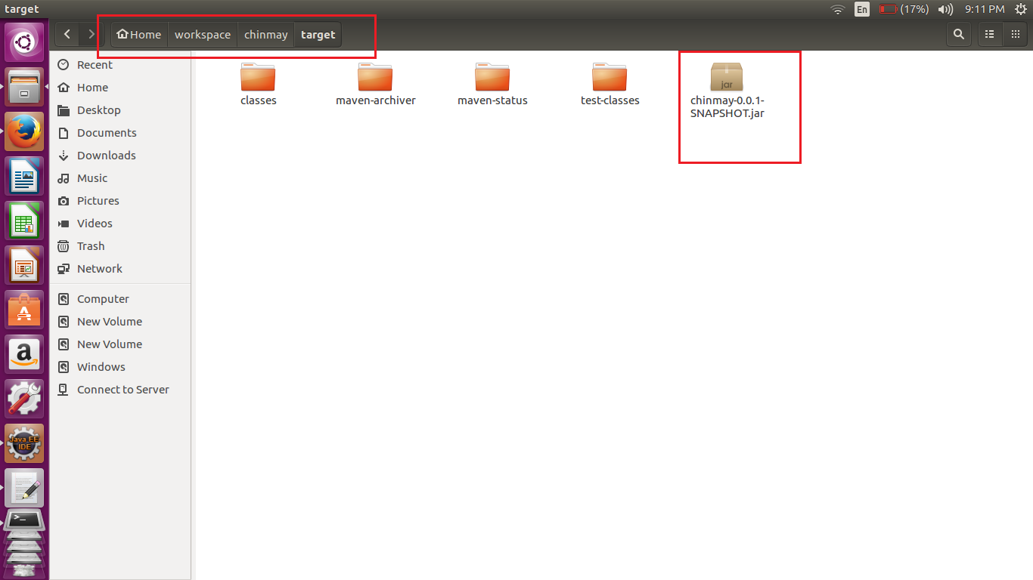

**If we implement the above jar with the proper input we get the word count.**

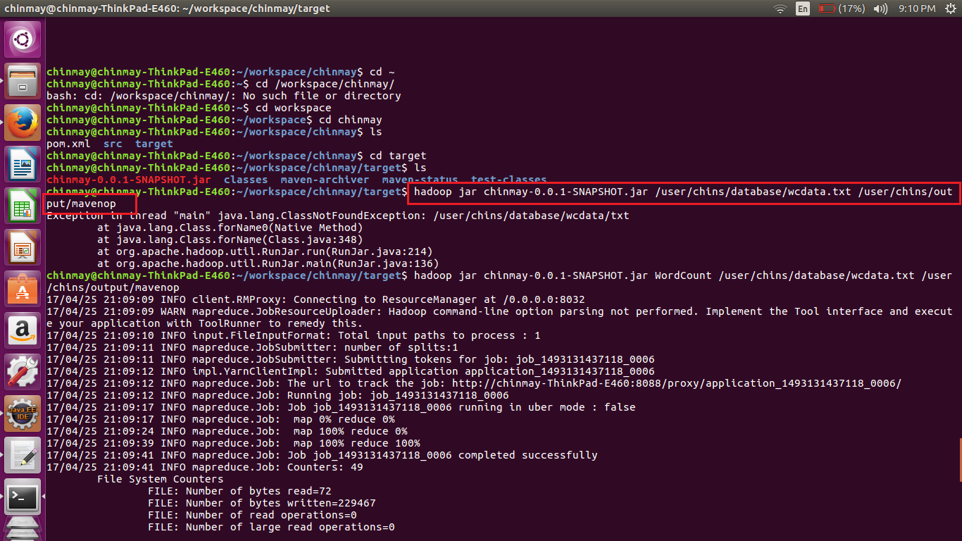

**//output**

