Write some test cases to test a sample hadoop word count program using MRUnit.

//word count program

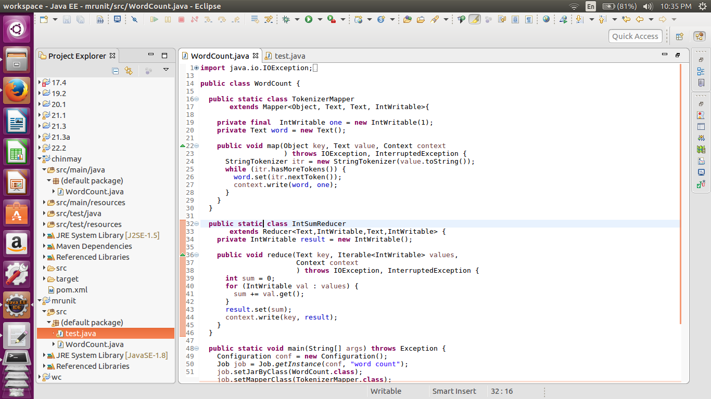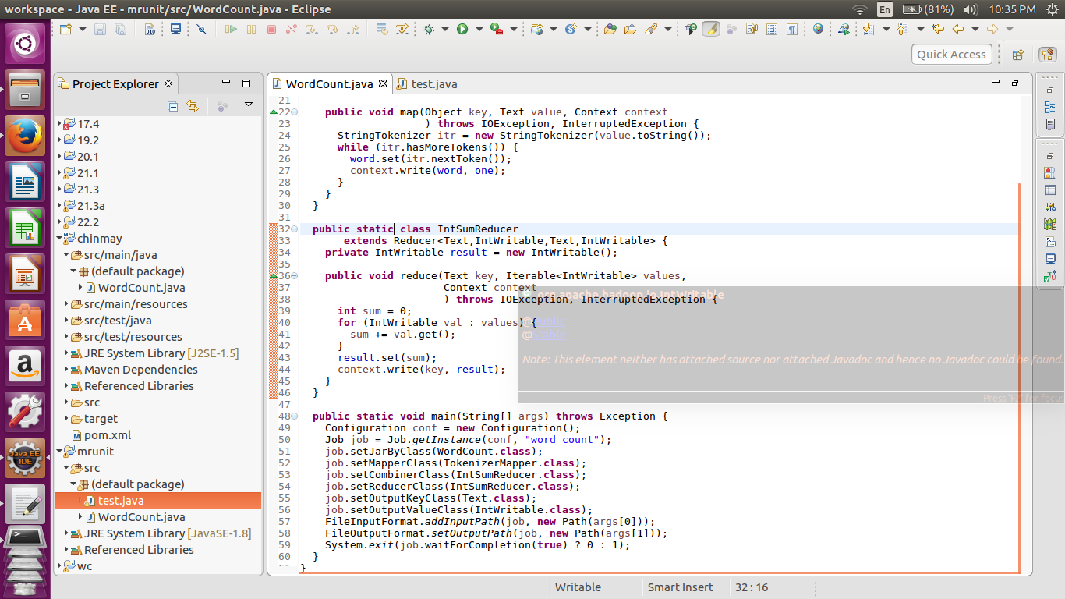

//testing code

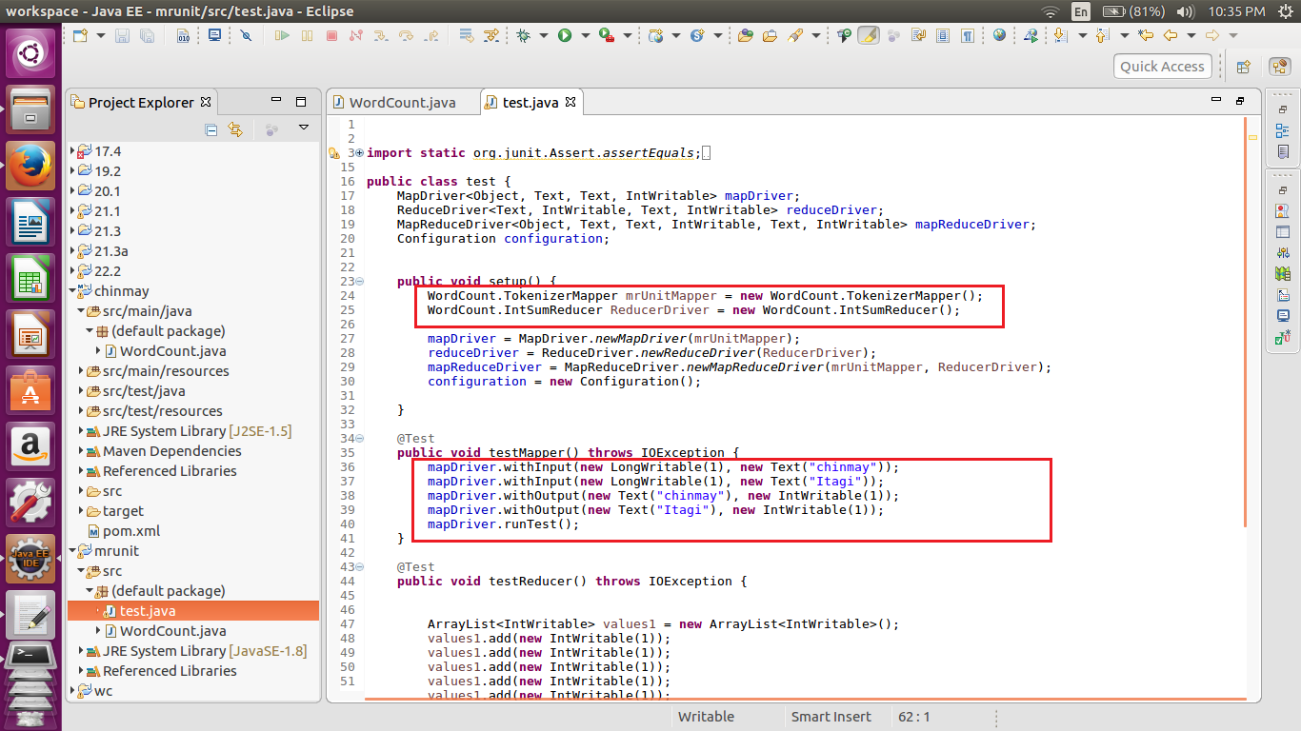

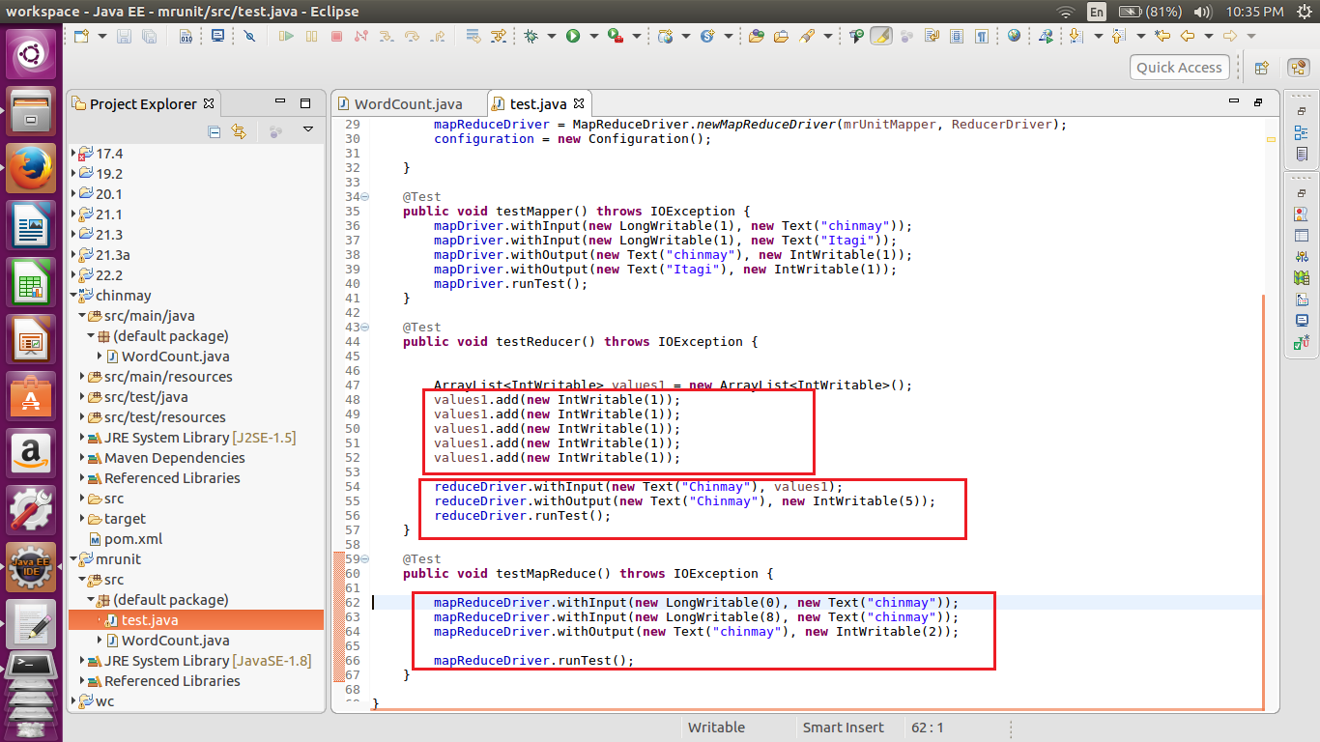

//Correct test case.

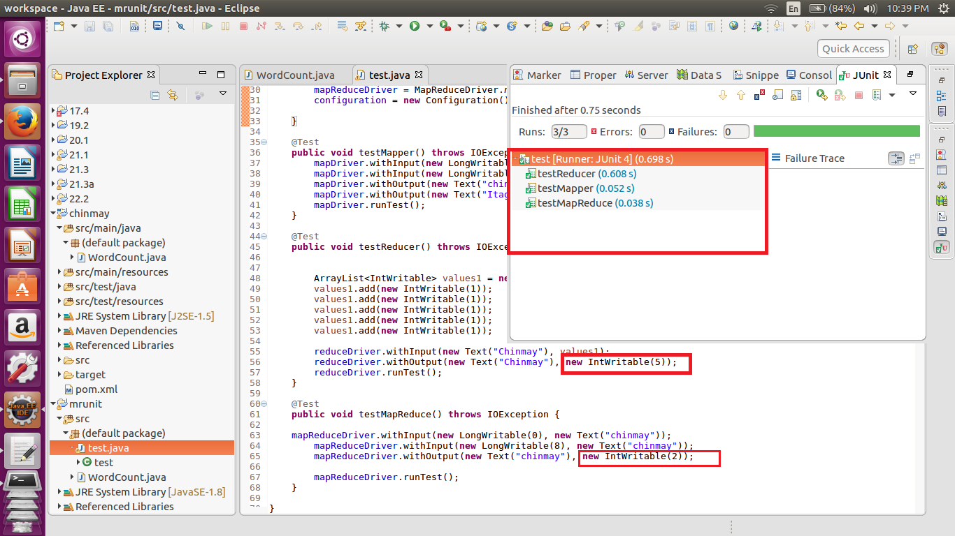

Here we can see that all the values are entered correctly and hence we are getting all the values correct.

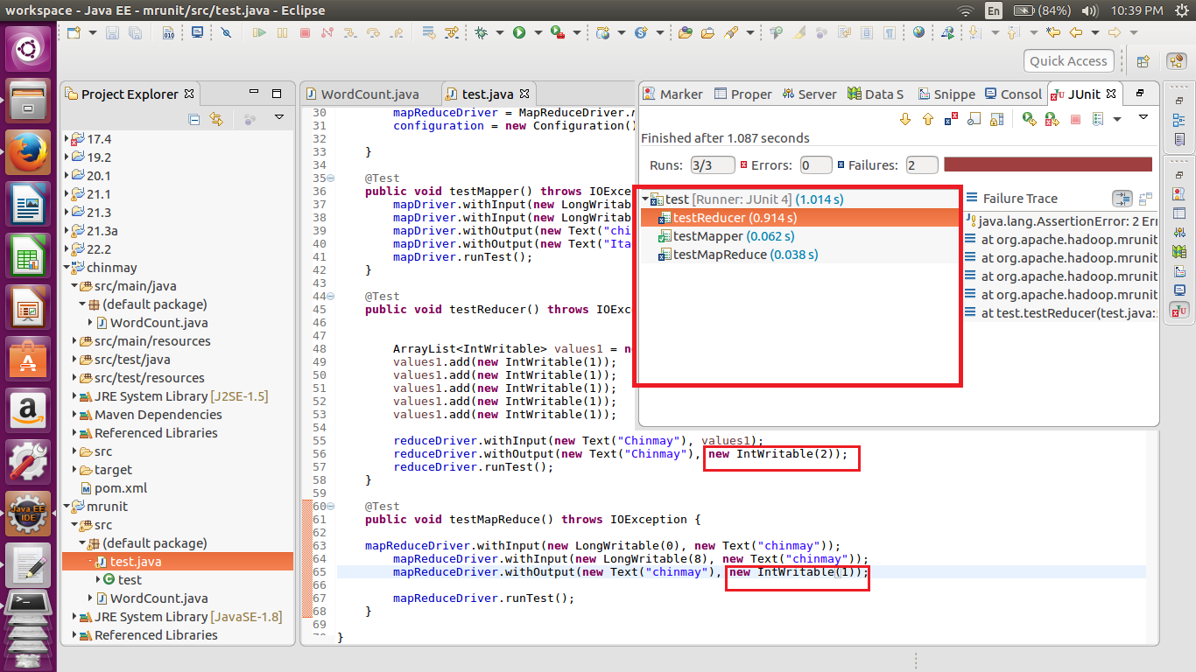

Here we can see that intentionally wrong input are given so the test cases fail.