Task 10: Enhance the task 8 (refer session 19, assignment 1) to calculate the top 3 state-wise sales for each company. You may use multiple reducers for this activity.

//Driver class

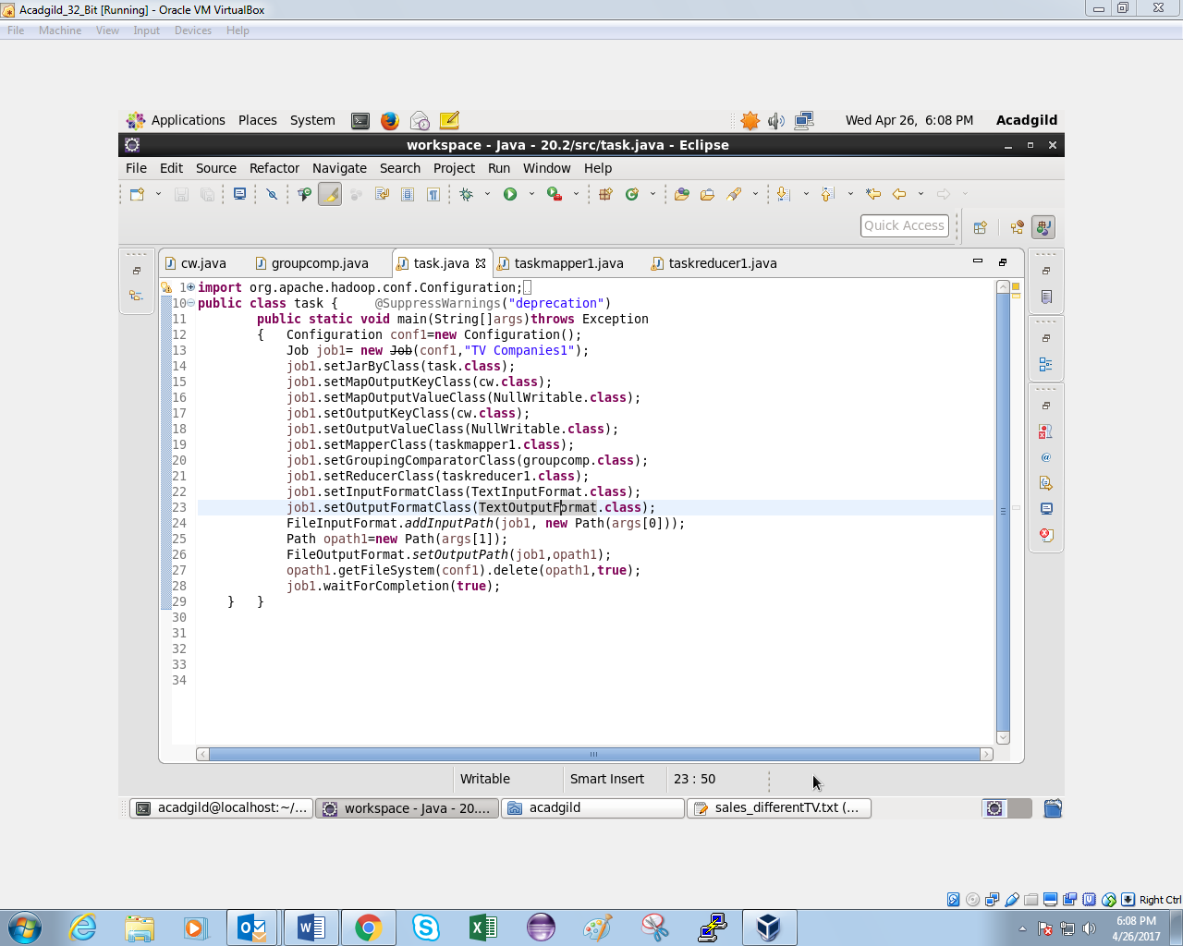

//Mapper class

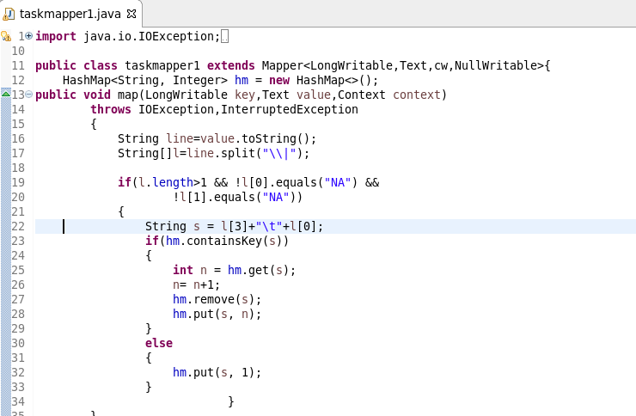

//reducer

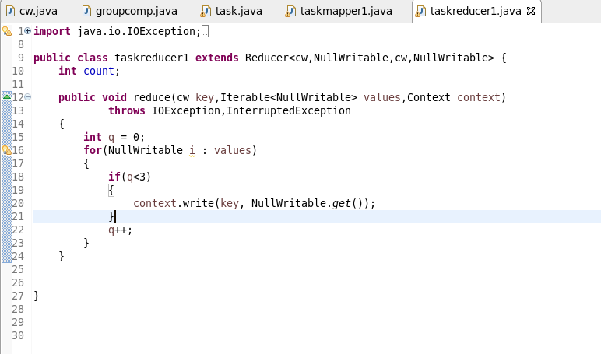

In the reducer we are just limiting the value to 3.

As it is sorted according to sold units in descending order hence we will get top 3 values only

//customkey

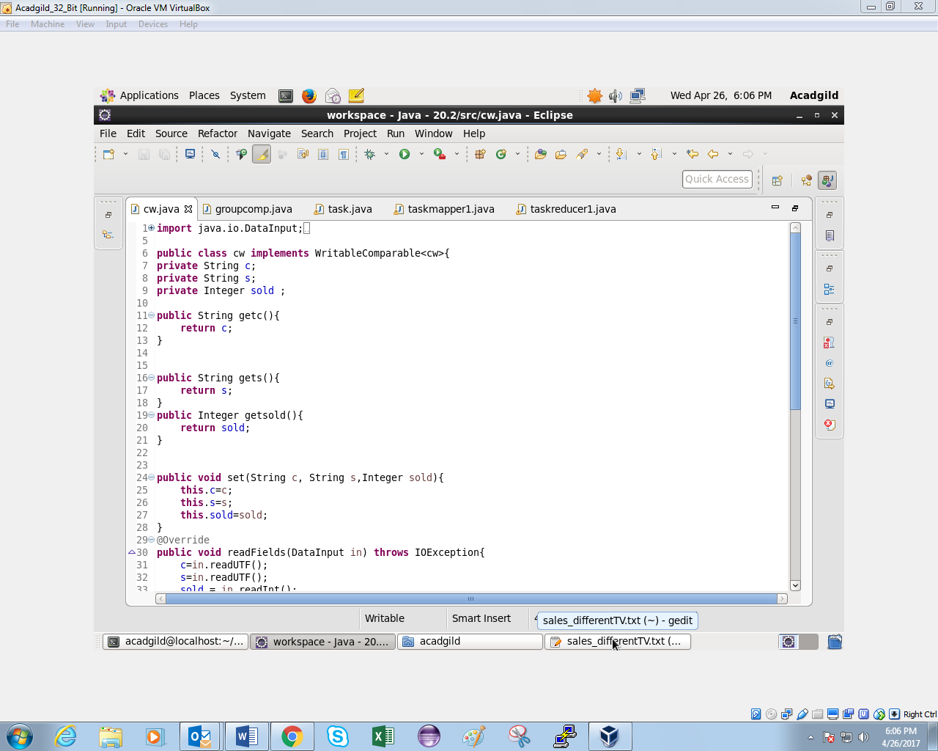

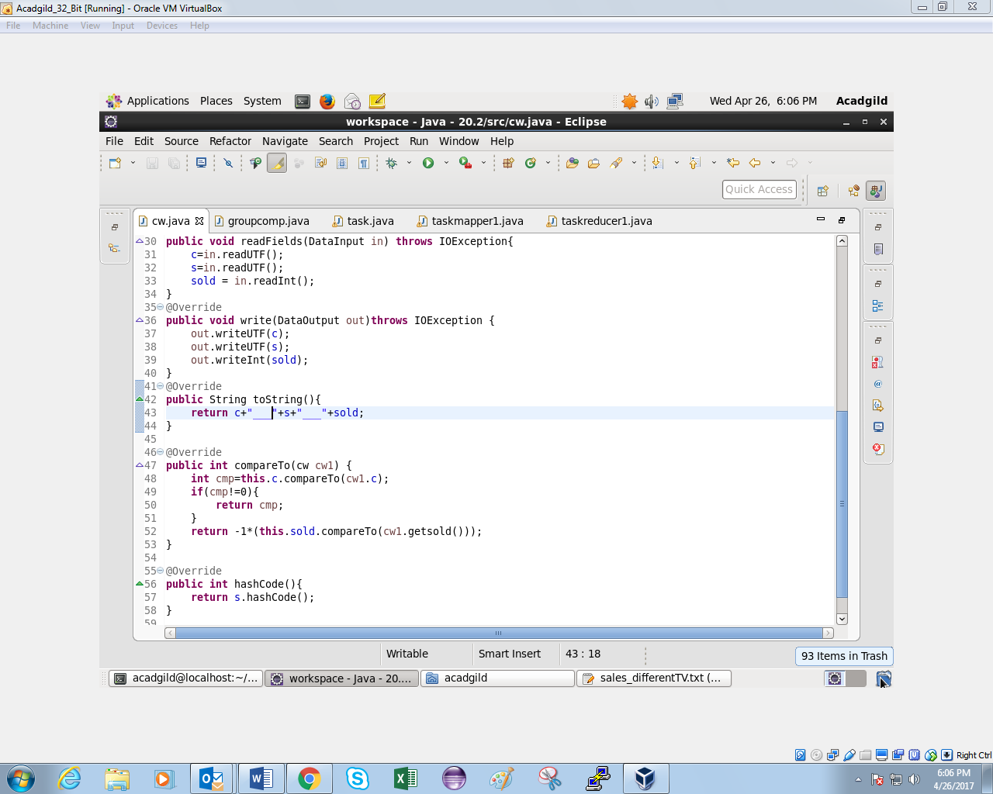

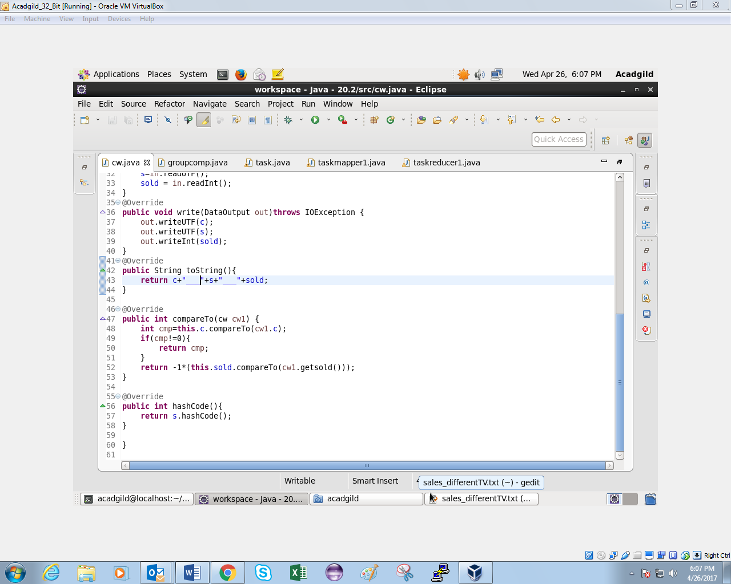

In this custom writable class we are first comparing the company and then the units sold.

//Group comparator

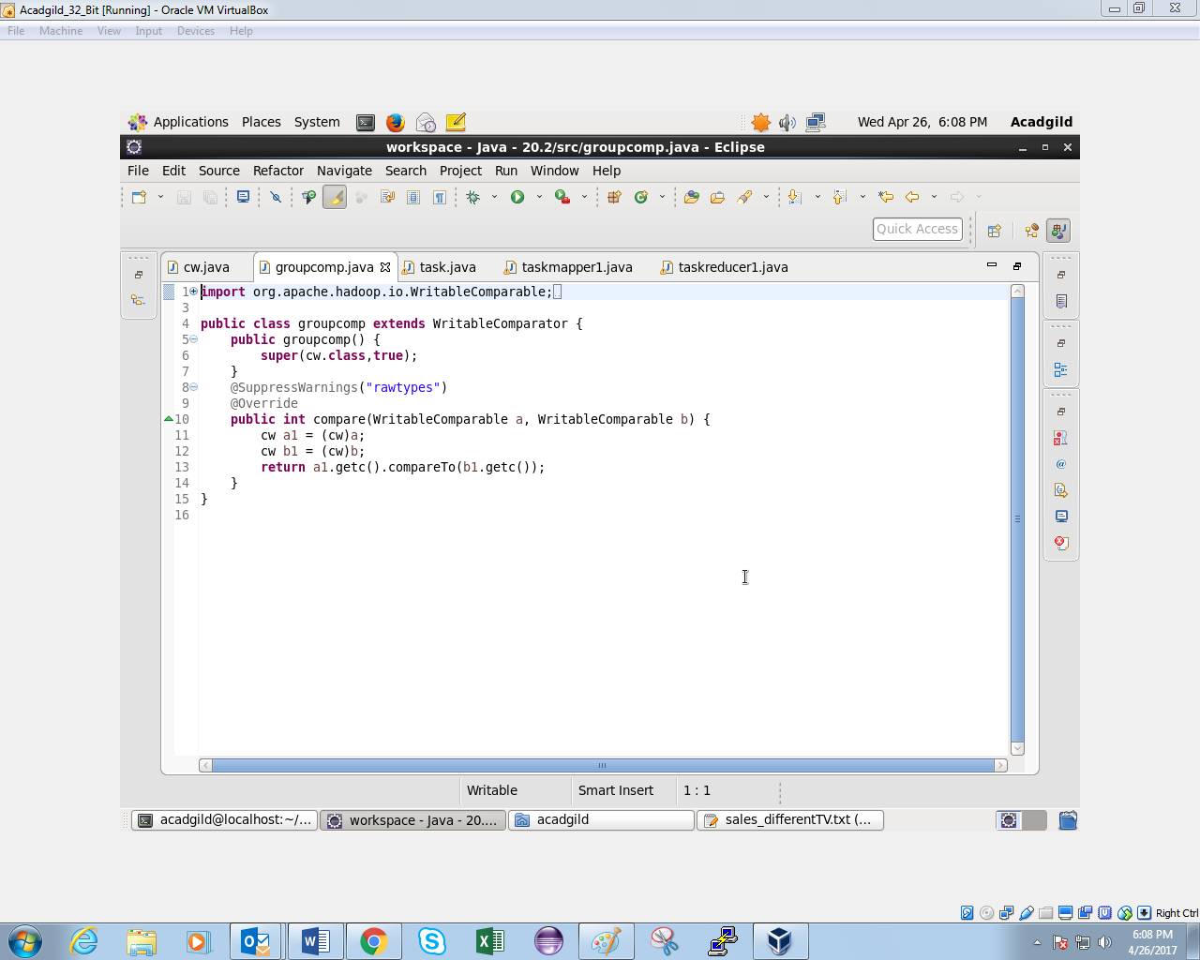

The group comparator is grouping is done according to the company only and not by natural key.

//output

