Write a Wordcount program and Store the result in Mysql db.

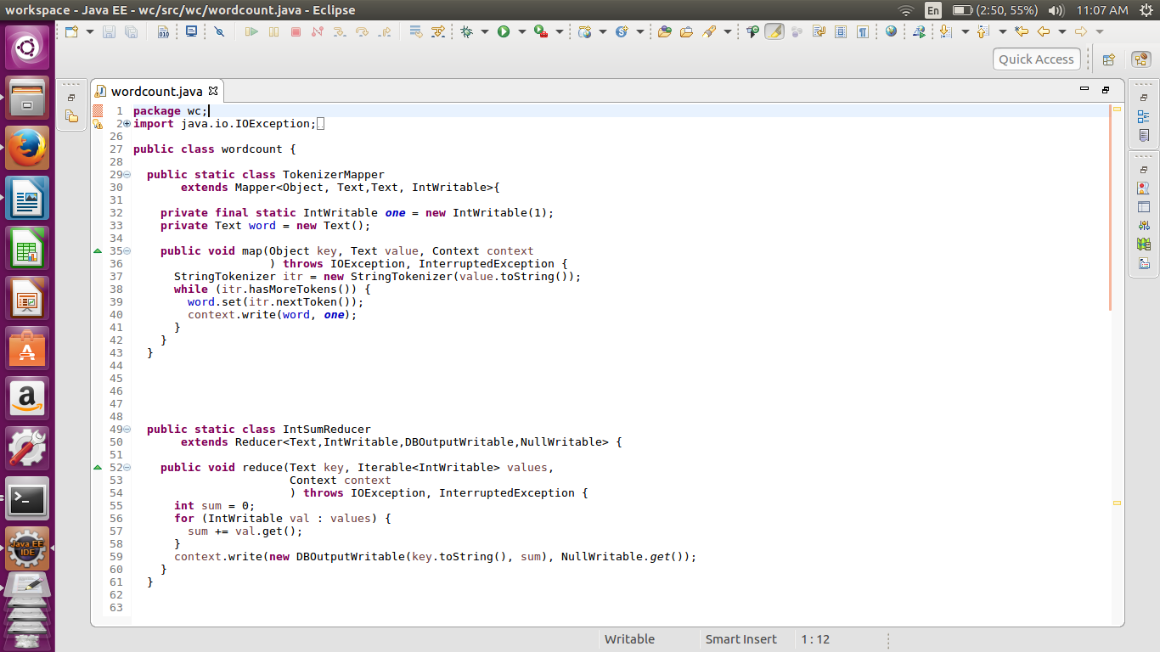

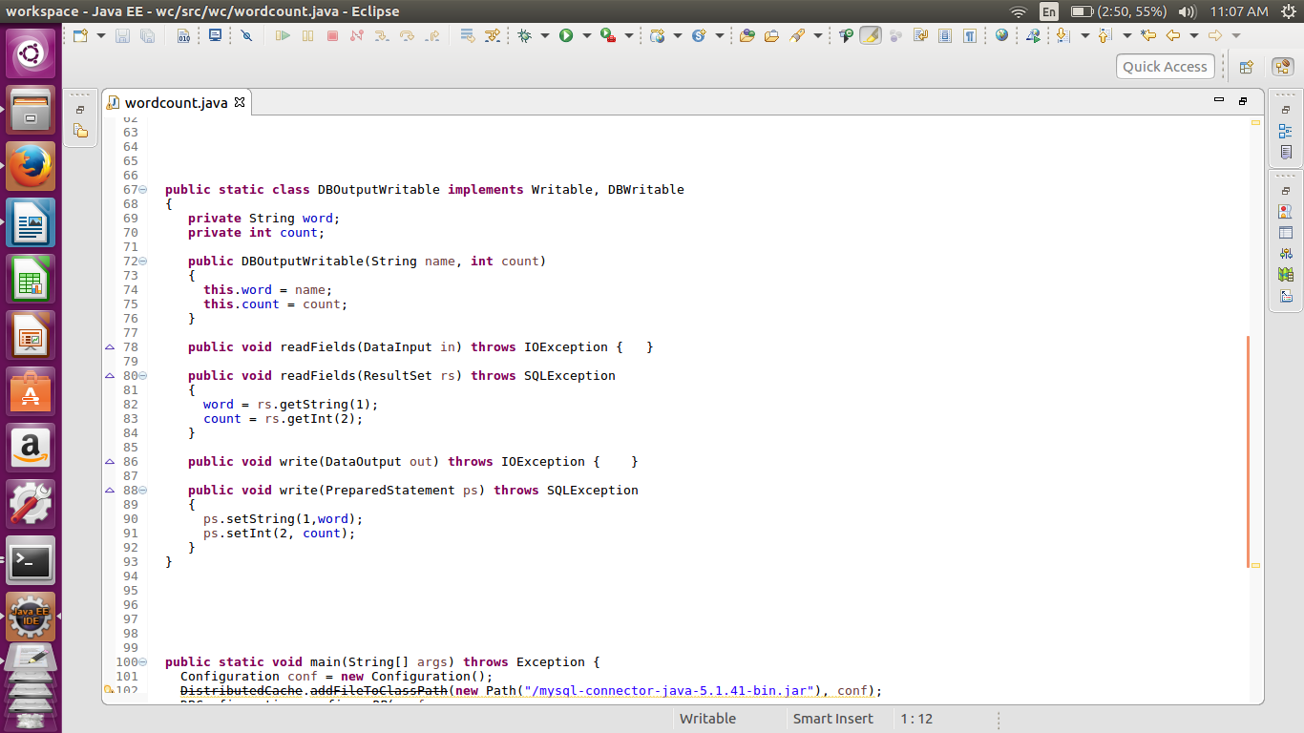

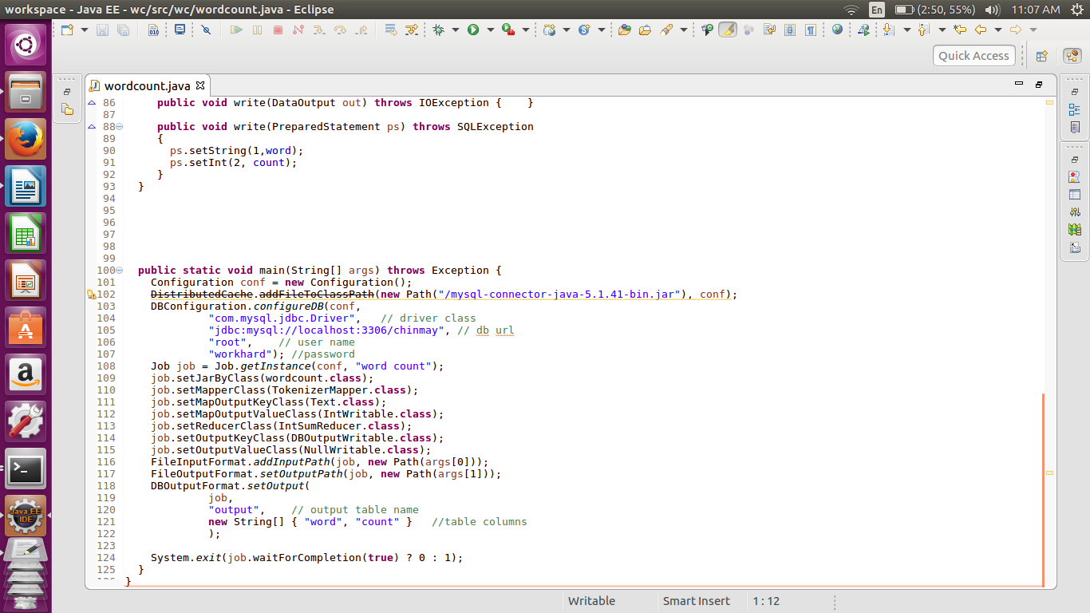

Here we are taking input from simple text file and storing it in the sql format Hence we are creating the custom key called as the DBoutputwritable which extends the writable,dbwritable DBwritable is the class specially used for the storing the values in database format such as sql.

In the Driver class we have to configure the database in which were going to put the output.

So first we have to set the driver class, and then mention the database in which we are going to store the data. The database should have been created beforehand. Also the table should be prepared beforehand.

Then in the configuration we have to also mention the user name and the password used to login in to that user.

Above configuration is used to access the mysql.

In the DBoutputformat we have select the table as well as the which is already prepared and then we have prepare the columns.

In the above code I have already created the table output in mysqldb.

And in the code I have created the columns word and count.

//implementation

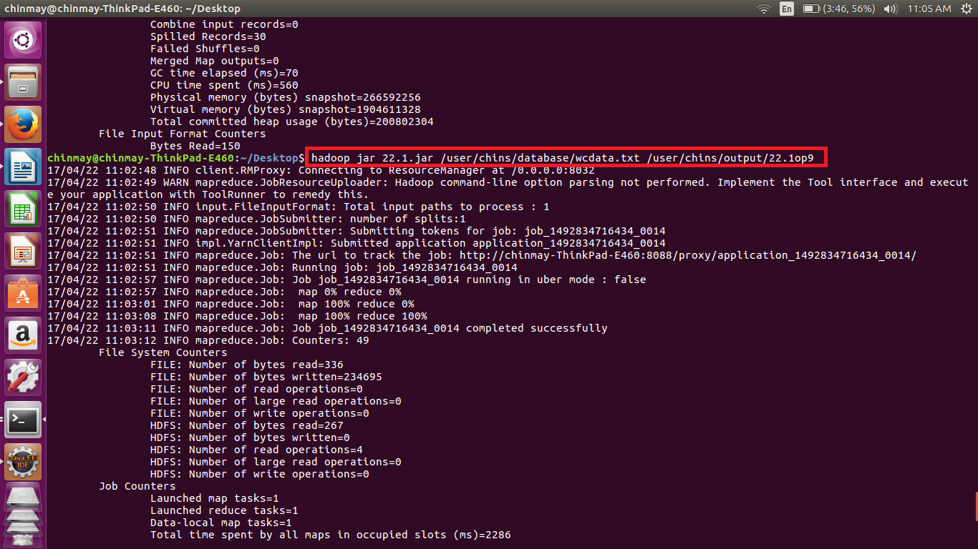

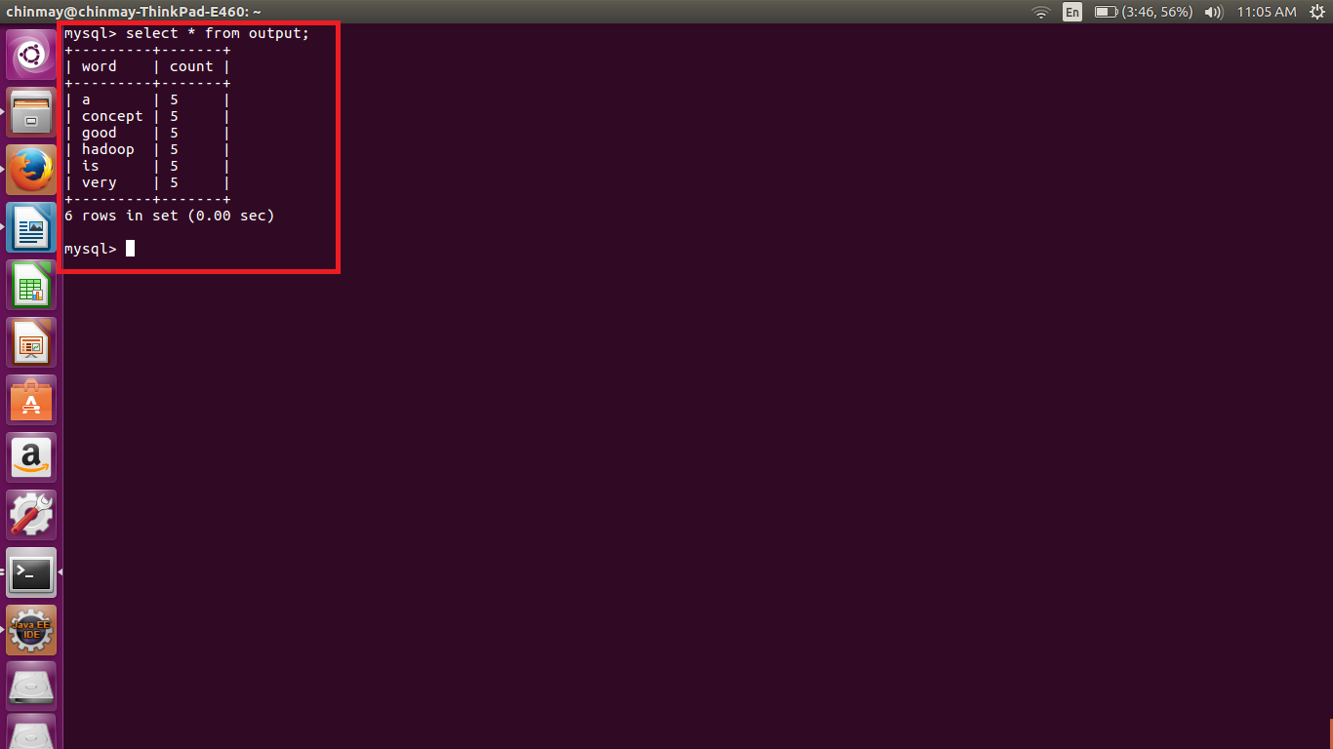

Here we can see that two columns word and the count of each word.

// The input used for the word count was as shown below.

