Use Hive Scripts to run the below queries.
● Get a list of employees who receive a salary less than 100, compared to their immediate employee with higher salary in the same unit
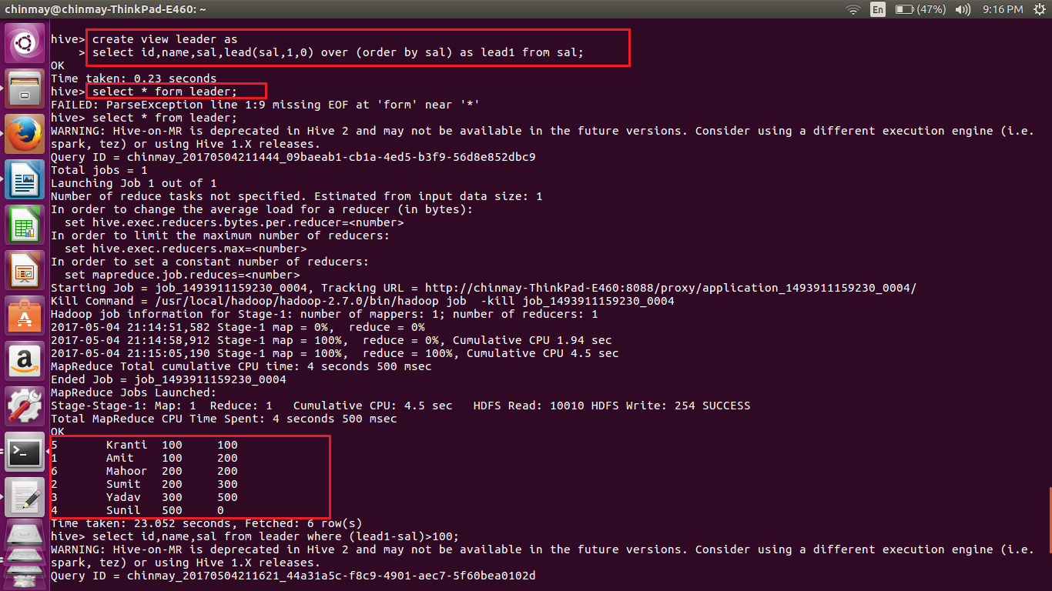
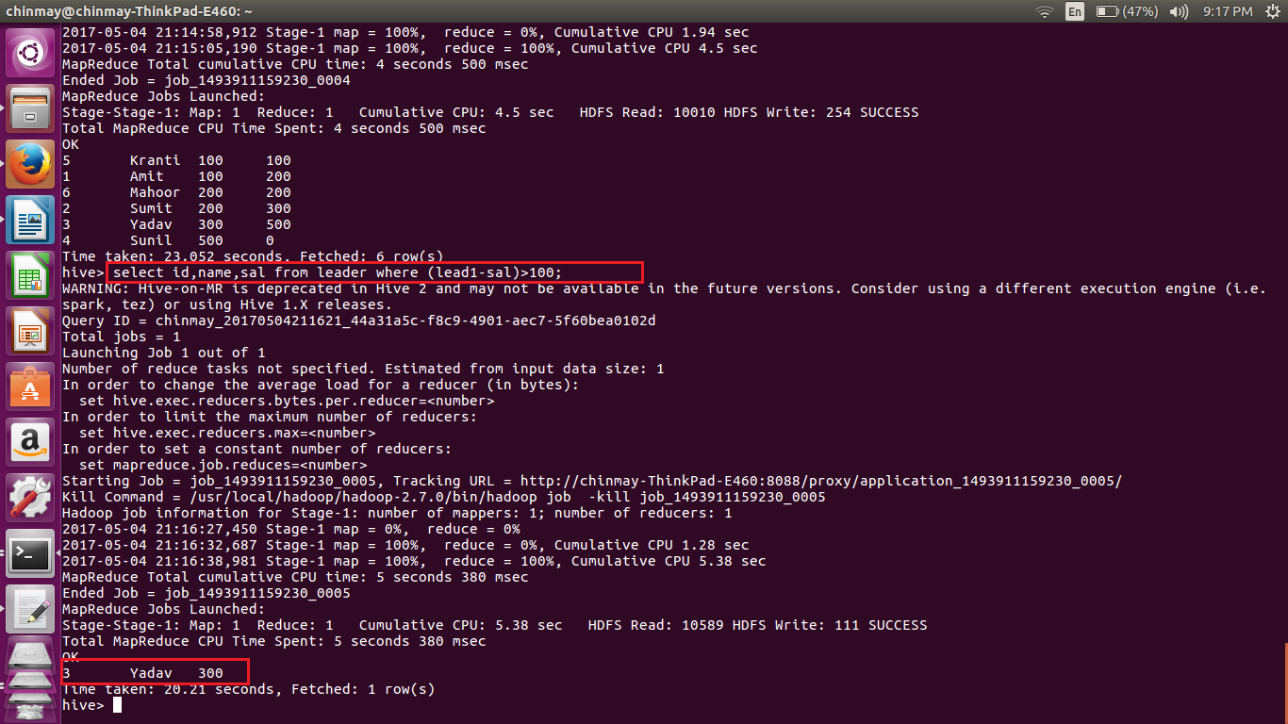

● List of all employees who draw higher salary than the average salary of that department
