1.Write a hive query to find the top 20 destination people travel the most: Based on the given data 2. Write a hive query to find the top 20 locations from where people travel the most

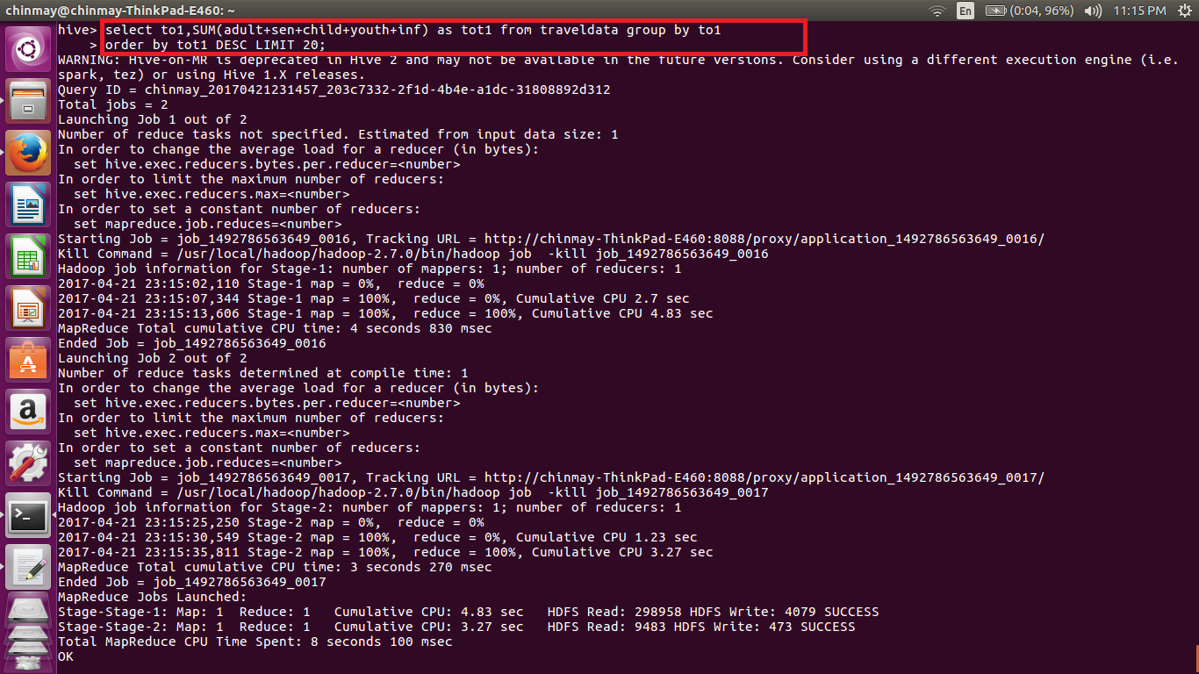

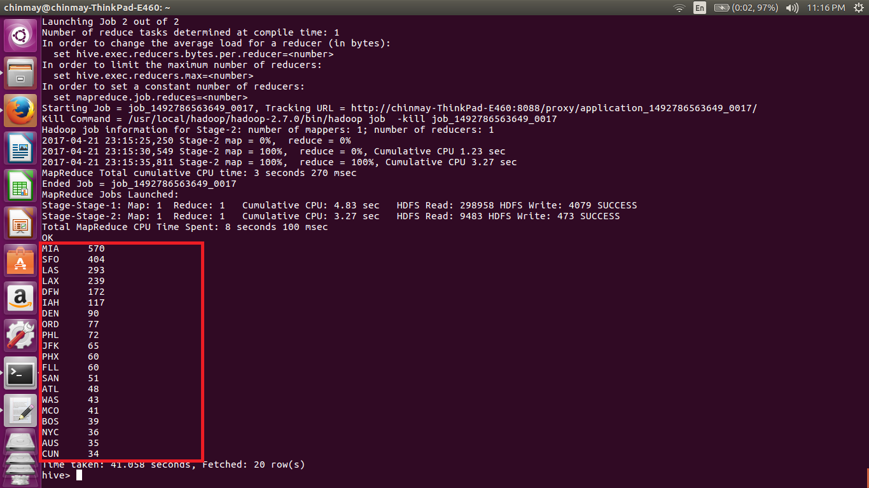

Here we are we add up the number of people travelling to particular city. The fields displaying are the city and sum of all the people travelling to. Also sum includes children, infant, adult, senior citizens, youth.

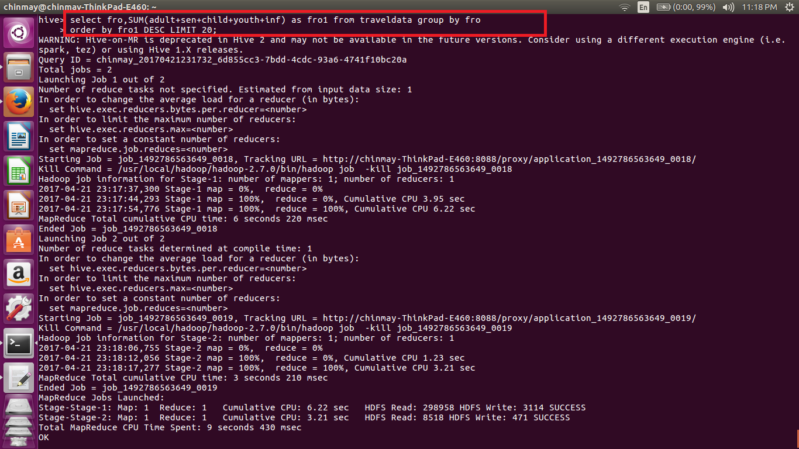

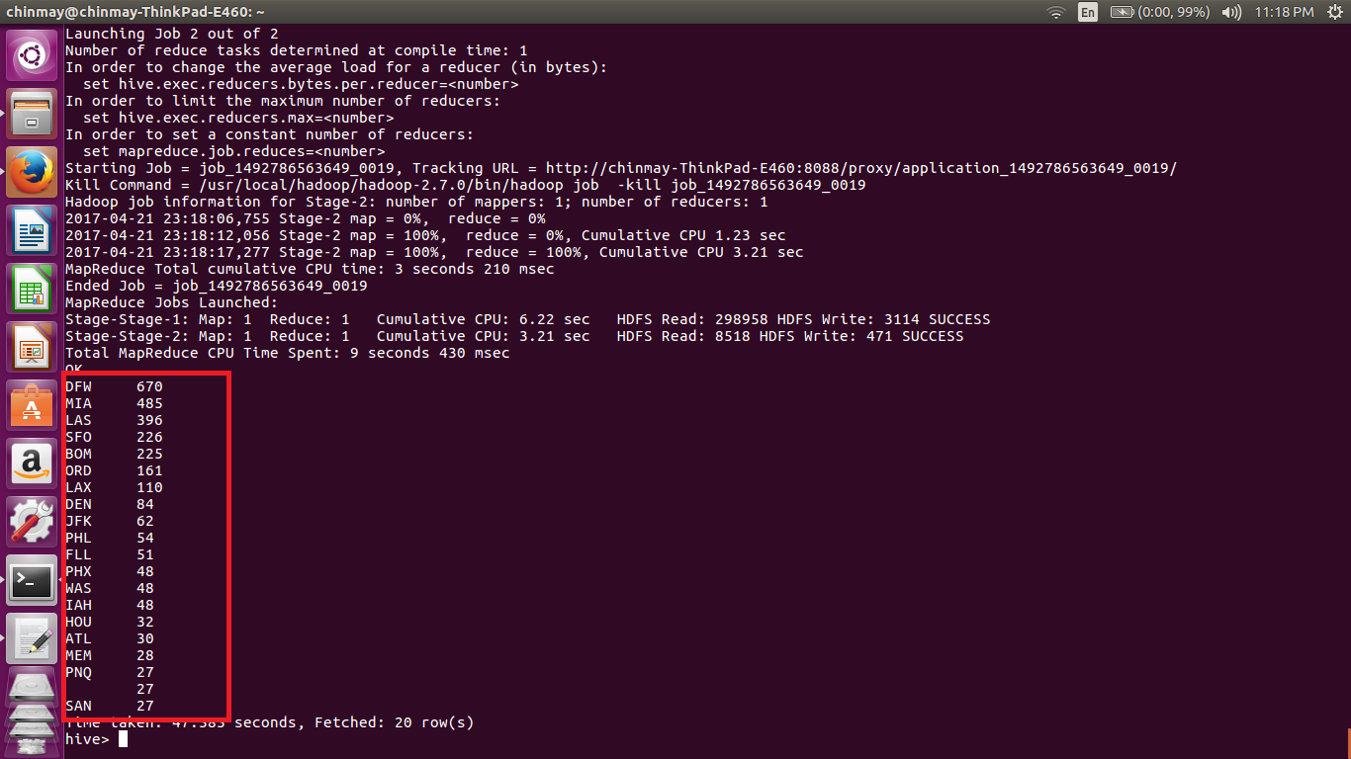

Here we using similar query where we are just changing the field of destination city to departure city.