1. Write a hive query to list top 5 residency details which lie in the budget of 60000-120000, an area more than 1450, sold after 17th may, min bedroom 3 and, min bathroom 2.

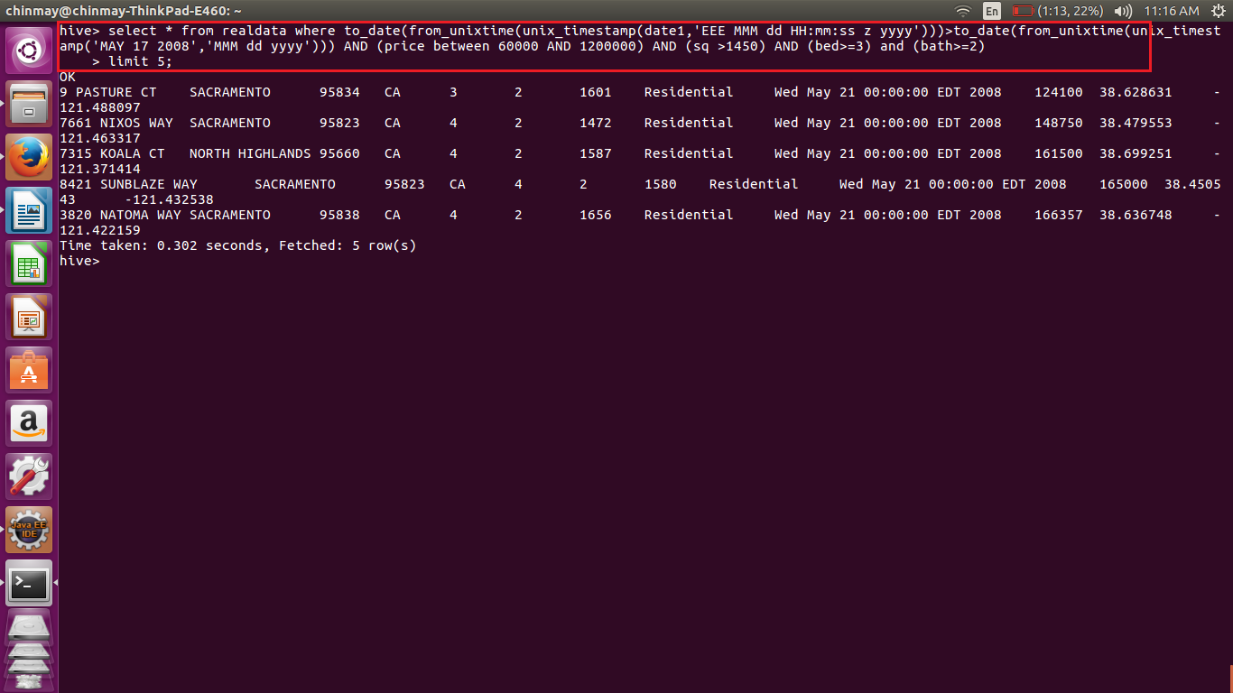

As we have stored the date in String so we have to convert it from String to date format.

Then conversion is done using to_date(from_unixtime((unix_timestamp()));

And using the other conditions for price,bed,sq etc;

Also limited the output to limited to top 5;

1. Write a hive query to separate list of residential apartments with more than 2 beds. Also include columns in following order City,Baths,Sq_feet,Price,flat_type,Beds respectively.

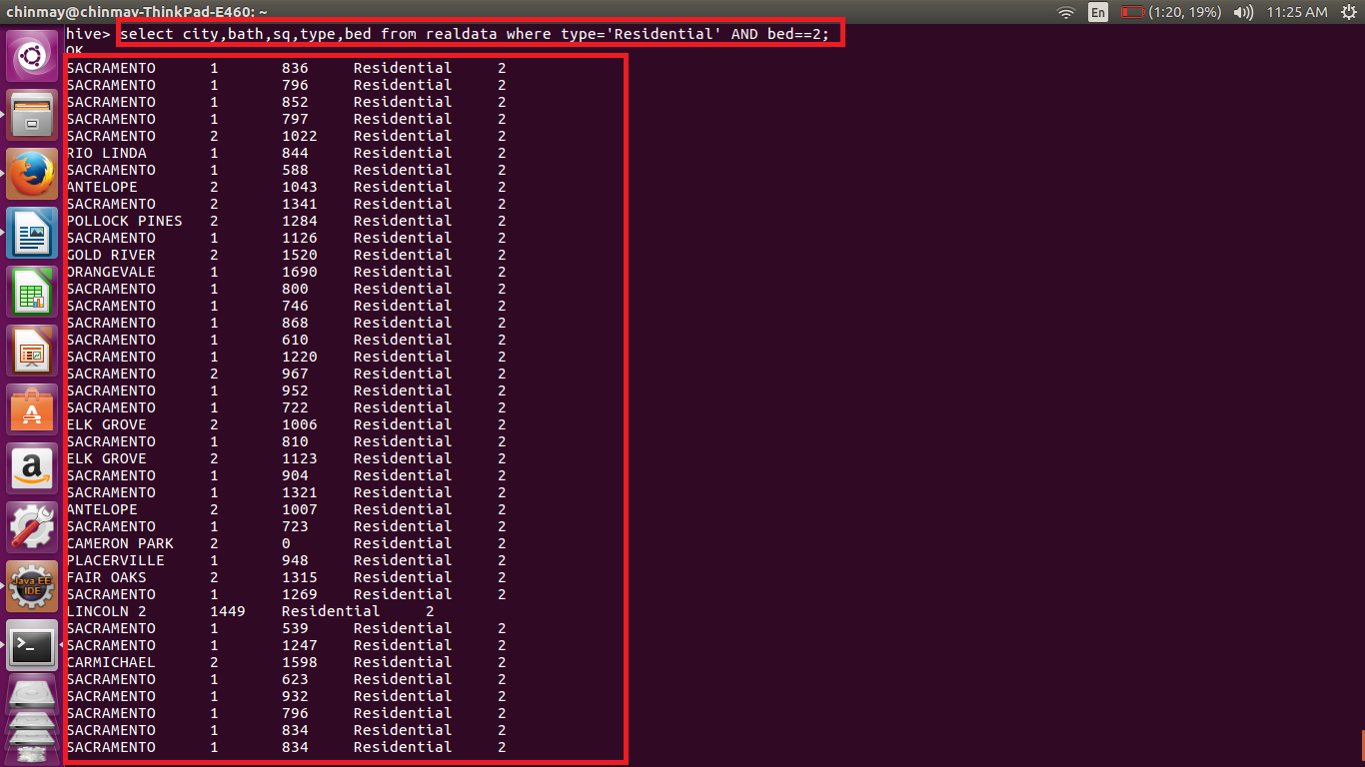

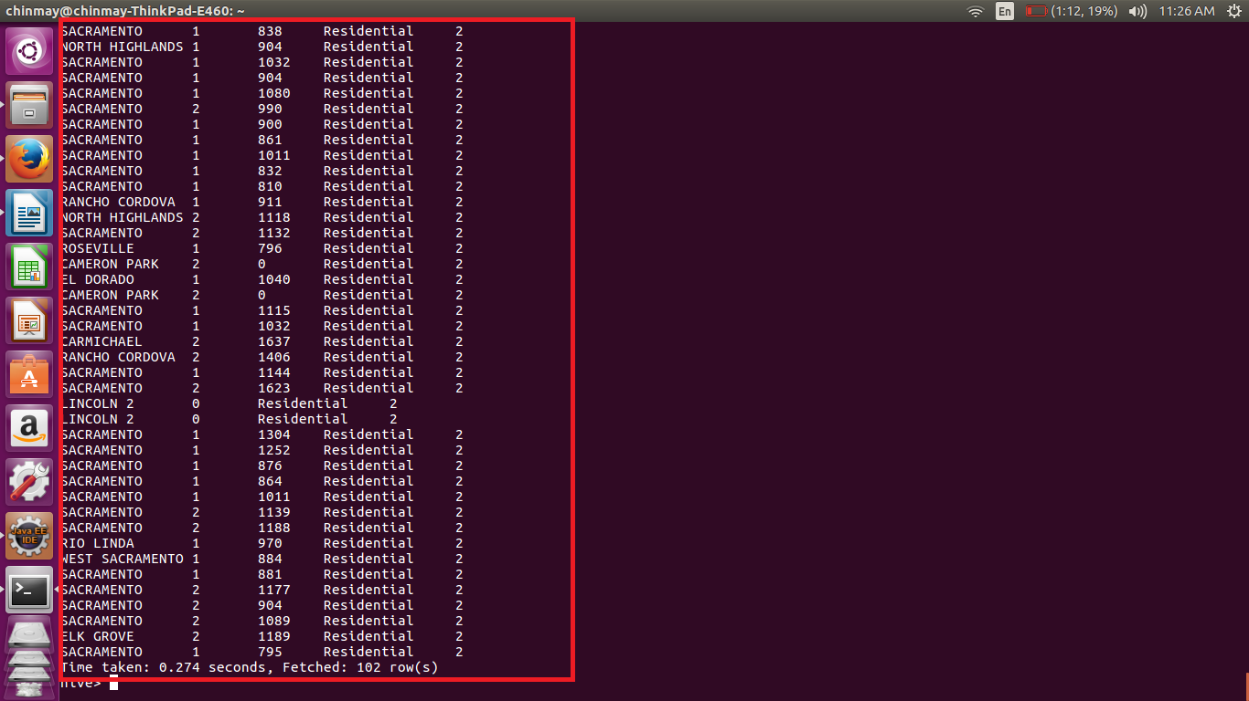

Above is simple query using the where clause.