1.Write a hive query to find the city wise list all the Condos which is not less than ten thousand.

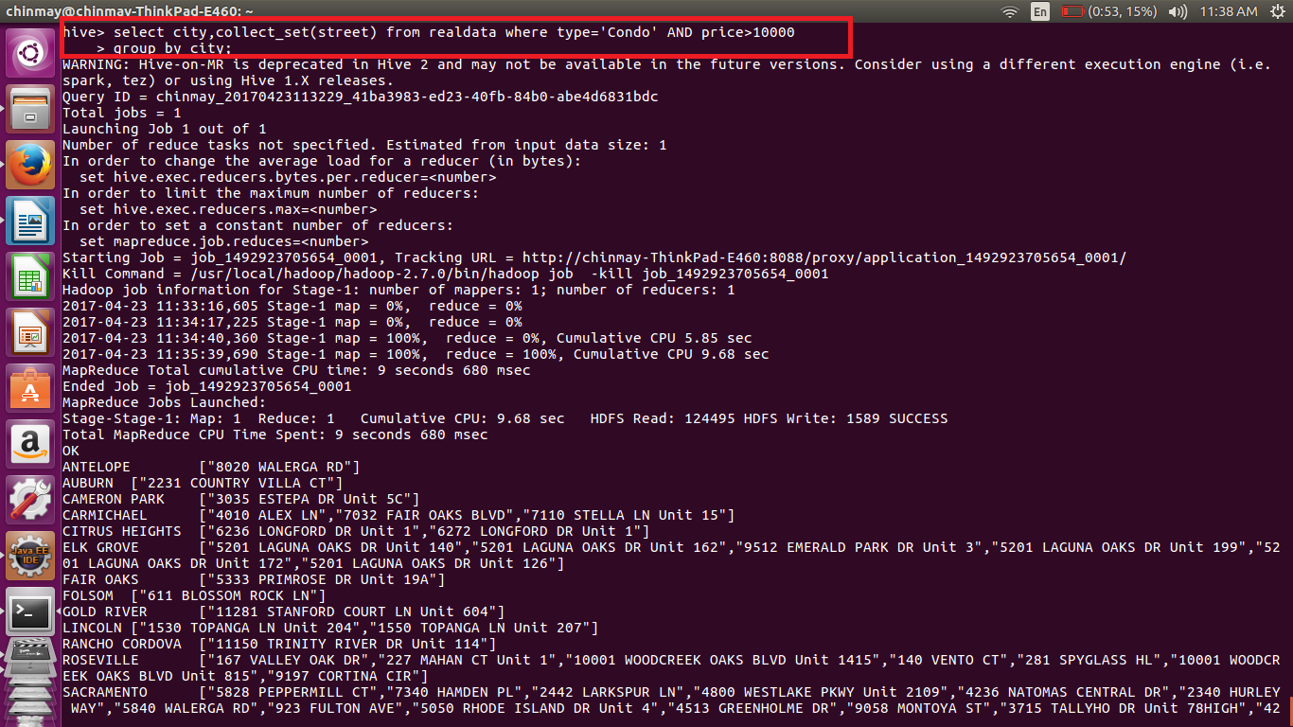

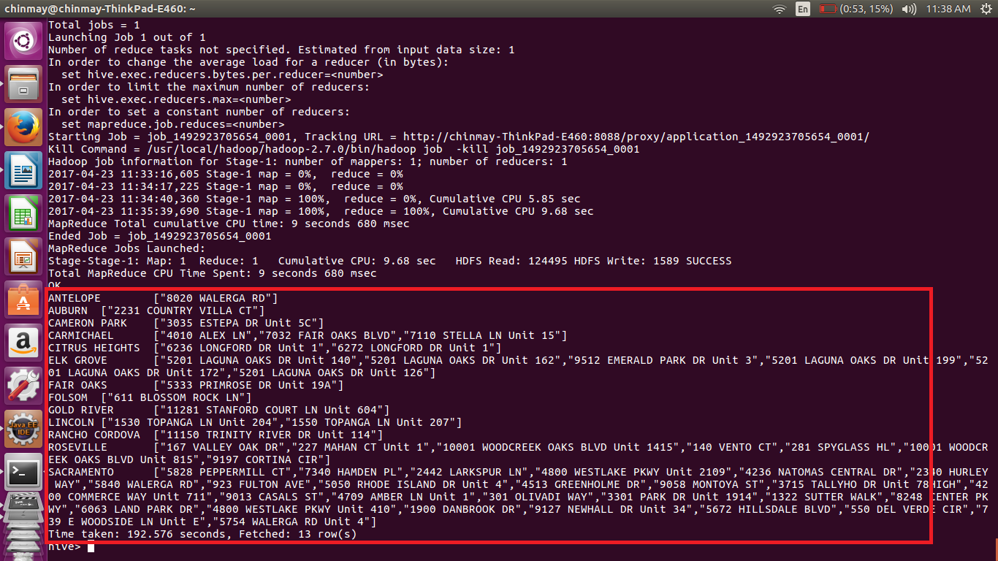

As we want city we have grouped by city. We are also displaying the city along with the city. Here we ahave used **collect set** to get the list of street where each condo is located.

2. Write a hive query to find which is the cheapest Condo in CA. name the city,street and price for the Condo.

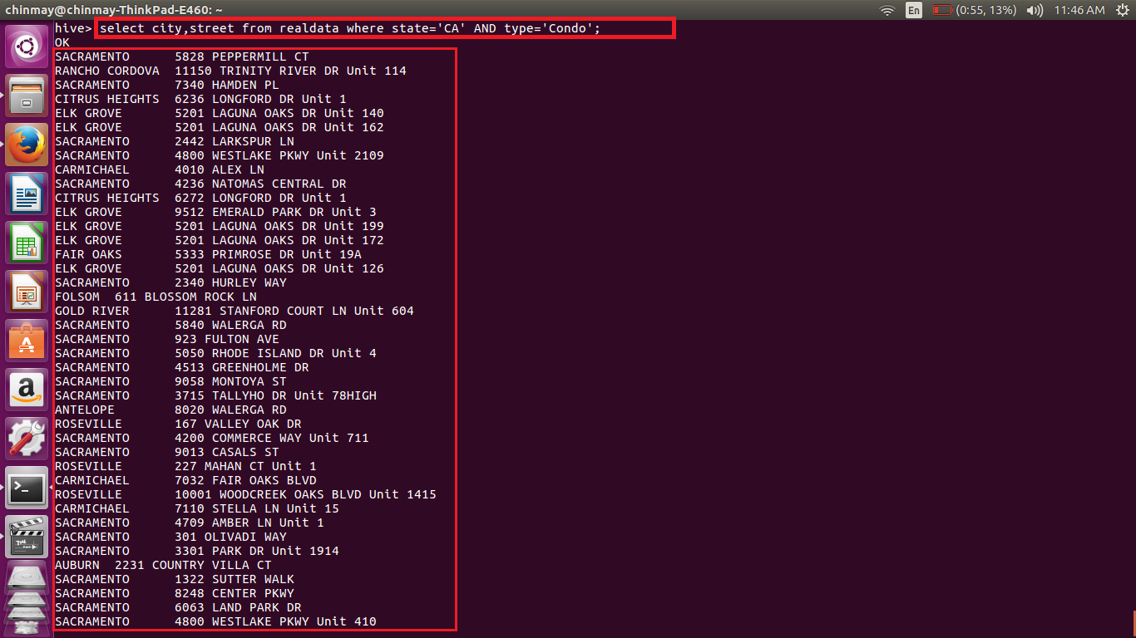

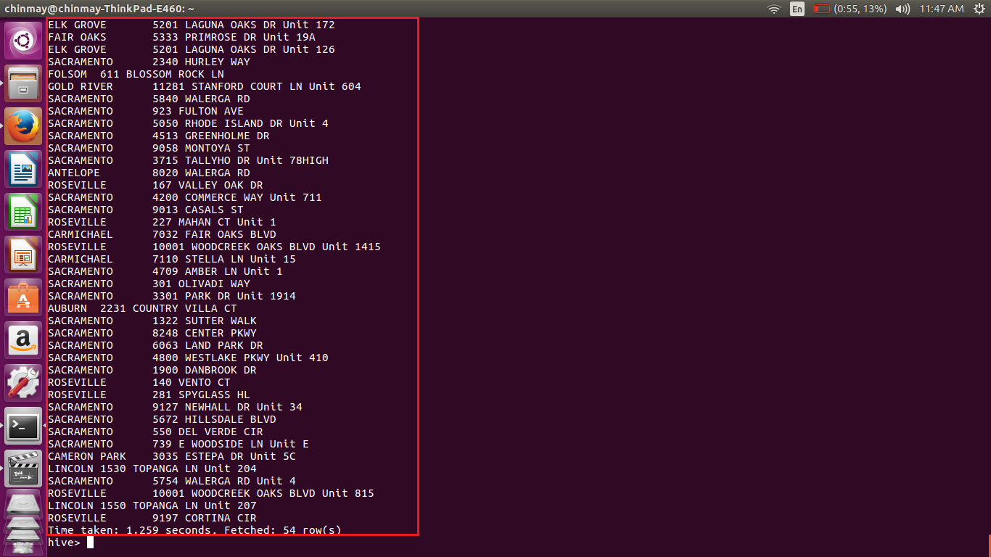

Here we are executing simple where clause to filter the state and the type.

3. Write a hive query to list top 5 residency details which lie in the budget of 60000-120000, an area more than 1450, sold after 17th may, min bedroom 3 and,min bathroom 2.

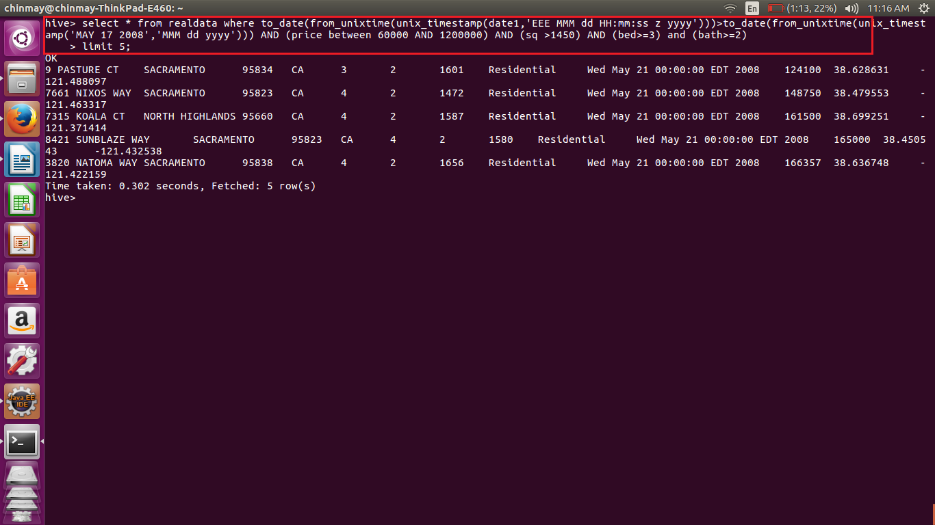

As we have stored the date in String so we have to convert it from String to date format.

Then conversion is done using to_date(from_unixtime((unix_timestamp()));

And using the other conditions for price,bed,sq etc;

Also limited the output to limited to top 5;

4. Write a hive query to separate list of residential apartments with more than 2 beds. Also include columns in following order City,Baths,Sq_feet,Price,flat_type,Beds respectively.

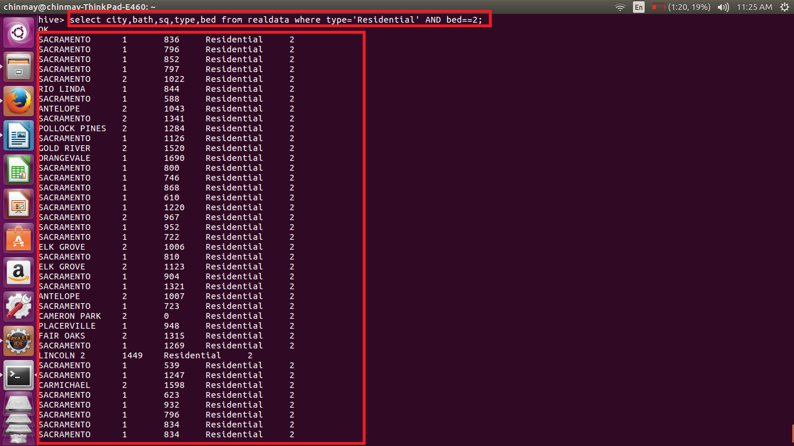

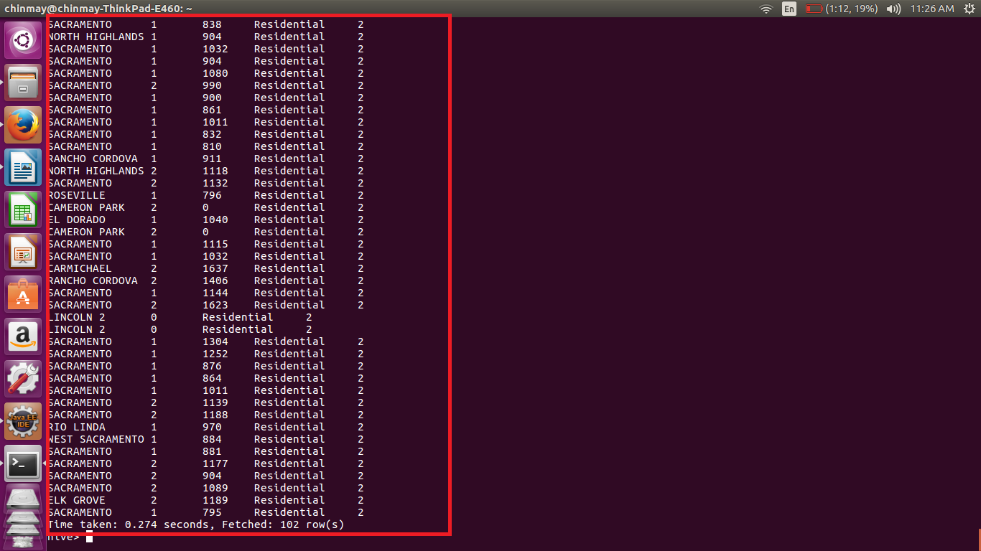

Here we are selecting the residential data and the bed==2.