● Using Dynamic partition get separate lists of residential apartments with more than 2 beds and include columns in following order City,Baths,Sq_feet,Price,flat_type,Beds respectively.

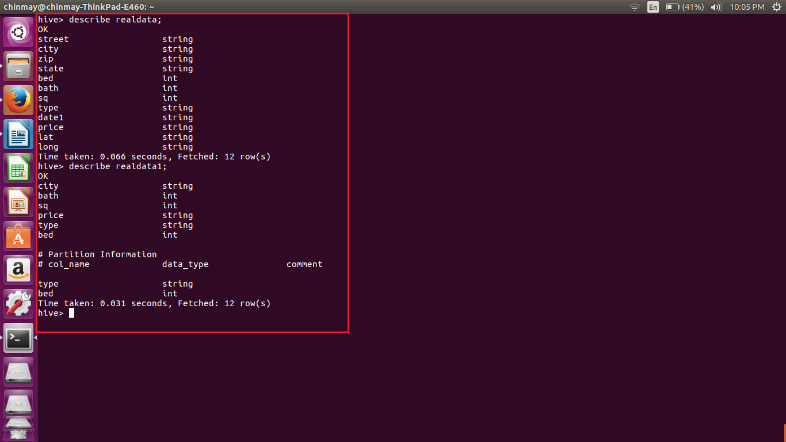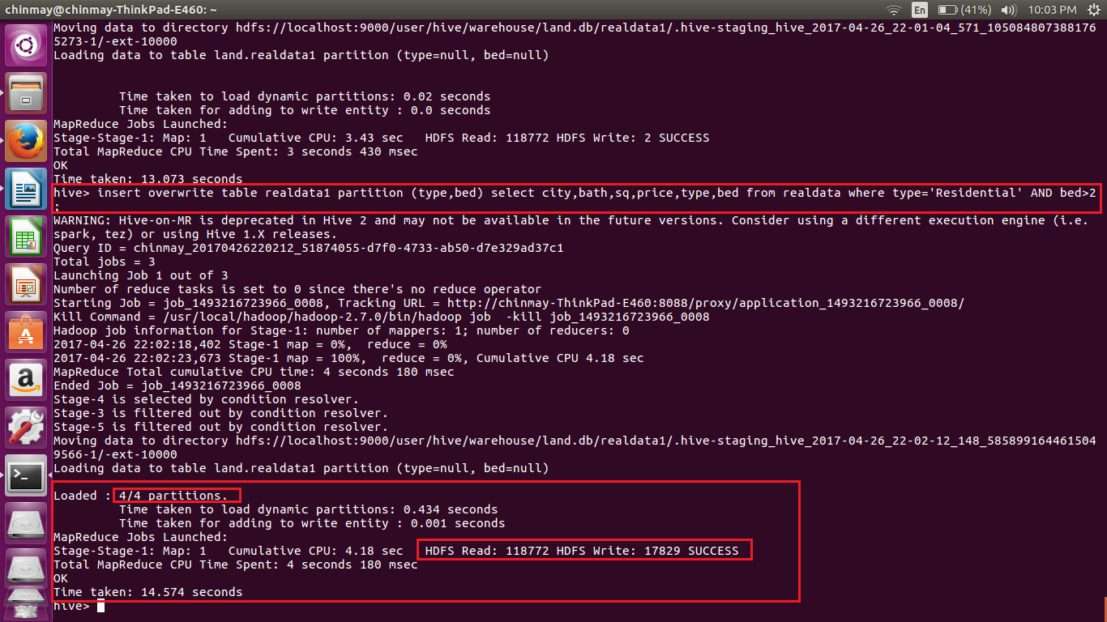

Here we have created the two tables, one for storing full data and other for storing the partitioned data.

Using the insert command we are putting the partitioned data into the partitioned table. Here we can see that the partitioned has been done dynamically.

