Run parallel jobs in hive by following the steps in the below blog link

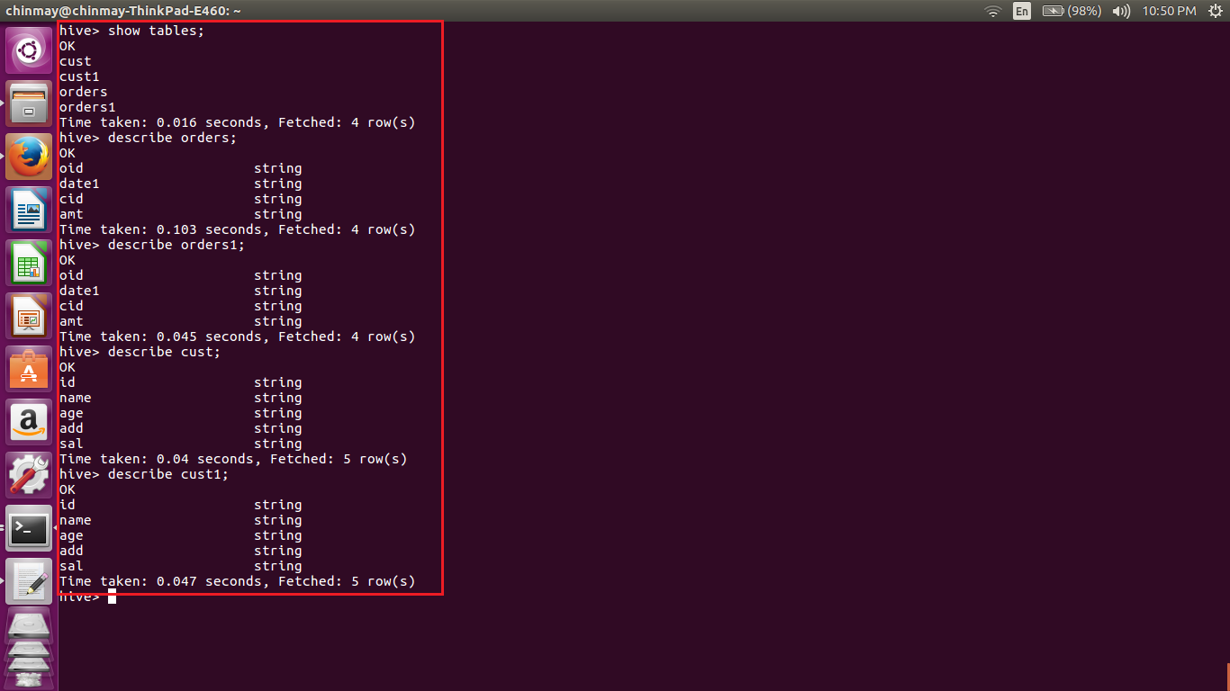

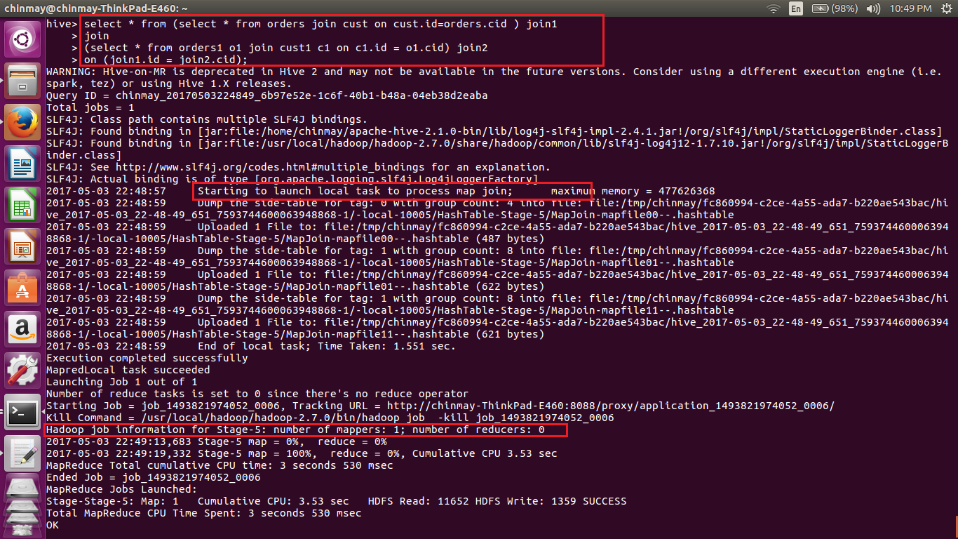

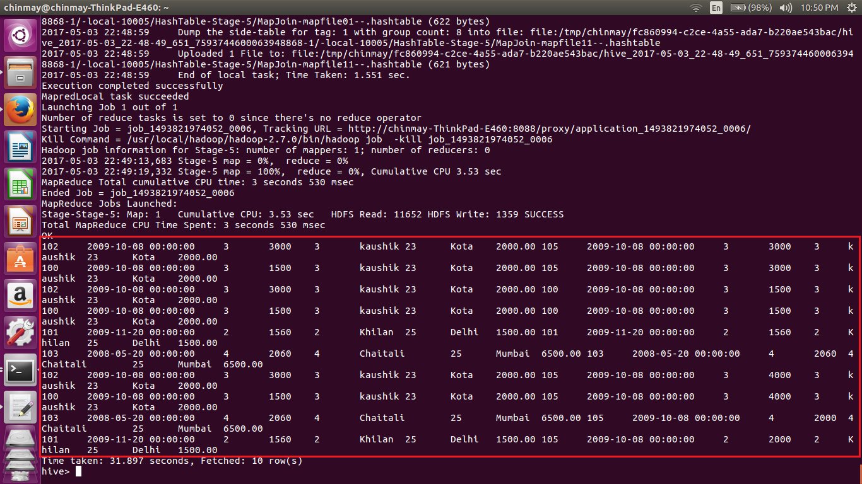

Here we are performing two joins by setting the following configurations in the hive-default.xml file in hive installation.

In that file we are setting hive.exec.parallel as true so that hive executes divides the jobs in tasks and starts multiple task at the same time so that whole job in total gets completed in shorter time.

<property>

<name>hive.exec.parallel</name>

<value>true</value>

<description>Whether to execute jobs in parallel</description>

</property>