Bucket Map join

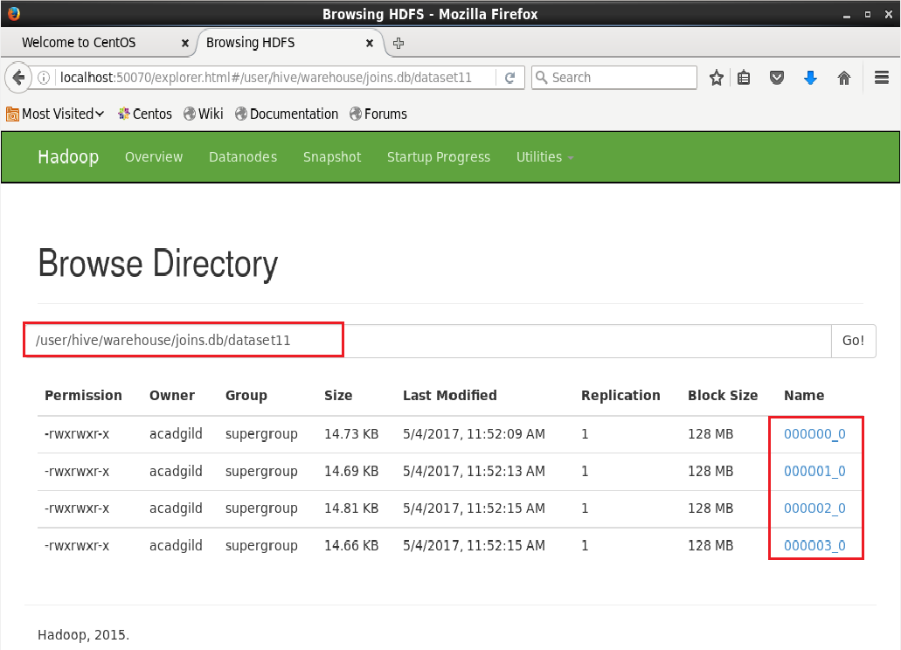

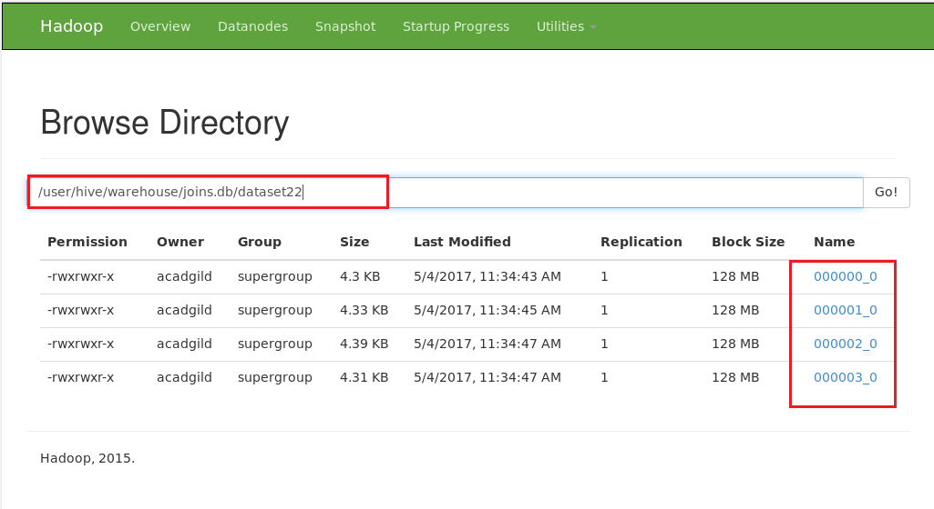

Here we can see that the tables dataset11 and 22 are bucketed with 4 buckets

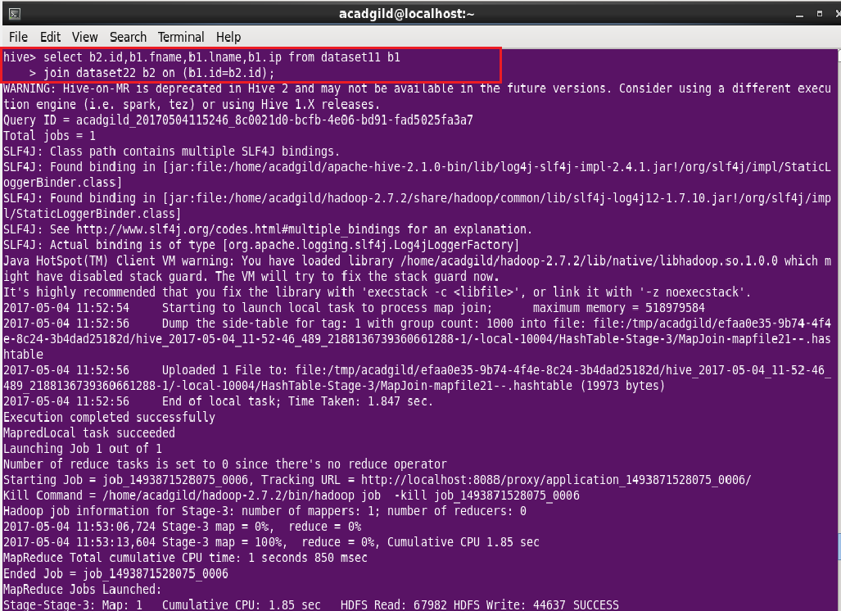

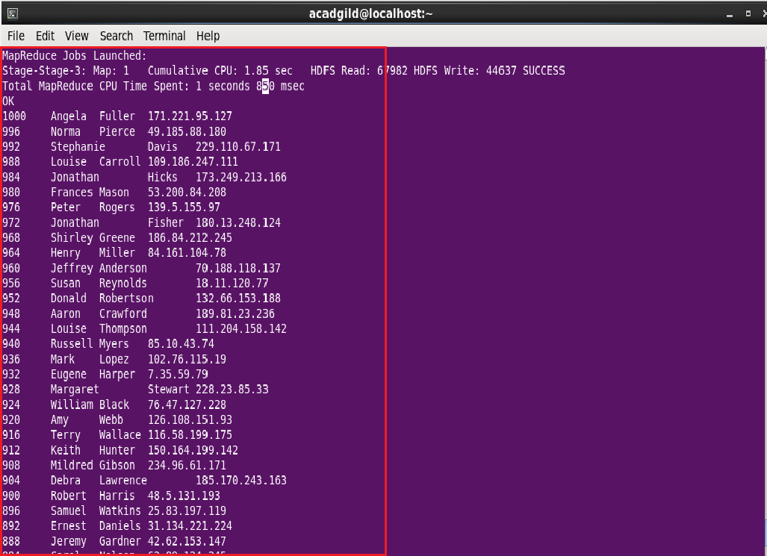

Sort-Merge Bucket join

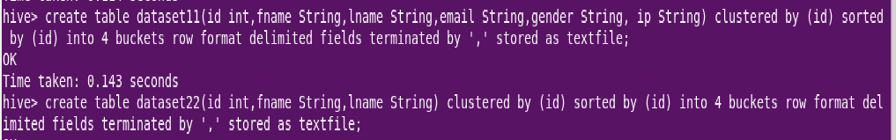

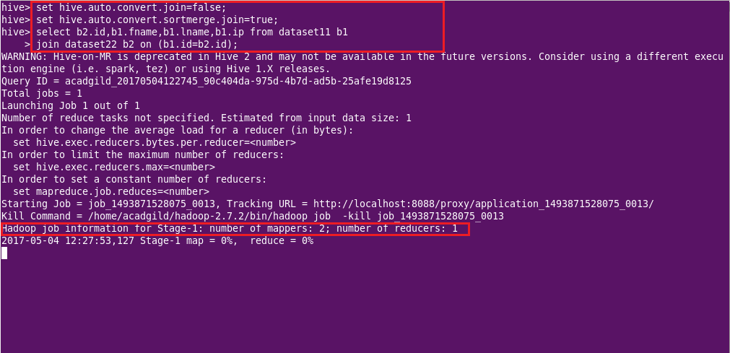

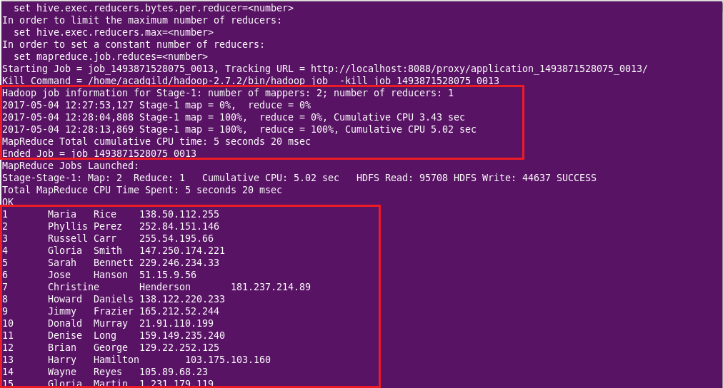

Here we can see that the join is done the bucketed tables but both map and reduce operations are being done.

This is possible by setting the auto.convert config of join to false. Here sort merge optimization of join is set to true.

Sort-Merge Bucket Map join

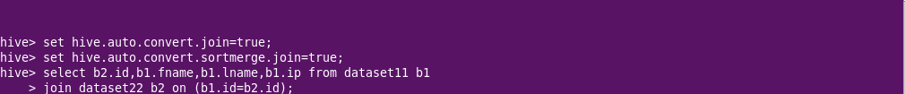

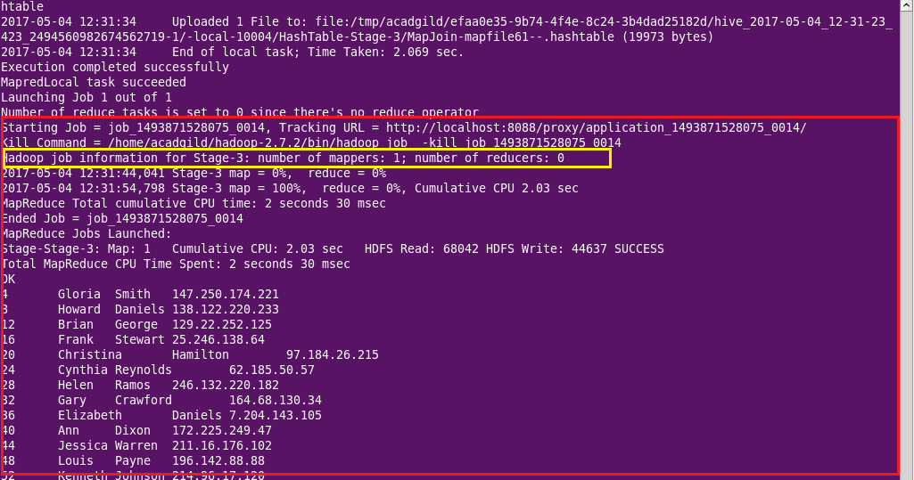

Here the auto convert join is set to true hence map side join takes place. Number of reducers are zero.

Left semi join



