What are ACID properties and Explain Transactions in Hive?
ACID
ACID represents the transaction properties of the hive transactions.
A – Atomicity
Atomicity states that all the transactions are either completely done or failed totally. No partial execution of the transaction takes place.
C- Consistency
If the transaction is completed then the results are visible to all the subsequent transactions.
I – Isolation
If an erroneous transaction is done by the user then other users do not have any effect of that transaction.
D- Durability
Once an operation is complete it will be preserved even in the face of machine or system failure

Transactions of the HIVE
There are 3 transactions that can be performed
- INSERT
- UPDATE
- DELETE
INSERT – This command is used to insert the data into the hive table. This transaction does not need requirement of the switching on the transactions in hive
UPDATE – This is used to update the already present data in the hive table.
DELETE –This is used to delete the record from the hive table.
For update and delete the transaction should be enabled in hive.

Example of the hive transactions
Insert Query
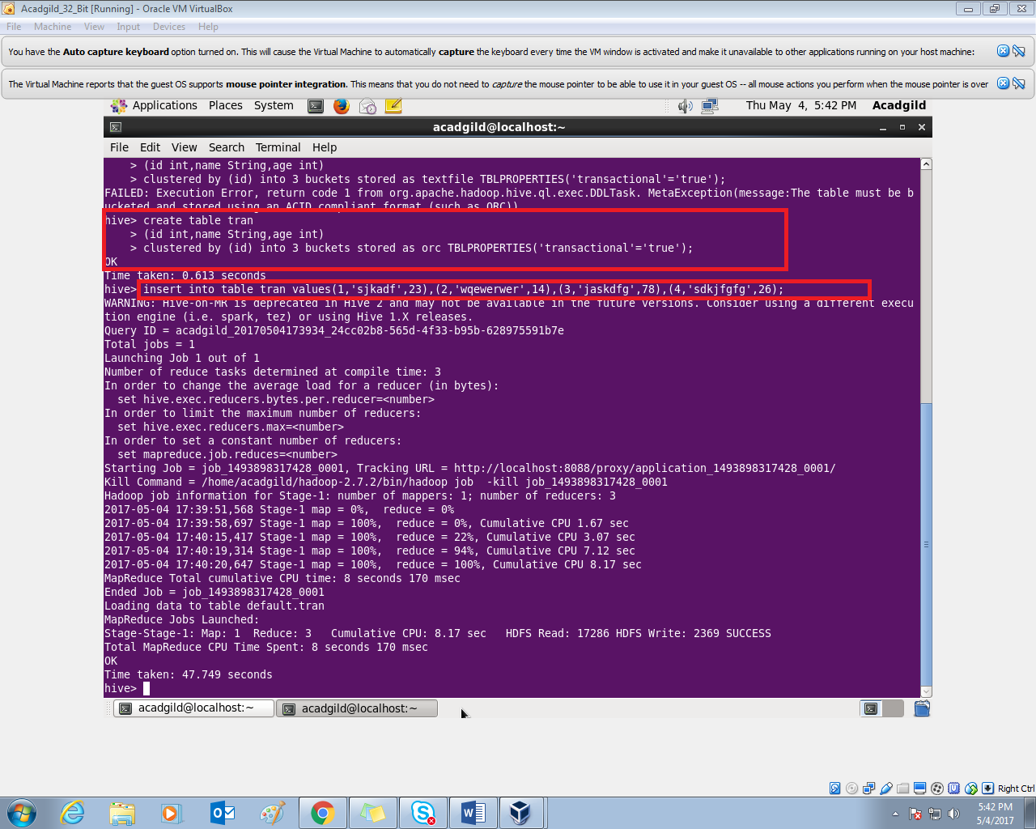

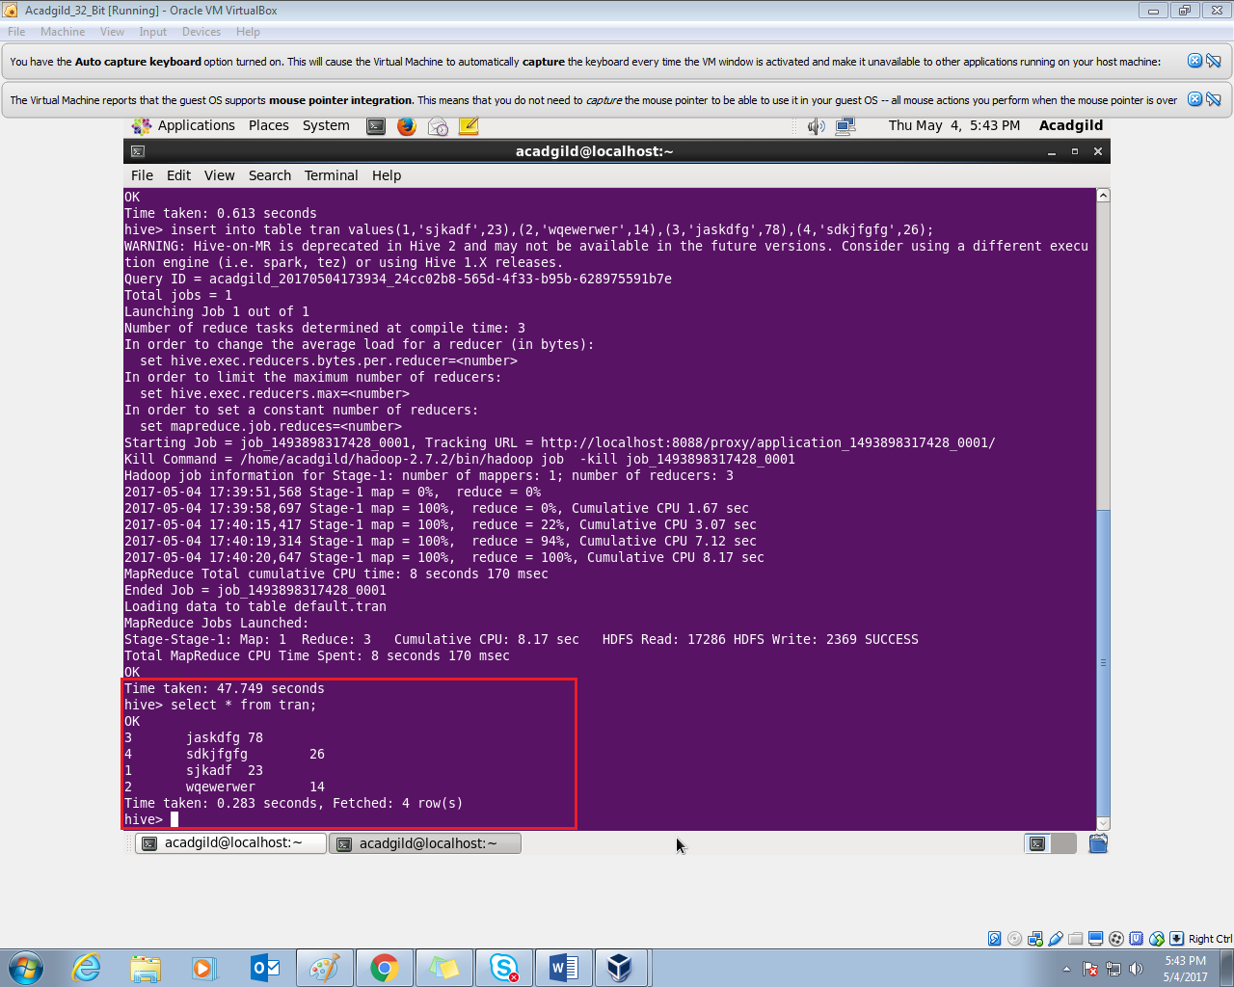

update query

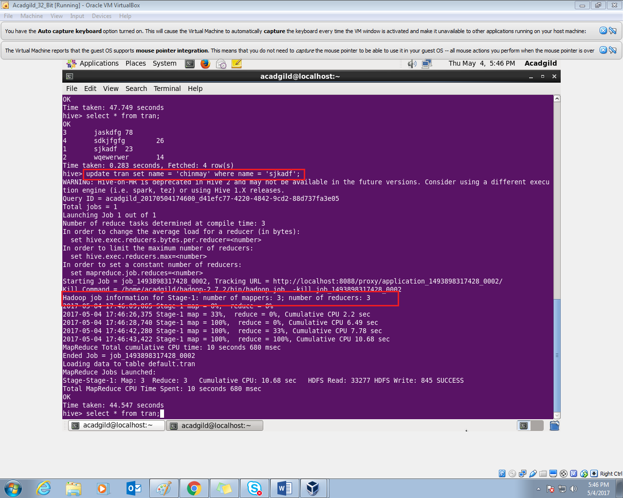
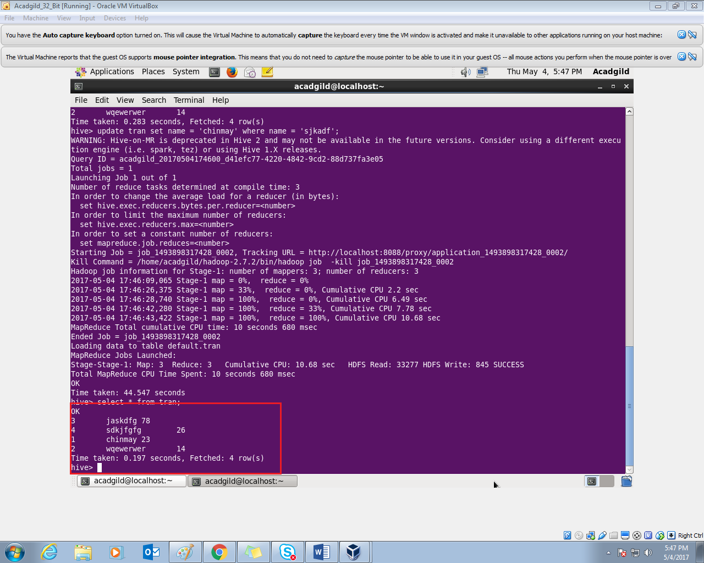

Delete query
