Use Hive Scripts to run the below queries.

● Get a list of employees who receive a salary less than 100, compared to their immediate employee with higher salary in the same unit

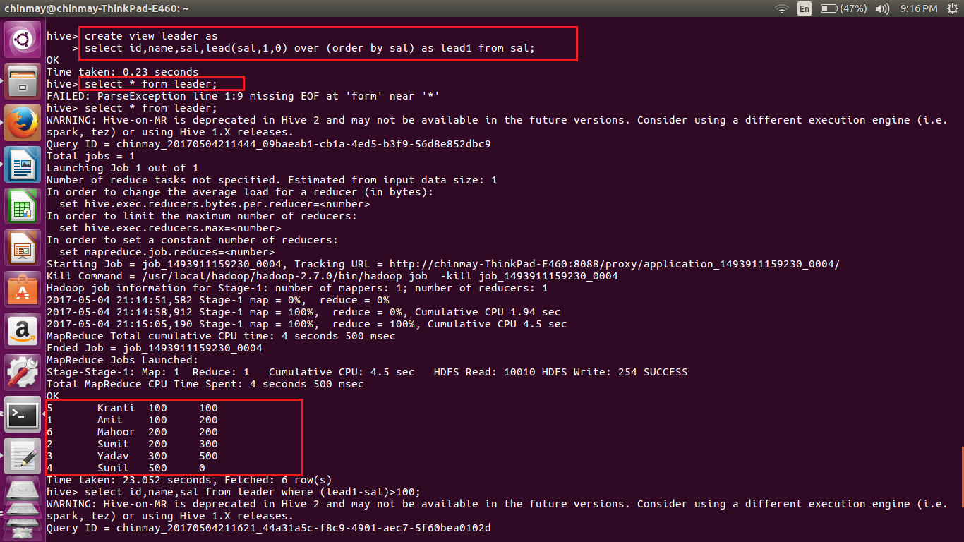

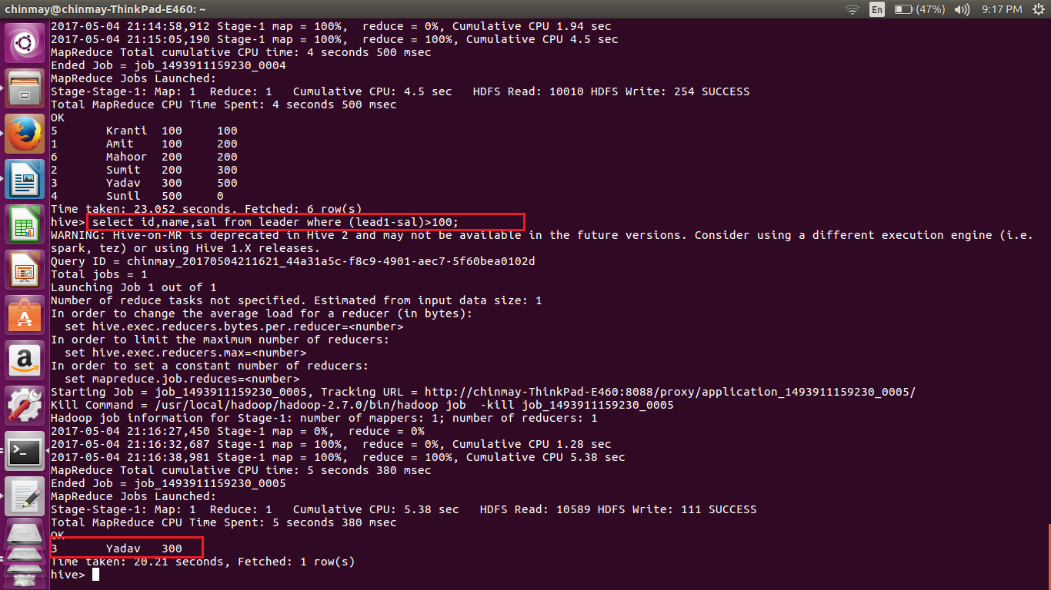

● List of all employees who draw higher salary than the average salary of that department

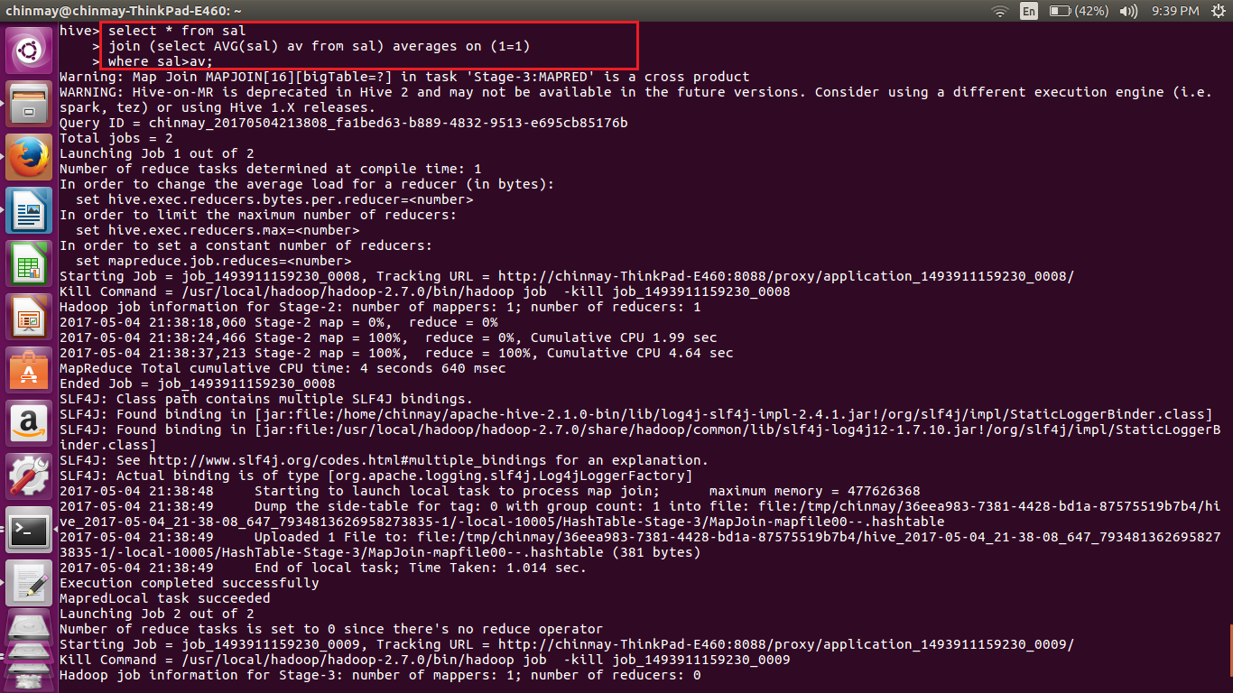

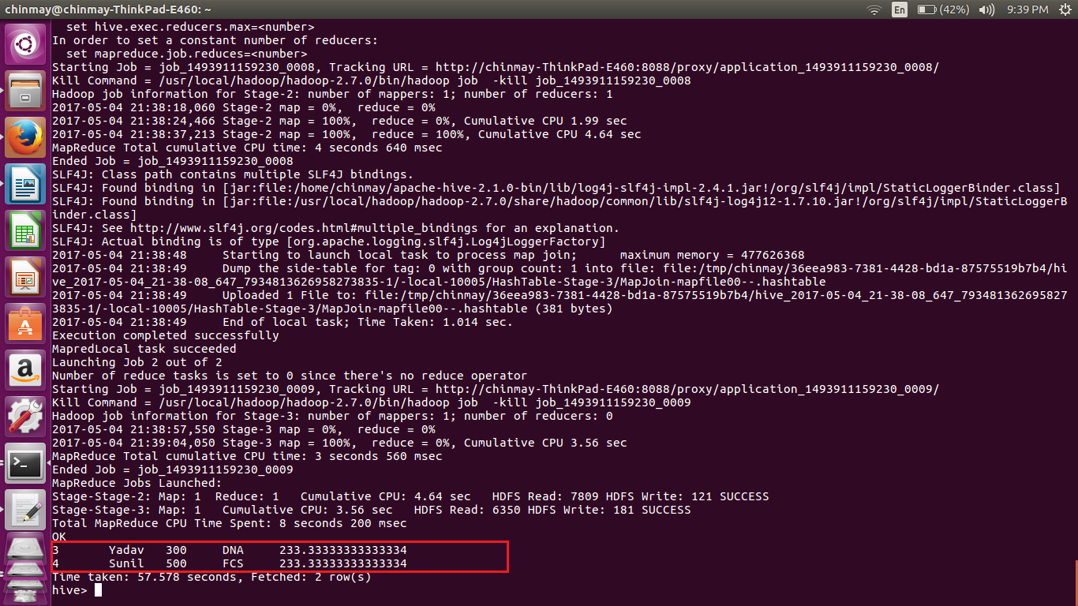

Store the above dataset into the following file formats.

● SEQUECEFILE

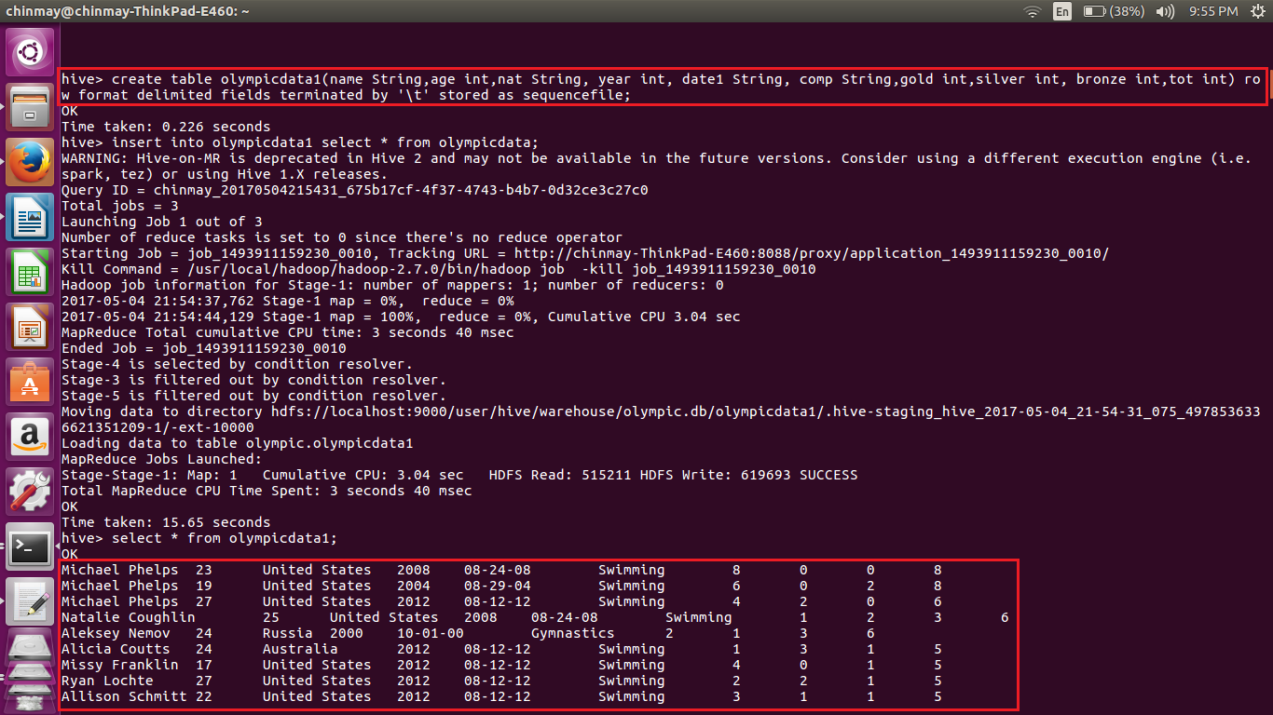

● RCFILE

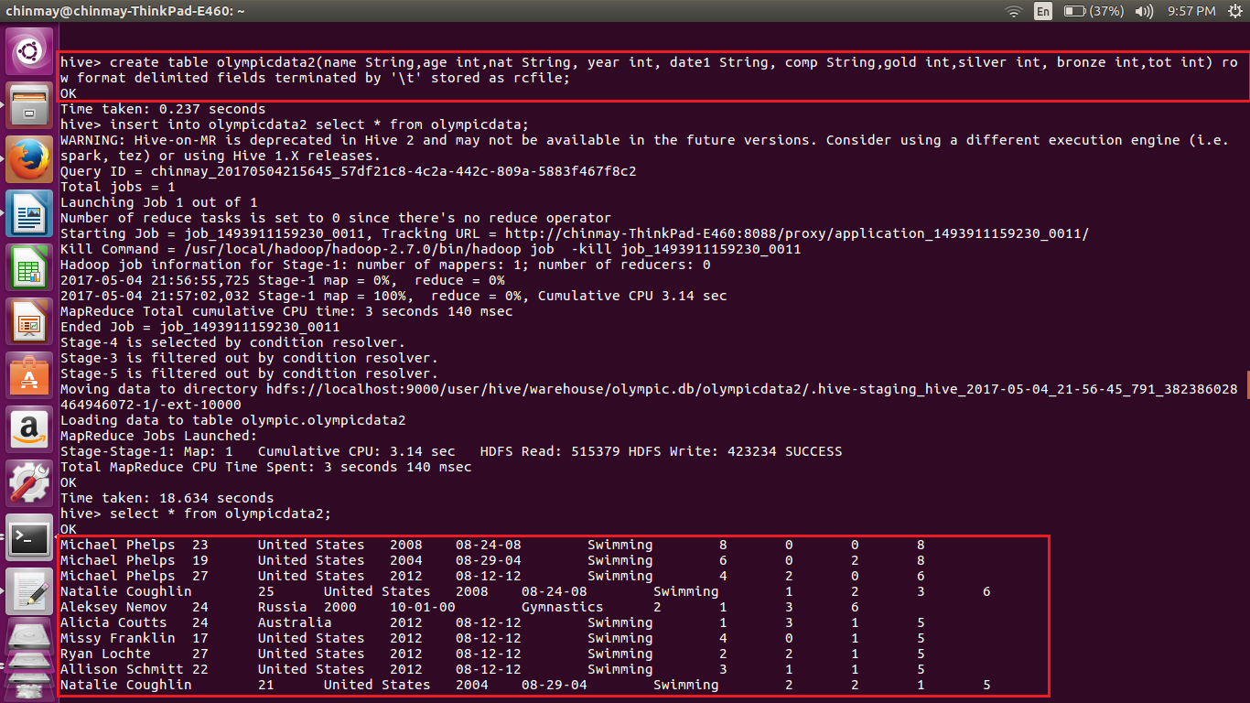

● ORC FILE

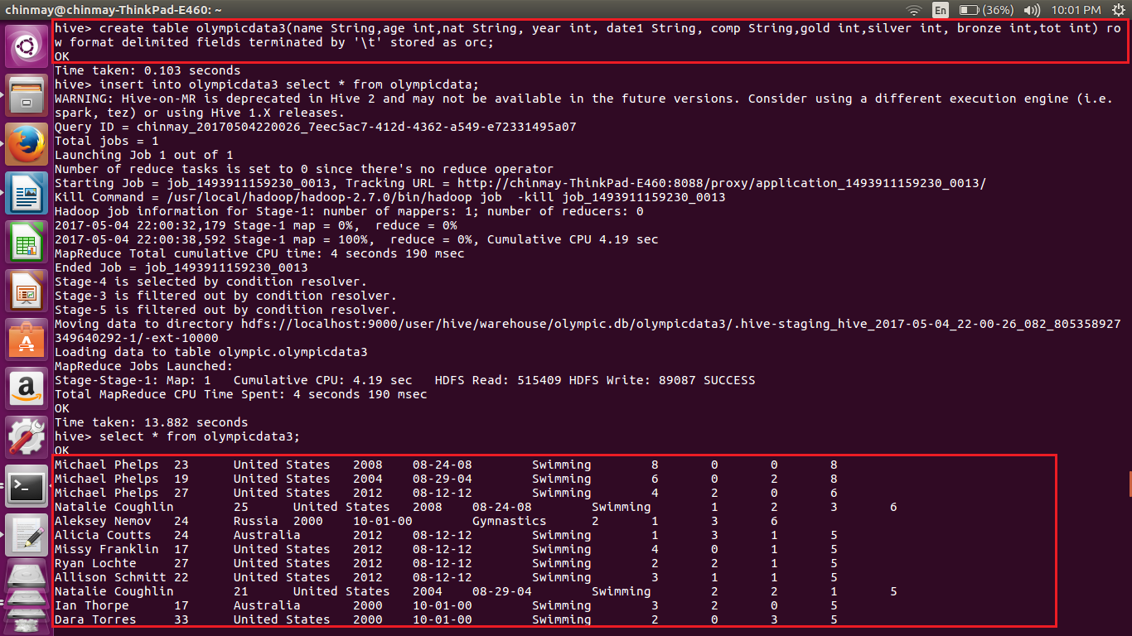

Share the commands used with their results.