Write a hive UDF that implements functionality of string concat_ws(string SEP, array). This UDF will accept two arguments, one string and one array of string. It will return a single string where all the elements of the array are separated by the SEP.

//udf function

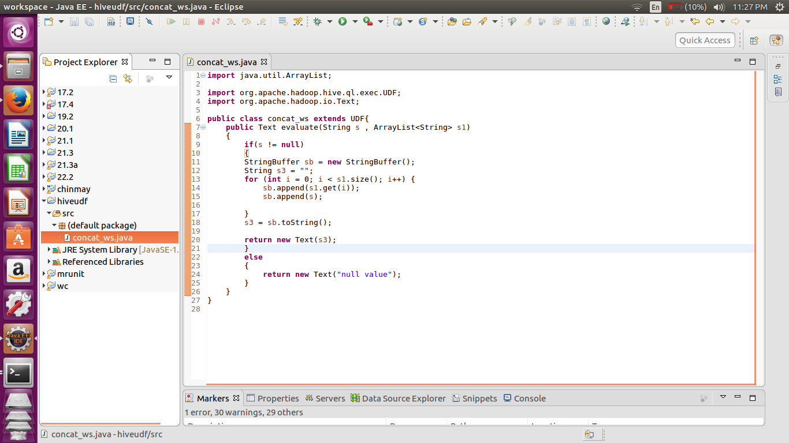

I am using the string buffer to concatenate the first String argument in between all the elements of the array list.

Also the hive takes the complex datatype as the array<String>.

//output

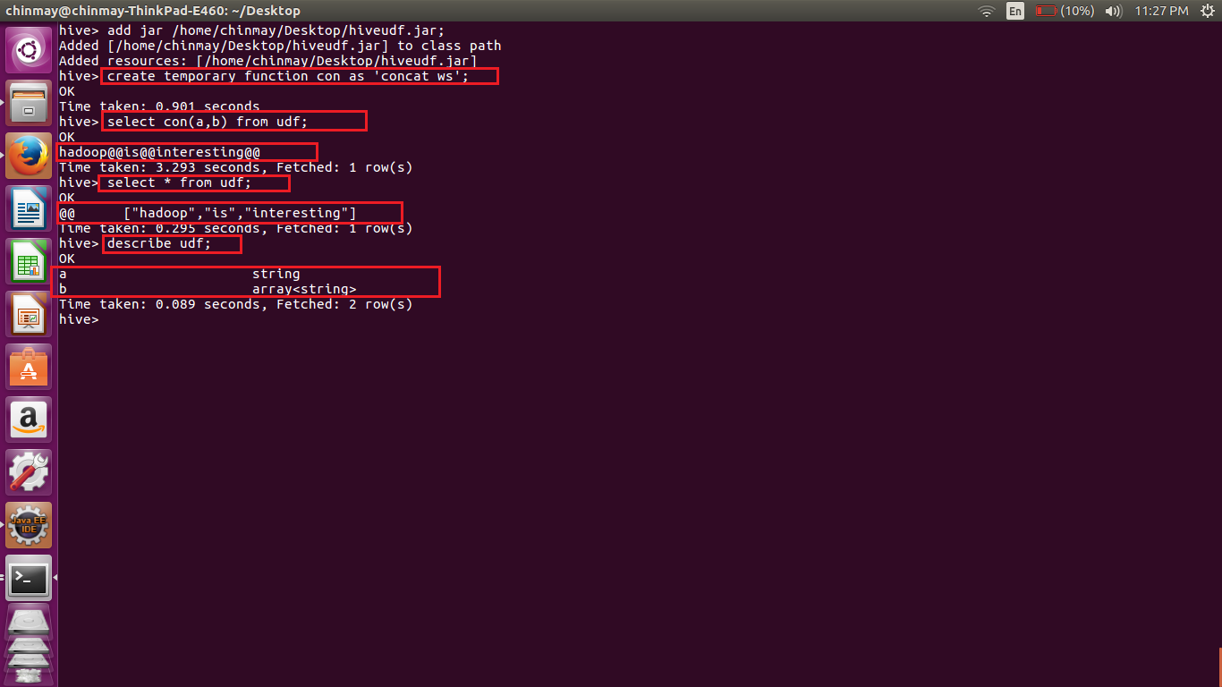

Here we can see that the table udf has only one row with first row as ‘@@’ and second arraylist with elements ‘hadoop is interesting’.

The first value in the string is concatenated between all the elements of the arraylist and the value is returned as the single string.