Write a hive UDAF to find the largest integer in a column. Use your own dataset for the above
problem statement and attach the steps performed, codes used with the result.

//udaf code
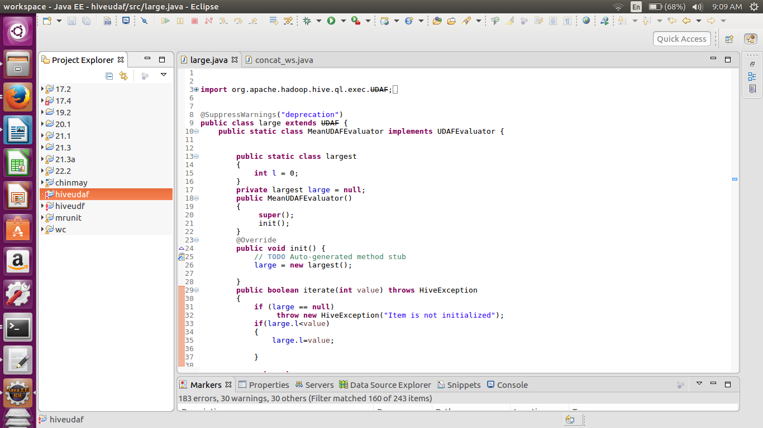
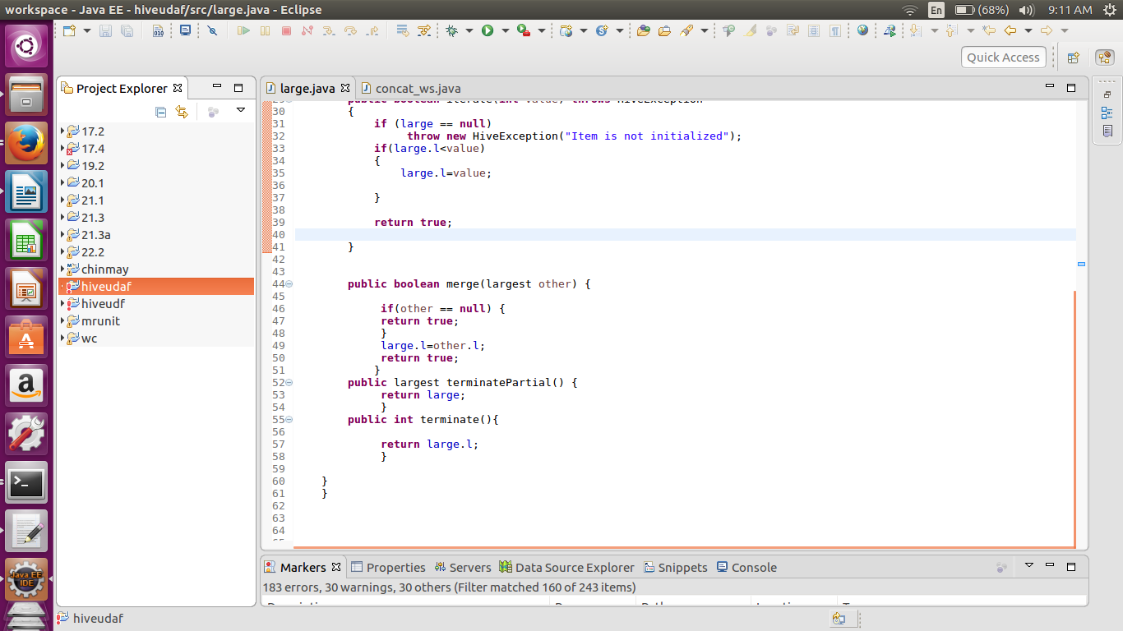
In this code i have created class called as largest which initialize the integer. I have compared this value with the all the other values . If the upcoming value is greater that the present value then the integer value is replaced by the new one. This is all done in the iterate method. The merge method is used to merge partial output. The terminate method is used for final output.

//table
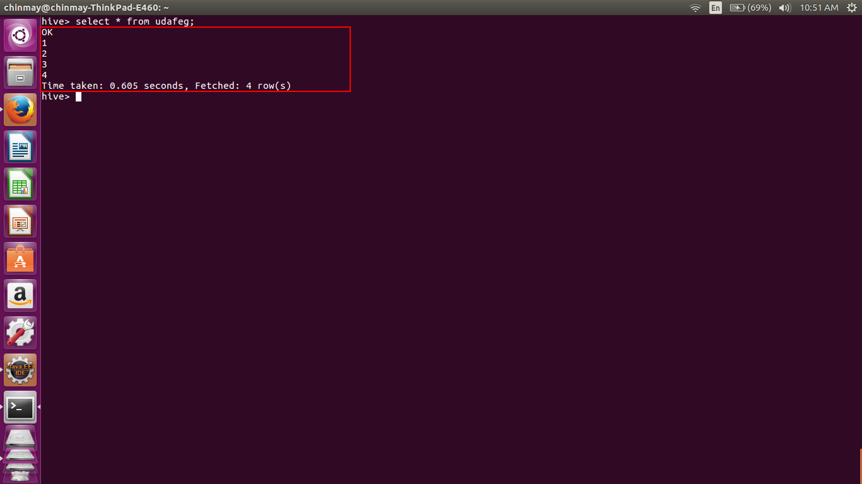
here I have crerated a table called as the udafeg which contains only single field of integer type.
//query
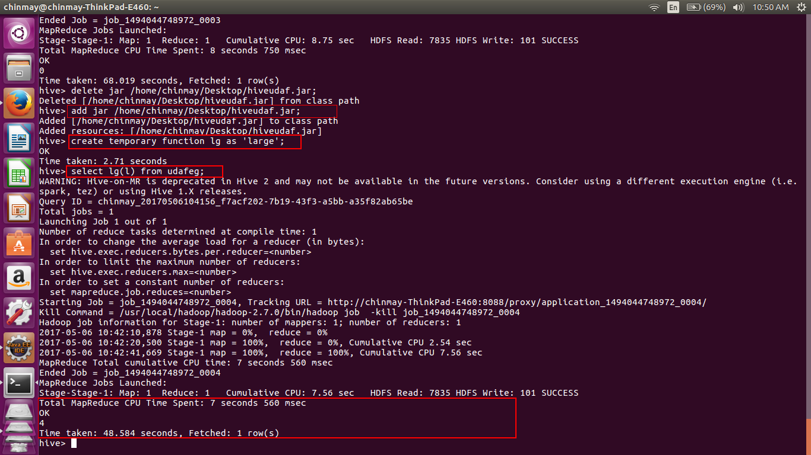
here i have added the jar as well as created the a temporary function called as lg.
When the fuction is applied on the same table we get the answer ‘4’ whic is the largest number in the table.

