Explain Brief of the following in brief
●Hive UDF
Hive UDF is simple function which used to perform custom operations on EACH ROW. We can use our own logic to get particular fuction to be done. But important thing is that the fuctions in simple UDF will be performed only on single row and not on the whole of the table.

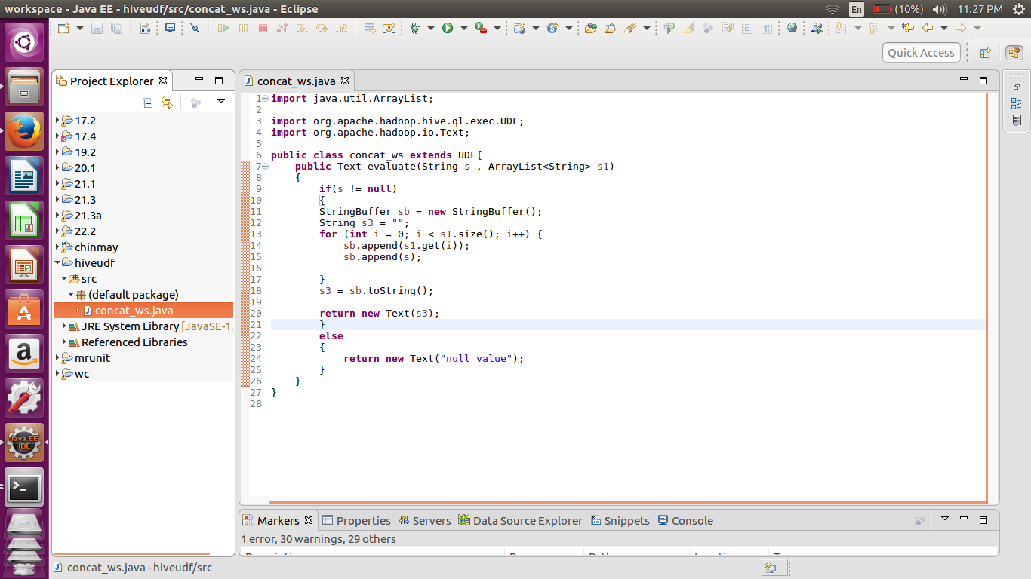
Above shows the example of the UDF
●Hive UDAF
UDAF (User defined Aggregate function) this is used to design a custom operation that is performed on te group of rows. For example finding out the average, sum etc. All these function have to consider all the rows of the particular fileld.

●Hive UDTF
This is opposite to that of the UDAF. As in the UDAF it takes input as multiple rows and output is the computation of the whole row on the other hand here we are taking input as a single row and spliitting them into multiple rows. For example explode function in hive

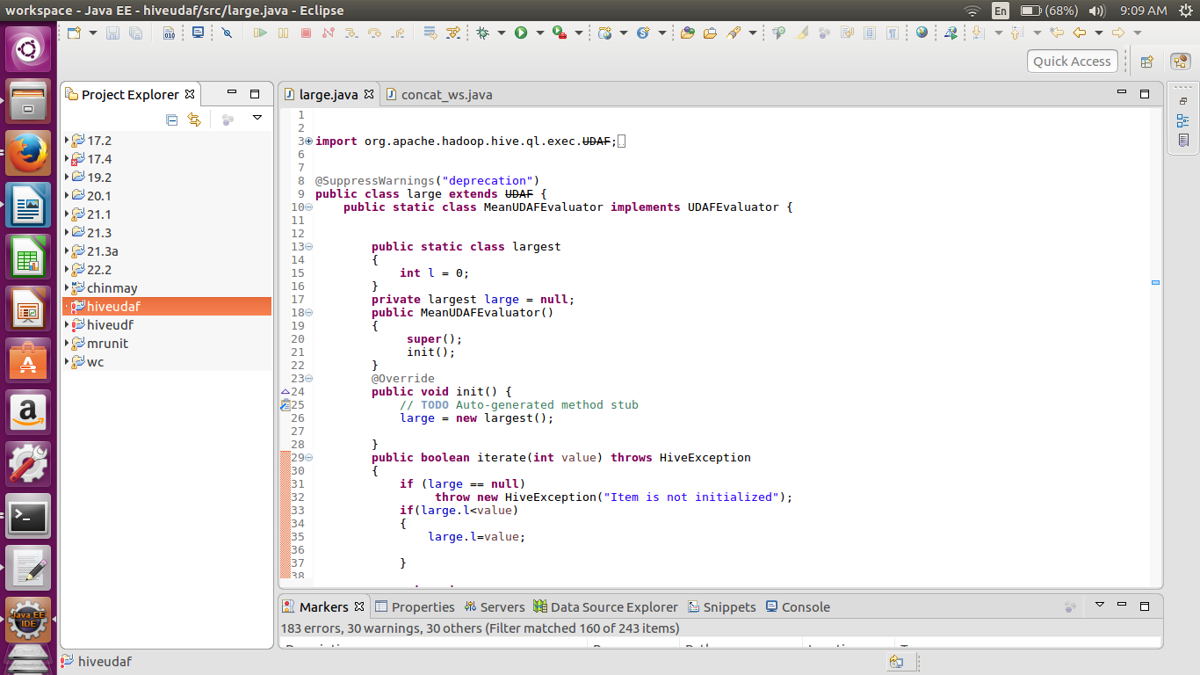
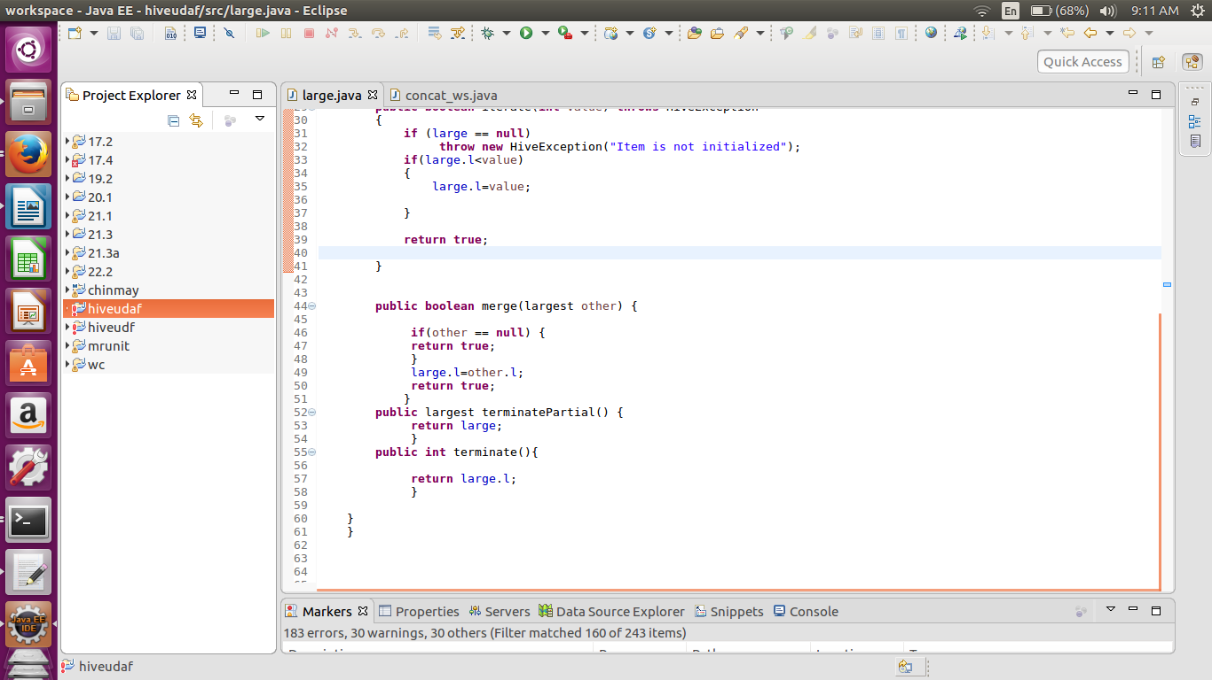
Here we have created the UDAF to get the largest number from the group of columns.

●Thrift server
Thrift is an RPC framework for building cross-platform services. Its stack consists of 4 layers: Server, Transport, Protocol, and Processor.
When you query any hive tables or database, in background automatically your requests is transferred between hive service and hive server
when you want to create your own service or project you can use thrift protocols which will help you in creating layers, think this as you are creating your user defined functions using libraries, so in that case libraries will be thrift.

