Write a java program to read data from hive.

//Hive server 2 starting

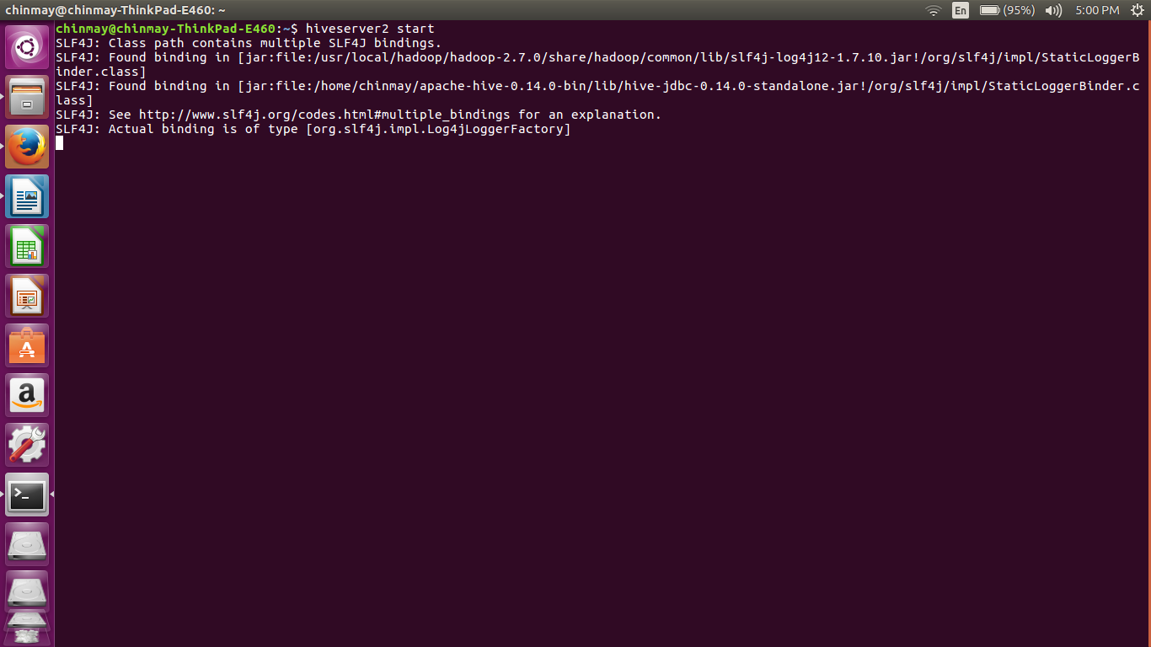
here we have started the hiveserver 2. The configurations were done in the hive-site.xml file . Here we set the port number for the connection as 10000.
//hivesitexml file
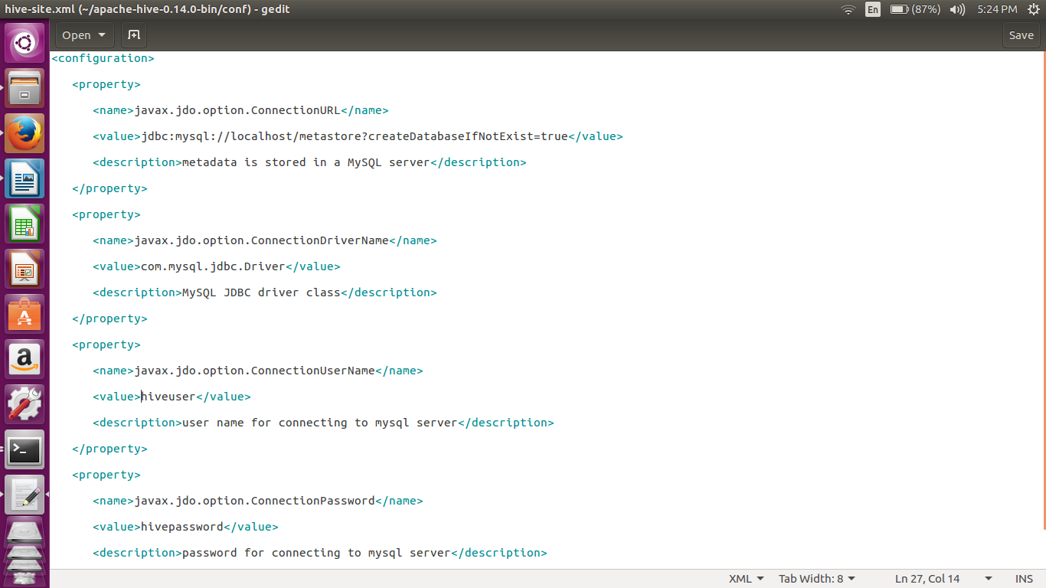
we have installed the mysql as the metastore for the hive. We have created a special user which has all the permissions.
For setting the mysql as the metastore we have to upload the above xml configurations in hive-site.xml

//code
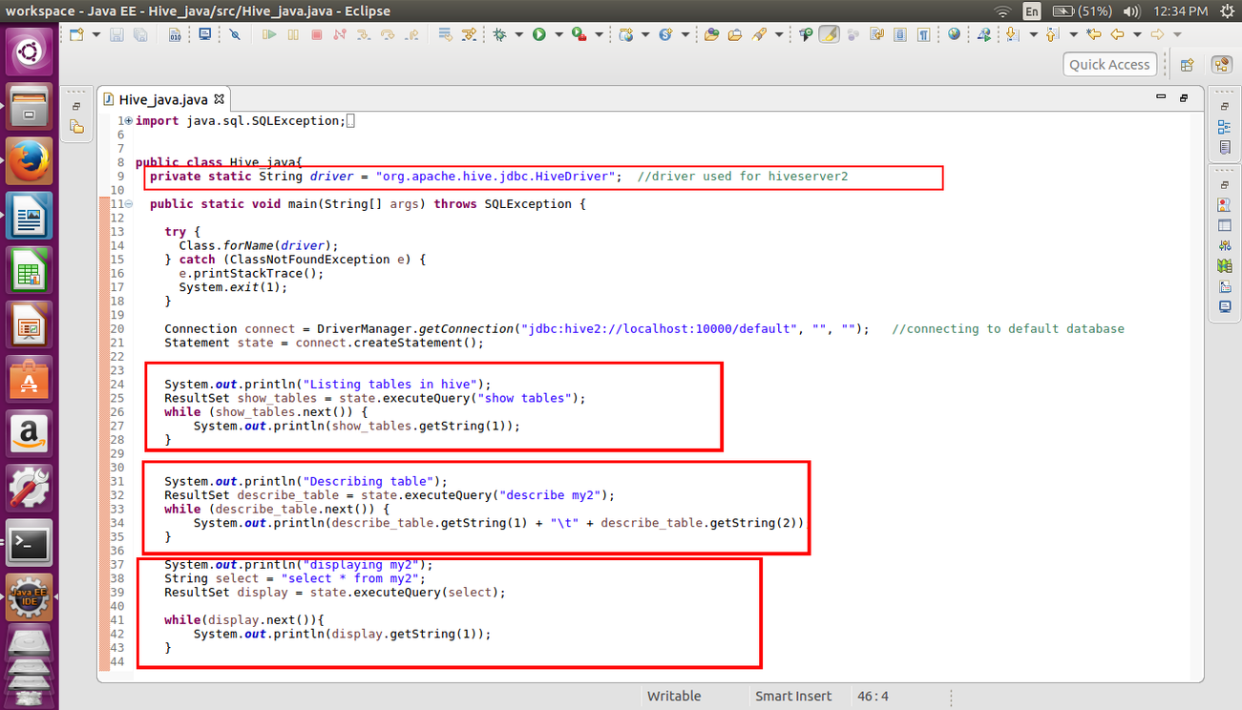
In the above code we can see that we have made all the connection with the localhost port 10000

In the subsequent part we have listed all the tables.
For listing the tables,describing the tables and also displaying the contents in the table we are using the executequery in order to execute the query.
For notifying the part of the execution i have used the print statements

// output
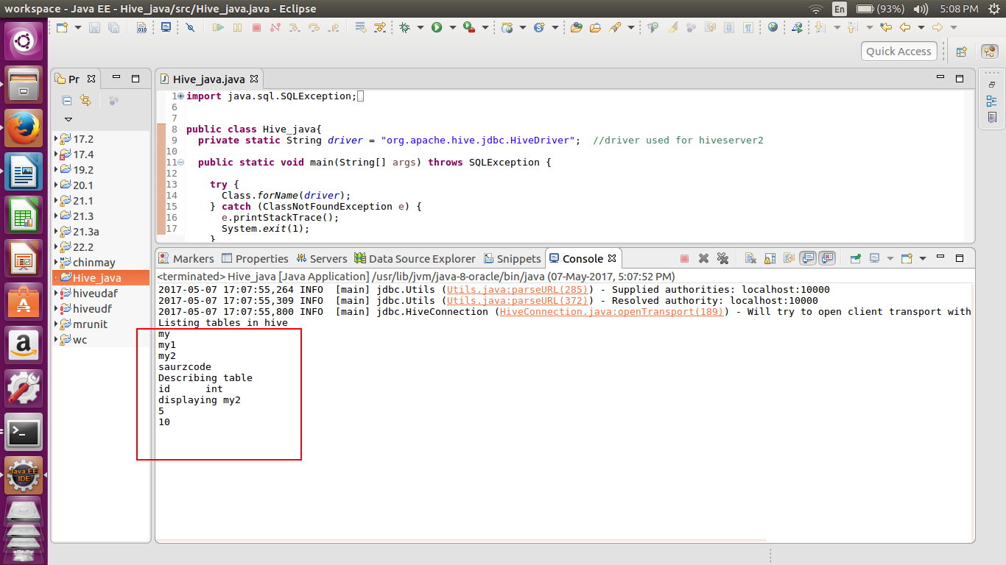
In the console we can see that the code has been successfully executed it has listed all the tables e.g my1,my2,saurzecode etc.
Hence we have read data from hive using the java api.

