Write a java program to write data into an hive table.
//Hive server 2 starting

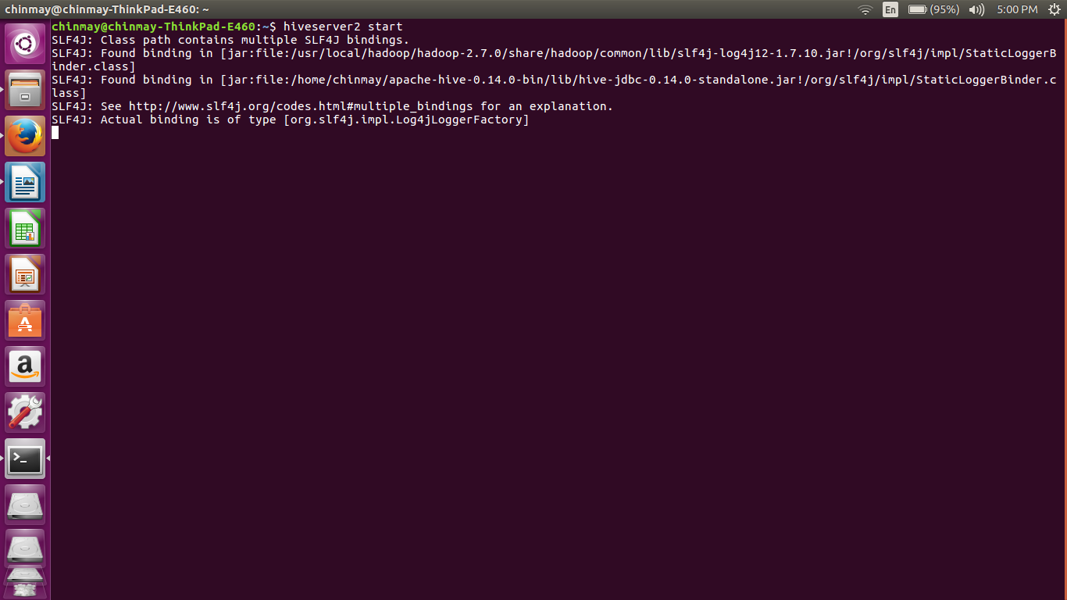
here we have started the hiveserver 2. The configurations were done in the hive-site.xml file . Here we set the port number for the connection as 10000.
//hivesitexml file
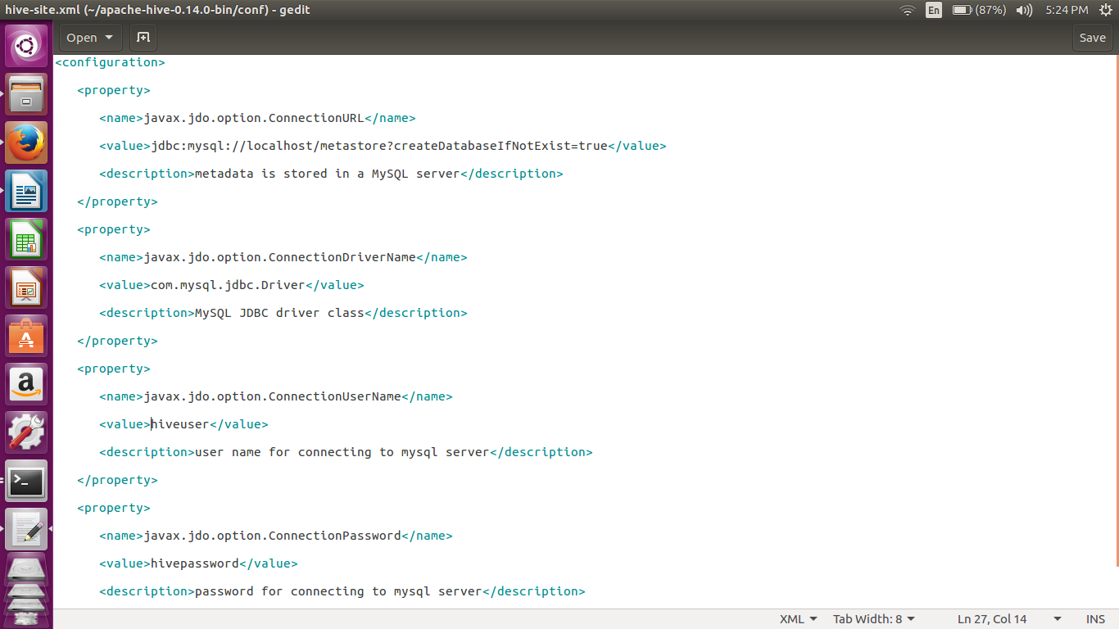
we have installed the mysql as the metastore for the hive. We have created a special user which has all the permissions.
For setting the mysql as the metastore we have to upload the above xml configurations in hive-site.xml

//code
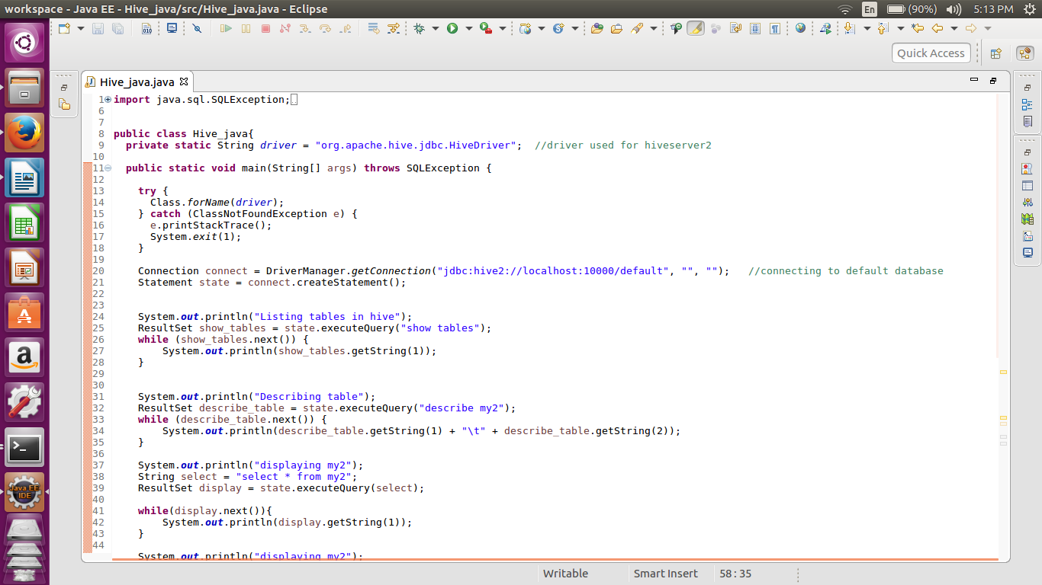
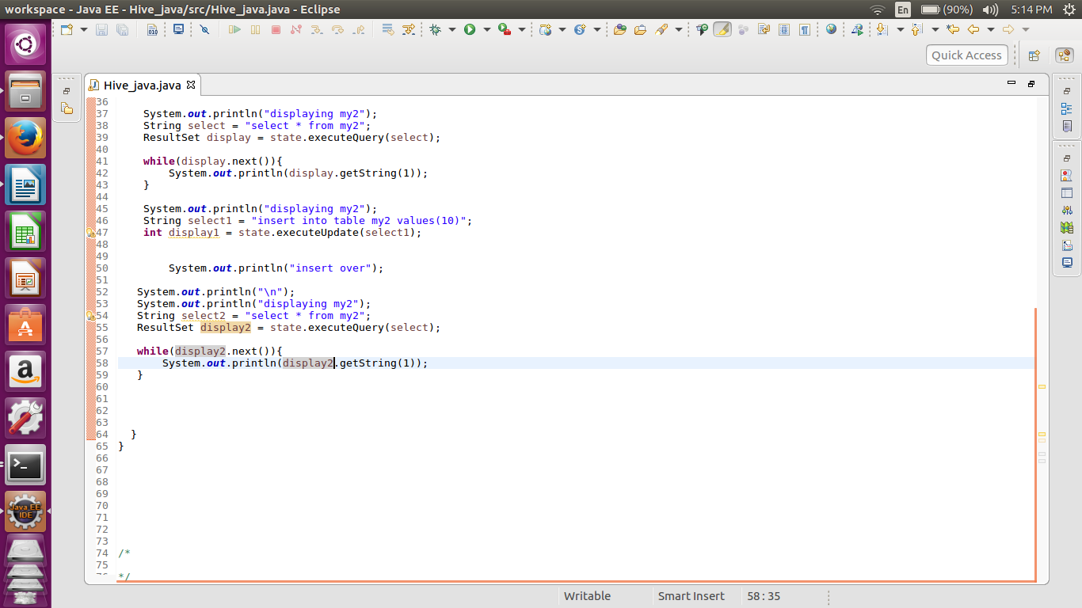
In this code we first displaying all the tables and then displaying the contents of the table my2.
After that we are inserting the value integer ‘10’ in the same table using the method of update query.
Again the displaying the same same table will give us the updated table having the value 10.

//output
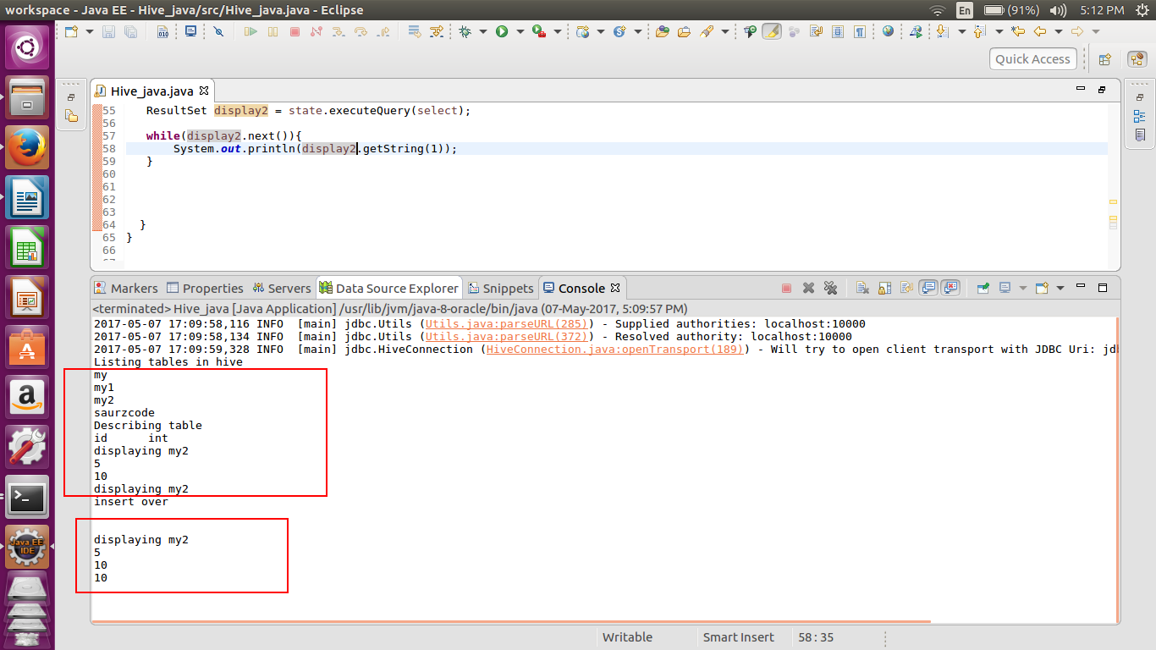
In the output we can see that in the displaying of the first table there are only two elements. 5 and 10 .
After the execution of the insert statement the values are 5,10 and 10.
for notifying the completion of the insert statement we are using the print statement ‘insert over’

//activity taken place in hiveserver
