Use Hbase shell for performing the following operations

● Create the table customer with two column families

● Personal details and order details as column families. Create a unique number as row key (ssn/Aadhar no.,etc) Insert at least 10 records to each column Insert following values for personal details column family Name, age, city, state

● Insert following values for order details column family

● Order no., order quantity, and order amount

● Use put command to insert the values for each record. Use get command, to retrieve all the records of single customer.

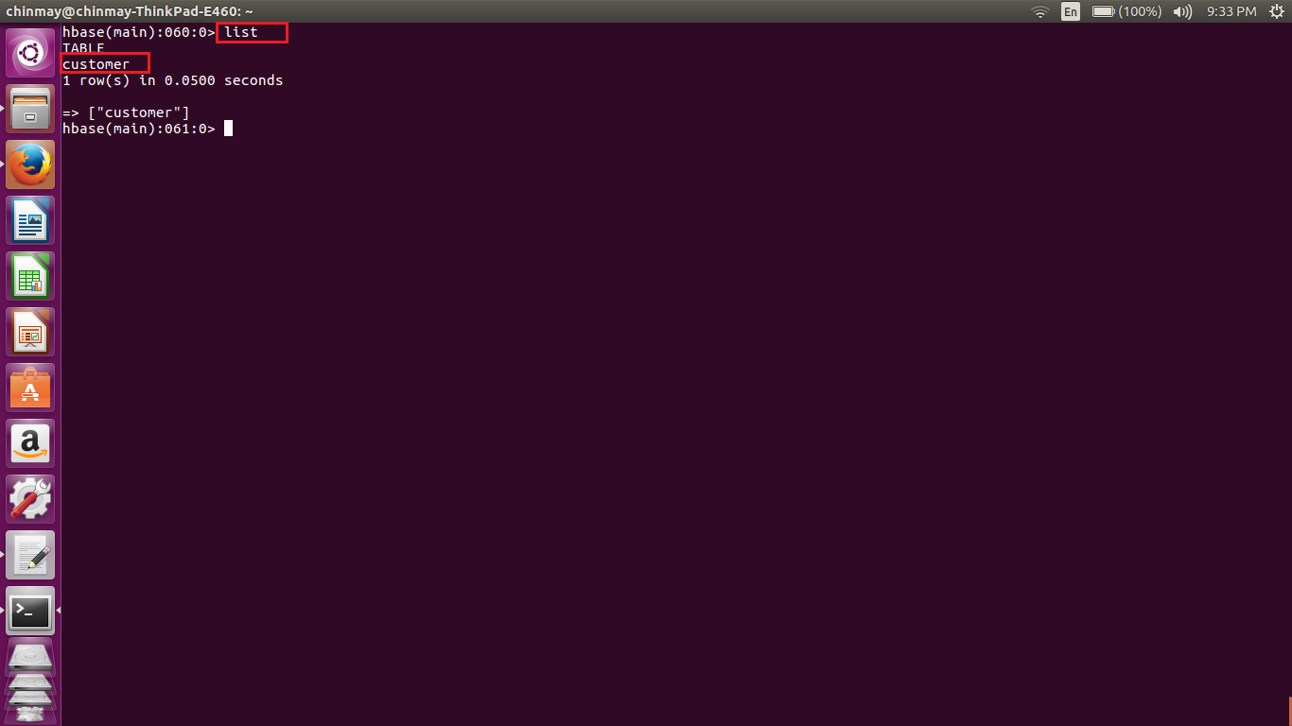

Using the list we can see that the Customer table is created.

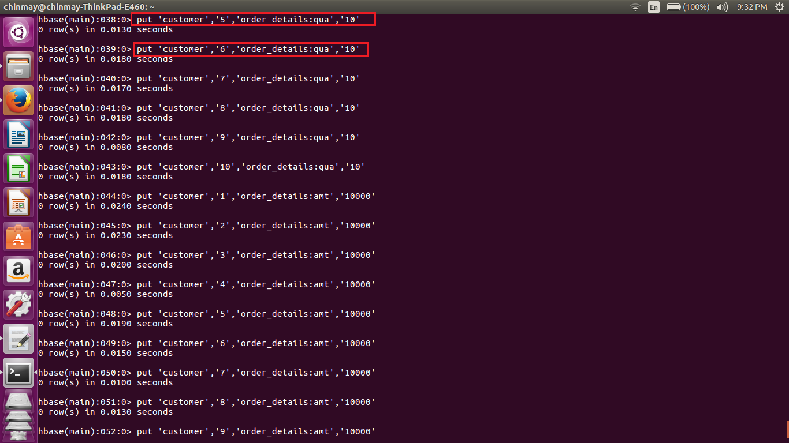

By using the put command we have inserted 10 values in each column. Above is the sample screen shot for the same.

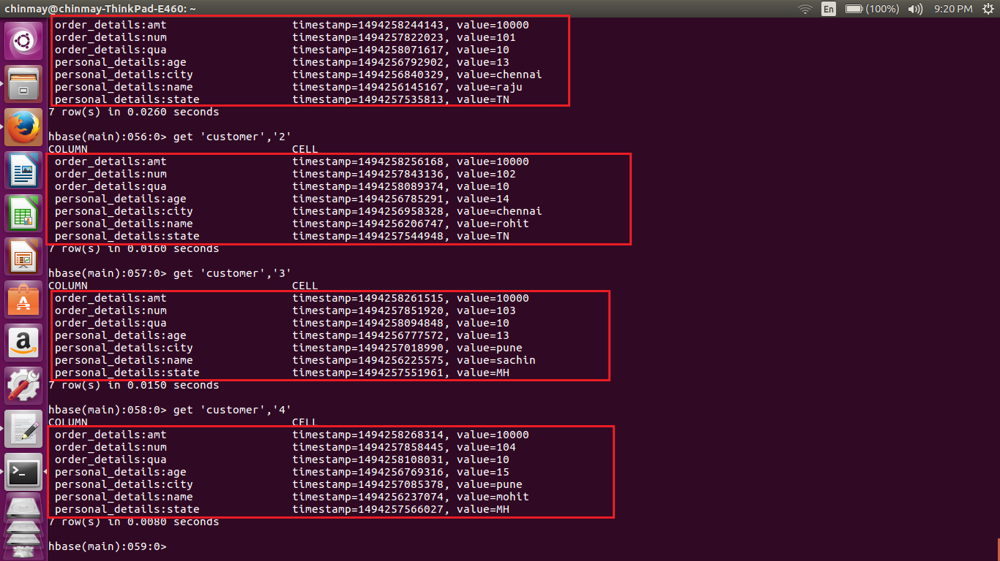

Using the get command we are able to see the details of each row.

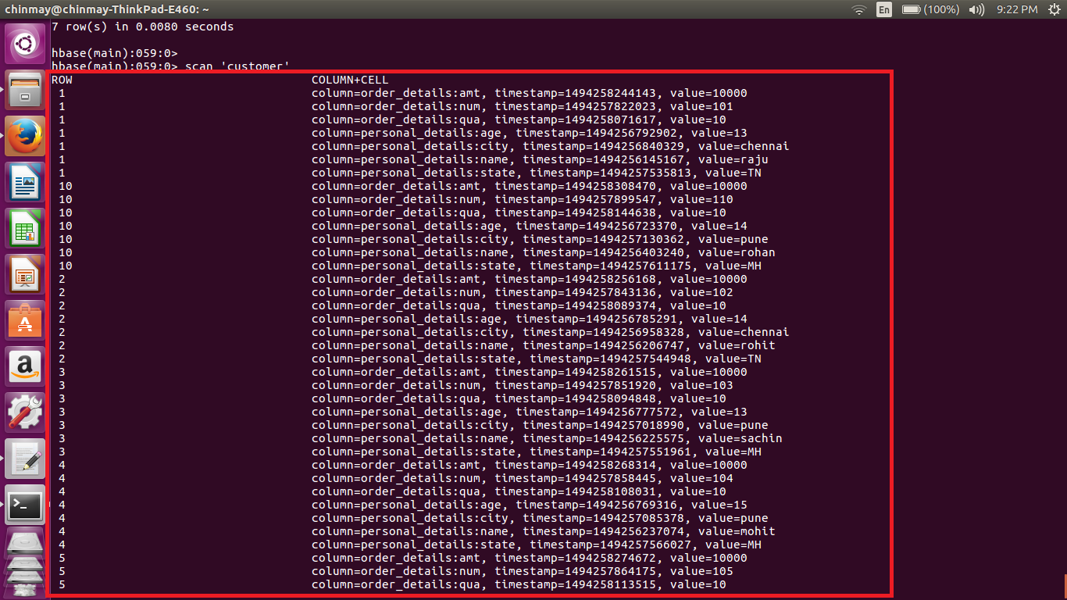

By doing the scan operation we are getting the all the details of particular table.