Write a Java client API to perform following operations:

● Use HBaseAdmin class and create the table named company with one column family name details.

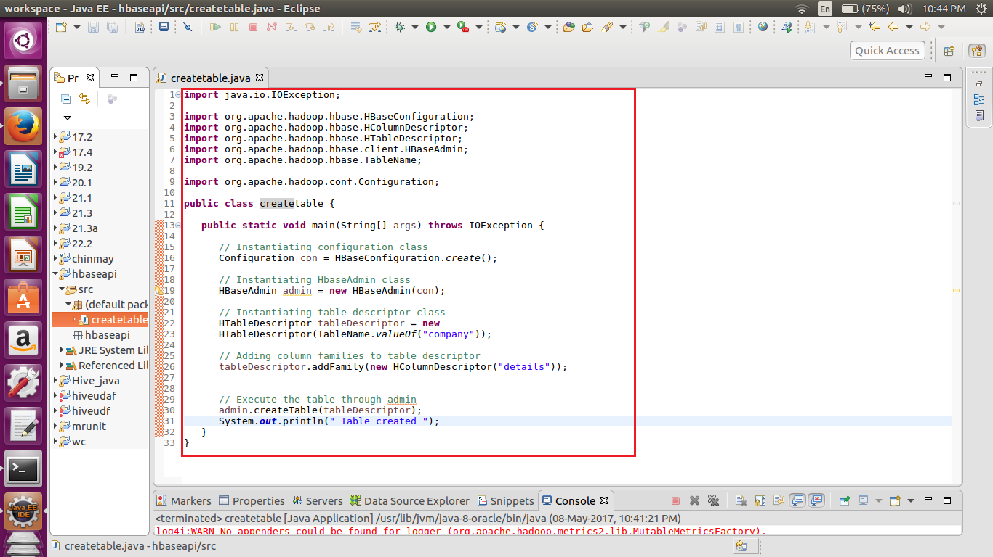

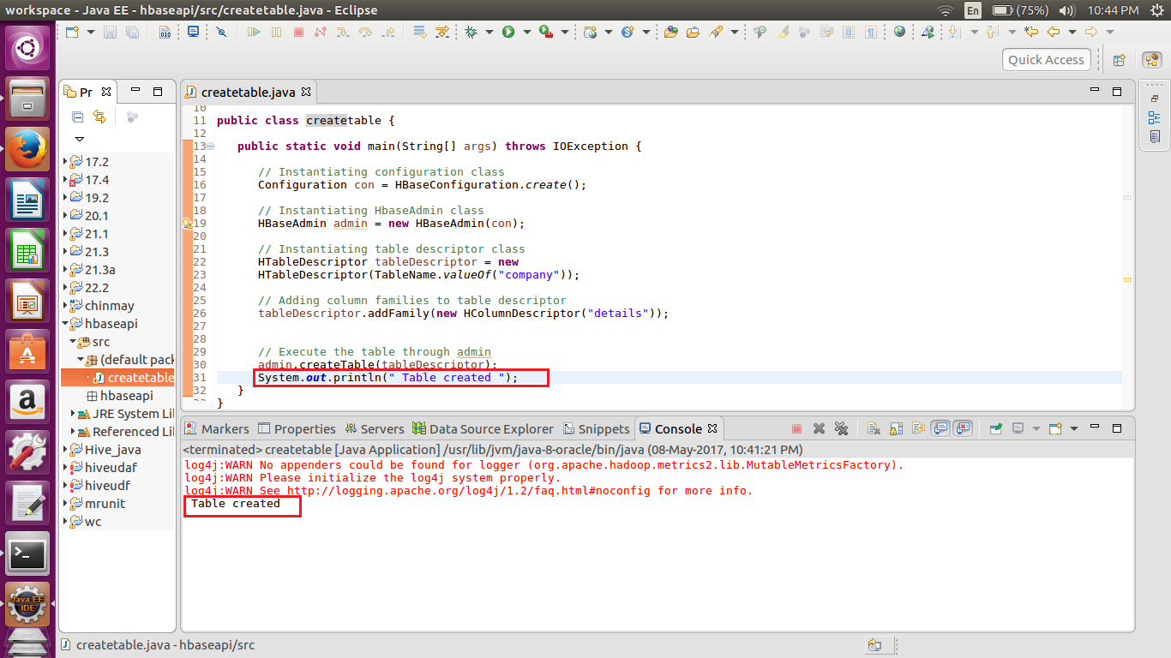

**HTableDescriptor** is a class that belongs to the **org.apache.hadoop.hbase** class. This class is like a container of table names and column families.

Using the **createTable()** method of **HBaseAdmin** class, you can execute the created table in Admin mode.

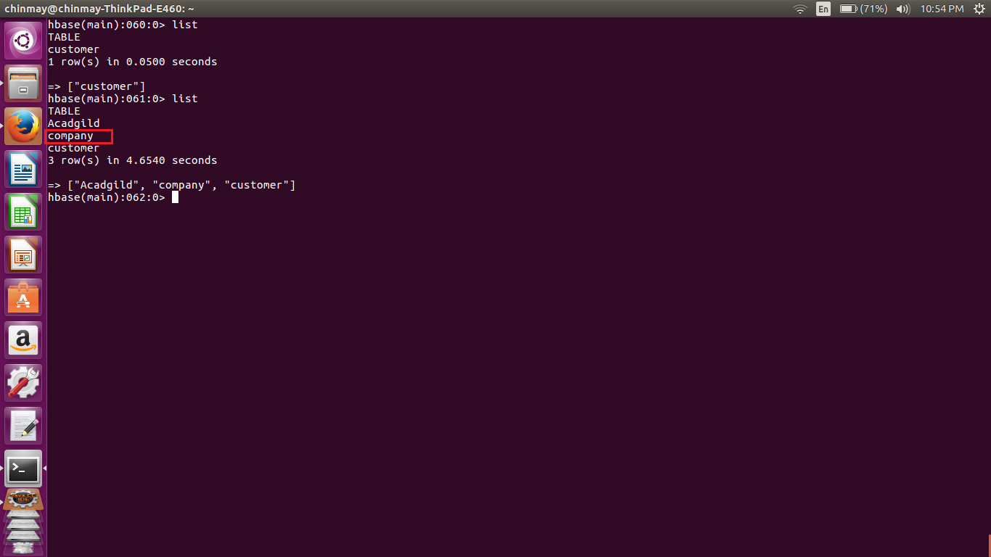

--------------------------------------------------------------------------------------------------------------------------------------------------------------

● Create the method name insert and use put class to insert records to company table

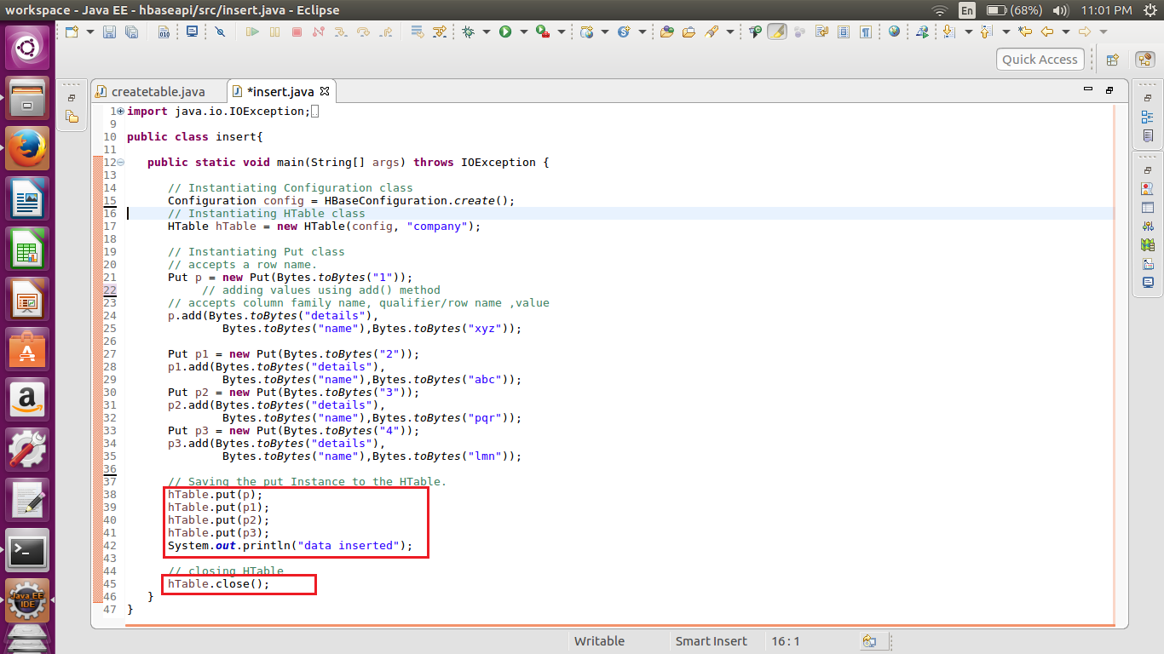

The **Configuration** class adds HBase configuration files to its object. You can create a configuration object using the **create()** method of the **HbaseConfiguration** class.

You have a class called **HTable**, an implementation of Table in HBase. This class is used to communicate with a single HBase table.

To insert data into an HBase table, the **add()** method and its variants are used. This method belongs to **Put**, therefore instantiate the put class.

The **add()** method of **Put** class is used to insert data. It requires 3 byte arrays representing column family, column qualifier (column name), and the value to be inserted, respectively.

After inserting the required rows, save the changes by adding the put instance **hTable.put().**

After creating data in the HBase Table, close the **HTable** instance using the **close()** method as shown below.

