Write Java client API to perform following operations:

● Create the method name get record and use get class to retrieve one record at a time record from company table.

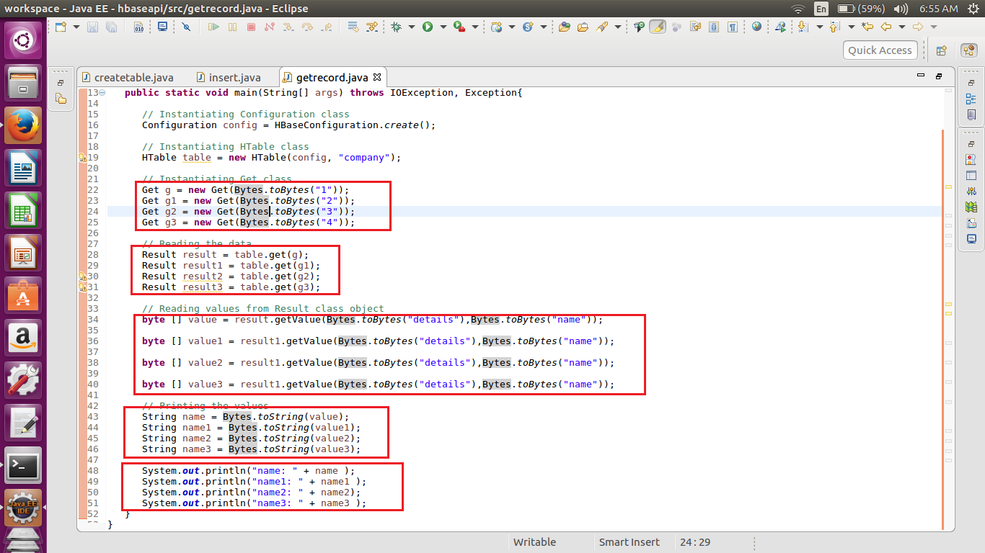

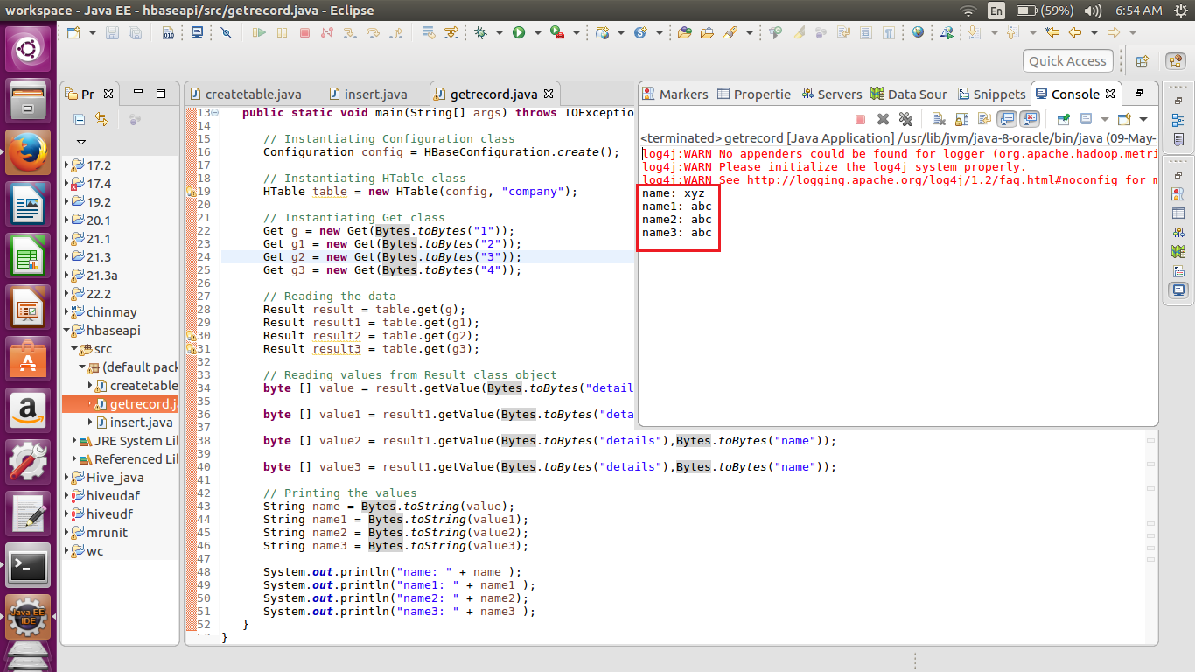

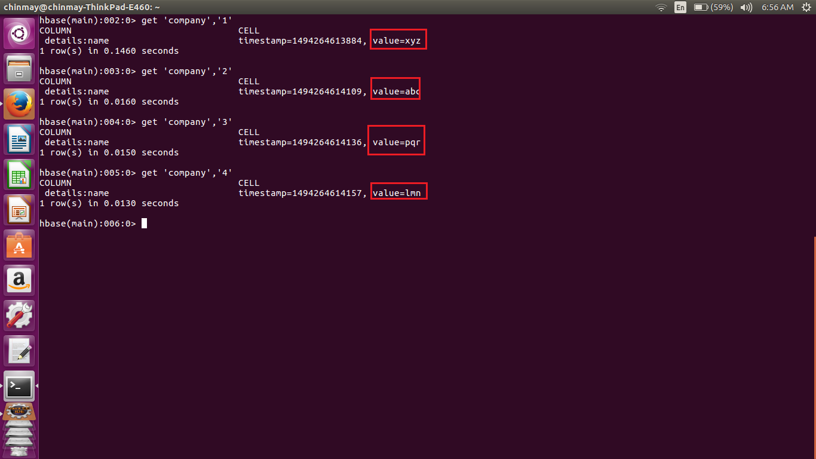

----------------------------------------------------------------------------------------------------------------------------------------------------------------

● Create the method name display and use scan class to display all records from company table.

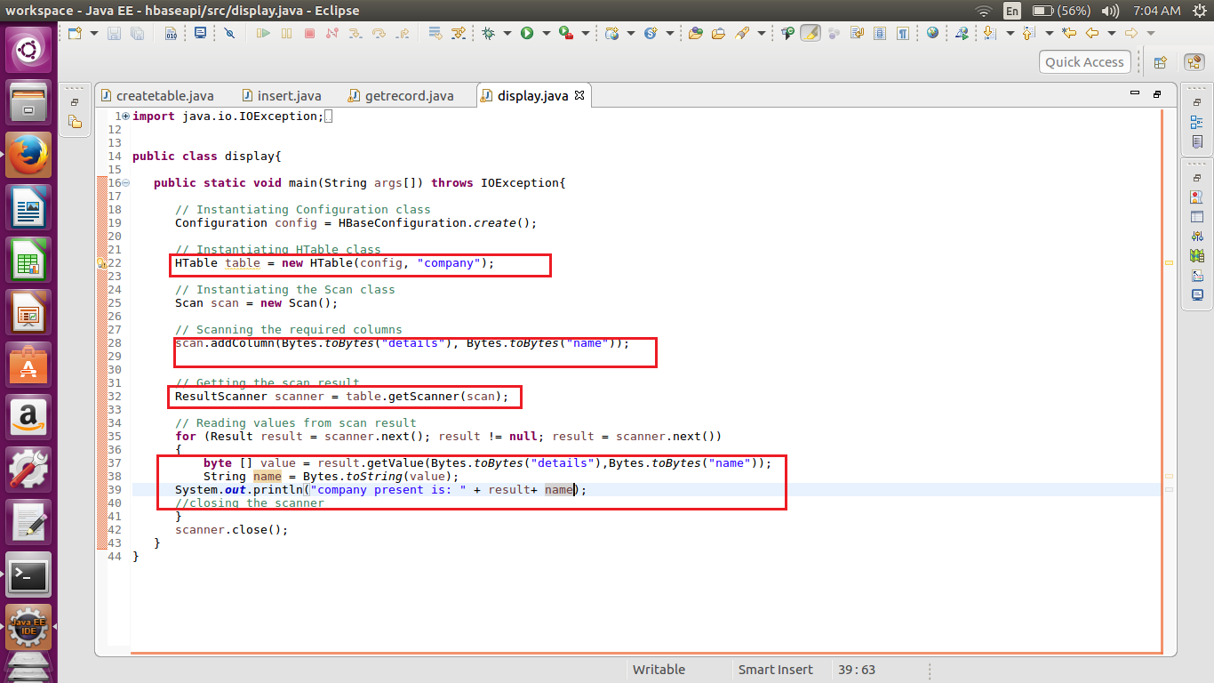

You have a class called **HTable**, an implementation of Table in HBase. This class is used to communicate with a single HBase table.

**Scan()** method is from class **Scan** for which we have created object called as scan

Then we are iterating using the for loop till the scanner gets null value.

Also in the above code I have displayed the values. Here in the output we can see the name of the company at the end.

Simple result of the scanner will give row name , time stamp, length of value, column family and column name

