Integrate Hbase with Hive

● Load Data (Bulk Load) from Hive table to Hbase Table

● Explain the procedures and code implemented with screenshots.

● Note: Candidates should Load their own data into Hbase table.

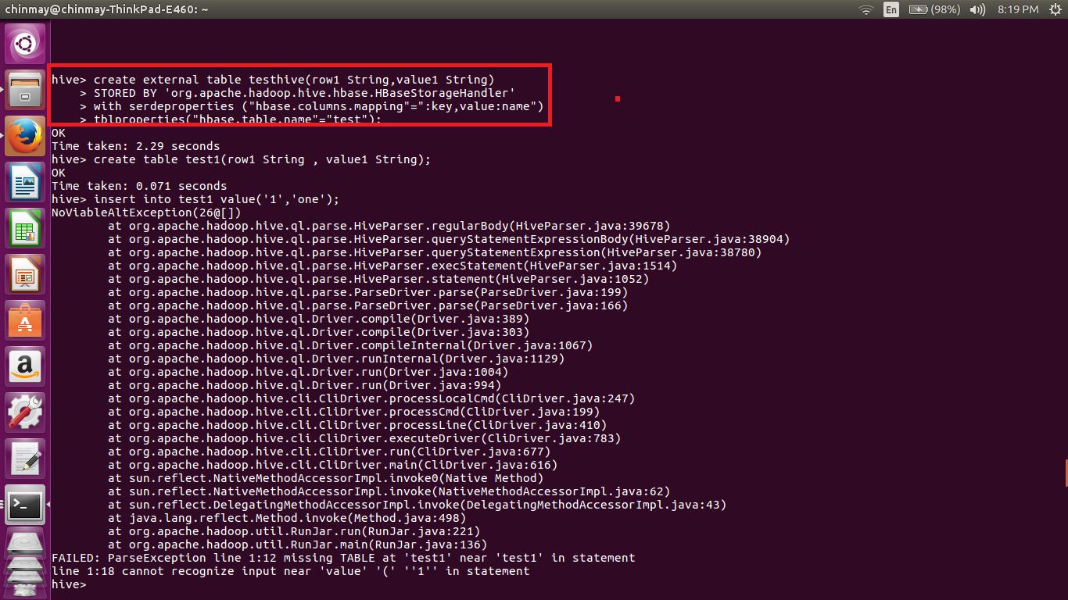

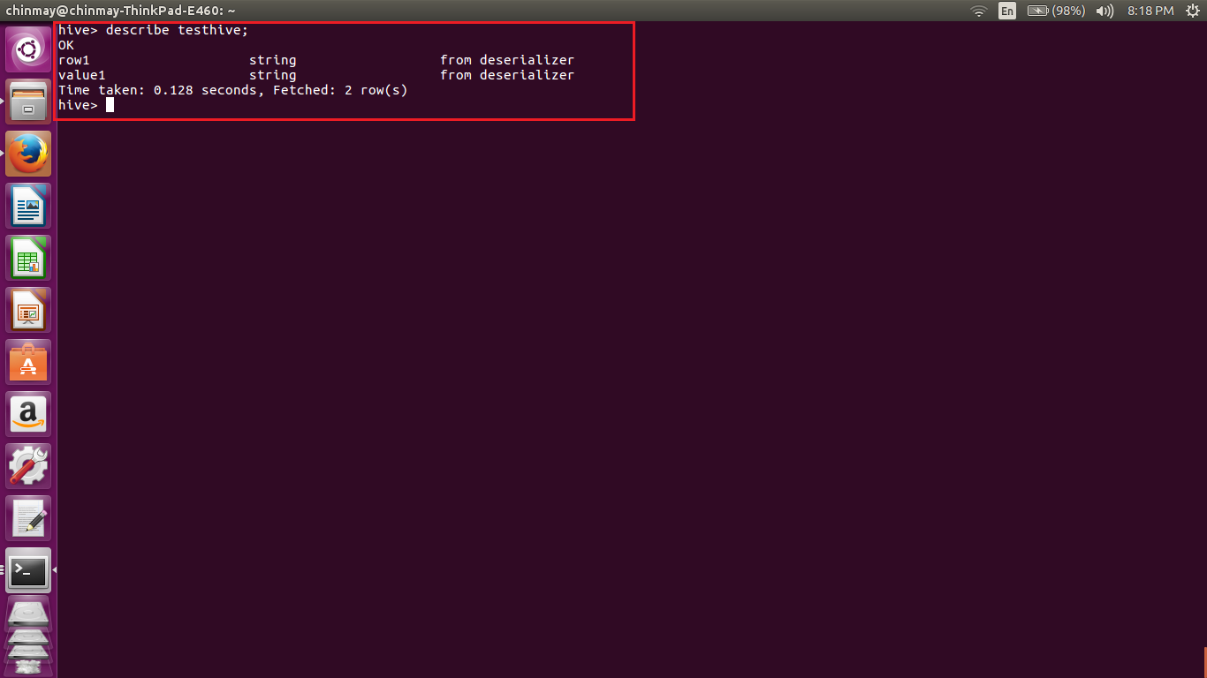

In this we have created the external table called as ‘testhive’ as row and String. This is stored by using the hbase storagehandler. We have also mentioned table name which we have created in the hbase.

Now we have created the another table called as ‘test1’ with same fields and we have put values into the that table.

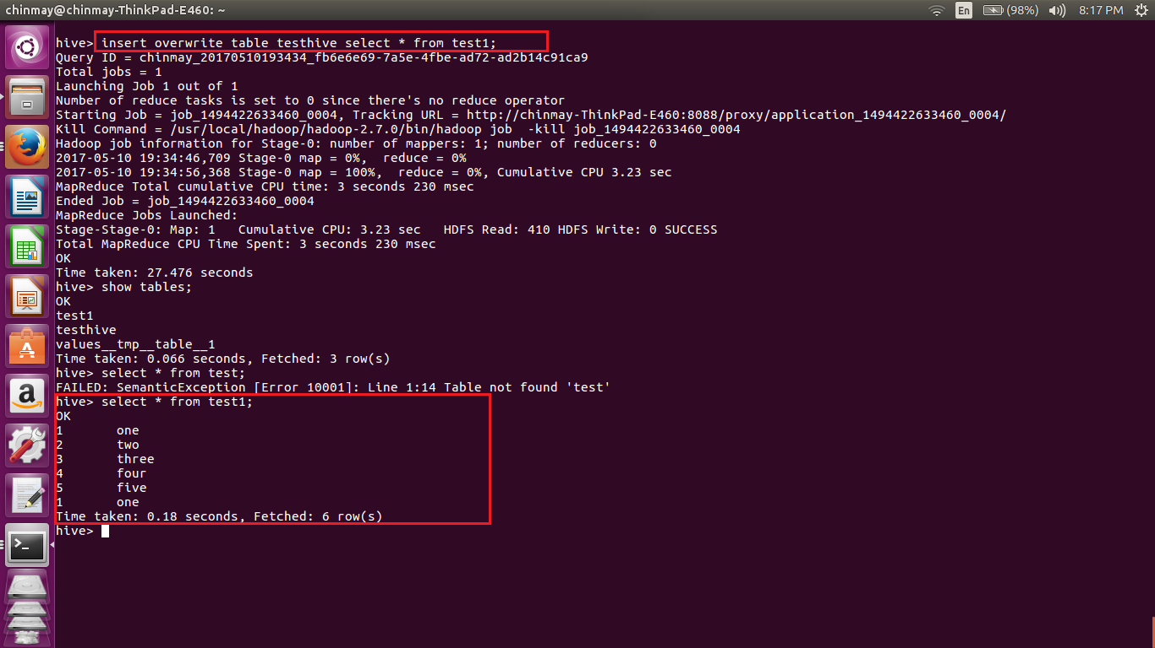

Here we have copied the contents from test1 to the testhive table which we have stored using the hbasehandler.

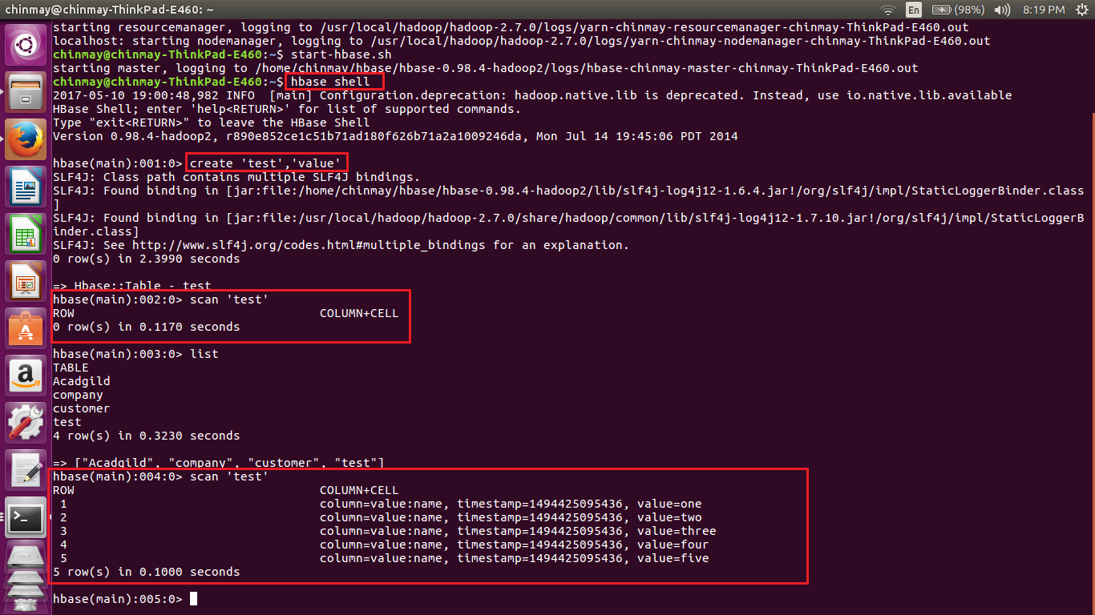

Here we can see that earlier there were no values stores in the table ‘test’ . After executing the insert command in the hive we got the values stored in ‘test’. Thus we have loaded data from hive table into the hbase.