Integrate Hbase with Pig

● Load Data (Bulk Load) from HDFS to Hbase Table using Pig.

● Explain the procedures and code implemented with screenshots.

● Note: Candidates should Load their own data into Hbase table.

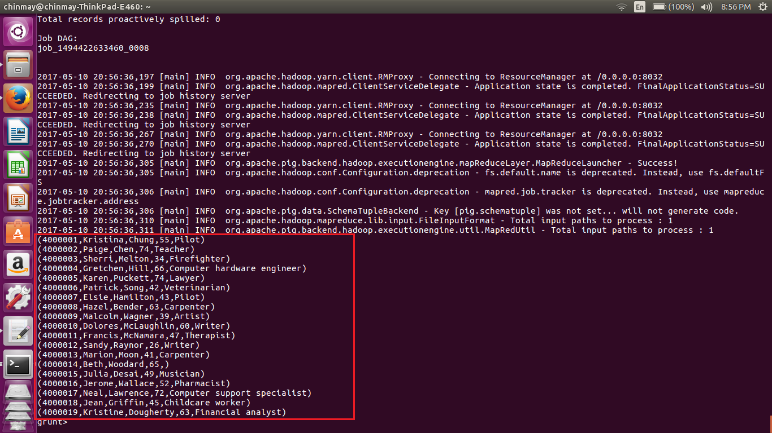

In pig we have loaded a value with following details as show n above.

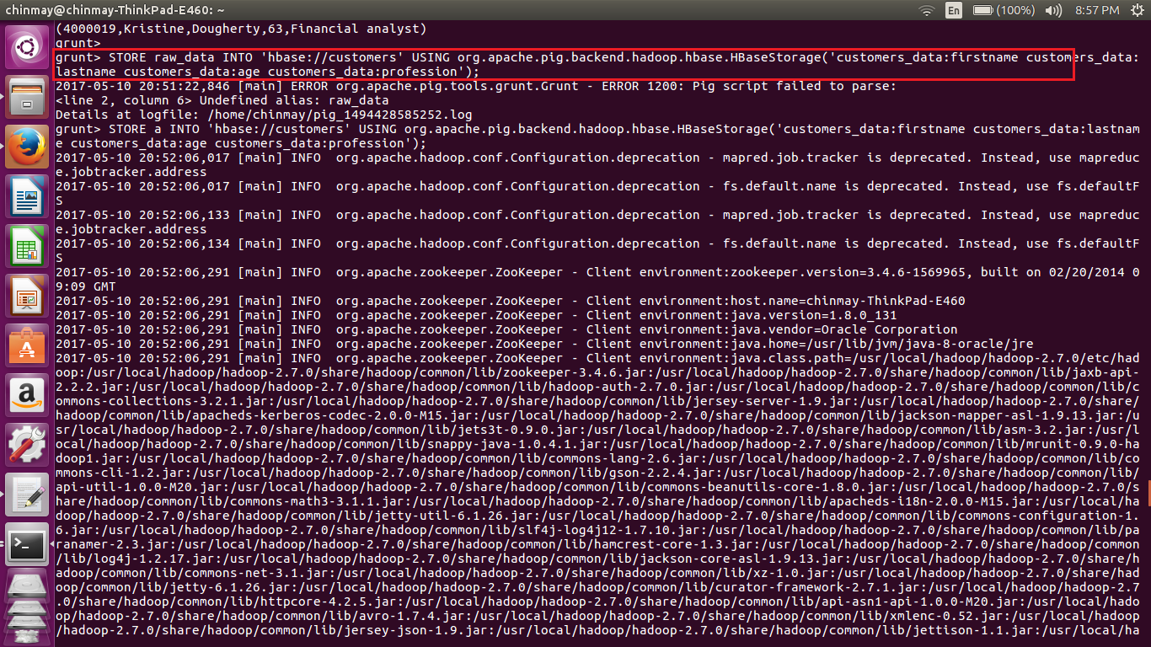

By using the store command in PIG we have stored the data into table customers and also mentioned the column families in which we have store the values. Here we are using the hbase storage to store the values into hbase.

The table name is mentioned in the ‘hbase://customers’

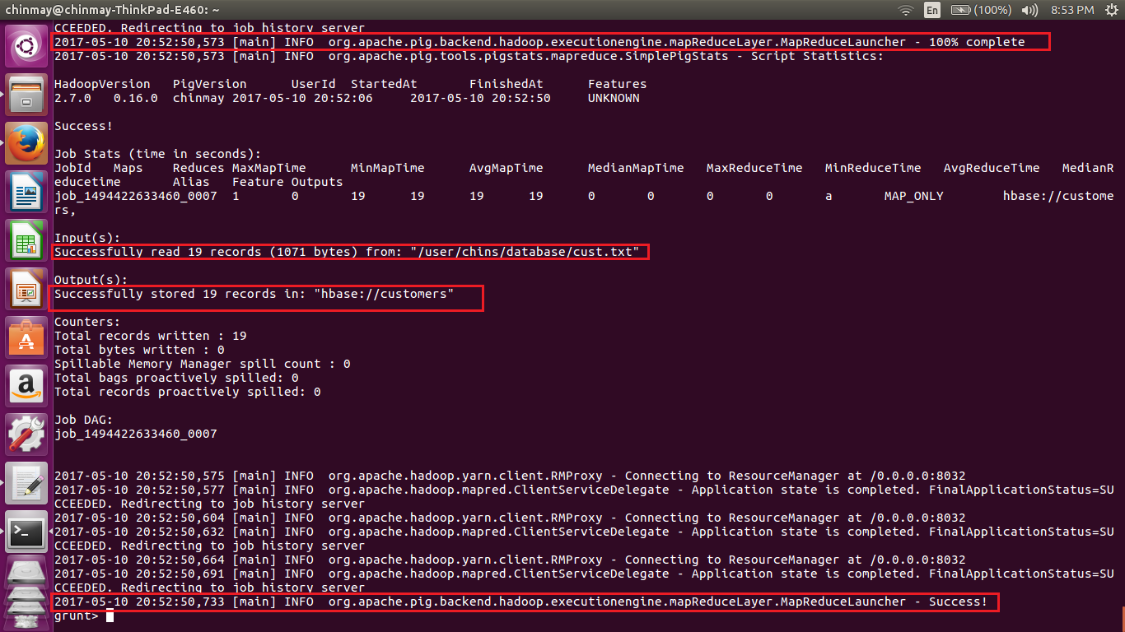

We can see that the store command has been executed and completed successfully.

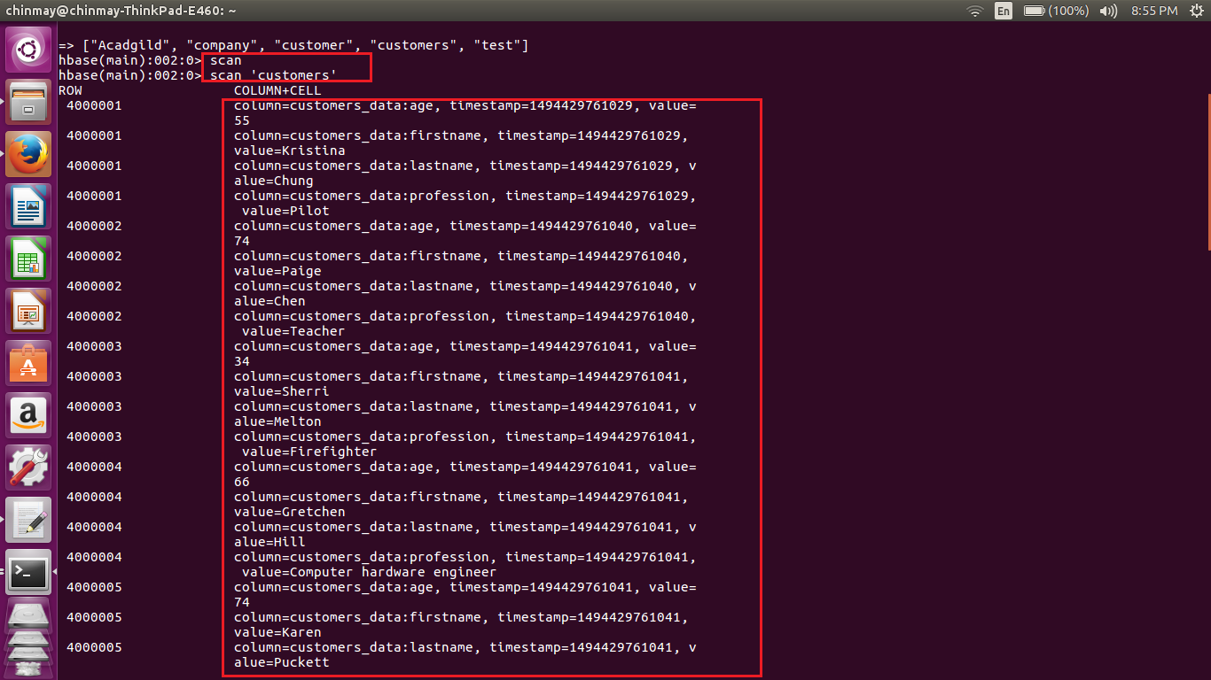

If we perform the scan statement for table customers we can see that all the contents from the pig table have been stored in the customers table.

Thus we have transferred files from pig to hbase.