Explain in brief with their uses.

● Oozie Action and Decision Nodes

● Oozie Workflow Nodes

● Fork and Join

● Oozie Web Console

**Apache Oozie is a Java Web application used to schedule Apache Hadoop jobs. It supports Apache MapReduce, Apache Pig, Apache Hive, and Apache Sqoop. Oozie can also schedule jobs specific to a system, like Java programs or shell scripts.**

**Oozie accomplishes the jobs in two parts**

**Oozie Workflow**

**Workflow nodes are classified in control flow nodes and action nodes:**

**Control Nodes**

**Action Node**

**control nodes and action nodes.control nodes are used to define how the jobs will progress in the course of execution. Also the order of the job execution is also decide by the control node, provide the rules for beginning and ending a workflow.**

**The action node triggers the execution of the job. In particular, an action node can be a MapReduce job, a Pig application, a file system task, or a Java application.**

**Decision Node**

**This node helps the workflow to select the execution path. This Decision Node is like a switch statement. A decision node consists of a list of predicates-transition pairs plus a default transition. Predicates are the conditions and for particular predicate a specific transition has to carried out, if none of the predicates evaluates to true the default transition is taken.**

**Fork And Join**

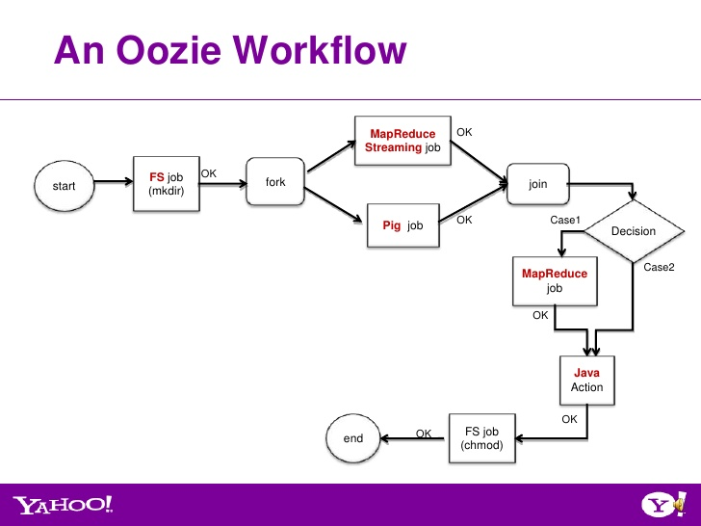

**Workflow has two nodes called as fork and join node. The fork and join nodes must be used in pairs. The join node assumes concurrent execution paths are children of the same fork node.**

**Fork node splits the one single path of execution into multiple paths of execution. The join accepts inputs from the these multiple paths of execution and combines into one. This puts overhead on the processing capabilities which gives faster results.**

**Above we can see that the job was split into two jobs one is pig and other one is mapreduce job.**

**Oozie web console**

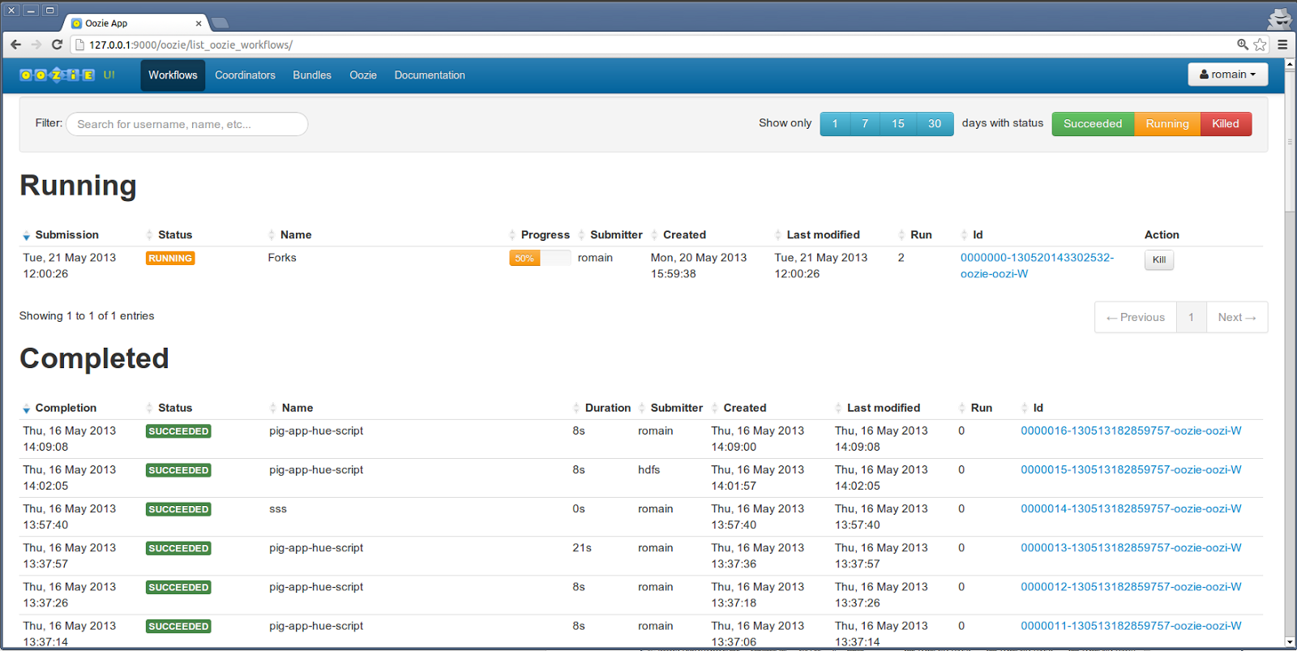

**Oozie web console is one which is used for monitoring the Status of the job. workflow applications status and workflow jobs status. It is read only interface and we cannot create any workflow. We can only read only.**