Assignment -

* Create a employee table in Mysql and columns as Emp_id, Emp_name, Dept_name(Hadoop Developer), Emp_sal.
* Import the employee table contents into the HDFS directory using Sqoop.
* Create an employee2 table in Mysql and Export employee details file from HDFS directory to Mysql table employee2 using Sqoop.
* Explain the procedures performed, Share the screenshots of commands and results for the same.

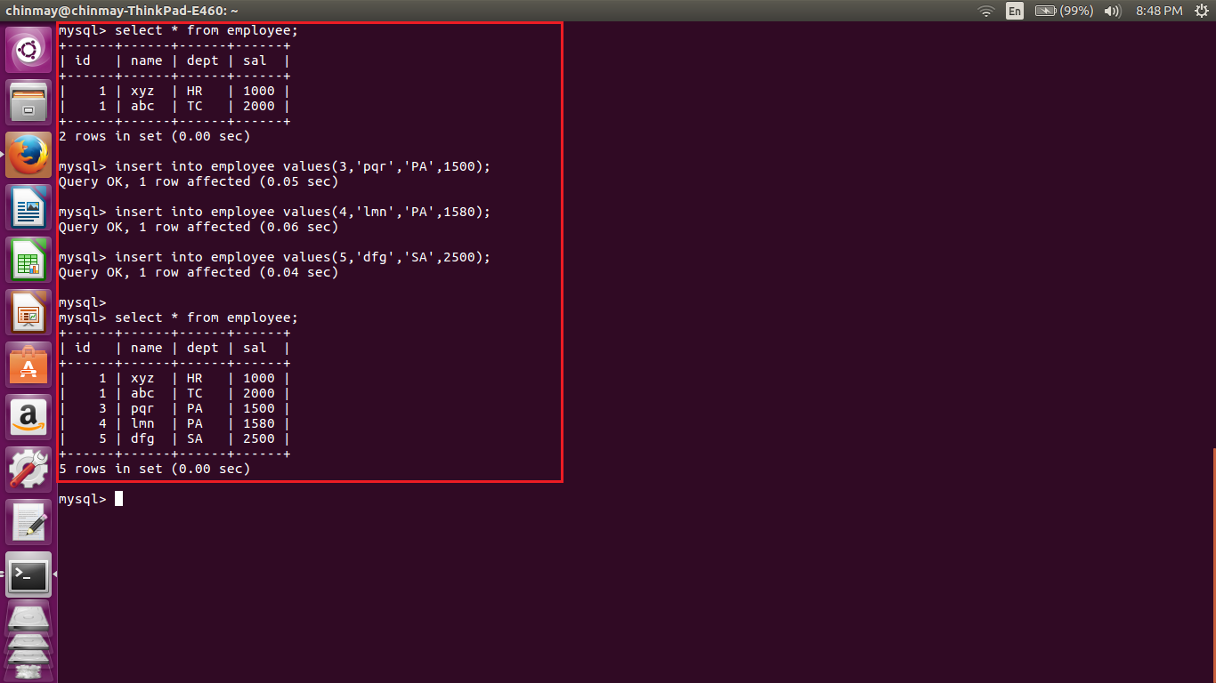

Here we are creating the table called as employee and inserted certain values inside the table.

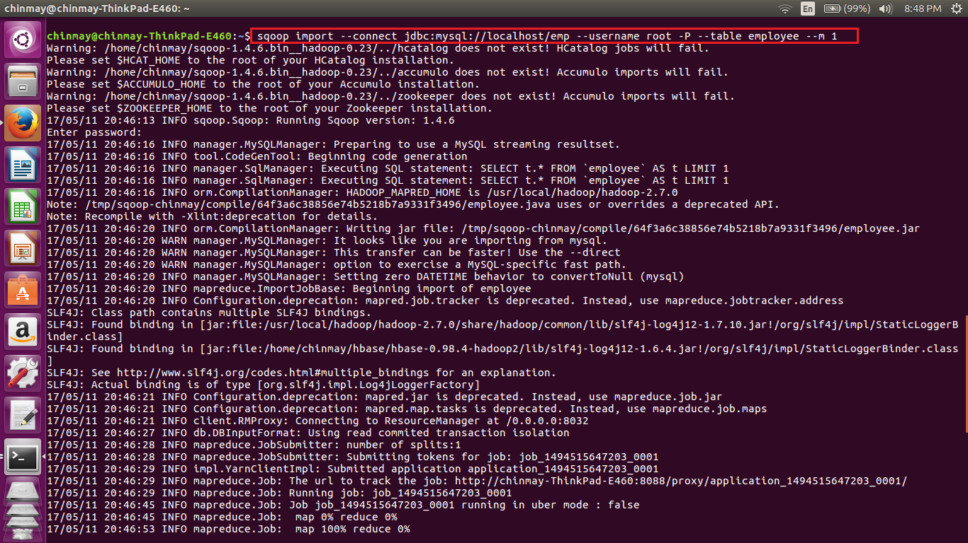

I the above table we have use the scoop command to put values from mysql db to hdfs in the command we have mentioned the database name and table name.

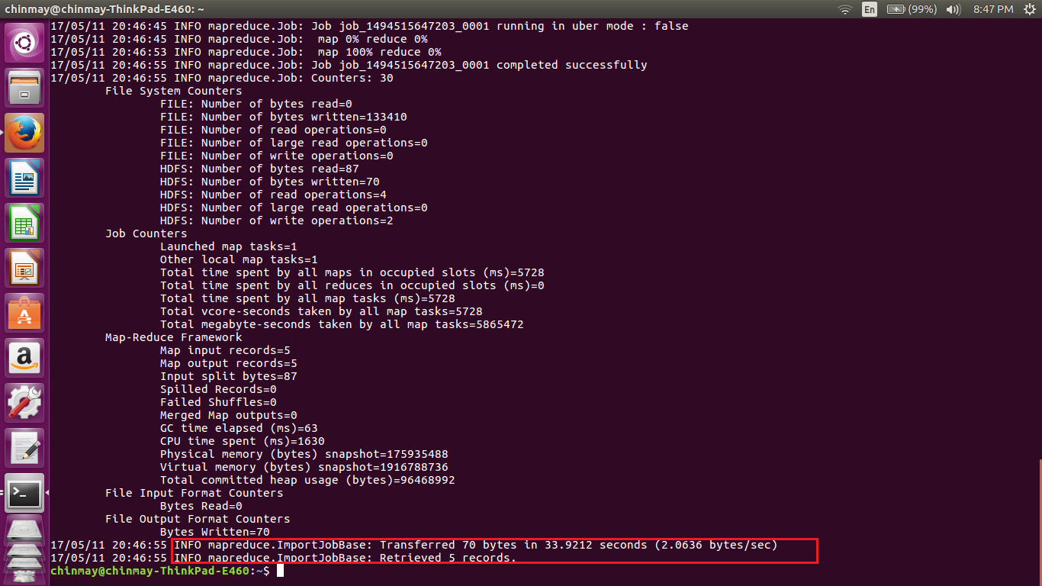

We can see that the few bytes have been transferred. Also the number of records that have been transferred is seen

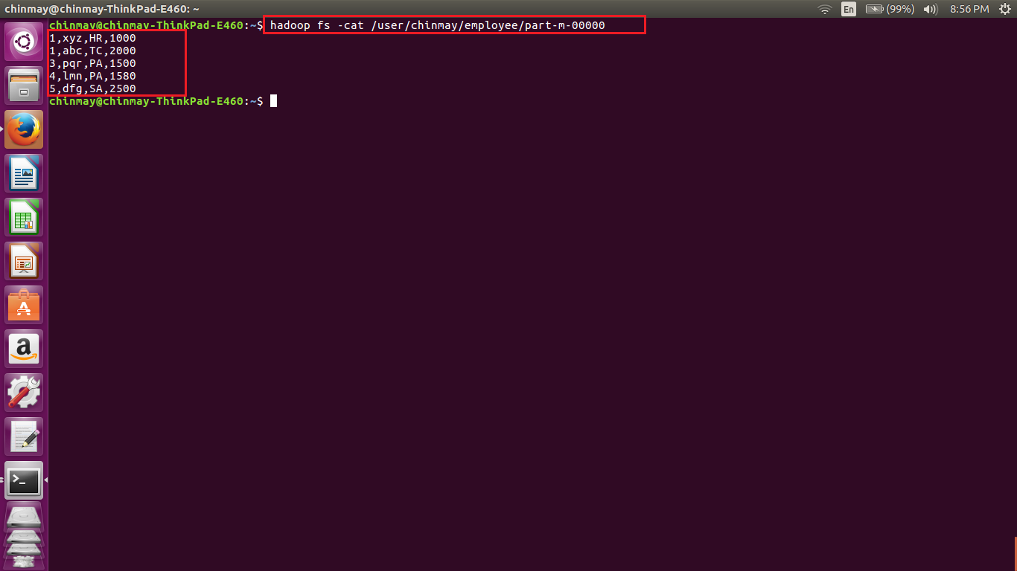

We can see that the values are in the hdfs as comma separated values.

----------------------------------------------------------------------------------------------------------------------------------------------------------------

Employee2 creation

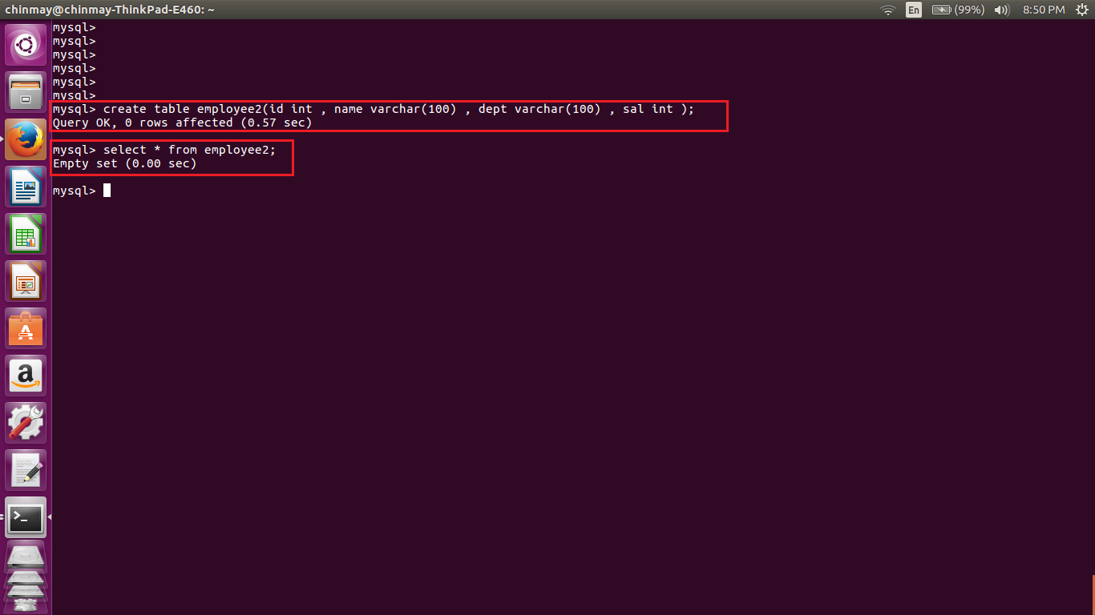

Above we can see that no data is stored in the table.

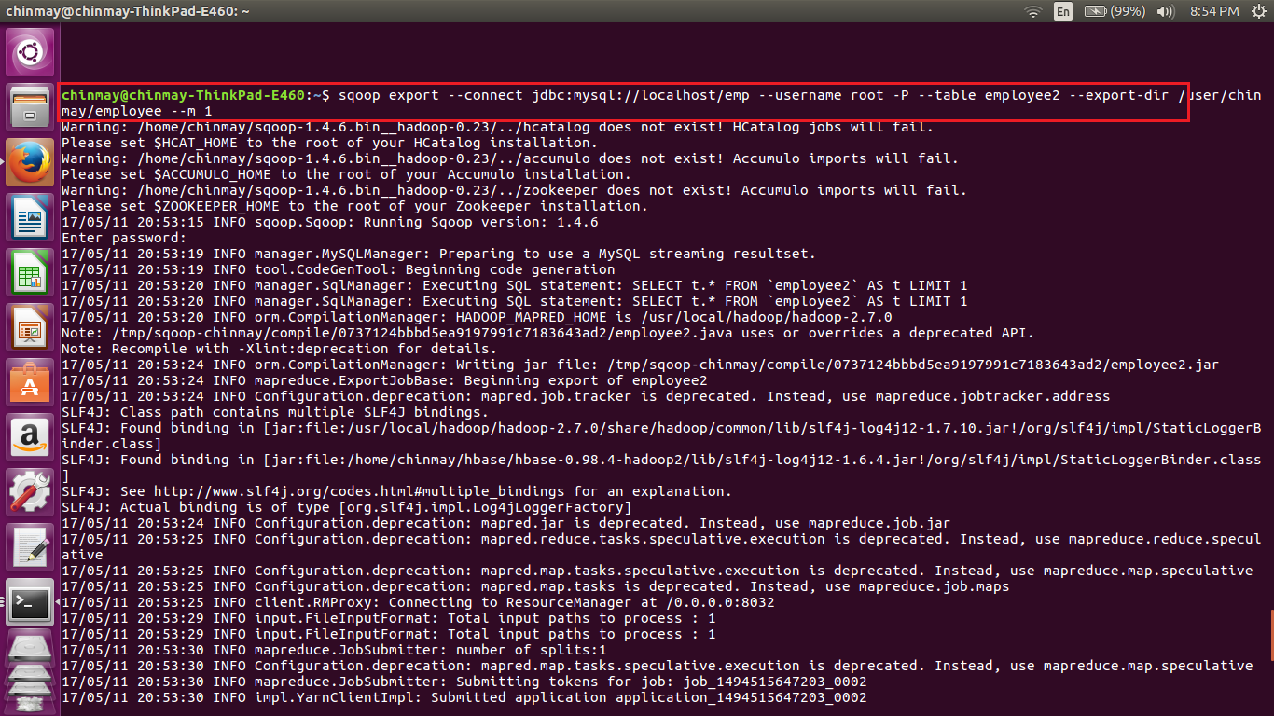

Here we are executing the sqoop export query. Here we are giving the export directory as the employee which was earlier in the hdfs.

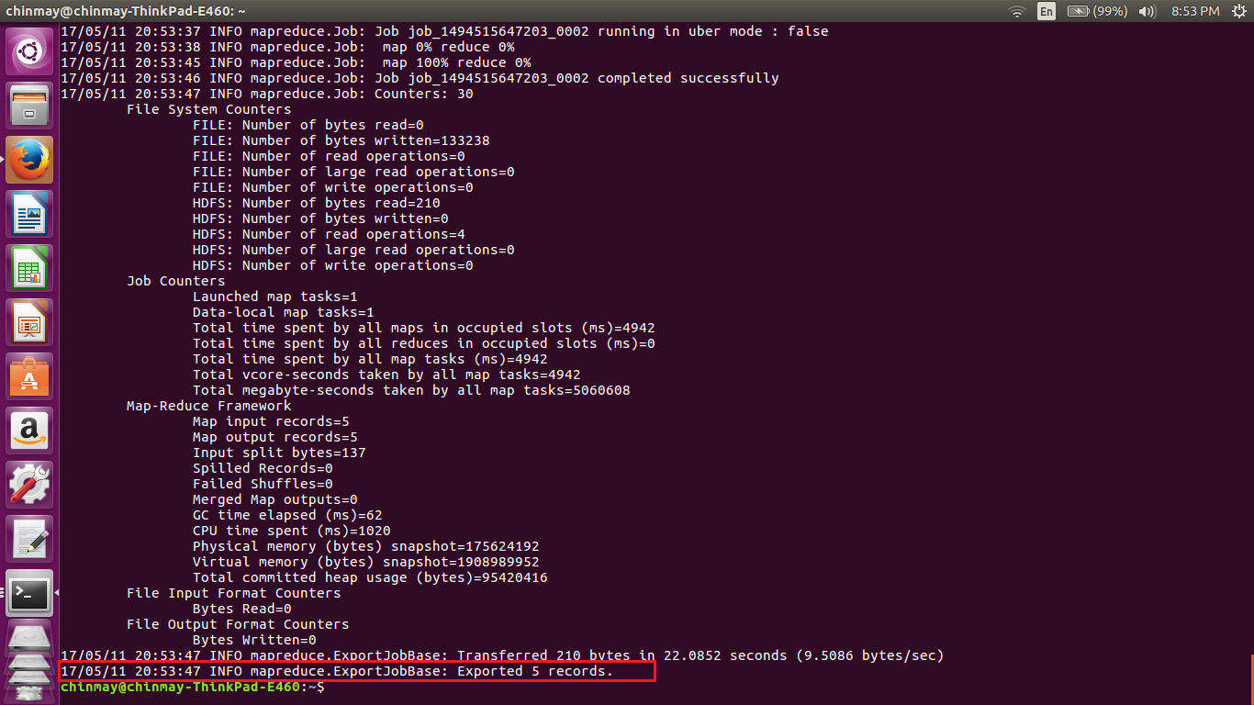

Completion of the sqoop command

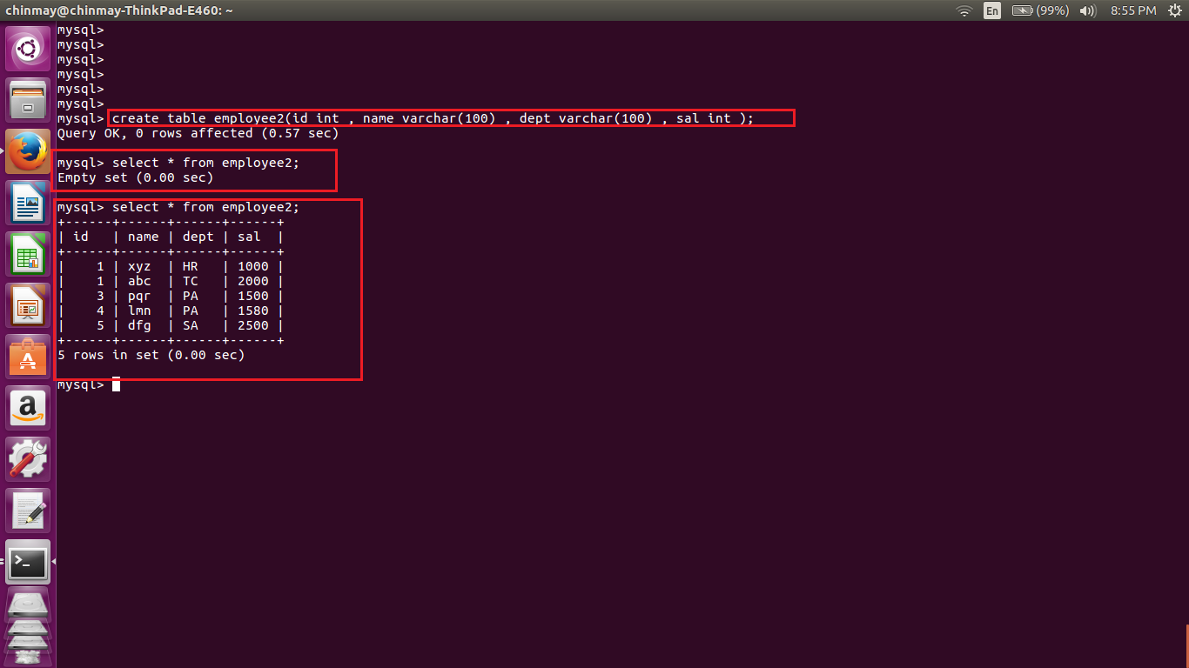

Here we can see that employee2 has the same data as employee.